The supply of computer services via the internet utilizing a pay-as-you-go pricing mechanism is known as cloud computing. You usually just pay for the cloud services you utilize, which allows you to do things like

* + Reduce your operational expenses.
  + Improve the efficiency of your infrastructure.
  + Scale up or down as your company's requirements vary.

Power, cooling and networking is the responsibility of Cloud service provider.

Physical security.

It is programmable data center.

|  |  |  |  |
| --- | --- | --- | --- |
|  | **laaS** | **PaaS** | **SaaS** |
| **Who uses it** | System administrators | Developers | End users |
| **What users get** | Virtual data center to store information &create platforms for services and app development, testing, and deployment | Virtual platform and tools to create, test and deploy apps and services | Web software and apps to complete business tasks |
| **example** | Virtual machines | A Azure SQL Database.  Azure Functions.  Azure Logic Apps.  Azure Kubernetes Ser vice.  Azure CosmosDB.  Azure Storage | Dynamics 365, Outlook, and Office 365 |

* AAzure Reservations help you save money by committing to one-year or three-year plans for multiple products. Azure Reservation is a long-term contract for a variety of Azure services.
* You pay the money monthly or in full upfront, but you can make almost 72% profit compared to pay-as-you-go pricing.
* This is good for businesses that have similar usage patterns most of the time.

### Cloud Computing Models

##### Public Cloud:

* In this kind of cloud, the whole infrastructure is situated at the cloud vendor aka the business that sells its services to the general public.
* In the case of the public cloud, we just need to go to the website of the relevant cloud provider and build or administer the resources.
* Others can use the resources that we previously utilized once we destroy them. Examples:- Microsoft Azure, Amazon Web Services,

##### Private Cloud:

* + This type of cloud is similar to a public cloud, but the difference is that the infrastructure and requirements are reserved for just a single organization only.
  + The resources are isolated and can’t be used by other organizations.
  + The cloud can be located on-premise as well.

*Examples:- Azure stack, Amazon private cloud*

**Hybrid Cloud:**

This is a combination of public cloud and private cloud. This is much more complex than public or private clouds. In this type of cloud

* + The public cloud is used for non-critical tasks.
  + The private cloud is used to carry out critical tasks.

### Shared Responsibility Model

**In the traditional infrastructure,**

* Company is responsible for maintaining the physical space, security, and maintaining servers and infrastructure, and replacing servers.
* The IT department is responsible for maintaining all the infrastructure and software required to keep the datacentre up and running and keeping all systems patched to the correct version.

**With Shared Responsibility Model, the responsibilities** like Physical Infrastructure, Security, and Softwares updates get shared between the cloud provider and the consumer.

**Cloud Provider is responsible for -** Physical Infrastructure (security, power, cooling, and network)

**Consumer is responsible for -** Data and information stored in cloud & managing security access.

**Azure Spot Instances:**

* These make use of Microsoft's leftover Compute Capacity.
* You can save almost 90% compared to pay-as-you-go pricing, but you should use Spot Instances for mostly stateless periodic workloads.
* This suggests that they should only be used when stopping in the middle of work is not a problem.
* Azure Spot instances - not suitable for a production-based environment.

# **Practical scenario: (1) Database Backup and Snapshot Operations**

****Scenario:****An online portal has a standard backup operation for its SQL databases scheduled during the weekend.

****Use of Spot VM:**** For operations like periodic backups, which can be paused and resumed, Spot VMs offer a more affordable alternative to continuously running VMs.

# **Data Warehousing & ETL Operations**

****Scenario:**** A marketing agency gathers data from various sources and requires periodic ETL (Extract, Transform, Load) operations to consolidate this data into their SQL data warehouse.

****Use of Spot VM:****Since these operations often run in batches and can be scheduled during off-peak hours, Spot VMs provide a cost-effective way to handle these ETL tasks.

**Important concepts for billing, low latency, Security and Compliance.**

### Geography, Azure regions, Region pairs, and Sovereign regions

### Geography:

### India, England, United States.

### Contains on or more Regions.

### 

### 

### 

##### Azure Regions:

* A region is a geographical location on the globe with at least one, but possibly many, data centers close by and connected by a low-latency network.
* Contains one or more data centers.
* When you create a resource in Azure, you must define the location/region to which it should belong. There are a few exceptions, such as Azure DNS, but generally, all resources must be created with a location specified.
* Azure makes it simple to select the data center and regions appropriate for you and your clients, with more announced regions than any other cloud provider (60+).

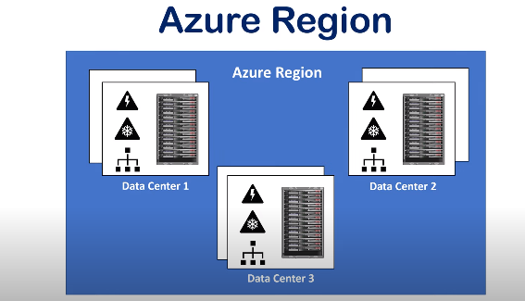

##### Azure Region Pairs:

Azure Region Pair is a relationship between two Azure Regions within the same geographic location for disaster recovery purposes.

* Azure regions are paired with other regions in the same geography at least 300 miles away.
* This approach allows for the replication of resources across geography to help mitigate disruptions due to events such as natural disasters, civil unrest, power outages, or physical network outages affecting the entire region.
* May may have one or more availability zones.
* Regions are paired for Business Continuity and Disaster Recovery. - BCDR

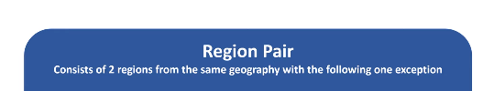

Ex: if a region in a pair was affected by a natural disaster, services would automatically failover to the other region(2nd Region) in its region pair.

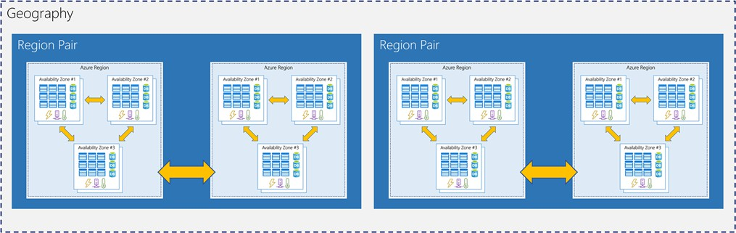

(Reference: Microsoft Docs)

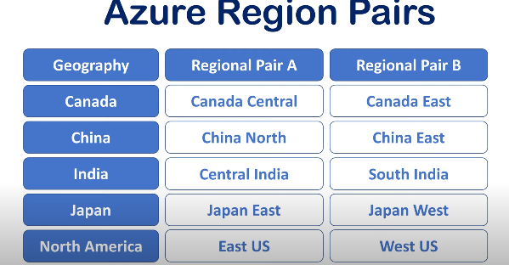

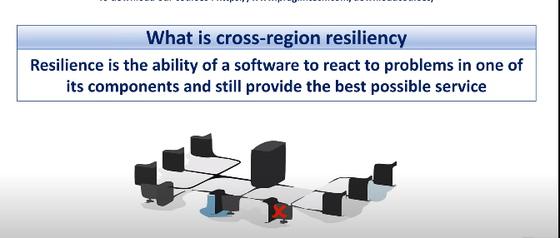

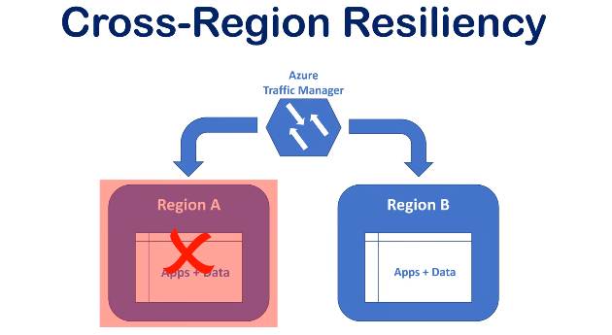

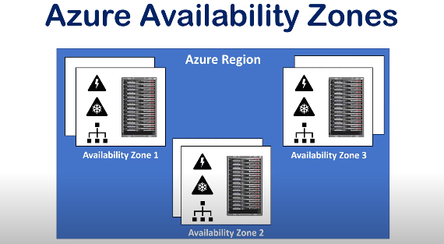

**SLA = 99.9%**

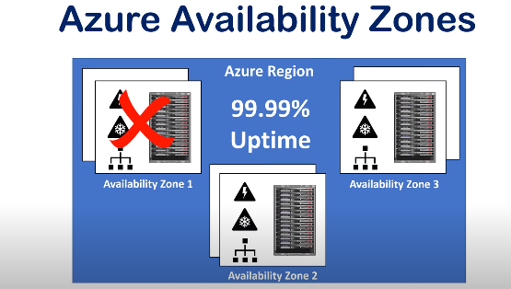

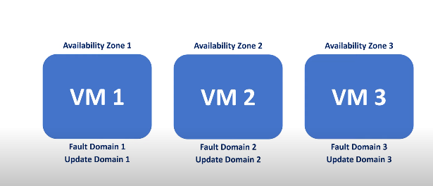

##### Sovereign Regions:

* Azure Sovereign regions are dedicated to specific sovereign entities.
* These cloud regions are isolated in-country platforms with independent authentication, storage, and compliance requirements.
* They are not necessarily managed by Microsoft and may be restricted to certain types of customers.

Examples: Azure China 21Vianet, Azure Germany, Azure Government - the US, Australia

### Azure Availability Zones and Datacentres

##### Azure Availability Zones

* + Within an Azure region, availability zones are physically distinct data centers.
  + Physically seperated.
  + Each availability zone comprises one or more data centers that are self-contained in terms of power, cooling, and networking.
  + Availability zones are connected through high-speed, private fiber-optic networks.
  + The goal of having more than one availability zone in a region is to allow data to be redundantly stored in more than one availability zone, ensuring that even if a data center fails, it does not affect our resources.

##### Azure Datacentres

* Datacentres are unique physical buildings like a group of networked computer servers.
* It contains a number of physical servers with their own power, cooling, & networking infra.
* Individual datacentres aren’t directly accessible.
* Azure Datacentres are grouped into Azure Regions/Availability Zones that are designed to help you achieve resiliency and reliability for your business-critical workloads.

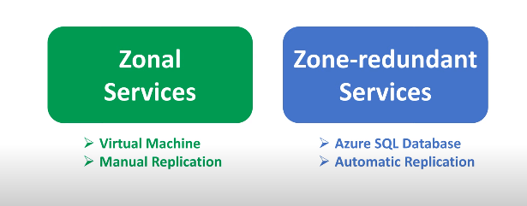

### Azure Resources and Resource groups

##### Azure Resources:

* + A resource is something that is used to manage services in azure.
  + At any one moment, a resource can only be in one resource group.
  + The final component in the Azure architectural hierarchy is the resource.
  + A resource group and a resource can be in two different locations; there is no restriction.

##### Azure Resource Group:

* + A resource group is the next level in the hierarchy of Azure Architecture. A resource group is the logical mapping of the resources.
  + For Creating Any Resource, you need a resource group.
  + An Azure Management group is optional. However, azure resource groups and subscriptions are required. Resource groups can’t be nested.

### Azure Subscriptions and Management Groups

#### Azure Subscriptions

* + As the name implies, a subscription is a logical entity that grants access to deploy and consume Azure resources.
  + A resource may be anything from a virtual machine to a storage account or something that's related to networking.
  + Almost anything in Azure can be utilized as a resource.
  + A subscription is something that can be purchased and used for a certain amount of time. The same is true for Azure subscriptions.

#### Azure Management Groups

* + A company may use Azure management groups to govern and *manage access, compliance, and rules* for their subscription inside their tenancy.
  + An azure management group comes above the azure subscription in the hierarchy of management of resources in Azure.
  + A subscription can only have one management group.

##### Hierarchy of Management Groups, Subscriptions, Resource Groups, and Resources

