- Introduction to Data Structure

This course is designed to teach you how to program efficiently. It assumes that
- you know the basics of programming in C,
- can write, debug and run simple programs in C, and
- have some simple understanding of object-oriented design.
An introduction to object-oriented programming using ANSI standard C may be found in the companion Object First course.

Good Programs
There are a number of facets to good programs: they must
- run correctly
- run efficiently
- be easy to read and understand
- be easy to debug and
- be easy to modify.

The first of these is obvious - programs which don't run correctly are clearly of little use. "Efficiently" is usually understood to mean in the minimum time - but occasionally there will be other constraints, such as memory use, which will be paramount. As will be demonstrated later, better running times will generally be obtained from use of the most appropriate data structures and algorithms, rather than through "hacking", i.e. removing a few statements by some clever coding - or even worse, programming in assembler!
This course will focus on solving problems efficiently: you will be introduced to a number of fundamental data structures and algorithms (or procedures) for manipulating them.
The importance of the other points is less obvious. The early history of many computer installations is, however, testimony to their importance. Many studies have quantified the enormous costs of failing to build software systems that had all the characteristics listed. (A classic reference is Boehm's text.) Unfortunately, much recent evidence suggests that these principles are still not well understood! Any perusal of Risks forum will soon convince you that there is an enormous amount of poor software in use. The discipline of software engineering is concerned with building large software systems which perform as their users expected, are reliable and easy to maintain. This course will introduce some software engineering principles but we will concentrate on the creation of small programs only. By using well-known, efficient techniques for solving problems, not only do you produce correct and fast programs in the minimum time, but you make your programs easier to modify. Another software engineer will find it much simpler to work with a well-known solution than something that has been hacked together and "looks a bit like" some textbook algorithm.

2. Programming Strategies
It is necessary to have some formal way of constructing a program so that it can be built efficiently and reliably. Research has shown that this can be best done by decomposing a program into suitable small modules, which can themselves be written and tested before being incorporated into larger modules, which are in turn constructed and tested. The alternative is create what was often called "sphaghetti code" because of its tangled of statements and jumps. Many expensive, failed projects have demonstrated that, however much you like to eat sphaghetti, using it as a model for program construction is not a good idea!
It's rather obvious that if we split any task into a number of smaller tasks which can be completed individually, then the management of the larger task becomes easier. However, we need a formal basis for partitioning our large task into smaller ones. The notion of abstraction is extremely useful here. Abstractions are high level views of objects or functions which enable us to forget about the low level details and concentrate on the problem at hand.
To illustrate, a truck manufacturer uses a computer to control the engine operation - adjusting fuel and air flow to match the load. The computer is composed of a number of silicon chips, their interconnections and a program. These details are irrelevant to the manufacturer - the computer is a black box to which a host of sensors (for engines speed, accelerator pedal position, air temperature, etc) are connected. The computer reads these sensors and adjusts the engine controls (air inlet and fuel valves, valve timing, etc) appropriately. Thus the manufacturer has a high level or abstract view of the computer. He has specified its behaviour with statements like:
"When the accelerator pedal is 50% depressed, air and fuel valves should be opened until the engine speed reaches 2500rpm".
He doesn't care how the computer calculates the optimum valve settings - for instance it could use either integer or floating point arithmetic - he is only interested in behaviour that matches his specification.
In turn, the manager of a transport company has an even higher level or more abstract view of a truck. It's simply a means of transporting goods from point A to point B in the minimum time allowed by the road traffic laws. His specification contains statements like:
"The truck, when laden with 10 tonnes, shall need no more than 20l/100km of fuel when travelling at 110kph."
How this specification is achieved is irrelevant to him: it matters little whether there is a control computer or some mechanical engineer's dream of cams, rods, gears, etc.
There are two important forms of abstraction: functional abstraction and structural abstraction. In functional abstraction, we specify a function for a module, i.e.
"This module will sort the items in its input stream into ascending order based on an ordering rule for the items and place them on its output stream."
As we will see later, there are many ways to sort items - some more efficient than others. At this level, we are not concerned with how the sort is performed, but simply that the output is sorted according to our ordering rule.
The second type of abstraction - structural abstraction - is better known as object orientation. In this approach, we construct software models of the behaviour of real world items, i.e. our truck manufacturer, in analysing the performance of his vehicle, would employ a software model of the control computer. For him, this model is abstract - it could mimic the behaviour of the real computer by simply providing a behavioural model with program statements like: | if ( pedal_pos > 50.0 ) {  set_air_intake( 0.78*pedal_pos);  set_fuel_valve( 0.12 + 0.32*pedal_pos);  }
Alternatively, his model could incorporate details of the computer and its program.
However, he isn't concerned: the computer is a "black box" to him and he's solely concerned with its external behaviour. To simplify the complexity of his own model (the vehicle as a whole), he doesn't want to concern himself with the internal workings of the control computer; he wants to assume that someone else has correctly constructed a reliable model of it for him.

2.1 Objects and ADTs
In this course, we won't delve into the full theory of object-oriented design. We'll concentrate on the pre-cursor of OO design: abstract data types (ADTs). A theory for the full object oriented approach is readily built on the ideas for abstract data types.
In some programming languages having the feature to construct a new data type by combining one or more data types which must be meaningful for manipulation.Such meaningful data types are referred as abstract data type. An abstract data type is a data structure and a collection of functions or procedures which operate on the data structure.
To align ourselves with OO theory, we'll call the functions and procedures methods and the data structure and its methods a class, i.e. we'll call our ADTs classes. However our classes do not have the full capabilities associated with classes in OO theory. An instance of the class is called an object . Objects represent objects in the real world and appear in programs as variables of a type defined by the class. These terms have exactly the same meaning in OO design methodologies, but they have additional properties such as inheritance that we will not discuss here.
It is important to note the object orientation is a design methodology. As a consequence, it is possible to write OO programs using languages such as C, Ada and Pascal. The so-called OO languages such as C++ and Eiffel simply provide some compiler support for OO design: this support must be provided by the programmer in non-OO languages.

2.2 An Example: Collections
Programs often deal with collections of items. These collections may be organised in many ways and use many different program structures to represent them, yet, from an abstract point of view, there will be a few common operations on any collection. These might include:
create | Create a new collection
add | Add an item to a collection
delete | Delete an item from a collection
find | Find an item matching some criterion in the collection
destroy | Destroy the collection

Data Structures:
The logical or mathematical model of a particular organization of data is called data structure. It is an implementation of Abstract data type in which atomic or composite data aggregate into a set with defined relationship.

A data structure is an arrangement of data in a computer's memory or even disk storage.
Data structures can be classified into two types

- Linear Data Structures
- Non Linear Data Structures

Linear Data Structures:
Linear data structures are those data structures in which data elements are accessed (read and written) in sequential fashion ( one by one)
Eg: Stacks , Queues, Lists, Arrays

Non Linear Data Structures:
Non Linear Data Structures are those in which data elements are not accessed in sequential fashion.
Eg: trees, graphs

Algorithm:
Step by Step process of representing solution to a problem in words is called an Algorithm.

Characteristics of an Algorithm:
- Input : An algorithm should have zero or more inputs
- Output: An algorithm should have one or more outputs
- Finiteness: Every step in an algorithm should end in finite amount of time
- Unambiguous: Each step in an algorithm should clearly stated
- Effectiveness: Each step in an algorithm should be effective

Characteristics of Data Structures
Data Structure | Advantages | Disadvantages
Array | Quick inserts  Fast access if index known | Slow search  Slow deletes  Fixed size
Ordered Array | Faster search than unsorted array | Slow inserts  Slow deletes  Fixed size
Stack | Last-in, first-out acces | Slow access to other items
Queue | First-in, first-out access | Slow access to other items
Linked List | Quick inserts  Quick deletes | Slow search
Binary Tree | Quick search  Quick inserts  Quick deletes  (If the tree remains balanced) | Deletion algorithm is complex
Red-Black Tree | Quick search  Quick inserts  Quick deletes  (Tree always remains balanced) | Complex to implement
2-3-4 Tree | Quick search  Quick inserts  Quick deletes  (Tree always remains balanced)  (Similar trees good for disk storage) | Complex to implement
Hash Table | Very fast access if key is known  Quick inserts | Slow deletes  Access slow if key is not known  Inefficient memory usage
Heap | Quick inserts  Quick deletes  Access to largest item | Slow access to other items
Graph | Best models real-world situations | Some algorithms are slow and very complex

Stack :
Stack is a Linear Data Structure which follows Last in First Out mechanism.
It means: the first element inserted is the last one to be removed
Stack uses a variable called top which points topmost element in the stack. top is incremented while pushing (inserting) an element in to the stack and decremented while poping (deleting) an element from the stack

A

B
A

C
B
A

C
BA

top
top

top

top

D
C
B
A
top

Push(A) Push(B) Push(C) Push(D) Pop()

Valid Operations on Stack:

- Inserting an element in to the stack (Push)
- Deleting an element in to the stack (Pop)
- Displaying the elements in the queue (Display)
Note:
While pushing an element into the stack, stack is full condition should be checked
While deleting an element from the stack, stack is empty condition should be checked

Applications of Stack:

- Stacks are used in recursion programs
- Stacks are used in function calls
- Stacks are used in interrupt implementation

Queue:

Queue is a Linear Data Structure which follows First in First out mechanism.
It means: the first element inserted is the first one to be removed
Queue uses two variables rear and front. Rear is incremented while inserting an element into the queue and front is incremented while deleting element from the queue

Insert(A) Insert(B) Insert(C) Insert(D) Delete()

A

B
A

C
B
A
D
C
B
A

D
C
B
rear
front
rear
front
rear

front
rear

front
rear

front

Valid Operations on Queue:

- Inserting an element in to the queue
- Deleting an element in to the queue
- Displaying the elements in the queue

Note:
While inserting an element into the queue, queue is full condition should be checked
While deleting an element from the queue, queue is empty condition should be checked
Applications of Queues:
- Real life examples
  - Waiting in line
  - Waiting on hold for tech support
- Applications related to Computer Science
  - Threads
  - Job scheduling (e.g. Round-Robin algorithm for CPU allocation)
Linked List:
To overcome the disadvantage of fixed size arrays linked list were introduced.
A linked list consists of nodes of data which are connected with each other. Every node consist of two parts data and the link to other nodes. The nodes are created dynamically.
NODE
bat •
Data link

bat •
cat •
sat •
vat NULL

Types of Linked Lists:
- Single linked list
- Double linked list
- Circular linked list

Valid operations on linked list:
- Inserting an element at first position
- Deleting an element at first position
- Inserting an element at end
- Deleting an element at end
- Inserting an element after given element
- Inserting an element before given element
- Deleting given element

Trees :

A tree is a Non-Linear Data Structure which consists of set of nodes called vertices and set of edges which links vertices

Terminology:

- Root Node: The starting node of a tree is called Root node of that tree
- Terminal Nodes: The node which has no children is said to be terminal node or leaf .
- Non-Terminal Node: The nodes which have children is said to be Non-Terminal Nodes
- Degree: The degree of a node is number of sub trees of that node
- Depth: The length of largest path from root to terminals is said to be depth or height of the tree
- Siblings: The children of same parent are said to be siblings
- Ancestors: The ancestors of a node are all the nodes along the path from the root to the node

A
B
C
D
G
E
F
I
H
Property Value
Number of nodes : 9
Height: 4
Root Node: A
Leaves: ED, H, I, F, C
Interior nodes: D, E, G
Number of levels: 5
Ancestors of H: I
Descendants of B: D,E, F
Siblings of E: D, F

Binary Trees:
Binary trees are special class of trees in which max degree for each node is 2
Recursive definition:
A binary tree is a finite set of nodes that is either empty or consists of a root and two disjoint binary trees called the left subtree and the right subtree.
Any tree can be transformed into binary tree. By left child-right sibling representation.
A
B
C
D
E
F
G
K

Binary Tree Traversal Techniques:

There are three binary tree traversing techniques
- Inorder
- Preorder
- Postorder

Inorder: In inorder traversing first left subtree is visited followed by root and right subtree
Preorder: In preorder traversing first root is visited followed by left subtree and right subtree.
Postorder: In post order traversing first left tree is visited followed by right subtree and root.
Binary Search Tree:
A Binary Search Tree (BST) is a binary tree which follows the following conditons
- Every element has a unique key.
- The keys in a nonempty left subtree are smaller than the key in the root of subtree.
- The keys in a nonempty right subtree are grater than the key in the root of subtree.
- The left and right subtrees are also binary search trees.
63
41
89
34
56
72
95

Valid Operations on Binary Search Tree:
- Inserting an element
- Deleting an element
- Searching for an element
- Traversing
Avl Tree:
If in a binary search tree, the elements are inserted in sorted order then the height will be n, where n is number of elements. To overcome this disadvantage balanced trees were introduced.
- Balanced binary search trees
- An AVL Tree is a binary search tree such that for every internal node v of T, the heights of the children of v can differ by at most 1.

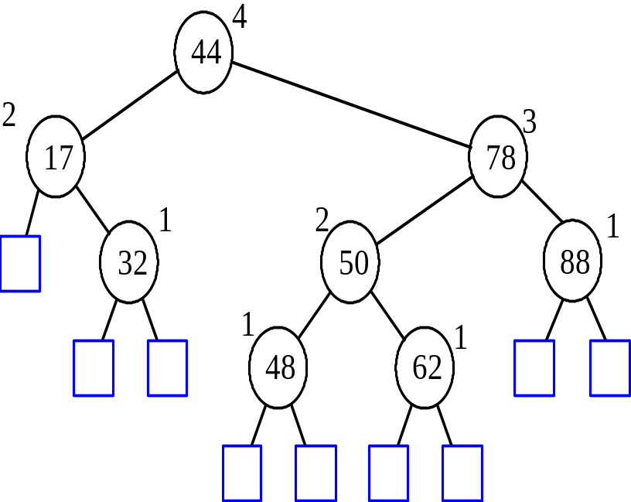
Operations of Avl tree:
- Inserting an element
- Deleting an element
- Searching for an element
- Traversing
- Height balancing
Graphs
A graph is a Non-Linear Data Structure which consists of set of nodes called vertices V and set of edges E which links vertices

Note: A tree is a graph with out loops

0
1
2
3
0
1
2
3
4
5
6

Graph Tree

Graph Traversal:
- Problem: Search for a certain node or traverse all nodes in the graph
- Depth First Search
  - Once a possible path is found, continue the search until the end of the path
- Breadth First Search
  - Start several paths at a time, and advance in each one step at a time

