Errors: An Overview

Error may be defined as the algebraic difference between the indication and the ideal value of the signal. The error is often termed as the instrumental error which is actually the difference between the average of a number of up and down readings.
The relationship between the output y of an instrument or a part of an instrument and its input x is generally given by the expression

Y=f(x)
This correct y is seldom obtained from an instrument and the relation requires t9o be modified to

Y’= f(x) + e
Where e is the error of the output, i.e., the deviation of the observed output y’ from the true or correct value y. Hence

E=y’ – y
The error is usually complex and has a number of components,
- the scale error which is further sub classified into

- Zero error or bias:- A constant amount by which the observed output may deviate from the correct value over the entire range is called bias or zero error. There are two types of bias:
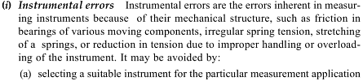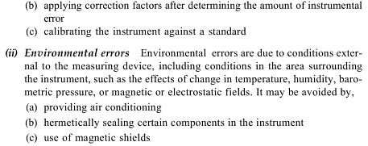

- Nonconformity:- When the experimental transfer function between the input and output is seen to deviate from the postulated one, then nonconformity is said to occur.

- Hysteresis Error:- When the output is dependent both on the present as well as past inputs or on the past history, the deviation due to the latter is called hysteresis error.
- The dynamic error:- When the output of the measurement system depends on the time function, and not just on the instantaneous input value alone,such as time derivatives or frequency of the input quantity, the deviation that occurs is known as dynamic error.
- Noise and Drift:- When the output is dependent, in addition to the input signal, on a signal originating in the system, an additional output is obtained which is termed as noise and when varying condition is considered it is called drift.

Besides, subjected to environmental influences such as change of temperature, pressure, acceleration, electric or magnetic field, change of supply voltage, the output is likely to vary because of the ‘interference’ as mentioned and in consequence errors result. In this way, a number of other errors may also occur which can often be isolated and corrected when the conditions in which the error develop are actually known. A few such types are discussed below:
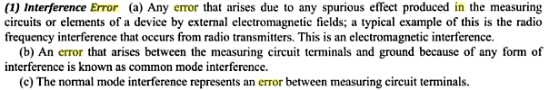

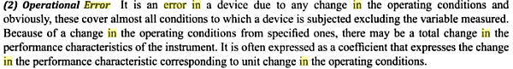

(3) Installation Error:- Installation of the primary element of a measurement system is very important. It must follow some standards or reference conditions on the basis of which information regarding the correction coefficients are obtained. In some of the above cases the error may be as high as 5 to 10 percent and to reduce this, non-standard practice of installation in its entirety is to be avoided.

(4) Equipment Error:- When the measured value is equipment- dependent, any change in it after installation would change the measured output causing an error to develop. Such an error may be termed as an equipment error. Error due to material incompatibility may also be termed as equipment error.

  - Loading Error:- Error also arrises in measurement system because of the loading of the preceding unit by the succeeding unit, this loading can be either static or dynamic in nature. Loading errors are very common in measurement. It occurs due to excessive loading on the measuring instrument. If the measuring device is deflected during the loading process it produces the loading error.
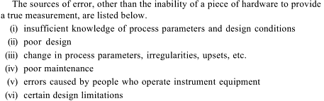

Hysteresis is the dependence of a system not only on its current environment but also on its past environment. This dependence arises because the system can be in more than one internal state. To predict its future development, either its internal state or its history must be known. If a given input alternately increases and decreases, the output tends to form a loop as in the figure. However, loops may also occur because of a dynamic lag between input and output. Often, this effect is also referred to as hysteresis, or rate-dependent hysteresis. This effect disappears as the input changes more slowly, so many experts do not regard it as true hysteresis.
Hysteresis occurs in ferromagnetic materials and ferroelectric materials, as well as in the deformation of some materials (such as rubber bands and shape-memory alloys) in response to a varying force. In natural systems hysteresis is often associated with irreversible thermodynamic change. Many artificial systems are designed to have hysteresis: for example, in thermostats and Schmitt triggers, hysteresis is produced by positive feedback to avoid unwanted rapid switching. Hysteresis has been identified in many other fields, including economics and biology.
