MAGNETIC WIND TYPE PARAMAGNETIC GAS ANALYZER
This is one of the methods utilizing the paramagnetic property of oxygen.
When a sample gas contains oxygen, the oxygen is drawn into the magnetic field, thereby decreasing the flow rate of auxiliary gas in stream B. The difference in flow rates of the two streams, A and B, which is caused by the effect of flow restriction in stream B, is proportional to the oxygen concentration of the sample gas. The flow rates are determined by the thermistors and converted into electrical signals, the difference of which is computed as an oxygen signal.
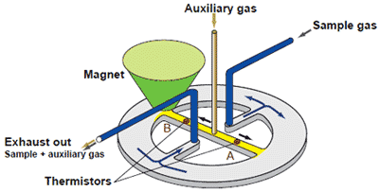
Advantages : | • | Capable of measuring flammable gas mixtures that cannot be measured by a zirconia oxygen analyzer.
Advantages : | • | Because there is no sensor in the detecting section in contact with the sample gas, the paramagnetic system can also measure corrosive gases.
Advantages : | • | Among the magnetic types, the paramagnetic system offers a faster response time than other systems.
Advantages : | • | Among the magnetic types, the paramagnetic system is more resistant to vibration or shock than other systems.
Disadvantages : |  | Requires a sampling unit corresponding to the sample gas properties or applications.

