SAFETY AND HAZARDS

Intrinsic Safety:
Intrinsic safety (IS) is a protection technique for safe operation of electrical equipment in hazardous areas by limiting the energy available for ignition. In signal and control circuits that can operate with low currents and voltages, the intrinsic safety approach simplifies circuits and reduces installation cost over other protection methods. Areas with dangerous concentrations of flammable gases or dust are found in applications such as petrochemical refineries and mines. As a discipline, it is an application of inherent safety in instrumentation. High-power circuits such as electric motors or lighting cannot use intrinsic safety methods for protection.
Intrinsic safety is specified by what is called safety triangle. The sides of the triangle are constituted by 1) Combustible material, 2) Heat and 3) Oxygen. The central area is denoted as fire.
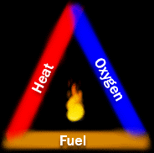
When combustible material reaches a concentration that can be explosive--- the fire explosion may be initiated by 1) the apparatus surface temperature if it exceeds the ignition temperature of the combustible material (gases) or by 2) electric spark.

An alternate triangular representation is below:
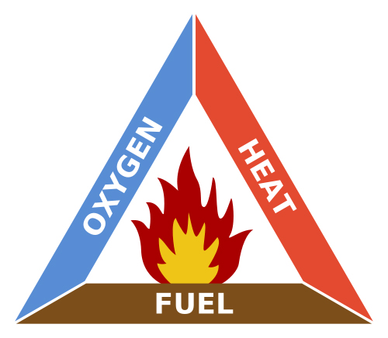
Instrinsic safety of an apparatus is an hazardous location is ensured by 1) provide electrical and mechanical isolation, 2) limiting voltage and current, 3) by providing shunt elements.
Electrical isolation is provided by a transformer--- the primary and secondary windings are provided with a grounded shield which ensures any fault on the primary side to be grounded shielded and the secondary side potential is kept within the safe limit.
Mechanical isolation is basically a spatial isolation and is provided by encapsulation.
Voltages are limited using zener diodes.

