The Hysteresis Loop and Magnetic Properties
A great deal of information can be learned about the magnetic properties of a material by studying its hysteresis loop. A hysteresis loop shows the relationship between the induced magnetic flux density (B) and the magnetizing force (H). It is often referred to as the B-H loop. An example hysteresis loop is shown below.
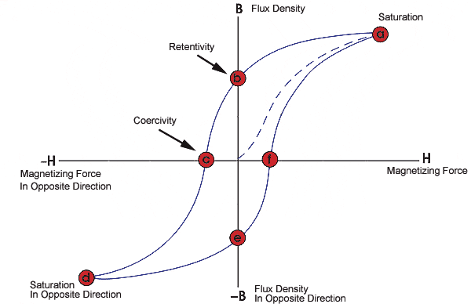
The loop is generated by measuring the magnetic flux of a ferromagnetic material while the magnetizing force is changed. A ferromagnetic material that has never been previously magnetized or has been thoroughly demagnetized will follow the dashed line as H is increased. As the line demonstrates, the greater the amount of current applied (H+), the stronger the magnetic field in the component (B+). At point "a" almost all of the magnetic domains are aligned and an additional increase in the magnetizing force will produce very little increase in magnetic flux. The material has reached the point of magnetic saturation. When H is reduced to zero, the curve will move from point "a" to point "b." At this point, it can be seen that some magnetic flux remains in the material even though the magnetizing force is zero. This is referred to as the point of retentivity on the graph and indicates the remanence or level of residual magnetism in the material. (Some of the magnetic domains remain aligned but some have lost their alignment.) As the magnetizing force is reversed, the curve moves to point "c", where the flux has been reduced to zero. This is called the point of coercivity on the curve. (The reversed magnetizing force has flipped enough of the domains so that the net flux within the material is zero.) The force required to remove the residual magnetism from the material is called the coercive force or coercivity of the material.
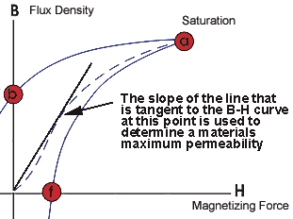
As the magnetizing force is increased in the negative direction, the material will again become magnetically saturated but in the opposite direction (point "d"). Reducing H to zero brings the curve to point "e." It will have a level of residual magnetism equal to that achieved in the other direction. Increasing H back in the positive direction will return B to zero. Notice that the curve did not return to the origin of the graph because some force is required to remove the residual magnetism. The curve will take a different path from point "f" back to the saturation point where it with complete the loop.
From the hysteresis loop, a number of primary magnetic properties of a material can be determined.
- Retentivity - A measure of the residual flux density corresponding to the saturation induction of a magnetic material. In other words, it is a material's ability to retain a certain amount of residual magnetic field when the magnetizing force is removed after achieving saturation. (The value of B at point b on the hysteresis curve.)
- Residual Magnetism or Residual Flux - the magnetic flux density that remains in a material when the magnetizing force is zero. Note that residual magnetism and retentivity are the same when the material has been magnetized to the saturation point. However, the level of residual magnetism may be lower than the retentivity value when the magnetizing force did not reach the saturation level.
- Coercive Force - The amount of reverse magnetic field which must be applied to a magnetic material to make the magnetic flux return to zero. (The value of H at point c on the hysteresis curve.)
- Permeability, μ - A property of a material that describes the ease with which a magnetic flux is established in the component.
- Reluctance - Is the opposition that a ferromagnetic material shows to the establishment of a magnetic field. Reluctance is analogous to the resistance in an electrical circuit.
As previously mentioned, permeability (μ) is a material property that describes the ease with which a magnetic flux is established in a component. It is the ratio of the flux density (B) created within a material to the magnetizing field (H) and is represented by the following equation:
μ = Β/Η
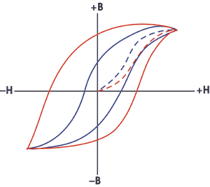
It is clear that this equation describes the slope of the curve at any point on the hysteresis loop. The permeability value given in papers and reference materials is usually the maximum permeability or the maximum relative permeability. The maximum permeability is the point where the slope of the B/H curve for the unmagnetized material is the greatest. This point is often taken as the point where a straight line from the origin is tangent to the B/H curve.
The relative permeability is arrived at by taking the ratio of the material's permeability to the permeability in free space (air).
μ(relative) = μ(material) / μ(air)
where: μ(air) = 1.256 x 10⁻⁶ H/m
The shape of the hysteresis loop tells a great deal about the material being magnetized. The hysteresis curves of two different materials are shown in the graph.
Relative to other materials, a material with a wider hysteresis loop has:
- Lower Permeability
- Higher Retentivity
- Higher Coercivity
- Higher Reluctance
- Higher Residual Magnetism
Relative to other materials, a material with the narrower hysteresis loop has:
- Higher Permeability
- Lower Retentivity
- Lower Coercivity
- Lower Reluctance
- Lower Residual Magnetism.
In magnetic particle testing, the level of residual magnetism is important. Residual magnetic fields are affected by the permeability, which can be related to the carbon content and alloying of the material. A component with high carbon content will have low permeability and will retain more magnetic flux than a material with low carbon content.

