Parabolic Reflector Antenna Theory
The theory behind the parabolic reflector can be understood relatively easily.
Some of the mathematics behind the parabolic reflector antenna can be straightforward and easy to understand.
The basic concept of the parabolic reflector antenna theory rests on the parabolic shape and its unique properties.

Parabolic reflector theory basics
A parabolic reflector is formed from a shape known as a paraboloid. This shape forms a reflective surface in the antenna that enables waves reflected by the surface to retain their phase relationship. In other words, RF energy in the form of electromagnetic waves travelling towards the antenna in a plane wavefront will be reflected by the reflector and remain in phase at the focal point. In this way the whole signal remains in phase and there is no cancellation. Conversely signals radiated from the focal point will be reflected by the parabolic reflector and form a parallel wavefront (in-phase) travelling outwards from the antenna.
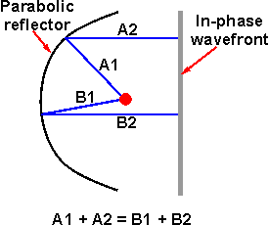
A paraboloid enables the wavefronts to combine and not be out of phase
In view of the fact that total length A1 + A2 is the same as B1 + B2, etc, this means that the phase integrity of the system is retained. Incoming waves add at the focal point, and outgoing waves produce a single wavefront moving in parallel away from the reflector.
It is this concept that is at the centre of parabolic reflector antenna theory.

Parabolic reflector shape theory
Parabolic reflector theory relies on the shape of the reflector for its properties.
The reflector uses a parabolic shape to ensure that all the power is reflected in a beam in which the wave traces run parallel to each other. Also all the reflected power is in the same phase, because the path length from the source to the reflector and then outwards is the same wherever it is reflected on the surface of the parabola.
The parabolic curve follows the equation:
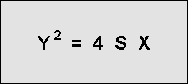
The measurements and references for the parabolic reflector antenna formula can be seen on the diagram below:
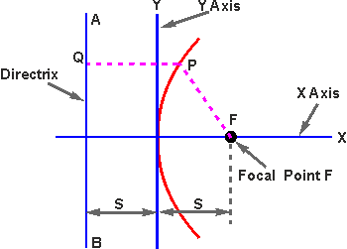
The parabolic curve and its details
The theory shows the parabolic curve is the locus of points that are equidistant from a fixed point known as the focus located on the X axis and a fixed line detailed as AB which is known as the directrix. On this the length FP = PQ wherever it is located on the parabolic curve.
As the surface acts as a reflector, the directix has the same properties when located in front of the reflector. In other words the parabolic reflector theory shows that the emanating wavefront will have an in-phase wavefront.
The parabolic reflector antenna theory also shows the emanating beam will tend to be parallel.

Parabolic antenna focal length
One important element of the parabolic reflector antenna theory is its focal length. To ensure that the antenna operates correctly, it is necessary to ensure that the radiating element is placed at the focal point. To determine this it is necessary to know the focal length.
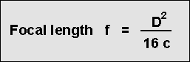
Where:
f is the focal length
D is the diameter of the reflector
c is the depth of the reflector
In addition to this the f/D ratio is important. As the f/D ratio is often specified along with the diameter, the focal length can be obtained very easily by multiplying its f/D ratio by the specified diameter D

Parabolic reflector antenna gain is one of the key parameters of this type of antenna.
The high level of gain that can be achieved by using a parabolic reflector is one of the main reasons they are used.
Parabolic reflector antenna gain can be as high as 30 to 40 dB - figures that would not be easily achievable using other forms of antenna. Antennas would be mechanically large and unwieldy.

The parabolic reflector antenna is ideal for high gain applications. At microwave frequencies where these antennas are normally used, they are able to produce very high levels of gain, and they offer a very convenient and robust structure that is able to withstand the rigours of external use, while still being able to perform well. Many other types of antenna design are not practicable at these frequencies.
High gain parabolic reflector antennas come in a variety of sizes. The most commonly seen are those used for satellite television reception. However parabolic antennas are used in many other applications. Parabolic reflector antennas are also often seen on microwave towers for communications. Larger ones still can often be seen on TV broadcast stations where signals need to be transmitted up to a broadcast satellite and where performance is paramount. Even larger antennas may also be used for other communications or even space research applications. Some these parabolic antennas are many tens of metres across.
The one common feature of all these examples is the parabolic antenna gain, or parabolic dish gain. While the larger antennas have greater levels of parabolic antenna gain, the performance of all these antennas is of prime importance.

Factors affecting parabolic reflector antenna gain
There are a number of factors that affect the parabolic antenna gain. These factors include the following:
- Diameter of reflecting surface The larger the diameter of the reflecting surface of the antenna the higher the parabolic reflector gain will be.
- Antenna efficiency: The efficiency of the antenna has a significant effect on the overall parabolic reflector gain. Typical figures are between 50 and 70%. Further details are given below.
- Operational wavelength: The parabolic reflector antenna gain is dependent upon the reflector size in terms of wavelengths. Therefore if the same reflector is used on two different frequencies, the gain will be different and inversely proportional to the wavelength.

Parabolic reflector antenna gain
The parabolic antenna gain can easily be calculated from a knowledge of the diameter of the reflecting surface, the wavelength of the signal, and a knowledge or estimate of the efficiency of the antenna.
The parabolic reflector antenna gain is calculated as the gain over an isotropic source, i.e. relative to a source that radiates equally in all directions. This is a theoretical source that is used as the benchmark against which most antennas are compared. The gain is quoted in this manner is denoted as dBi.
The standard formula for the parabolic reflector antenna gain is:
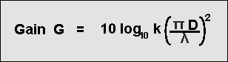
Where:
G is the gain over an isotropic source in dB
k is the efficiency factor which is generally around 50% to 60%, i.e. 0.5 to 0.6
D is the diameter of the parabolic reflector in metres
λ is the wavelength of the signal in metres
From this it can be seen that very large gains can be achieved if sufficiently large reflectors are used. However when the antenna has a very large gain, the beamwidth is also very small and the antenna requires very careful control over its position. In professional systems electrical servo systems are used to provide very precise positioning.
It can be seen that the parabolic reflector gain can be of the order of 50dB for antennas that have a reflector diameter of a hundred wavelengths or more. Whilst antennas of this size would not be practicable for many antennas designs such as the Yagi, and many others, the parabolic reflector can be made very large in comparison to the wavelength and therefore it can achieve these enormous gain levels. More normal sizes for these antennas are a few wavelengths, but these are still able to provide very high levels of gain.
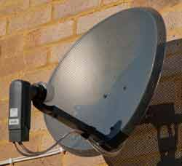

Parabolic reflector gain efficiency
In the overall gain formula for the antenna, an efficiency factor is included. Typically this may be between 50 and 70% dependent upon the actual antenna.
The parabolic reflector antenna gain efficiency is dependent upon a variety of factors. These are all multiplied together to give the overall efficiency.
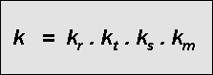
- Radiation efficiency: The radiation efficiency is denoted as kr above. It is governed by the resistive or Ohmic losses within the antenna. It is controlled by the radiation efficiency of the element of the antenna that radiates the RF energy. For most antennas this is high and close to unity. Therefore the radiation efficiency does not have a major effect on the parabolic reflector antenna gain and is normally ignored.
- Aperture Taper Efficiency: The aperture taper efficiency is denoted as kt above. It affects the antenna gain because the whole parabolic reflector needs to be properly illuminated for the optimum gain to be achieved. If parts of the surface are not optimally illuminated by the radiated energy from the radiator then the parabolic reflector gain will be reduced. The optimum performance is achieved when the centre is illuminated a little more than the edges.
- Spillover Efficiency: The spillover efficiency is denoted as ks above. Any energy that spills over the edge of the reflector surface will reduce the efficiency and hence the parabolic reflector antenna gain. In the ideal case, the reflector surface needs to be equally and fully illuminated and none should spill over the edge. In the real case this is not viable and some reduction in efficiency, and hence the antenna gain is experienced.
- Surface Error : In order to provide the highest levels of parabolic reflector antenna gain, the surface must follow the parabolic contour as accurately as possible. Deviations from this will result in poor reflection accuracy. However it is possible to use a gauze for the reflector to reduce weight and wind resistance provided that the holes in the gauze or mesh are small in comparison with a wavelength. The width of the slots or holes in the reflective metal mesh must be less than λ/10.
- Cross Polarization : As with any other antenna the polarisation of the transmitted and received signals must match otherwise there is a loss equal to the sine of the angle between the polarisations, assuming linear polarisation.
- Aperture Blockage: The physical structure of the feed and other elements of the antenna often mask part of the reflector. This naturally reduces the efficiency and hence the antenna gain. This factor needs to be accommodated within the antenna gain calculation.
- Non-Single Point Feed: The focal point of the reflector is a single point. However all antennas have a finite size and therefore this will mean that the antenna extends outside the focal point of the reflector. The larger the radiating element with respect to the reflecting surface, the more of a problem this is and the larger impact it has on the antenna gain.
The term km is used to denote the various miscellaneous efficiency elements that are often more difficult to determine. These include those due to surface effort, cross polarisation, aperture blockage, and the non-single point feed.

Parabolic antenna beamwidth calculation
As the gain of the parabolic antenna, or any antenna, increases, so the beamwidth falls.
Normally the beamwidth is defined as the points where the power falls to half of the maximum, i.e. the -3dB points on a radiation pattern polar diagram.
It is possible to estimate the beamwidth reasonably accurately from the following formula.
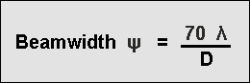
Where:
G is the gain over an isotropic source in dB
D is the diameter of the parabolic reflector
λ is the wavelength of the signal
All dimensions must be in the same units for the calculation to be correct, e.g. both diameter and wavelength in metres, or both in feet, etc..

Optimising parabolic antenna gain
To provide the optimum illumination of the reflecting surface, the level of illumination should be greater in the centre than at the sides. It can be shown that the optimum situation occurs when the centre is around 10 to 11 dB greater than the illumination at the edge. Lower levels of edge illumination result in lower levels of side lobes.
The reflecting surface antenna forms a major part of the whole system. In many respects it is not as critical as may be thought at first. Often a wire mesh may be used. Provided that the pitch of the mesh is small compared to a wavelength it will be seen as a continuous surface by the radio signals. If a mesh is used then the wind resistance will be reduced, and this provides significant advantages
The feed systems for parabolic reflector antennas or dish antennas are of great importance.
The parabolic reflector antenna feed element has a major impact on the performance and therefore correctly designing it means that the optimum performance can be obtained from the overall antenna system.
The actual antenna element within the overall parabolic reflector antenna, i.e. the device that interfaces the transmission line or waveguide containing the radio-frequency energy to free space, is the feed element for the parabolic reflector antenna. The reflector surface itself is entirely passive.

Parabolic reflector feed length
While there are many different types of parabolic reflector antenna feed systems, one key element of many of them is the feed point and hence the focal length of the reflector.
The parabolic reflector focal point is the point where all reflected waves will be concentrated. The focal length f (distance of focal point from the centre of the reflector) is calculated with the following equation:
Where:
f is the focal length of the reflector
D is reflector diameter in same units as wavelength
c is depth of the reflector
The radiation from the feed element induces a current flow in the conductive reflector surface which, in turn, re-radiates in the desired direction, perpendicular to the directrix plane of the paraboloid. The feed element can be any one of a multitude of antenna types. Whichever type is used, it must exhibit a directivity that efficiently illuminates the reflector and must have the correct polarization for the application -- the polarization of the feed determining the polarization of the entire antenna system. The simplest feed is a half-wave dipole which is commonly used at lower frequencies, sometimes in conjunction with a closely coupled parasitic reflector or "splash plate". At higher frequencies a horn-type becomes more feasible and efficient. To adapt the horn to a coaxial antenna cable, a length of waveguide is used to effect the transition.
There are two dimensions for the parabolic antenna that are of particular importance. These are the focal length, f and the diameter, D. Typically one of the parameters used to specific parabolic antennas is the f / D ratio. As the f/D ratio is often specified along with the diameter, the focal length can be obtained very easily by multiplying its f/D ratio by the specified diameter D.

Parabolic reflector feed types
There are several different types of parabolic reflector feed systems that can be used. Each has its own characteristics that can be matched to the requirements of the application.
- Focal feed - often also known as axial or front feed system
- Cassegrain feed system
- Gregorian feed system
- Off Axis or offset feed

Focal feed system
The parabolic reflector or dish antenna consists of a radiating element which may be a simple dipole or a waveguide horn antenna. This is placed at the focal point of the parabolic reflecting surface. The energy from the radiating element is arranged so that it illuminates the reflecting surface. Once the energy is reflected it leaves the antenna system in a narrow beam. As a result considerable levels of gain can be achieved.
Achieving this is not always easy because it is dependent upon the radiator that is used. For lower frequencies a dipole element is often employed whereas at higher frequencies a circular waveguide may be used. In fact the circular waveguide provides one of the optimum sources of illumination.
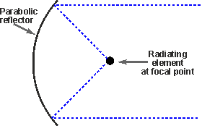
Diagram of a focal feed parabolic reflector antenna
The focal feed system is one of the most widely used feed system for larger parabolic reflector antennas as it is straightforward. The major disadvantage is that the feed and its supports block some of the beam, and this typically limits the aperture efficiency to only about 55 to 60%.

Cassegrain feed system
The Cassegrain feed system, although requiring a second reflecting surface has the advantage that the overall length of the dish antenna between the two reflectors is shorter than the length between the radiating element and the parabolic reflector. This is because there is a reflection in the focusing of the signal which shortens the physical length. This can be an advantage in some systems.
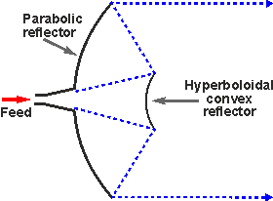
Diagram of a Cassegrain feed parabolic reflector or dish antenna
Typical efficiency levels of 65 to 70% can be achieved using this form of parabolic reflector feed system
The Cassegrain parabolic reflector antenna design and feed system gains its name because the basic concept was adapted from the Cassegrain telescope. This was reflecting telescope which was developed around 1672 and attributed to French priest Laurent Cassegrain.

Gregorian parabolic reflector feed
The Gregorian parabolic reflector feed technique is very similar to the Cassegrain design. The major difference is that except that the secondary reflector is concave or more correctly ellipsoidal in shape.
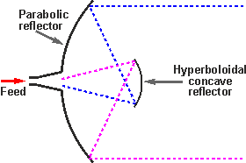
Diagram of a Gregorian feed parabolic reflector or dish antenna
Typical aperture efficiency levels of over 70% can be achieved because the system is able to provide a better illumination of all of the reflector surface..

Off axis or offset parabolic reflector antenna feed
As the name indicates this form of parabolic reflector antenna feed is offset from the centre of the actual antenna dish used.
The reflector used in this type of feed system is an asymmetrical segment of the parabolic shape normally used. In this way the focus, and the feed antenna are located to one side of the reflector surface.
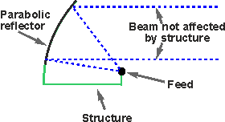
Diagram of an Offset feed parabolic reflector or dish antenna
The advantage of using this approach to the parabolic reflector feed system is to move the feed structure out of the beam path. In this way it does not block the beam.
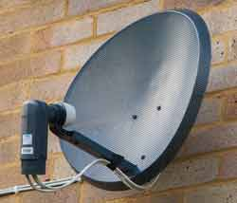
Domestic satellite parabolic reflector antenna with offset feed
This approach is widely used in home satellite television antennas, which are often relatively small and this would mean that any the feed structure including the low noise box (amplifier, etc) would otherwise block a significant percentage of the beam and thereby reduce the antenna efficiency and signal level.
The offset feed is also used in multiple reflector designs such as the Cassegrain and Gregorian because the small reflector would also suffer the same issues

