Satellite Subsystems
An operating communications satellite system consists of several elements or segments, ranging from an orbital configuration of space components to ground based components and network elements. The particular application of the satellite system, for example fixed satellite
service, mobile service, or broadcast service, will determine the specific elements of the system. A generic satellite system, applicable to most satellite applications, can be described by the elements shown in Figure 3.1.

The basic system consists of a satellite (or satellites) in space, relaying information between two or more users through ground terminals and the satellite. The information relayed may be voice, data, video, or a combination of the three. The user information may require transmission
via terrestrial means to connect with the ground terminal. The satellite is controlled from the ground through a satellite control facility, often called the master control center (MCC), which provides tracking, telemetry, command, and monitoring functions for the system.

The space segment of the satellite system consists of the orbiting satellite (or satellites) and the ground satellite control facilities necessary to keep the satellites operational. The ground segment, or earth segment, of the satellite system consists of the transmit and receive earth stations and the associated equipment to interface with the user network. This chapter describes the basic elements of the space segment, specifically as it applies to general communications satellites. Ground segment elements are unique to the type of communications satellite application, such as fixed service, mobile service, broadcast service, or satellite broadband, and will be covered in later chapters where the specific applications are discussed. The space segment equipment carried aboard the satellite can be classified under two functional areas: the bus and the payload, as shown in Figure 3.2.

• Bus: The bus refers to the basic satellite structure itself and the subsystems that support the satellite. The bus subsystems are: the physical structure, power subsystem, attitude and orbital control subsystem, thermal control subsystem, and command and telemetry subsystem.

.Payload :The payload on a satellite is the equipment that provides the service or services intended for the satellite.Acommunications satellite payload consists of the communications equipment that provides the relay link between the up- and downlinks from the ground. The communications payload can be further divided into the transponder and the antenna subsystems.
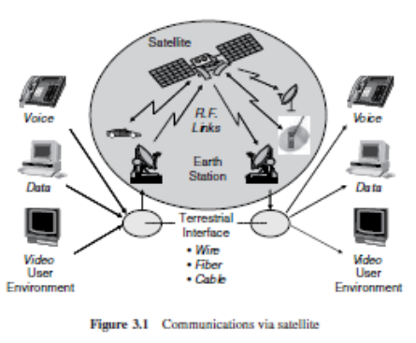
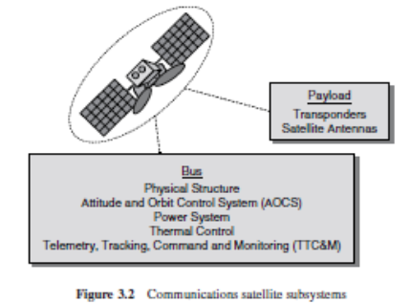
A satellite may have more than one payload. The early Tracking and Data Relay Satellites (TDRS), for example, had an ‘Advanced Westar’ communications payload in addition to the tracking and data payload, which was the major mission of the satellite.

3.1 Satellite Bus
The basic characteristics of each of the bus subsystems are described in the following subsections.
3.1.1 Physical Structure
The physical structure of the satellite provides a ‘home’ for all the components of the satellite. The basic shape of the structure depends of the method of stabilization employed to keep the satellite stable and pointing in the desired direction, usually to keep the antennas properly oriented toward earth. Two methods are commonly employed: spin stabilization and three-axis or body stabilization. Both methods are used for GSO and NGSO satellites. Figure 3.3 highlights the basic configurations of each, along with an example of a satellite of each type.
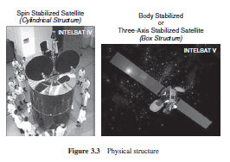
3.1.1.1 Spin Stabilization
A spin stabilized satellite is usually cylindrical in shape, because the satellite is required to be mechanically balanced about an axis, so that it can be maintained in orbit by spinning on its axis. For GSO satellites, the spin axis is maintained parallel to the spin axis of the earth, with
spin rates in the range of 30 to 100 revolutions per minute. The spinning satellite will maintain its correct attitude without additional effort, unless disturbance torques are introduced. External forces such as solar radiation, gravitational gradients, and meteorite impacts can generate undesired torques. Internal effects such as motor bearing friction and antenna subsystem movement can also produce unwanted torque in the system.
Impulse type thrusters, or jets, are used to maintain spin rate and correct any wobbling or nutation to the satellite spin axis. The entire spacecraft rotates for spin-stabilized satellites that employ Omni directional antennas. When directional antennas are used, which is the prevalent case, the antenna subsystem must be despun, so that the antenna is kept properly pointed towards earth. Figure 3.4 shows a typical implementation of a despun platform on a spin-stabilized satellite. The antenna subsystem is mounted on a platform or shelf, which may also contain some of the transponder equipment. The satellite is spun-up by small radial gas jets on the surface of the drum. The rotation, ranging from 30 to 100 rpm, provides gyroscopic force stability for the satellite. The propellants used include heated hydrazine or a bipropellant mix of hydrazine and nitrogen
tetroxide. The despun platform is driven by an electric motor in the opposite direction of the satellite spin, on the same spin axis and at the same spin rate as the satellite body, to maintain a fixed orientation for the antennas, relative to earth.
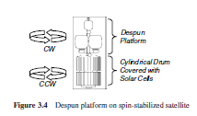
3.1.1.2 Three-axis Stabilization
A three-axis stabilized satellite is maintained in space with stabilizing elements for each of the three axes, referred to as roll, pitch, and yaw, in conformance with the definitions first used in the aircraft industry. The entire body of the spacecraft remains fixed in space, relative to the earth, which is why the three-axis stabilized satellite is also referred to as a body-stabilized satellite. Active attitude control is required with three-axis stabilization. Control jets or reaction wheels are used, either separately or in combination, to provide correction and control for each of the three axes. A reaction wheel is basically a flywheel that absorbs the undesired torques that would shift spacecraft orientation. Fuel is expended for both the control jets and for the reaction wheels, which must periodically be ‘unloaded’ of momentum energy that builds up in the wheel. The three-axis stabilized satellite does not need to be symmetric or cylindrical, and most tend be box-like, with numerous appendages attached. Typical appendages include antenna systems and solar cell panels, which are often unfurled after placement at the on-orbit location.
3.1.2 Power Subsystem
The electrical power for operating equipment on a communications satellite is obtained primarily from solar cells, which convert incident sunlight into electrical energy. The radiation on a satellite from the sun has an intensity averaging about 1.4 kW/m2. Solar cells operate at an efficiency of 20–25% at beginning of life (BOL), and can degrade to 5–10% at end of life (EOL), usually considered to be 15 years. Because of this, large numbers of cells, connected in serial-parallel arrays, are required to support the communications satellite electronic systems, which often require more than one to two kilowatts of prime power to function. The spin-stabilized satellite usually has cylindrical panels, which may be extended after deployment to provide additional exposure area. A cylindrical spin-stabilized satellite must carry a larger number of solar cells than an equivalent three-axis stabilized satellite, because only about one-third of the cells are exposed to the sun at any one time. The three-axis stabilized satellite configuration allows for better utilization of solar cell area, because the cells can be arranged in flat panels, or sails, which can be rotated to maintain normal exposure to the sun – levels up to 10kW are attainable with rotating panels. All spacecraft must also carry storage batteries to provide power during launch and during eclipse periods when sun blockage occurs. Eclipses occur for a GSO satellite twice a year, around the spring and fall equinoxes, when earth’s shadow passes across the spacecraft. Daily eclipses start about 23 days before the equinox, and end the same number of days after. The daily eclipse duration increases a few minutes each day to about a 70-minute peak on equinox day, then decreases a similar amount each day following the peak [1]. Sealed nickel cadmium (Ni-Cd) batteries are most often used for satellite battery systems. They have good reliability and long life, and do not outgas when in a charging cycle. Nickel-hydrogen (NiH2) batteries, which provide a significant improvement in power-to-weight ratio, are also used. A power conditioning unit is also included in the power subsystem, for the control of battery charging and for power regulation and monitoring. The power generating and control systems on a communications satellite account for a large part of its weight, often 10 to 20% of total dry weight.3
3.1.3 Attitude Control
The attitude of a satellite refers to its orientation in space with respect to earth. Attitude control is necessary so that the antennas, which usually have narrow directional beams, are pointed correctly towards earth. Several forces can interact to affect the attitude of the spacecraft, including gravitational forces from the sun, moon, and planets; solar pressures acting on the spacecraft body, antennas or solar panels; and earth’s magnetic field. Orientation is monitored on the spacecraft by infrared horizon detectors, which detect the rim of earth against the background of space. Four detectors are used to establish a reference point, usually the center of the earth, and any shift in orientation is detected by one or more of
the sensors.Acontrol signal is generated that activates attitude control devices to restore proper orientation. Gas jets, ion thrusters, or momentum wheels are used to provide active attitude control on communications satellites. Since the earth is not a perfect sphere, the satellite will be accelerated towards one of two ‘stable’ points in the equatorial plane. The locations are 105◦W and 75◦ E. Figure 3.5 shows the geometry of the stable points and the resulting drift patterns. If no orbit control (station keeping) is provided, the satellite will drift to and eventually settle at one of the stable points. This could take several years and several passes through the stable point before the satellite finally comes to rest at a stable point. The stable points are sometimes referred to as the ‘satellite graveyard’, for obvious reasons.
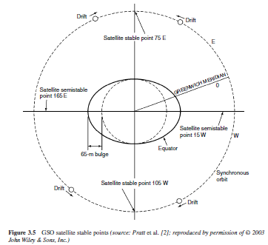
3.1.4 Orbital Control
Orbital control, often called station keeping, is the process required to maintain a satellite in its proper orbit location. It is similar to, although not functionally the same as, attitude control, discussed in the previous section. GSO satellites will undergo forces that would cause the satellite to drift in the east-west (longitude) and north-south (latitude) directions, as well as in altitude, if not compensated for with active orbital control jets. Orbital control is usually maintained with the same thruster system as is attitude control. The non-spherical (oblate) properties of the earth, primarily exhibited as an equatorial bulge, cause the satellite to drift slowly in longitude along the equatorial plane. Control jets are pulsed
to impart an opposite velocity component to the satellite, which causes the satellite to drift back to its nominal position. These corrections are referred to as east-west station keeping maneuvers, which are accomplished periodically every two to three weeks. Typical C-band satellites must be maintained within ±0.1◦, and Ku-band satellites within ±0.05◦, of nominal longitude, to keep the satellites within the beamwidths of the ground terminal antennas. For a nominal geostationary radius of 42 000 km, the total longitude variation would be about 150 km for C-band and about 75 km for Ku-band. Latitude drift will be induced primarily by gravitational forces from the sun and the moon. These forces cause the satellite inclination to change about 0.075◦ per month if left uncorrected. Periodic pulsing to compensate for these forces, called north-south station keeping maneuvers, must also be accomplished periodically to maintain the nominal satellite orbit location. North south station-keeping tolerance requirements are similar to those for east-west station keeping, ± 0.1◦ for C-band, and ± 0.05◦ for Ku-band.
Satellite altitude will vary about ± 0.1 %, which is about 72 km for a nominal 36 000-km geostationary altitude.AC-band satellite, therefore, must be maintained in a ‘box’ with longitudinal, and latitudinal sides of about 150 km and an altitude side of 72 km. TheKu-band satellite
requires a box with approximately equal sides of 75 km. Figure 3.6 summarizes the orbital control limits and indicates the typical ‘orbital box’ that a GSO satellite can be maintained in for the C-band and Ku-band cases.
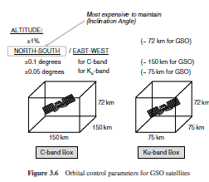
North-south station keeping requires much more fuel than east-west station keeping, and often satellites are maintained with little or no north-south station keeping to extend on-orbit life. The satellite is allowed to drift with a higher inclination, with the drift compensated for on the ground with tracking and/or smaller aperture antennas.

The expendable fuel that must be carried on-board the satellite to provide orbital and attitude control is usually the determining factor in the on-orbit lifetime of a communications satellite. As much as one-half of the satellite launch weight is station-keeping fuel. The lifetimes of most of the critical electronic and mechanical components usually exceed the allowable time for active orbit control, which is limited by the weight of fuel that can be carried to orbit with current conventional launch vehicles. It is not unusual for a communications satellite to ‘run out of fuel’ with most of its electronic communications subsystems still functioning.
3.1.5 Thermal Control
Orbiting satellites will experience large temperature variations, which must be controlled in the harsh environment of outer space. Thermal radiation from the sun heats one side of the spacecraft, while the side facing outer space is exposed to the extremely low temperatures of space. Much of the equipment in the satellite itself generates heat, which must be controlled. Low orbiting satellites can also be affected by thermal radiation reflected from the earth itself.

The satellite thermal control system is designed to control the large thermal gradients generated in the satellite by removing or relocating the heat to provide an as stable as possible temperature environment for the satellite. Several techniques are employed to provide thermal control in a satellite. Thermal blankets and thermal shields are placed at critical locations to provide insulation. Radiation mirrors are placed around electronic subsystems, particularly for spin-stabilized satellites, to protect critical equipment. Heat pumps are used to relocate heat from power devices such as traveling wave power amplifiers to outer walls or heat sinks to provide a more effective thermal path for heat to escape. Thermal heaters may also be used to maintain adequate temperature conditions for some components, such as propulsion lines or thrusters, where low temperatures would cause severe problems.

The satellite antenna structure is one of the critical components that can be affected by thermal radiation from the sun. Large aperture antennas can be twisted or contorted as the sun moves around the satellite, heating and cooling various portions of the structure. This ‘potato chip’ effect is most critical for apertures exceeding about 15m designed to operate at high frequencies, i.e., Ku-band, Ka-band, and above, because the small wavelengths react more severely resulting in antenna beam point distortions and possible gain degradation.
3.1.6 Tracking, Telemetry, Command, and Monitoring
The tracking, telemetry, command, and monitoring (TTC&M) subsystem provides essential spacecraft management and control functions to keep the satellite operating safely in orbit. The TTC&M links between the spacecraft and the ground are usually separate from the communications system links. TTC&M links may operate in the same frequency bands or in other bands. TTC&M is most often accomplished through a separate earth terminal facility specifically designed for the complex operations required to maintain a spacecraft in orbit. One TTC&M facility may maintain several spacecraft simultaneously in orbit through TTC&M links to each vehicle. Figure 3.7 shows the typical TTC&M functional elements for the satellite and ground facility for a communications satellite application.

The satellite TTC&M subsystems comprise the antenna, command receiver, tracking and telemetry transmitter, and possibly tracking sensors. Telemetry data are received from the other subsystems of the spacecraft, such as the payload, power, attitude control, and thermal control. Command data are relayed from the command receiver to other subsystems to control such parameters as antenna pointing, transponder modes of operation, battery and solar cell changes, etc.

The elements on the ground include the TTC&M antenna, telemetry receiver, command transmitter, tracking subsystem, and associated processing and analysis functions. Satellite control and monitoring is accomplished through monitors and keyboard interface. Major operations of TTC&M may be automated, with minimal human interface required.
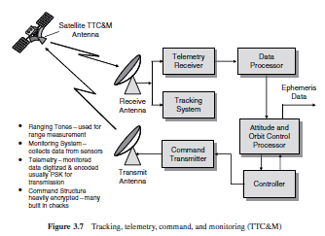
Tracking refers to the determination of the current orbit, position, and movement of the spacecraft. The tracking function is accomplished by a number of techniques, usually involving satellite beacon signals, which are received at the satellite TTC&M earth station. The Doppler
shift of the beacon (or the telemetry carrier) is monitored to determine the rate at which the range is changing (the range rate). Angular measurements from one or more earth terminals can be used to determine spacecraft location. The range can be determined by observing the
time delay of a pulse or sequence of pulses transmitted from the satellite. Acceleration and velocity sensors on the satellite can be used to monitor orbital location and changes in orbital location.

The telemetry function involves the collection of data from sensors on-board the spacecraft and the relay of this information to the ground. The telemetered data include such parameters as voltage and current conditions in the power subsystem, temperature of critical subsystems,
status of switches and relays in the communications and antenna subsystems, fuel tank pressures, and attitude control sensor status. A typical communications satellite telemetry link could involve over 100 channels of sensor information, usually in digital form, but occasionally
in analog form for diagnostic evaluations. The telemetry carrier modulation is typically frequency or phase shift keying (FSK or PSK), with the telemetry channels transmitted in a time division multiplex (TDM) format. Telemetry channel data rates are low, usually only a few kbps.

Command is the complementary function to telemetry. The command system relays specific control and operations information from the ground to the spacecraft, often in response to telemetry information received from the spacecraft. Parameters involved in typical command links include
• changes and corrections in attitude control and orbital control;
• antenna pointing and control;
• transponder mode of operation;
• battery voltage control.
The command system is used during launch to control the firing of the boost motor, deploy appendages such as solar panels and antenna reflectors, and ‘spin-up’ a spin-stabilized spacecraft body.

Security is an important factor in the command system for a communications satellite. The structure of the command system must contain safeguards against intentional or unintentional signals corrupting the command link, or unauthorized commands from being transmitted and
accepted by the spacecraft. Command links are nearly always encrypted with a secure code format to maintain the health and safety of the satellite. The command procedure also involves multiple transmissions to the spacecraft, to assure the validity and correct reception of the
command, before the execute instruction is transmitted.

Telemetry and command during the launch and transfer orbit phases usually requires a backup TTC&M system, since the main TTC&M system may be inoperable because the antenna is not deployed, or the spacecraft attitude is not proper for transmission to earth. The backup system usually operates with an Omni directional antenna, at UHF or S-band, with sufficient margin to allow operation in the most adverse conditions. The backup system could also be used if the main TTC&M system fails on orbit.
3.2 Satellite Payload
The next two sections discuss the key elements of the payload portion of the space segment, specifically for communications satellite systems: the transponder and antenna subsystems.

3.2.1 Transponder
The transponder in a communications satellite is the series of components that provides the communications channel, or link, between the uplink signal received at the uplink antenna, and the downlink signal transmitted by the downlink antenna. A typical communications satellite will contain several transponders, and some of the equipment may be common to more than one transponder.

Each transponder generally operates in a different frequency band, with the allocated frequency spectrum band divided into slots, with a specified center frequency and operating bandwidth. The C-band FSS service allocation, for example, is 500MHz wide. A typical design would accommodate 12 transponders, each with a bandwidth of 36 MHz, with guard bands of 4MHz between each. Atypical commercial communications satellite today can have 24 to 48 transponders, operating in the C-band, Ku-band, or Ka-bands.

The number of transponders can be doubled by the use of polarization frequency reuse, where two carriers at the same frequency, but with orthogonal polarization, are used. Both linear polarization (horizontal and vertical sense) and circular polarization (right-hand and left-hand sense) have been used. Additional frequency reuse may be achieved through spatial separation of the signals, in the form of narrow spot beams, which allow the reuse of the same frequency carrier for physically separate locations on the earth. Polarization reuse and spot beams can be combined to provide four times, six times, eight times, or even higher frequency reuse factors in advanced satellite systems. The communications satellite transponder is implemented in one of two general types of configurations: the frequency translation transponder and the on-board processing transponder.
3.2.1.1 Frequency Translation Transponder
The first type, which has been the dominant configuration since the inception of satellite communications, is the frequency translation transponder. The frequency translation transponder, also referred to as a non-regenerative repeater, or bent pipe, receives the uplink signal and, after amplification, retransmits it with only a translation in carrier frequency. Figure 3.8 shows the typical implementation of a dual conversion frequency translation transponder, where the uplink radio frequency, f_{up}, is converted to an intermediate lower frequency, f_{if} , amplified, and then converted back up to the downlink RF frequency, f_{dwn}, for transmission to earth. Frequency translation transponders are used for FSS, BSS, and MSS applications, in both GSO and NGSO orbits. The uplinks and downlinks are codependent, meaning that any degradation introduced on the uplink will be transferred to the downlink, affecting the total communications link.
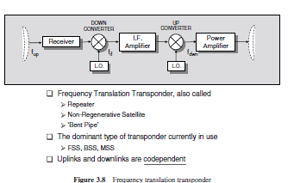
3.2.1.2 On-board Processing Transponder
Figure 3.9 shows the second type of satellite transponder, the on-board processing transponder, also called a regenerative repeater demod/remod transponder, or smart satellite. The uplink signal at f_{up} is demodulated to baseband, f_{baseband} . The baseband signal is available for processing on-board, including reformatting and error-correction. The baseband information is then remodulated to the downlink carrier at f_{dwn}, possibly in a different modulation format to the uplink and, after final amplification, transmitted to the ground. The demodulation/remodulation process removes uplink noise and interference from the downlink, while allowing additional on-board processing to be accomplished. Thus the uplinks and downlinks are independent with respect to evaluation of overall link performance, unlike the frequency translation transponder where uplink degradations are codependent, as discussed earlier.
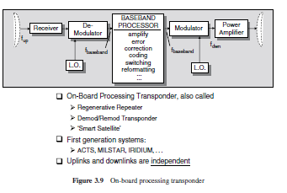
On-board processing satellites tend to be more complex and expensive than frequency translation satellites; however, they offer significant performance advantages, particularly for small terminal users or for large diverse networks.

Traveling wave tube amplifiers (TWTAs) or solid state amplifiers (SSPAs) are used to provide the final output power required for each transponder channel. The TWTA is a slow wave structure device, which operates in a vacuum envelope, and requires permanent magnet focusing and high voltage DC power supply support systems. The major advantage of the TWTA is its wide bandwidth capability at microwave frequencies. TWTAs for space applications can operate to well above 30 GHz, with output powers of 150 watts or more, and RF bandwidths exceeding 1 GHz. SSPAs are used when power requirements in the 2–20 watt region are required. SSPAs operate with slightly better power efficiency than the TWTA, however both are nonlinear devices, which directly impacts system performance.

Other devices may be included in the basic transponder configurations of Figures 3.8 and 3.9, including band pass filters, switches, input multiplexers, switch matrices, and output multiplexers. Each device must be considered when evaluating the signal losses and system performance of the space segment of the satellite network.
3.2.2 Antennas
The antenna systems on the spacecraft are used for transmitting and receiving the RF signals that comprise the space links of the communications channels. The antenna system is a critical part of the satellite communications system, because it is the essential element in increasing the
strength of the transmitted or received signal to allow amplification, processing, and eventual retransmission.

The most important parameters that define the performance of an antenna are antenna gain, antenna beam width, and antenna side lobes. The gain defines the increase in strength achieved in concentrating the radiowave energy, either in transmission or reception, by the antenna system.
The antenna gain is usually expressed in dBi, decibels above an isotropic antenna, which is an antenna that radiates uniformly in all directions. The beam width is usually expressed as the half-power beam width or the 3-dB beam width, which is a measure of the angle over which maximum gain occurs. The side lobes define the amount of gain in the off-axis directions. Most satellite communications applications require an antenna to be highly directional (high gain, narrow beam width) with negligibly small side lobes. The common types of antennas used in satellite systems are the linear dipole, the horn antenna, the parabolic reflector, and the array antenna.

The linear dipole antenna is an isotropic radiator that radiates uniformly in all directions. Four or more dipole antennas are placed on the spacecraft to obtain a nearly omni-directional pattern. Dipole antennas are used primarily at VHF and UHF for tracking, telemetry, and command
links. Dipole antennas are also important during launch operations, where the spacecraft attitude has not yet been established, and for satellites that operate without attitude control or body stabilization (particularly for LEO systems).

Horn antennas are used at frequencies from about 4 GHz and up, when relatively wide beams are required, such as global coverage from a GSO satellite. A horn is a flared section of waveguide that provides gains of up to about 20 dBi, with beamwidths of 10◦ or higher. If higher gains or narrower bandwidths are required, a reflector or array antenna must be used.

The most often used antenna for satellite systems, particularly for those operating above 10 GHz, is the parabolic reflector antenna. Parabolic reflector antennas are usually illuminated by one or more horn antenna feeds at the focus of the paroboloid. Parabolic reflectors offer a much higher gain than that achievable by the horn antenna alone. Gains of 25 dB and higher, with beam widths of 1◦ or less, are achievable with parabolic reflector antennas operating in the C, Ku, or Ka bands. Narrow beam antennas usually require physical pointing mechanisms (gimbals) on the spacecraft to point the beam in the desired direction. There is increasing interest in the use of array antennas for satellite communications applications. A steerable, focused beam can be formed by combining the radiation from several small elements made up of dipoles, helices, or horns. Beam forming can be achieved by electronically phase shifting the signal at each element. Proper selection of the phase characteristicsbetween the elements allows the direction and beam width to be controlled, without physical movement of the antenna system. The array antenna gain increases with the square of the number of elements. Gains and beam widths comparable to those available from parabolic reflector antennas can be achieved with array antennas.

