Objective Questions

- Does any table have missing values or duplicates? If yes how would you handle it ?
Ans :
select * from album;

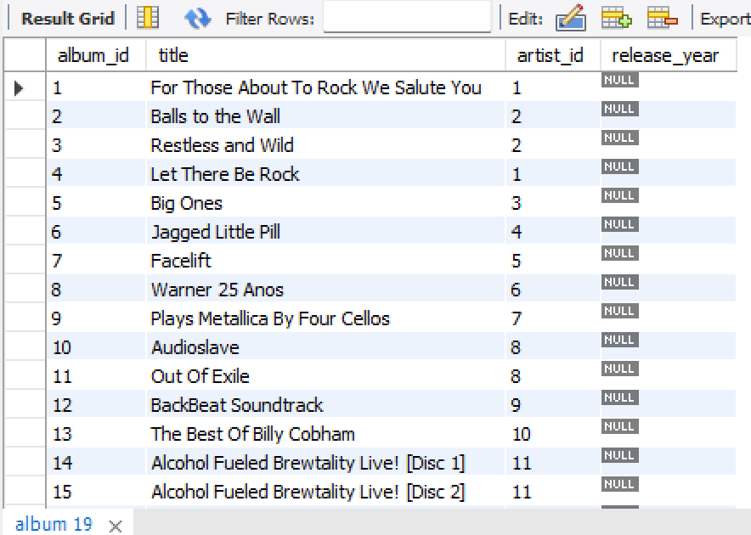

select * from artist;

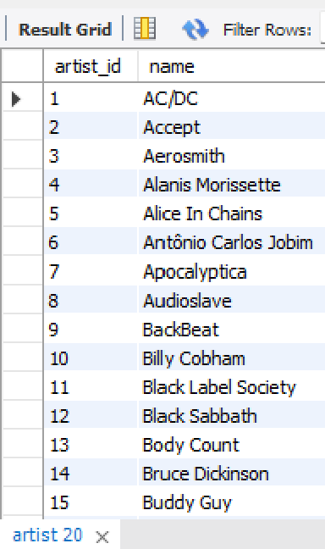

select * from customer;

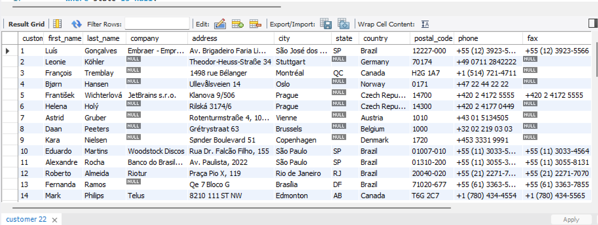

select count(*) from customer -- 49 company values are null in the customer table
where company is null;

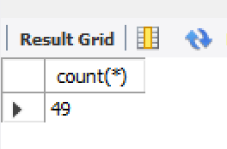

select count(*) from customer -- 29 state values are null in the customer table
where state is null;

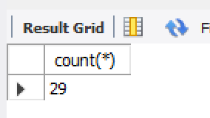

select count(*) from customer -- 47 fax values are null in the customer table
where fax is null;

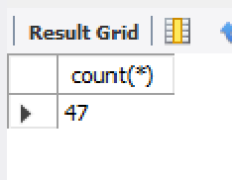
select * from employee; -- 1 reports_to value is null in the employee table

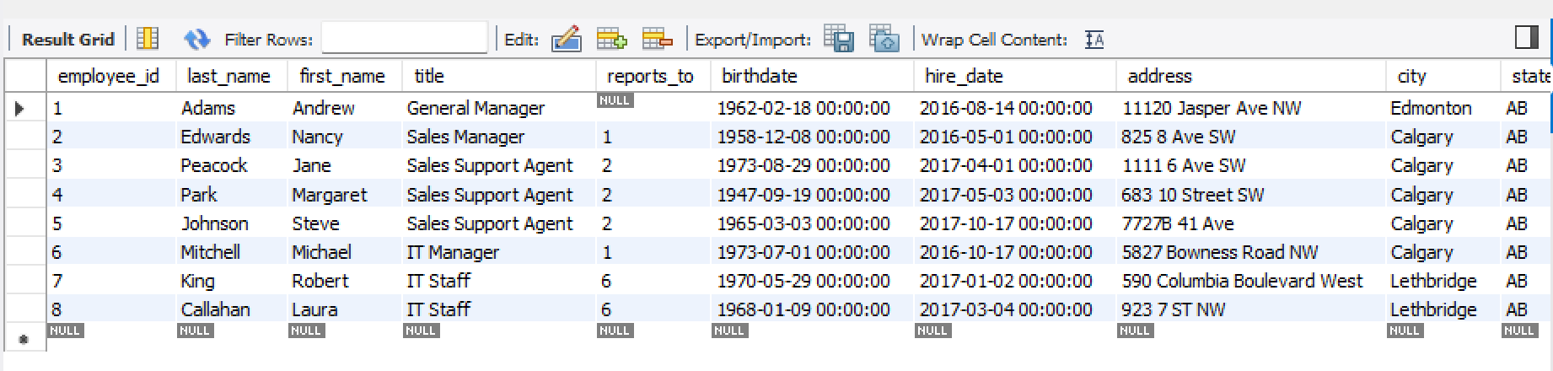
select * from genre;

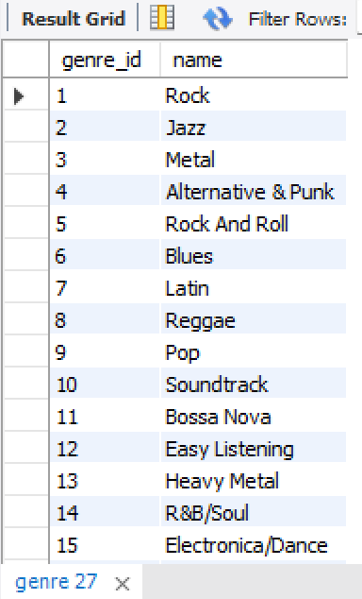

select * from invoice;

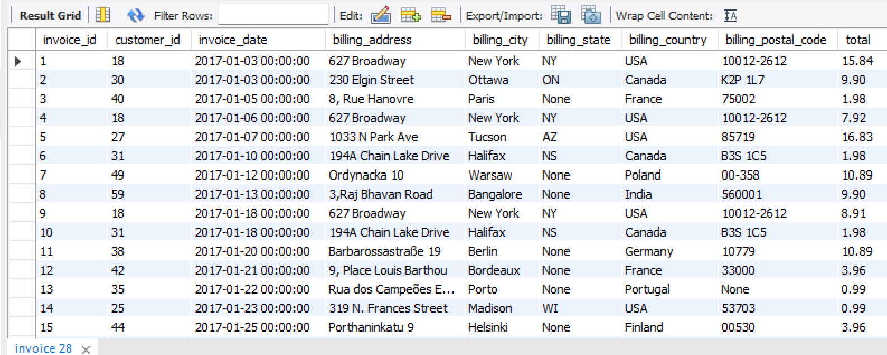

select * from invoice_line;

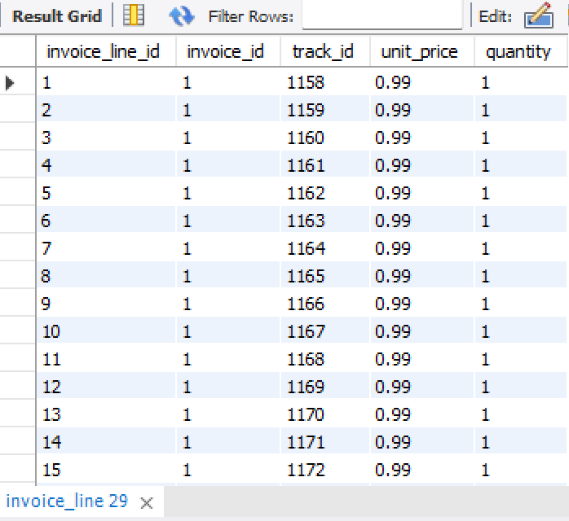

select * from media_type;



select * from playlist;

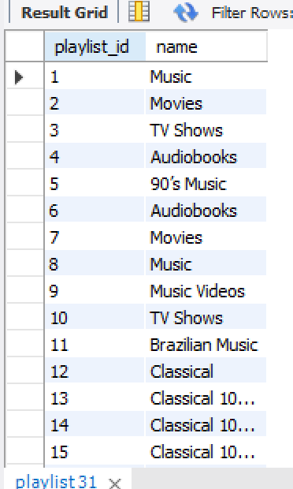

select * from playlist_track;

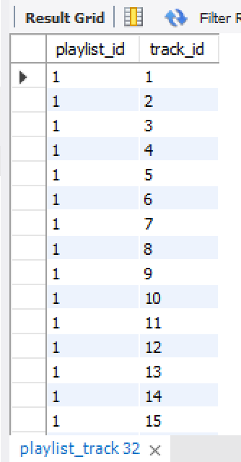

select * from track;

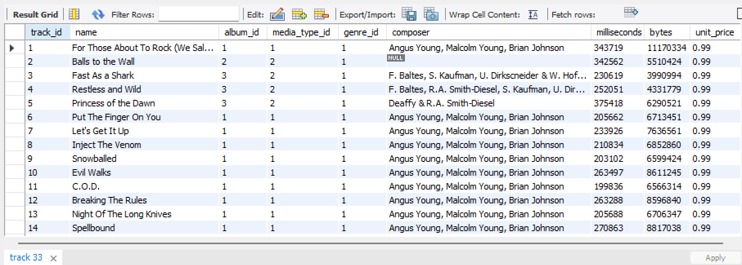

select count(*) from track -- 978 composer columns are null in the track table
where composer is null

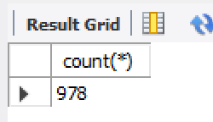

  - Yes, the customer table, employee table and track table has missing/NULL values in it.

  - No, duplicate values found in any of the given tables

  - To handle missing/NULL values,
- We can replace NULL with a default value
- We can replace missing values with N/A by using COALESCE().
- If the missing values makes the row unusable, we may also delete them

  - To handle duplicate values,
- To remove duplicate records, we can use distinct to keep only the first occurrence
- Instead of deleting duplicates we can just filter them while writing the query.

- Find the top-selling tracks and top artist in the USA and identify their most famous genres.
Ans :
with Result as
(
select t.name as Top_selling_track, a.name as Top_artist, g.name as Top_genre,
SUM(t.unit_price * il.quantity) as Total from track t
left join invoice_line il on t.track_id = il.track_id
left join invoice i on i.invoice_id = il.invoice_id
left join album al on al.album_id = t.album_id
left join artist a on a.artist_id = al.artist_id
left join genre g on g.genre_id = t.genre_id
where billing_country = "USA"
group by t.name, a.name, g.name
order by Total desc
limit 10
)
select Top_selling_track,Top_artist,Top_genre
from Result

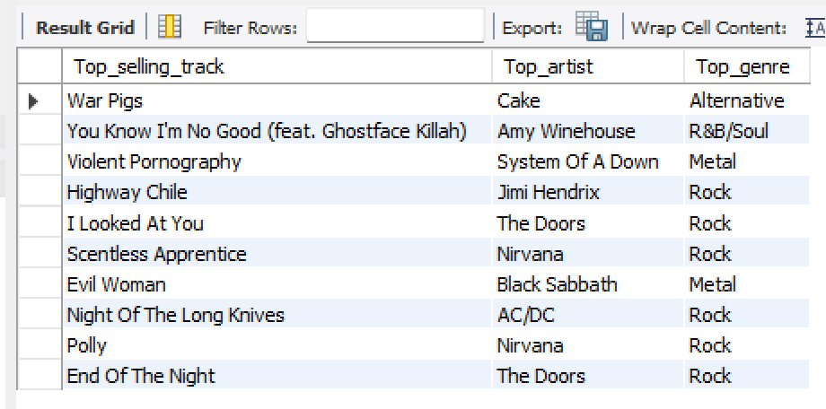

- What is the customer demographic breakdown (age, gender, location) of Chinook's customer base?
Ans:
- Grouping by Country:
select country, count(*) as TotalCustomers
from customer
group by country
order by TotalCustomers desc
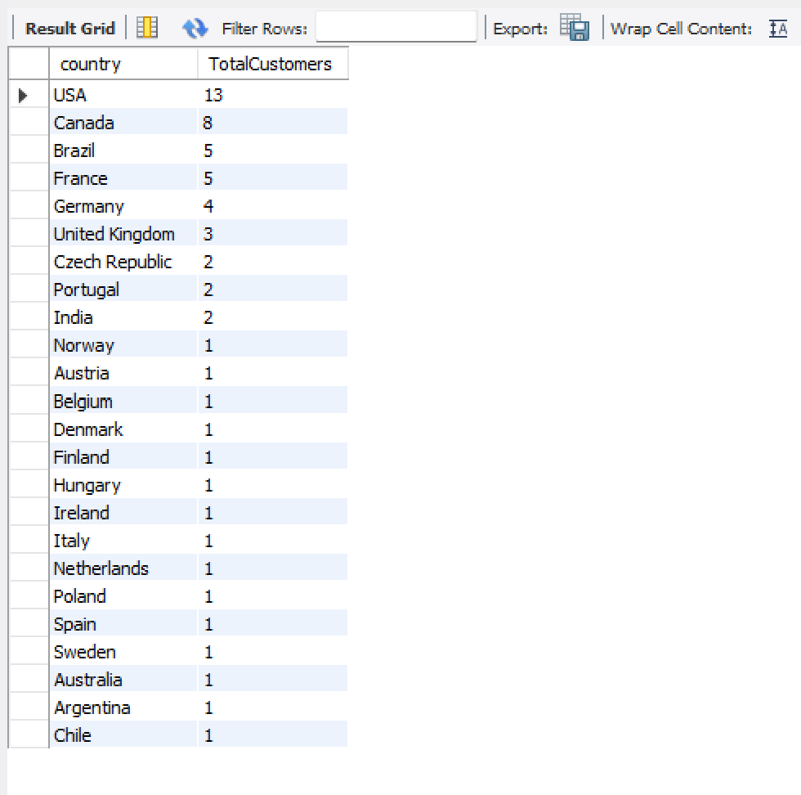
- Grouping by City:
select city, count(customer_id) as NumberOfCustomers
from customer
group by city
order by NumberOfCustomers desc
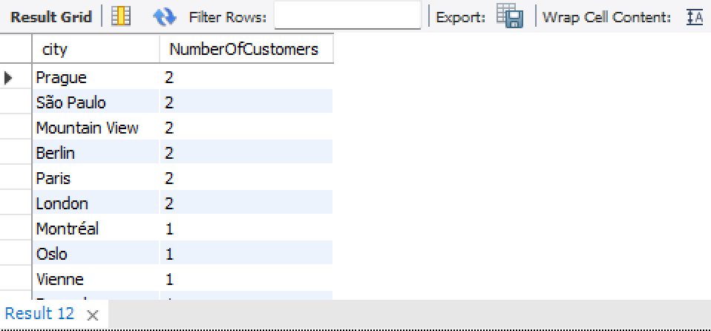
- select count(distinct country)as TotalCountries
from customer
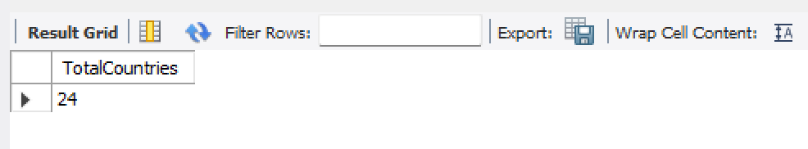

INSIGHTS:
- Customers are distributed across 24 countries.
- The United States has the highest number of customers.

RECOMMENDATIONS:
- Prioritize the US market due to its significant customer base.
- Identify growth opportunities in key countries like Canada, Brazil, France, and Germany.
- Develop region-specific marketing strategies to better target diverse markets.

- Calculate the total revenue and number of invoices for each country, state, and city:
Ans:
select billing_city, billing_state, billing_country, count(invoice_id) as NoOfInvoices, sum(total) as Total_Revenue
from invoice
group by billing_city, billing_state, billing_country
order by count(invoice_id) desc, sum(total) desc
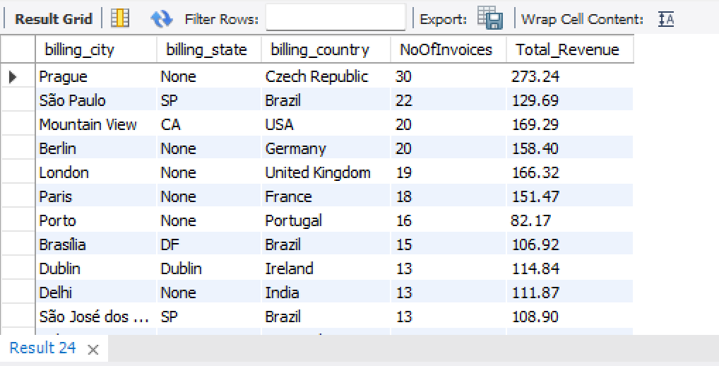

INSIGHTS:
- Prague (Czech Republic) leads in revenue generation.
- São Paulo (Brazil) records a high invoice count but comparatively lower revenue.

RECOMMENDATIONS:
- Study Prague's Model: Explore the factors behind Prague's high revenue per transaction and adapt successful practices for other cities.
- Evaluate Location Performance: Review revenue per invoice across all regions to uncover improvement opportunities and optimize pricing policies.

- Find the top 5 customers by total revenue in each country
Ans:
with Revenue as
(
select country, concat(first_name, " " ,last_name)as Customer_Name, sum(i.total) as Total_Revenue
from customer c
left join invoice i on i.customer_id = c.customer_id
group by country, first_name, last_name
order by country
)
,Result as
(
select *,
rank() over(partition by country order by Total_Revenue desc)as rnk
from Revenue
)

select * from Result
where rnk <=5
order by rnk,Total_Revenue desc

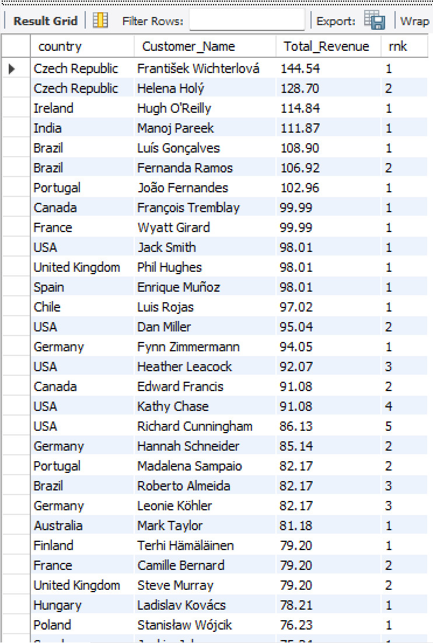

INSIGHTS:
- Top Performers by Country:
  - Czech Republic has the highest-performing customers, with František Wichterlová and Helena Holý generating the highest revenue (144.54 and 128.7 respectively).
  - Brazil also shows strong revenue, with multiple top customers including Luís Gonçalves (108.9), Fernanda Ramos (106.92), and others.
  - USA shows a variety of top-performing customers, with Jack Smith (98.01), Dan Miller (95.04), and Heather Leacock (92.07) among the top 5 in their country.

- Geographical Trends:
  - North America (USA, Canada) appears to have a large number of high-performing customers, with Canada’s François Tremblay (99.99) and Edward Francis (91.08) in the top positions.
  - Countries like India, Germany, and France also have notable performers, showing a diverse spread of revenue across the globe.

- Revenue Distribution:
  - Argentina, Denmark, Italy, and Norway have lower revenue generation compared to other countries in the list.
  - Some countries like Brazil, Czech Republic, and USA exhibit a more concentrated share of high revenue, highlighting potential key markets.

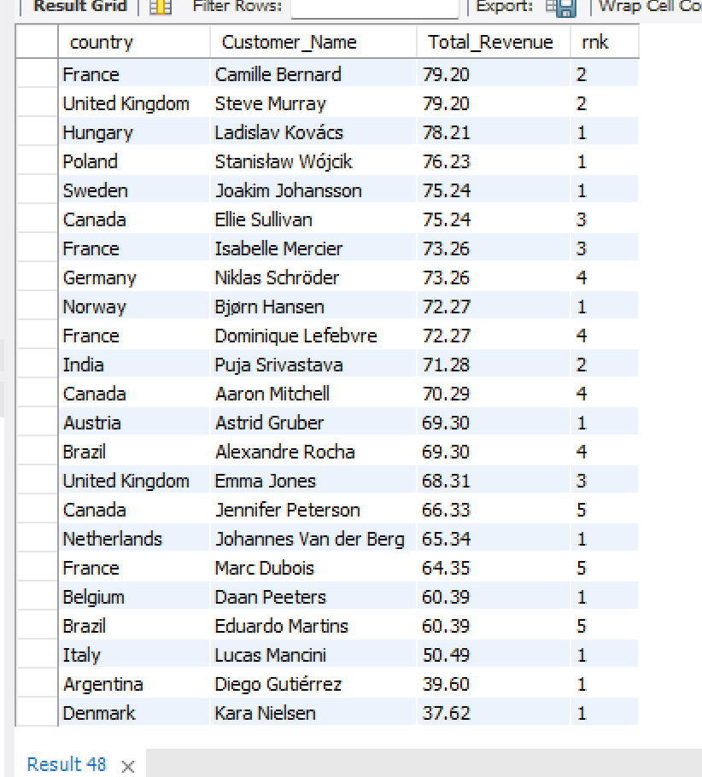

RECOMMENDATIOS:

- Focus on High Revenue Countries:
  - Target countries like Czech Republic, Brazil, and USA for future expansion and high-value campaigns. The performance in these regions is impressive, and strategies could be tailored to further capitalize on this strength.

- Customer Segmentation:
  - Evaluate customers from Argentina, Denmark, and Italy, as their lower revenue suggests potential for growth. Investigate the reasons behind their performance and create localized marketing strategies to increase engagement and sales.

- Leverage Top Performers for Marketing:
  - Use high performers in countries like Czech Republic, Germany, and USA as case studies or ambassadors to help expand reach and build trust in similar markets.

- Identify the top-selling track for each customer
Ans:
with customertracksales as
(
select i.customer_id, il.track_id, t.name as track_name,
sum(il.quantity) as total_quantity_sold
from invoice_line il
join invoice i on il.invoice_id = i.invoice_id
-- join customer c on i.customer_id = c.customer_id
join track t on il.track_id = t.track_id
group by i.customer_id, il.track_id, t.name
)
,rankedtracks as
(
select customer_id, track_name, total_quantity_sold,
row_number() over (partition by customer_id order by total_quantity_sold desc) as row_num
from customertracksales
)
select customer_id, track_name, total_quantity_sold
from rankedtracks
where row_num = 1



- Are there any patterns or trends in customer purchasing behavior (e.g., frequency of purchases, preferred payment methods, average order value)?
Ans:
- Frequency of Purchases:
select c.customer_id, concat(c.first_name, ' ', c.last_name) as customers,
year(i.invoice_date) as year,count(i.invoice_id) as purchase_count
from customer c
inner join invoice i on c.customer_id = i.customer_id
group by
c.customer_id, customers, year(i.invoice_date)
order by
c.customer_id, customers, year(i.invoice_date)

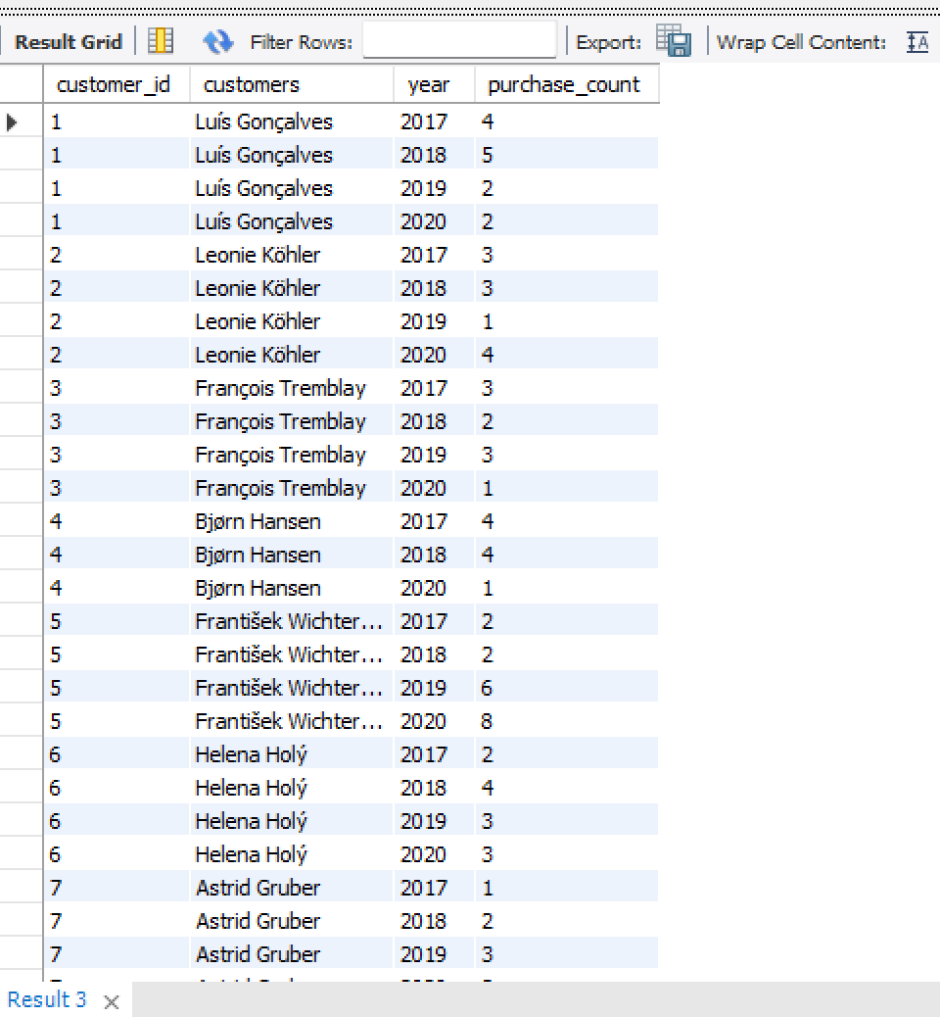

- Average Order Value:
select customer_id, avg(total) as avg_order_value,
count(invoice_id)as num_of_orders
from invoice
group by customer_id
order by customer_id,count(invoice_id),avg(total)

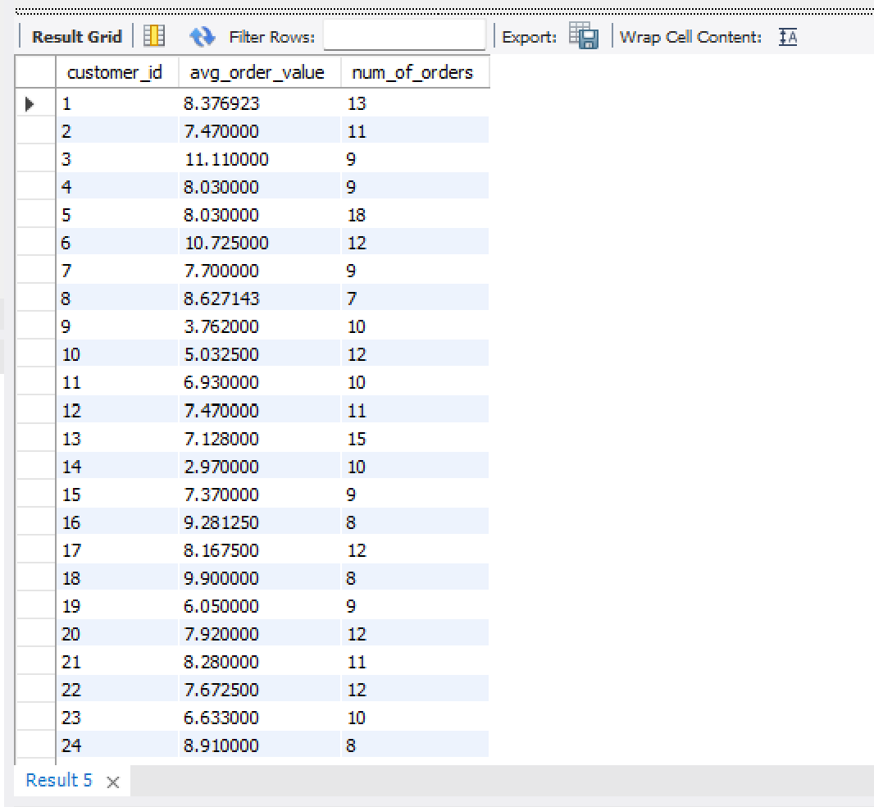

- Monthly Invoice Count
with daily_counts as (
select date(invoice_date) as invoice_day,
count(invoice_id) as daily_invoice_count, sum(total) as daily_sum_total
from invoice
group by date(invoice_date)
)
select
date_format(invoice_day, '%Y-%m') as YearMonth,
avg(daily_invoice_count) as avg_daily_invoices,
sum(daily_invoice_count) as total_invoices_in_month,
avg(daily_sum_total) as avg_daily_total,
sum(daily_sum_total) as monthly_sum_total
from daily_counts
group by
date_format(invoice_day, '%Y-%m')
order by
YearMonth;

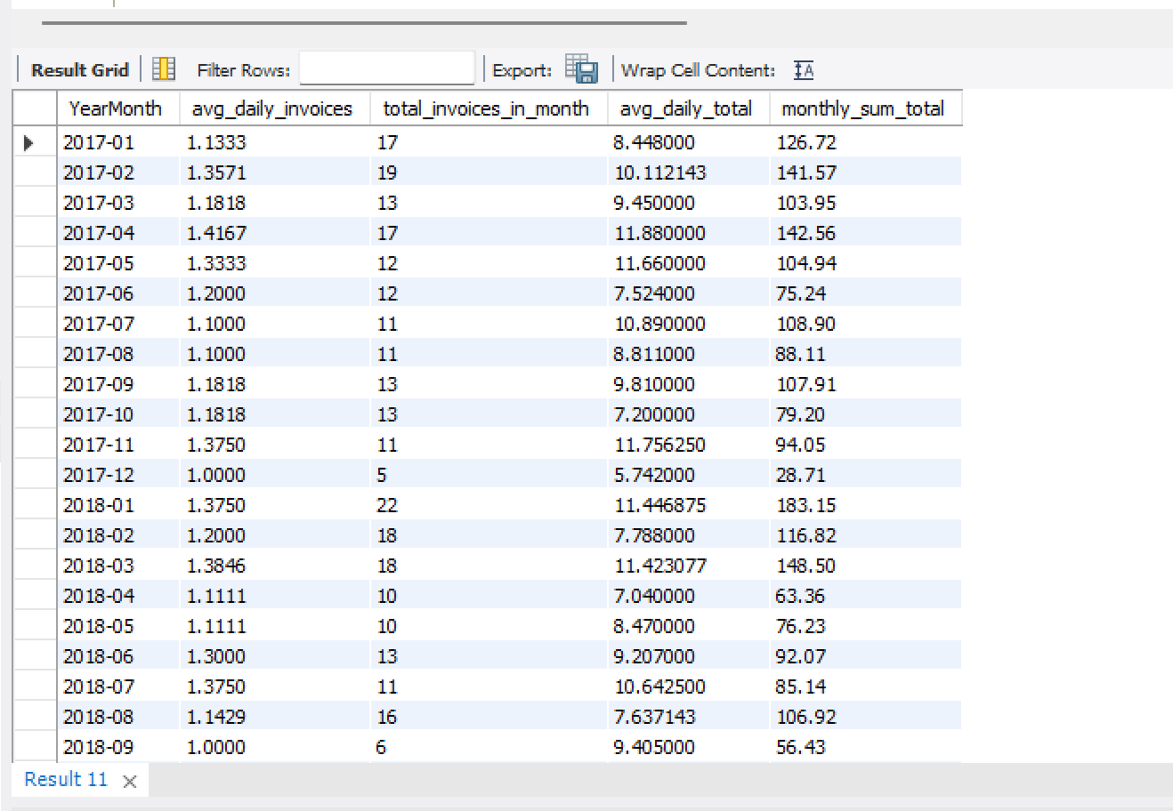

INSIGHTS:

- No there is no correlation or trend between the frequency of orders by different customers and the average sales generated by these customers.
The average sales most probably depend on the unit price of each track and not the number of orders.

- What is the customer churn rate?
Ans:

with last_purchase as (
select customer_id, max(invoice_date) as last_order_date
from invoice
group by customer_id
),
churned_customers as (
select count(customer_id) as churned_count
from last_purchase
where last_order_date < date_sub((select max(invoice_date) from invoice), interval 6 month)
),
total_customers as (
select count(distinct customer_id) as total_count
from customer
)
select c.churned_count as churned_customers,
t.total_count as total_customers,
round((c.churned_count / t.total_count) * 100, 2) as churn_rate_percentage
from churned_customers as c
cross join total_customers as t

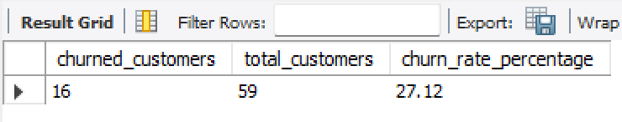

- Calculate the percentage of total sales contributed by each genre in the USA and identify the best-selling genres and artists.
Ans:
  - Total Sales Percentage by each Genre in the USA:
with genresales as (
select g.genre_id,g.name as genre_name,count(i.invoice_id)as TotalInvoices,sum(il.unit_price * il.quantity) as Total_Sales
from invoice i
join invoice_line il on i.invoice_id = il.invoice_id
join track t on il.track_id = t.track_id
join genre g on t.genre_id = g.genre_id
join customer c on i.customer_id = c.customer_id
where c.country = 'USA'
group by g.genre_id, g.name
),
totalsales as (
select sum(total_sales) as overall_sales from genresales
)
select gs.genre_name,gs.TotalInvoices as GenreCount,gs.total_sales,
round((gs.total_sales / ts.overall_sales) * 100, 2) as Sales_Percentage
from genresales gs
join totalsales ts
order by gs.total_sales desc;

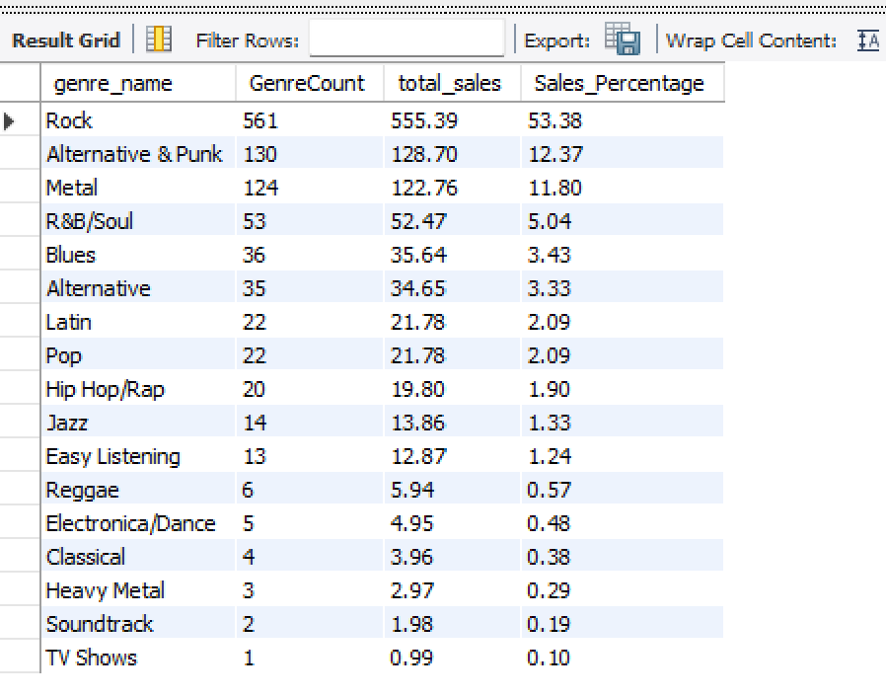

INSIGHTS:
- Dominant Genre: The genre Rock leads with 561 counts, making up 53.38% of the total, dominating the preferences.
- Top 3 Genres: Rock, Alternative & Punk, and Metal together contribute more than 77% of the total count, with Rock being the standout genre.
- Niche Genres: Genres like Classical, Heavy Metal, Soundtrack, and TV Shows have minimal representation, collectively accounting for only 1.91% of the total count.

RECOMMENDATIOS:
- Focus on Popular Genres: Given the high percentage of Rock, Alternative & Punk, and Metal, consider promoting or creating content that aligns with these genres to cater to the largest audience.
- Target Niche Audiences: Explore opportunities to grow less popular genres like Jazz, Reggae, and Classical by offering tailored experiences or specialized content for their audiences.
- Expand Genre Diversity: If looking to diversify, consider experimenting with Electronica/Dance, Pop, or Hip Hop/Rap, which have potential but currently contribute less.

  - Best-Selling artist in USA:

with artistsales as (
select ar.artist_id,ar.name as Artist_Name,
sum(il.unit_price * il.quantity) as Total_Sales
from invoice i
join invoice_line il on i.invoice_id = il.invoice_id
join track t on il.track_id = t.track_id
join album al on t.album_id = al.album_id
join artist ar on al.artist_id = ar.artist_id
join customer c on i.customer_id = c.customer_id
where c.country = 'USA'
group by ar.artist_id, ar.name
)
select Artist_Name, Total_Sales
from artistsales
order by Total_Sales desc
limit 5

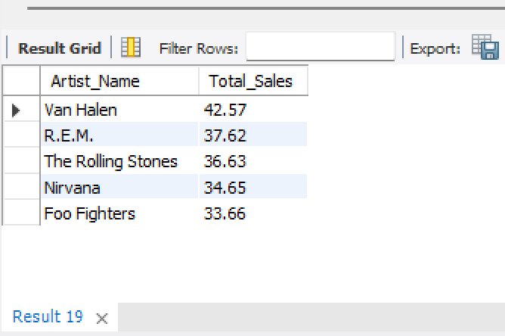

INSIGHTS:
- Van Halen has the highest sales contribution, meaning their albums/tracks are the most purchased.
- Both R.E.M. and The Rolling Stones contribute significantly to sales.

RECOMMENDATIOS:
- Investigate Nirvana & Foo Fighters Sales – Analyze customer engagement, pricing, and demand.

- Find customers who have purchased tracks from at least 3 different genres
Ans:
select concat(c.first_name, " " ,c.last_name)as Customer_Name,
count(distinct g.name) as Genre_Count
from customer c
inner join invoice i on c.customer_id = i.customer_id
inner join invoice_line il on i.invoice_id = il.invoice_id
inner join track t on il.track_id = t.track_id
inner join genre g on t.genre_id = g.genre_id
group by
Customer_Name
having count(distinct g.name) >= 3
order by
Genre_Count desc

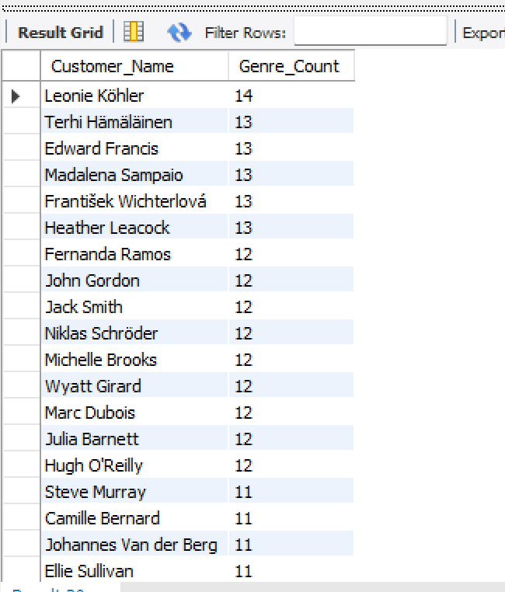

INSIGHTS:
- Top 5 Individuals: The top 5 individuals with the highest genre counts are Leonie (14), and Edward, Madalena, František, Heather, and Terhi (each with 13). These individuals show strong engagement in the genre.
- Consistent Engagement: Many individuals, such as Fernanda, Niklas, Michelle, and others, are closely following with 12 genre counts, indicating a high level of participation across a large group.
- Lower Engagement: There is a noticeable drop in engagement starting from Aaron, Eduardo, and Dan, each with 9 counts, and even lower for others further down the list, like Robert with 5 counts.

RECOMMENDATIOS:
- Recognize Top Contributors: Acknowledge individuals with higher genre counts (e.g., Leonie and those with 13 counts) as they show consistent engagement. Consider incentivizing them to further enhance their involvement.
- Increase Engagement for Lower Count Users: Investigate why individuals with lower counts, such as Robert, have fewer interactions. Offering targeted incentives or support could boost their activity.
- Analyse Genre Preferences: Understand the type of content or engagement driving high genre counts for specific individuals, especially those in the top ranks, to replicate successful strategies across the board.

- Rank genres based on their sales performance in the USA
Ans:
select g.name,sum(i.total) as genre_sum,
rank() over(order by sum(i.total) desc) as rnk
from customer c inner join invoice i on c.customer_id = i.customer_id
join invoice_line il on i.invoice_id = il.invoice_id
join track t on il.track_id = t.track_id
join genre g on t.genre_id = g.genre_id
where c.country = "USA"
group by g.name

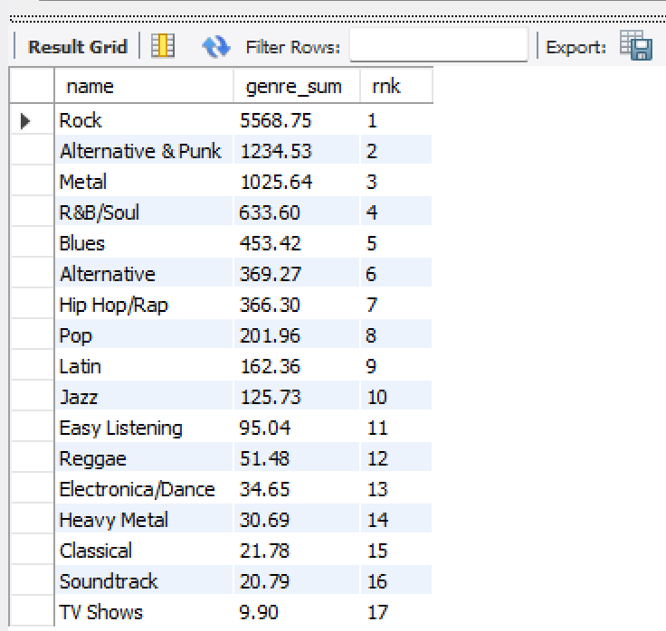

INSIGHTS:
- Top Genre (Rock): Rock leads by a significant margin with a genre sum of 5568.75, holding the top spot.
- High Ranking Genres: Alternative & Punk and Metal follow closely, ranking second and third with sums of 1234.53 and 1025.64, respectively.
- Lower Ranking Genres: TV Shows has the lowest genre sum at 9.9, with other less popular genres like Classical and Soundtrack also falling at the lower end of the ranking.

RECOMMENDATIOS:
- Focus on High-Performing Genres: Given the dominance of Rock, Alternative & Punk, and Metal, these genres should be prioritized for further development and engagement strategies.
- Explore Niche Genres: Genres such as Classical and Soundtrack are lower in the rankings but could be targeted for niche marketing efforts to grow their customer base.
- Diversify Content Offering: To attract a wider audience, consider diversifying the offerings in Pop, Hip Hop/Rap, and Electronica/Dance, which show potential for further growth.

- Identify customers who have not made a purchase in the last 3 months
Ans:
with last_3_months as
(
select *
from invoice
where invoice_date > (select max(invoice_date) from invoice) - interval 3 month
),
last_purchase as (
select c.customer_id,concat(c.first_name, ' ', c.last_name) as customer_name,
max(i.invoice_date) as last_purchase_date
from customer c
left join invoice i on c.customer_id = i.customer_id
group by c.customer_id, c.first_name, c.last_name
)
select lp.customer_name,date(lp.last_purchase_date)as last_purchase_date,
timestampdiff(month, lp.last_purchase_date, (select max(invoice_date) from invoice)) as months_since_last_purchase
from last_purchase lp
left join last_3_months lm on lp.customer_id = lm.customer_id
where lm.invoice_id is null
order by months_since_last_purchase desc;

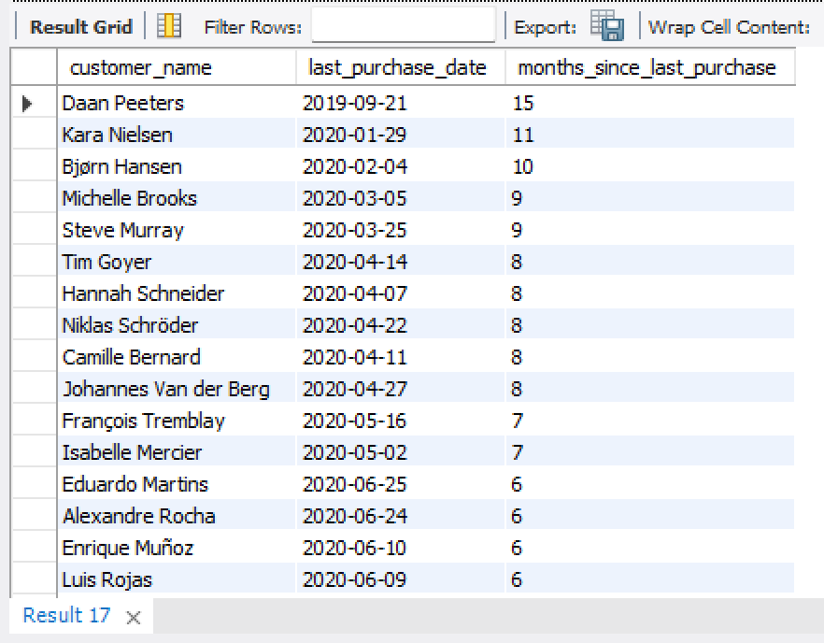
Subjective Questions

- Recommend the three albums from the new record label that should be prioritised for advertising and promotion in the USA based on genre sales analysis.
Ans:
with Result as
(
select g.name as GenreName, a.title as AlbumName,
sum(il.unit_price * il.quantity) as TotalSales
from invoice i
join invoice_line il on i.invoice_id = il.invoice_id
join track t on il.track_id = t.track_id
join album a on t.album_id = a.album_id
join genre g on t.genre_id = g.genre_id
where i.billing_country = 'USA'
group by
g.name, a.title
order by
TotalSales desc
)
select *,
dense_rank()over(order by TotalSales desc)as rnk
from Result
limit 3

TOP-3:
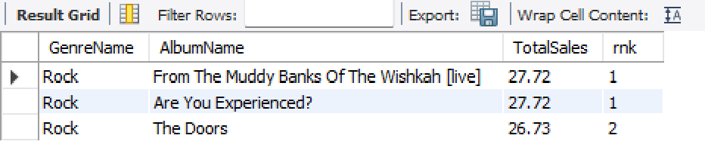

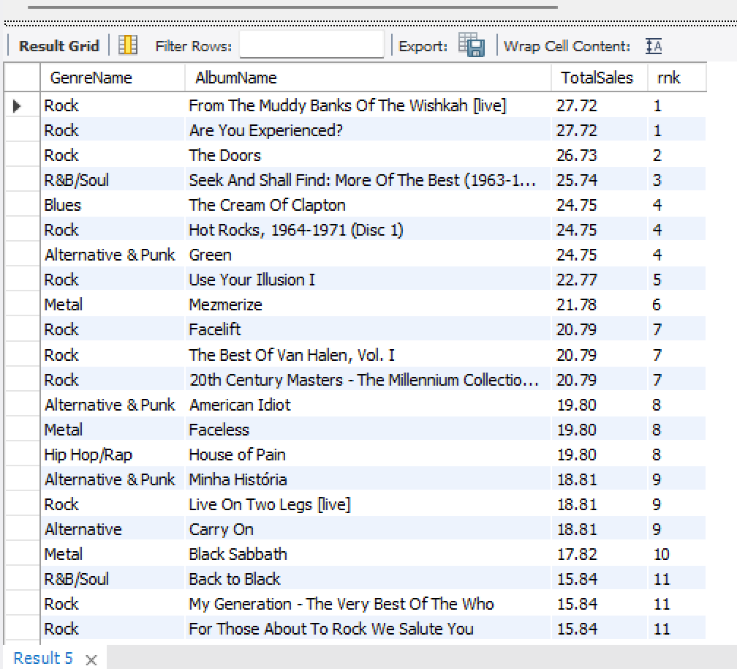

INSIGHTS:
- Top Genre (Rock): The Rock genre dominates with a strong presence across multiple albums, especially with albums like "From The Muddy Banks Of The Wishkah [live]" and "Are You Experienced?" both contributing significantly to sales, each with a genre sale of 27.72.
- R&B/Soul: R&B/Soul also performs well, with "Seek And Shall Find: More Of The Best (1963-1981)" reaching a sales total of 25.74 and securing a ranking of 3.
- Alternative & Punk: Alternative & Punk has a notable presence, with albums like "Green" and "American Idiot" reaching sales totals of 24.75 and 19.8 respectively.
- Blues and Metal: Blues and Metal also appear strong in the market, with albums like "The Cream Of Clapton" and "Mezmerize" earning respectable sales totals, but Rock continues to outperform these genres.

RECOMMENDATIOS:

- Prioritize Rock Albums:
  - Album 1: "From The Muddy Banks Of The Wishkah [live]" (Sales: 27.72) – This album is a top performer and should be heavily promoted, capitalizing on its strong sales and popularity.
  - Album 2: "Are You Experienced?" (Sales: 27.72) – With equal sales performance to the first album, this should be targeted for advertising efforts aimed at fans of classic rock in the USA.
  - Album 3: "Hot Rocks, 1964-1971 (Disc 1)" (Sales: 24.75) – Another top performer, this album offers a compelling collection that is likely to resonate well with a diverse rock audience.

- Target R&B/Soul and Alternative & Punk Genres:
  - R&B/Soul: Promote "Seek And Shall Find: More Of The Best (1963-1981)" (Sales: 25.74) as a key offering in the USA, as it performs well and appeals to a broad audience in this genre.
  - Alternative & Punk: Albums like "Green" (Sales: 24.75) and "American Idiot" (Sales: 19.8) should be considered for targeted campaigns to reach fans of alternative rock and punk music, as these albums show strong performance.

- Determine the top-selling genres in countries other than the USA and identify any commonalities or differences.
Ans:
select g.name,
sum(il.unit_price * il.quantity) as total_sales
from invoice_line il
join track t on t.track_id = il.track_id
join genre g on g.genre_id = t.genre_id
join invoice i on i.invoice_id = il.invoice_id
where billing_country != 'USA'
group by g.name
order by total_sales desc

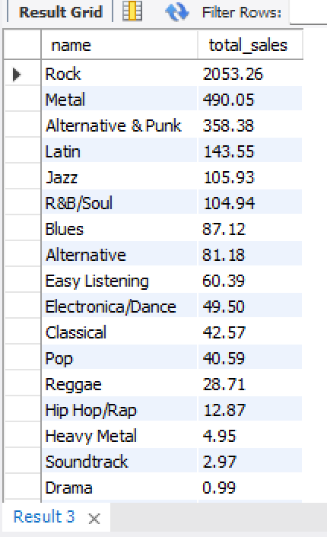

INSIGHTS:
- Rock's Universal Appeal: Rock music remains a dominant genre both in the USA and globally, continuing to capture wide-reaching popularity.
- Regional Preferences: There are noticeable differences in genre preferences between the USA and other countries, with Metal, Latin, and Jazz gaining more traction internationally.
- Growing Genres Outside the USA: Outside of the US, Metal, Latin, and Jazz are emerging as stronger genres, indicating a shift in musical tastes in global markets.

RECOMMENDATIOS:
- Focus on Rock Worldwide: Maintain a strong global strategy that emphasizes Rock music, as it consistently performs well across all regions.
- Tailored Regional Strategies: Adapt inventory management and promotional efforts to cater to the specific genre preferences of each region.
- Promote Metal, Latin, and Jazz Globally: Increase focus on promoting Metal, Latin, and Jazz in markets outside the USA where these genres are gaining popularity.
- Localized Marketing Campaigns: Develop region-specific marketing initiatives that resonate with local musical tastes and cultural preferences.
- Explore Genre Expansion: Investigate strategies to introduce and promote lesser-known genres both in the US and internationally, expanding the diversity of musical offerings in each market.

- Customer Purchasing Behavior Analysis: How do the purchasing habits (frequency, basket size, spending amount) of long-term customers differ from those of new customers? What insights can these patterns provide about customer loyalty and retention strategies?
Ans:
//CTE to calculate customer-related metrics such as last purchase date, first purchase date, total spent, items bought, frequency, and the number of days a customer has been active.
with cte as (
select
i.customer_id,
max(invoice_date) as last_purchase_date,
min(invoice_date) as first_purchase_date,
sum(total) as total_spent,
sum(quantity) as items_bought,
count(i.customer_id) as frequency,
abs(timestampdiff(day, max(invoice_date), min(invoice_date))) as customer_since_days
from invoice i
left join invoice_line il on il.invoice_id = i.invoice_id
left join customer c on c.customer_id = i.customer_id
group by i.customer_id
)
// CTE to classify customers into 'Long Term' or 'Short Term' based on their active days compared to the average customer active days.
,long_short_term as (
select total_spent,items_bought,frequency,customer_since_days,
case
when customer_since_days > (select avg(customer_since_days) as average_days from cte)
then 'Long Term'
else 'Short Term'
end as Term
from cte
)
// select avg(customer_since_days) as average_days from cte
//Final selection of the sum of total spent, items bought, and the count of customers, grouped by the classification of 'Long Term' or 'Short Term'.
select Term,sum(total_spent)as Total_Spent,
sum(items_bought)as Total_Items_Bought,count(frequency)as Number_Of_Customers
from long_short_term
group by Term

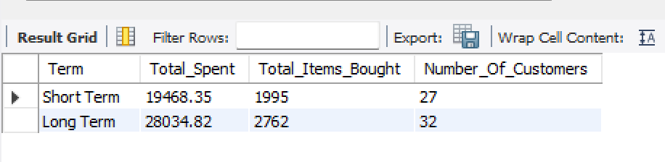

INSIGHTS:
- Total Spending: Long-term customers have spent significantly more ($28,034.82) compared to short-term customers ($19,468.35). This suggests that long-term customers are more likely to make larger purchases over time, showing greater overall value to the business.
- Items Bought: Long-term customers also buy more items, with a total of 2,762 items purchased, compared to 1,995 by short-term customers. This indicates a higher frequency of purchases and a larger basket size for long-term customers.
- Customer Loyalty: The higher spending and item count for long-term customers demonstrate stronger customer loyalty. These customers not only buy more frequently but also spend more per transaction, indicating a deepening relationship with the brand over time.
- New vs. Long-term Customers: While short-term customers are still valuable, they tend to purchase fewer items and spend less per transaction. This could suggest that new customers may not yet be fully engaged with the brand or product offerings.

RECOMMENDATIOS:
- Reward Long-term Customers: Develop targeted loyalty programs for long-term customers, offering exclusive discounts or rewards based on their continued purchasing behaviour. This can further enhance their loyalty and encourage even larger purchases.
- Increase Engagement with Short-term Customers: For short-term customers, implement personalized offers or promotions aimed at increasing their basket size and encouraging repeat purchases. This could include bundling offers or loyalty incentives to transition them into long-term customers.
- Strengthen Retention Strategies: Focus on customer retention by introducing more engagement points such as personalized email marketing, offering cross-sell or up-sell recommendations based on previous purchases, and nurturing their relationship with the brand to increase their lifetime value.
- Incentivize Repeat Purchases: Consider implementing incentives like a points-based system, where customers earn rewards for continued purchases. This could motivate both new and existing customers to spend more and purchase more frequently.
- Enhance Customer Experience: Deliver a seamless and personalized shopping experience to keep customers engaged. Providing excellent customer service, tailored recommendations, and easy returns could help in boosting retention and increasing the value of both short-term and long-term customers.

- Product Affinity Analysis: Which music genres, artists, or albums are frequently purchased together by customers? How can this information guide product recommendations and cross-selling initiatives?
Ans:
with track_combinations as (
select il1.track_id as track_id_1,
il2.track_id as track_id_2,
count(*) as times_purchased_together
from invoice_line il1
join invoice_line il2 on il1.invoice_id = il2.invoice_id
and il1.track_id < il2.track_id
group by il1.track_id, il2.track_id
)
,genre_combinations as (
select t1.genre_id as genre_id_1,t2.genre_id as genre_id_2,
count(*) as times_purchased_together
from track_combinations tc
join track t1 on tc.track_id_1 = t1.track_id
join track t2 on tc.track_id_2 = t2.track_id
where t1.genre_id != t2.genre_id
group by t1.genre_id, t2.genre_id
)
select g1.name as genre_1,g2.name as genre_2,
gc.times_purchased_together
from genre_combinations gc
join genre g1 on gc.genre_id_1 = g1.genre_id
join genre g2 on gc.genre_id_2 = g2.genre_id
order by gc.times_purchased_together desc

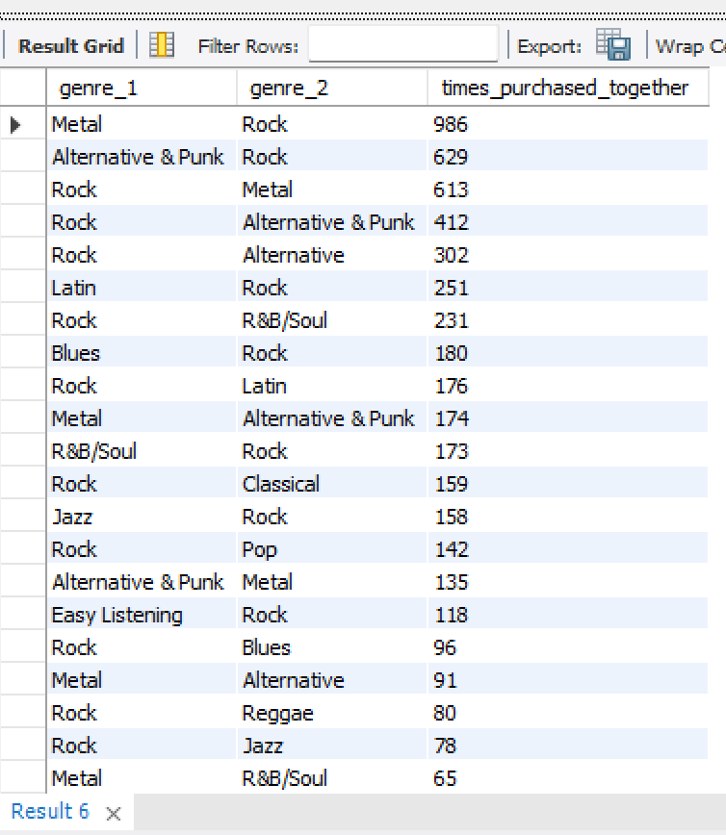
Product Affinity Analysis INSIGHTS:

- Frequent Genre Pairings: The most commonly purchased genre combinations include:
  - Rock & Metal (986 times)
  - Alternative & Punk & Rock (629 times)
  - Rock & Alternative & Punk (412 times)
  - Rock & R&B/Soul (231 times)
  - Blues & Rock (180 times)
These insights reveal that customers who purchase Rock albums tend to buy Metal, Alternative & Punk, and R&B/Soul genres frequently as well.
- Cross-Genre Preferences: Customers also show an affinity for pairing genres across a broader spectrum:
  - Latin & Rock (251 times)
  - Metal & Alternative & Punk (174 times)
  - Jazz & Rock (158 times)
  - Pop & Rock (142 times)
These combinations suggest a strong tendency to purchase genres from both classic and contemporary music styles.

Recommendations for Product Recommendations &
Cross-Selling:

- Optimize In-Store or Online Displays: Based on genre affinity, organize physical or digital stores to promote albums from genres often purchased together. For example:
  - Create a “Rock & Metal” display section in the store.
  - On an online platform, use the “Frequently Bought Together” feature to suggest albums from related genres.

- Bundle Related Genres: Based on frequently purchased genre pairs, create bundle offers that include both Rock and its frequent pairings, such as:
  - Rock & Metal
  - Rock & Alternative & Punk
  - Rock & R&B/Soul
  - Blues & Rock
Offering these bundles at a discounted price could increase basket size and customer satisfaction.

- Regional Market Analysis: Do customer purchasing behaviors and churn rates vary across different geographic regions or store locations? How might these correlate with local demographic or economic factors?
Ans:
// determine last purchase date per customer
with customeractivity as (
select c.customer_id,c.country,count(i.invoice_id) as total_purchases,
sum(i.total) as total_spent,max(i.invoice_date) as last_purchase_date
from customer c
join invoice i on c.customer_id = i.customer_id
group by c.customer_id, c.country
)
// identify customers who have not purchased in the last 12 months from the latest invoice date
,churnedcustomers as (
select country, count(customer_id) as churned_customers
from customeractivity
where last_purchase_date < date_sub((select max(invoice_date) from invoice), interval 12 month)
group by country
)
select ca.country, count(ca.customer_id) as total_customers,
sum(ca.total_purchases) as total_transactions,
round(avg(ca.total_spent), 2) as avg_spending_per_customer,
coalesce(cc.churned_customers, 0) as churned_customers,
round((coalesce(cc.churned_customers, 0) / nullif(count(ca.customer_id), 0)) * 100, 2) as churn_rate_percentage
from customeractivity ca
left join churnedcustomers cc on ca.country = cc.country
group by ca.country, cc.churned_customers
order by churn_rate_percentage desc

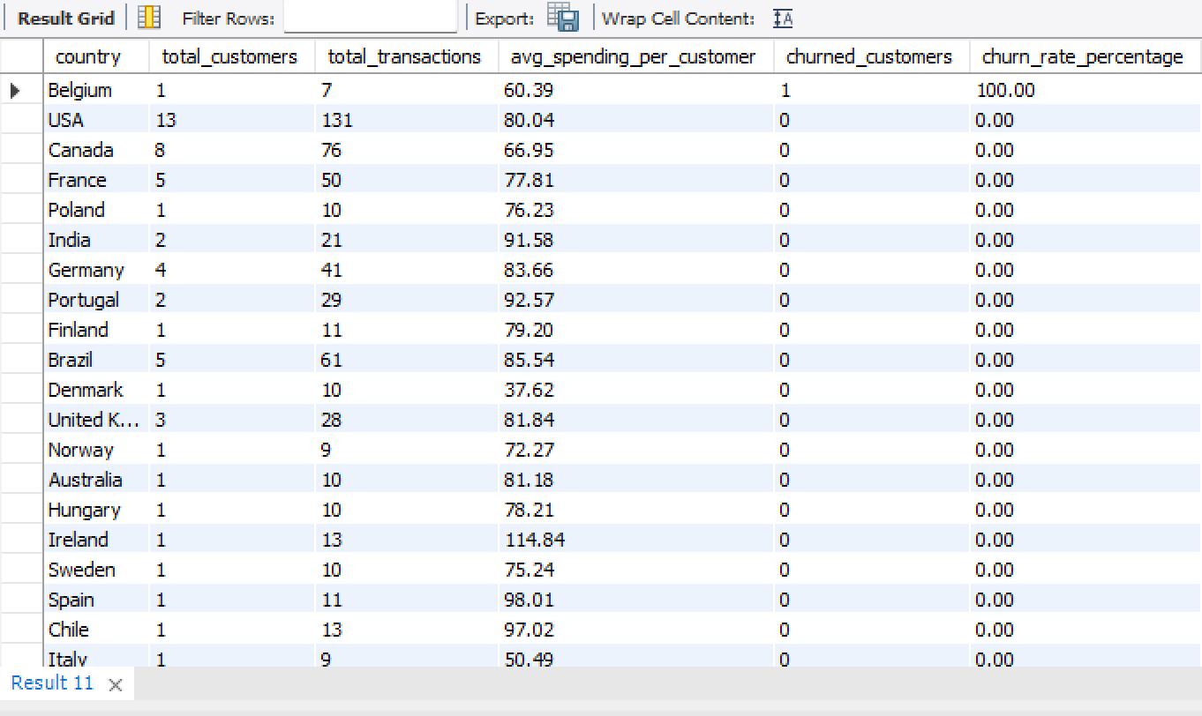

INSIGHTS:
- Very small customer base (only 1 customer) in Belgium, meaning a single churn skews the data.
- USA & Canada: Largest Customer Bases, No Churn
- Countries like France (5 customers), Germany (4 customers), and the UK (3 customers) also show zero churn, indicating stable engagement.
- Countries like Hungary, Austria, Netherlands, Sweden, Finland, etc., all have only 1-2 customers but report zero churn.
- Countries like India, Brazil, Portugal have a higher average spending per customer but still maintain zero churn.

RECOMMENDATIONS:
- Localized marketing campaigns or exclusive Belgian artist features could improve retention.
- Invest in local artist partnerships, regionalized playlists, and targeted email marketing.
- Offer bundled purchases or subscription discounts.
- Run targeted promotions to increase awareness and engagement.

- Customer Risk Profiling: Based on customer profiles (age, gender, location, purchase history), which customer segments are more likely to churn or pose a higher risk of reduced spending? What factors contribute to this risk?
Ans:
-- determine each customer's total purchases, total amount spent, and last purchase date
with customeractivity as (
select c.customer_id, c.country,count(i.invoice_id) as total_purchases,
sum(i.total) as total_spent,max(i.invoice_date) as last_purchase_date
from customer c
join invoice i on c.customer_id = i.customer_id
group by c.customer_id, c.country
)
-- categorize customers into high-risk, medium-risk, and low-risk based on purchase activity
,churnrisk as (
select customer_id, country, total_purchases, total_spent,last_purchase_date,
case
when last_purchase_date < date_sub((select max(invoice_date) from invoice), interval 12 month)
then 'high risk' -- no purchase in the last 12 months
when total_purchases <= 3 or total_spent < 50
then 'medium risk' -- low purchase frequency or spending
else 'low risk' -- regular customers
end as risk_category
from customeractivity
)
-- final aggregation: risk distribution by country
select country,
sum(case when risk_category = 'high risk' then 1 else 0 end) as high_risk_customers,
sum(case when risk_category = 'medium risk' then 1 else 0 end) as medium_risk_customers,
sum(case when risk_category = 'low risk' then 1 else 0 end) as low_risk_customers,
count(customer_id) as total_customers,
round((sum(case when risk_category = 'high risk' then 1 else 0 end) / count(customer_id)) * 100, 2) as high_risk_percentage
from churnrisk
group by country
order by high_risk_percentage desc
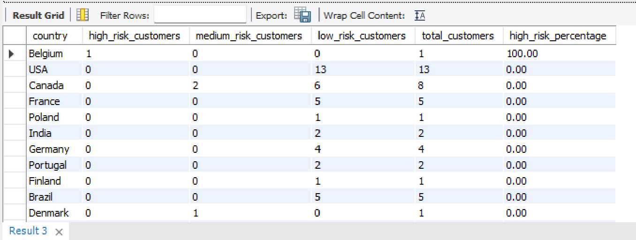

INSIGHTS:
- Belgium (100% churn risk) - Only one customer in Belgium, and they haven’t purchased in over a year
- Denmark (1 customer in Medium Risk),Argentina (1 customer in Medium Risk),Canada (2 customers in Medium Risk).These customers have either low purchase frequency or low spending (< $50 total).
- Countries with only one or two customers (e.g., Belgium, Denmark, Argentina) are more volatile. If these customers stop buying, the churn rate spikes.
- Belgium has 100% churn risk – possibly due to a lack of localization, pricing issues, or limited product variety.

ss
RECOMMENDATIONS:
- For High-Risk Customers:
- Re-engage inactive customers with personalized offers, discounts, or email reminders.
- Expand marketing efforts in low-performing regions like Belgium, Denmark, and Argentina.
- Improve customer experience by providing localized content, pricing, and recommendations.
- For Medium-Risk Customers:
- Encourage higher spending through bundles, discounts, or loyalty programs.
- Analyze customer preferences to recommend relevant music genres or albums.
- For Low-Risk Customers:
- Upsell and cross-sell based on their purchase history.
- Encourage referrals to acquire more customers in strong-performing regions.

- Customer Lifetime Value Modeling: How can you leverage customer data (tenure, purchase history, engagement) to predict the lifetime value of different customer segments? This could inform targeted marketing and loyalty program strategies. Can you observe any common characteristics or purchase patterns among customers who have stopped purchasing?
Ans:
with customertenure as (
select c.customer_id, concat(c.first_name,' ', c.last_name) as customer_name,
min(i.invoice_date) as first_purchase_date,max(i.invoice_date) as last_purchase_date,
datediff(max(i.invoice_date), min(i.invoice_date)) as tenure_days,
count(i.invoice_id) as purchase_frequency,sum(i.total) as total_spent
from customer c
join invoice i on c.customer_id = i.customer_id
group by c.customer_id
)
select customer_id,customer_name,tenure_days,purchase_frequency,
total_spent,round(total_spent / purchase_frequency, 2) as avg_order_value,
datediff(current_date, last_purchase_date) as days_since_last_purchase
from customertenure
order by days_since_last_purchase desc

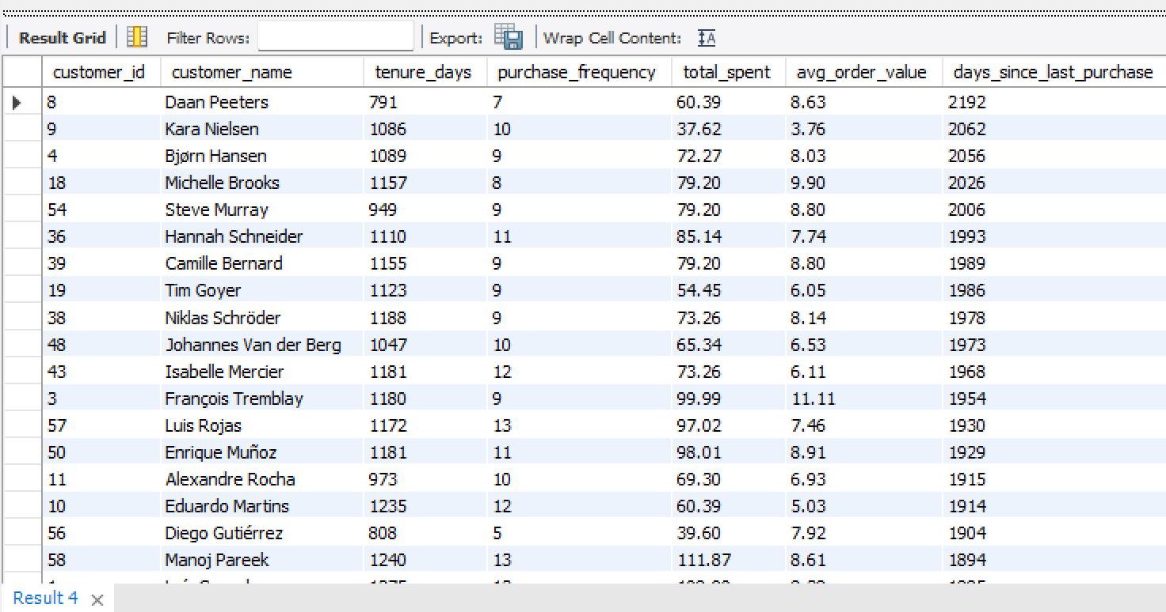

INSIGHTS & RECOMMENDATIONS:

- To predict the lifetime value of the customer segment, I could analyse the customer purchase history and the tenure for which a customer is with the company. With these two parameters we can judge whether a customer is a High value customer or not.
- If the tenure of the customer is small but the purchase history is big, then promotional campaigns should be targeted to these types of customers as they can be converted into loyal customers.
- The customers who have stopped purchasing have one thing in common that they belong to the under developed or developing countries. This shows that economic factor plays an important role in the sales of the company. This could be prevented by using adequate number of promotion channels like social media, articles and advertisements. Also giving discounts could boost the sales in those countries.

- If data on promotional campaigns (discounts, events, email marketing) is available, how could you measure their impact on customer acquisition, retention, and overall sales?
Ans:
Methods to Measure Impact:
- Compare Pre-Campaign and Post-Campaign Metrics: Compare the number of new customers acquired before and after the promotional campaign. This can also include measuring website traffic or sign-ups during the campaign to determine if the campaign generated initial interest.
- Post-Campaign Surveys: Use surveys or feedback mechanisms to understand if customers are satisfied with the promotional campaign and if it influenced their decision to remain loyal to the brand.
- Customer Lifetime Value (CLV): Track the CLV of customers who were acquired or retained through the promotional campaigns and compare it to the overall customer base. If CLV increases after the campaign, it suggests that the campaign positively impacted retention.
- Tracking Promotion Redemptions: If the campaign includes specific promotional codes or discount offers, track the redemption rates. A higher redemption rate indicates that the campaign has been effective in driving sales.

Measuring Campaign Impact with Data:
To properly measure the impact of your campaigns, you will need access to the following data:
- Customer Acquisition Data: Number of new customers during and after the campaign.
- Customer Retention Data: Repeat purchase rates and retention data for customers who engaged with the campaign.
- Sales Data: Total revenue, order values, and conversion rates during the campaign.
- Campaign-Specific Metrics: Discount codes, email open rates, event attendance, etc.

Recommended Analytical Approaches:
- Customer Segmentation: Segment your customer base to understand which segments (age, location, gender, etc.) are most responsive to the campaign and have the highest retention and sales growth. This will help you target future campaigns more effectively.
- Multi-Touch Attribution: Track how different touchpoints (e.g., email, ads, events) contribute to customer acquisition and retention. This helps identify which promotional activities had the most significant impact.

- How would you approach this problem, if the objective and subjective questions weren't given?
Ans:
If the objective and subjective questions were not provided,
I would first review the project's aim and, based on that, determine the key performance indicators that would assist me in achieving the objective.

Next, I would formulate various business questions such as:
- From which locations are the highest sales originating?
- Which tracks are the top sellers in each area?
- Who are the most popular artists and albums across different regions?
- How are sales distributed among various countries?
- Which genre is most favored in each country?

Additionally, I would examine trends in track purchases, including:
- What is the total revenue generated over a specific time frame?
- How has the invoice total for each customer changed over time?
- What is the trend for a particular genre in a specific country?

Finally, I would compile all the insights and present the data.

- How can you alter the "Albums" table to add a new column named "ReleaseYear" of type INTEGER to store the release year of each album?
Ans:
alter table album
add column release_year int;
desc album;



- Chinook is interested in understanding the purchasing behavior of customers based on their geographical location. They want to know the average total amount spent by customers from each country, along with the number of customers and the average number of tracks purchased per customer. Write an SQL query to provide this information.
Ans:
with customer_spending as
(
select i.customer_id,c.country,sum(i.total) as total_spent_by_customer
from invoice i
join customer c on i.customer_id = c.customer_id
group by i.customer_id, c.country
)
,country_inf as
(
select country,count(distinct customer_id) as total_customers,
avg(total_spent_by_customer) as avg_spent_per_customer
from customer_spending
group by country
)
select ci.country,ci.total_customers,
(count(il.track_id) / ci.total_customers) as avg_tracks_purchased_per_customer,
ci.avg_spent_per_customer
from country_inf ci
join invoice i on ci.country = i.billing_country
join invoice_line il on i.invoice_id = il.invoice_id
group by ci.country, ci.total_customers, ci.avg_spent_per_customer

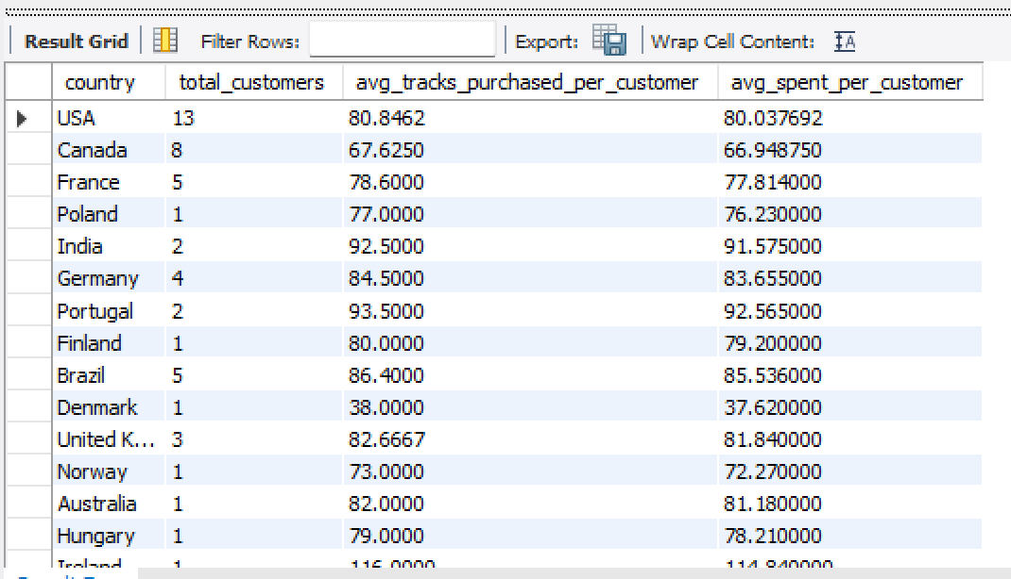
Insights:

- Czech Republic is the leader when it comes to both average total-amount spent by customers and average number of tracks purchased per customer.
- Speaking of total number of customers, USA wins with 13 customers.

Recommendations:

- The major issue seems to be only one customer in multiple countries. Referral incentives must be given to these customers and the store should be advertised to increase reach.

