**WORK-ENERGY THEOREM IN ROTATIONAL REFERENCE FRAMES**

**ABSTRACT**

We all have studied about Work Energy Theorem, but most of us know about Work Energy Theorem for inertial frames of references and it is clear that energy is conserved when there is no net-work of interaction forces. But what happens when Work Energy Theorem is applied in a non-inertial frame of reference? This important issue is frequently avoided.

So, here we are going to discuss the theorem for two observers in relative rotation showing explicitly the diﬀerences for them.

**INTRODUCTION**

A rotating frame of reference is a case of a non-inertial frame. Work Energy Theorem (WET) plays an important role in Mechanics, even though the idea that the work made by the net force applied on a particle give rise to the change of its kinetics energy is not a general principle, but is based on the deﬁnition of work and the Newton’s second law. On the other hand, a very relevant issue is the comparison of the Newton’s Law made by two observers in relative motion, this leads to the Galilean’s principle of relativity. The invariance of Newton’s Law is fully analysed in most textbooks of elementary physics, but usually the work energy balance is stated in a given reference frame without studying its Galilean invariance. Recently the problem of the validity of WET under change of reference systems, both inertial and non-inertial ones, has been addressed. It is not always straightforward to extend the physical laws from one observer to another in relative motion, even worse it is diﬃcult to make further connections between physical concepts. An extension to non-uniform translational motion shows the diﬀerence of kinetic energy K and mechanical work W between inertial and non-inertial observers. Under supposition of uniform translational motion (Galilean invariance) it has been stated the deep relationship among the WET and the impulse Theorem. Notwithstanding the wide variety of systems in rotational motion, such as earth, as far as we know there is no extension of these results for changes of coordinates to rotational (non-inertial) reference systems. Generally, results drawn in translational motion are not straightforwardly applied to rotating systems as can be seen in most text books, where rotational dynamics is only treated after a careful study of translational mechanics. The presentation of the concept of energy and its conservation in introductory physics courses is a major problem even though several approaches have been given to address it both in classics and relativistic theories. In the context we are dealing with, energy will be kinetic and the action of the interaction forces will be taken into account as the total work they do on the system. It is well known that is possible to give several deﬁnitions of work as can be pointed in. As we are dealing with a system of several particles it is worthily to note that the diﬀerence between centre of mass work and particle work, is essentially related to changes in the relative positions of the particles. This internal energy will be included in a general expression. In the present article we show the extension of WET to non-inertial rotating systems. As far as we know the connection between the content of energy of two system in relative rotation has been analysed only in the context of theoretical mechanics. Here we derive similar expression using a more intuitive approach extending the results to a system of particles.

In derivation we are also going to see work done by Centrifugal force. So, first let once understand what is Centrifugal force

In classical mechanics, centrifugal force is an outward force associated with rotation. Centrifugal force is one of several so-called pseudo-forces (also known as inertial forces), so named because, unlike real forces, they do not originate in interactions with other bodies situated in the environment of the particle upon which they act. Instead, centrifugal force originates in the rotation of the frame of reference within which observations are made.

The below diagram clearly explains

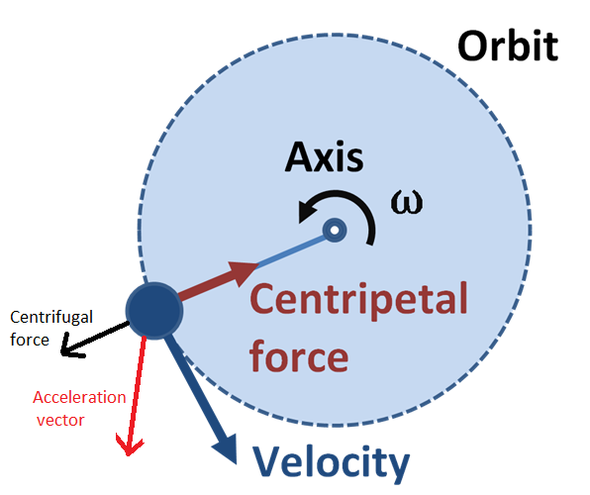

**DERIVATION**

We have two frames of reference one at rest(inertial), and other is non-inertial which is rotating with an angular velocity of **ω** relative to inertial frame of reference

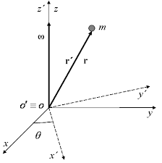

Let a particle of mass **m** have position vector **r** and **r’** in inertial and non-inertial frame of reference respectively

Where

**r′ = Mr** where M represents the rotation matrix

Suppose that there is a net force **F** acting on the particle, then from the point of view of an observer in inertial frame of reference the WET is stated as:

**mv.dv = F. dr**

or **dK = dW**

For observer in non-inertial frame of reference we have to include the so-called inertial forces (Coriolis and centrifugal forces) to preserve the Newton’s second law:

**mdv′/ dt= F – m[ dω /dt× r′ + 2ω × v′ + ω × ω × r′]**

by multiplying **dr’** both side we will get:

**mdv′.v′ = [F − mdω dt× r′ − 2mω × v′ − mω × (ω × r′)].dr′**

in abbreviated form:

**dK′ = dW** ′

So, this representation is same as in case of inertial frame.

Now if we want to relate work and energy in both frames,

**dW ′ = dW + dWrot**

While the same happens for the Kinetic Energy:

**dK′ = dK + dWrot**

where the rotational work is expressed by :

**dWrot = −dθ.(r × F) − m(ω × ω × r).dr − mdω.(r ×dr dt)**

It is clear that relation is same except an additional term due to inertial force.

## We can see that the ﬁrst term is due to the work done by the momentum of the applied forces, the second one corresponds to the work done by the centrifugal force as a function of the ﬁxed system’s variables, meanwhile the third one is related to the variation of the angular velocity.

**EXAMPLE:**

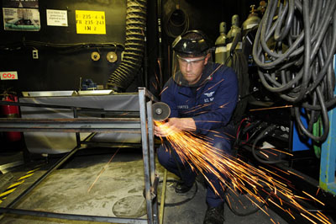

So, here we can calculate work associated with rotational motion of electrical grindstone. Here work went into heat, light, sound, vibration, and considerable rotational kinetic energy.

the net work done is the product of the force times the arc length travelled:

***net W=(net F)s***

To get torque and other rotational quantities into the equation, we multiply and divide the right-hand side of the equation by **r** , and gather terms:

**net W=(r netF)s/r**

We recognize that **r netF=net** and **s/r=theta** , so that

**net W=(net)theta**

This equation is the expression for rotational work. It is very similar to the familiar definition of translational work as force multiplied by distance.

**CONCLUSIONS**

We have examined the behaviour of the work and energy formulation for a system of particles under a change of reference frame.

We show expressly the Galilean variance of the work and energy theorem and show the approach during which such a theorem behaves in an exceedingly non-inertial frame.

It is worth pointing out that the form of the theorem is preserved when going to a non-inertial translational frame as long as the ﬁctitious works are included. In addition, we found that when the reference frame is attached to the centre of mass, the total ﬁctitious work is always null such that the work and energy.

Theorem is command while not the inclusion of ﬁctitious works notwithstanding such a frame is non-inertial.

Finally, we illustrate the fact that after a change of reference frame, the work done for each force also changes (even if the transformation is Galilean).

In consequence, the corresponding potential energies should be changed when they exist.

In explicit, we tend to show that standard forces might manufacture add some mechanical phenomenon reference frames.

**REFERENCES:**

* Internet articles
* NCERT book