Experiment 1

Student Name: Ashutosh Yadav UID: 23BCS11023
Branch: BE-CSE Section: Krg-3-A
Semester: 6 Date of performance: 08-01-2026
Subject name: System Design Subject code: 23CSH-314

Aim
To study and design a scalable URL Shortener system by analyzing its functional requirements, non-functional requirements, API design, database schema, and low-level design approaches including counter-based short URL generation for distributed systems.

Objective
- To understand the working of a URL shortening service.
- To design REST APIs for URL creation and redirection.
- To identify suitable database and server choices.
- To analyze different short URL generation techniques.
- To understand scalability challenges and their solutions.

Problem Statement
Design a URL Shortener system that converts long URLs into short URLs and redirects users from short URLs to original long URLs with low latency, high availability, and scalability.

Requirements
- Functional Requirements
  - Generate a short URL from a long URL.
  - Support custom URLs (optional).
  - Support URL expiration (default and custom).
  - Redirect short URL to the original long URL.

Non-Functional Requirements

  - Low Latency: URL creation and redirection < 200 ms.

Scalability:
    - 100M daily active users
    - 1B shortened URLs
  - Availability: System should be available 24×7.
  - Uniqueness: Each short URL must be unique.

CAP Theorem:
    - Availability > Consistency
    - Eventual Consistency model.
API Design
1.Create Short URL

Endpoint: POST /v1/url
Request Body:
{
"longURL": "string", "expirationDate": "date"
}
Response:
{
"shortURL": "https://short.ly/2bi"
}

2.Redirect Short URL
Endpoint: GET /v1/url/{shortURL} Action: Redirects to original long URL.

Database Design

URL Table
Column Description
id Primary Key
shortURL Unique
longURL Original URL
customURL Optional
expirationDate Expiry Time

Low Level Design (LLD)
Approach 01: Hashing (Encryption)
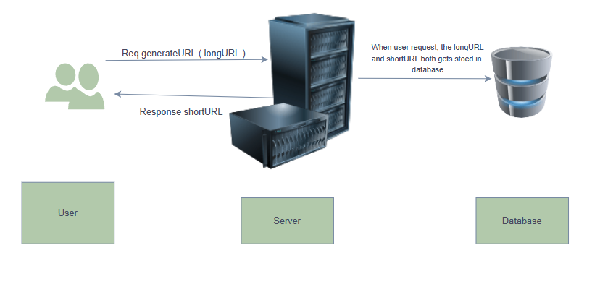
Method:
shortURL = encrypt(longURL)
Algorithms: MD5, SHA-1, Base64

Problems
- Long hash length (not short).
- High collision probability.
- Multiple DB lookups.
- High latency at scale.
Not suitable for large-scale systems

Approach 02: Counter-Based Approach (Recommended)

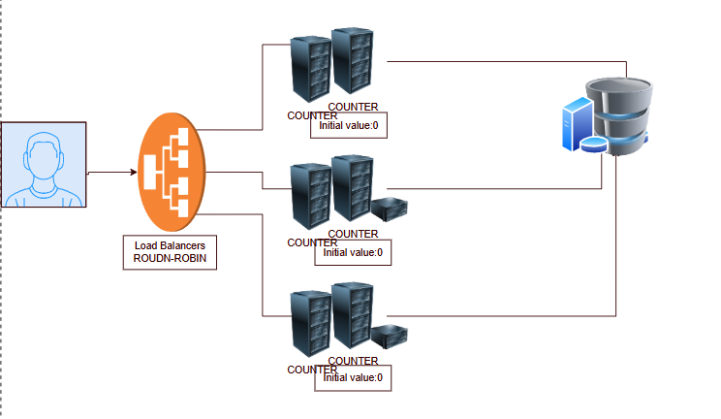

Logic:
- Generate a global counter value.
- Convert counter to Base62.
- Use Base62 value as short URL.

Example:
Counter = 10000 Base62 = 2bi
Short URL = short.ly/2bi

✅ Advantages
  - No collision
  - Fast generation
  - Predictable length

Scaling Challenges & Solutions Problem 1: Monolithic Server
  - Cannot handle 100M users.
Solution: Horizontal Scaling (Multiple Servers)

Problem 2: Distributed Counter Conflict
  - Multiple servers may generate same counter.

Solution:
Use Global Counter in Cache (Redis) with atomic increment.

Conclusion
The counter-based approach with centralized atomic counters provides the most efficient, scalable, and collision-free solution for a URL Shortener system handling millions of users with low latency.

