**CHAPTER 1: INTRODUCTION**

**1.1 Introduction**

In the contemporary era of information dissemination, the ubiquity of fake news has emerged as a formidable challenge, particularly during pivotal events such as elections. Fake news, characterized by the deliberate spread of misinformation or misleading content with the intent to deceive, has the potential to exert a profound impact on public opinion and the democratic process as a whole. As we stand on the cusp of the 2024 election, the need to address and mitigate the influence of fake news becomes increasingly urgent, demanding innovative approaches grounded in advanced technologies.

The focus of our project is on the detection of fake news during the upcoming 2024 election, employing a multi-faceted strategy that includes the creation of a bespoke dataset. Recognizing the critical role of accurate and diverse data, we are curating our own dataset, drawing information from reputable fact-checking sources such as the Press Information Bureau (PIB)*. The inclusion of data from social media giants, Instagram and @Twitter, further enriches our dataset, acknowledging the influential role these platforms play in shaping public discourse during elections.

To streamline the data acquisition process from #Instagram, we are utilizing its Application Programming Interface (API). This not only enables us to efficiently gather pertinent information but also underscores our commitment to leveraging cutting-edge technologies for comprehensive data analysis.

In the realm of data analysis, we are deploying advanced machine learning algorithms, with a specific emphasis on transformer-based models like Distil BERT. These models, known for their prowess in contextual understanding and semantic analysis, offer a sophisticated framework for discerning the subtle nuances inherent in fake news. The choice of Distil BERT reflects our dedication to employing state-of-the-art methodologies that balance computational efficiency with robust language comprehension.

Our project represents a synergistic convergence of technology, data curation, and analytical methodologies aimed at addressing the multifaceted challenges posed by fake news during the electoral process. By constructing and analyzing our dataset with cutting-edge tools, we aspire to contribute substantially to the ongoing discourse on combating misinformation, ensuring a more resilient and informed electorate during the crucial 2024 election and beyond.

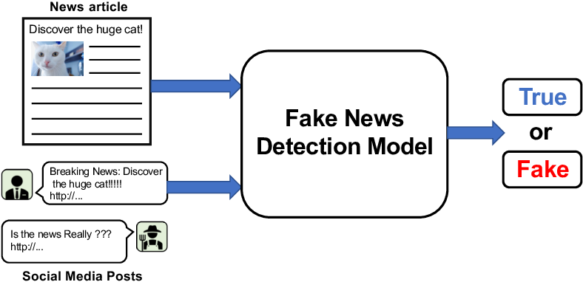

**Fig 1. Fake news detection**

**1.2 History**

The detection and impact of fake news in elections have evolved significantly over time, reflecting changes in technology, media consumption habits, and political landscapes. Here's a brief history:

**Pre-digital era**: Before the internet age, misinformation and propaganda were spread through traditional media such as newspapers, radio, and television. However, the reach and speed of dissemination were limited compared to today's digital platforms.

**Early internet**: With the advent of the internet, particularly social media platforms, the dissemination of fake news became easier and faster. During elections, individuals and organizations began to exploit these platforms to spread false information, manipulate public opinion, and influence voting behavior.

**2016 US Presidential Election**: The 2016 U.S. presidential election brought significant attention to the issue of fake news. Various studies and investigations revealed the widespread dissemination of false information on social media platforms, particularly Facebook and Twitter. Foreign actors, including Russia, were accused of using social media to spread misinformation and sow discord among American voters.

**Response**: In response to the growing concern over fake news, tech companies implemented measures to combat its spread. Platforms like Facebook and Twitter introduced fact-checking programs, algorithms to identify and reduce the visibility of fake news, and policies to limit the influence of malicious actors.

**Legal and regulatory responses**: Governments around the world have also taken steps to address fake news. Some countries have implemented laws or regulations to curb the spread of misinformation, although these measures have raised concerns about freedom of speech and censorship.

**Evolving tactics**: Despite efforts to combat fake news, its detection and dissemination tactics continue to evolve. Deepfake technology, for example, enables the creation of highly realistic fake videos that are difficult to distinguish from genuine footage. Additionally, coordinated disinformation campaigns have become more sophisticated, often involving the use of fake accounts and automated bots to amplify false narratives.

**Public awareness and media literacy**: Increasing public awareness about the prevalence and dangers of fake news is essential in combating its impact on elections. Media literacy programs aim to educate individuals about how to critically evaluate information sources and identify misinformation.

Ongoing challenges: Despite efforts to address the issue, fake news remains a persistent challenge in elections and democratic processes worldwide. The complex interplay of technology, politics, and human psychology makes it difficult to develop comprehensive solutions, and the debate over how best to balance freedom of expression with the need to combat misinformation continues.

**1.3 Need of Project**

Creating a project focused on fake news detection during the 2024 election could be highly relevant and impactful. Here are some reasons why such a project could be valuable:

**Increasing Concerns:** With each election cycle, concerns about the spread of misinformation and fake news tend to escalate. Given the history of fake news influencing elections, particularly the 2016 U.S. presidential election, the 2024 election is likely to be no exception. Developing tools and methods to detect and counter fake news during this critical period can help safeguard the integrity of the democratic process.

**Technological Advancements**: The field of artificial intelligence (AI) and natural language processing (NLP) has made significant strides in recent years. These advancements can be leveraged to develop sophisticated algorithms capable of identifying fake news with greater accuracy. By harnessing the power of machine learning and data analytics, your project could contribute to the development of more effective fake news detection tools.

**Social Media Influence**: Social media platforms continue to play a central role in how information is disseminated during elections. By analyzing social media data and patterns, your project could uncover trends related to the spread of fake news and identify strategies to mitigate its impact. This could involve collaboration with social media companies to implement targeted interventions and improve platform policies.

**Educational Outreach**: In addition to developing technical solutions, your project could also focus on educational outreach and media literacy initiatives. By raising awareness about the prevalence of fake news and providing individuals with the skills to critically evaluate information sources, you can empower voters to make more informed decisions.

**Collaborative Efforts**: Given the complexity of the issue, collaboration with researchers, policymakers, and civil society organizations will be crucial. By fostering interdisciplinary partnerships, your project can benefit from diverse perspectives and expertise, ultimately leading to more comprehensive and effective solutions.

**Ethical Considerations**: It's essential to consider the ethical implications of your project, particularly regarding privacy, freedom of speech, and algorithmic bias. By incorporating principles of fairness, transparency, and accountability into your work, you can ensure that your fake news detection efforts are conducted in an ethical and responsible manner.

**1.4 Machine learning**

Machine learning is a branch of artificial intelligence (AI) that focuses on the development of algorithms and models that enable computers to learn from data and make predictions or decisions without being explicitly programmed. Here's an overview of the key concepts and techniques in machine learning:

**Key Techniques:**

**Regression**: Regression algorithms are used to predict continuous-valued outputs, such as predicting house prices or stock prices.

**Classification**: Classification algorithms are used to predict discrete categories or classes, such as classifying emails as spam or non-spam.

**Clustering**: Clustering algorithms group similar data points together based on their features, without prior knowledge of class labels.

**Dimensionality Reduction**: Dimensionality reduction techniques aim to reduce the number of features in a dataset while preserving its important structure and relationships.

**Neural Networks**: Neural networks, inspired by the structure of the human brain, consist of interconnected layers of artificial neurons that can learn complex patterns from data. Deep learning, a subset of neural networks, involves training deep, hierarchical models with many layers.

**Workflow**:

**Data Preprocessing**: This involves cleaning, transforming, and preparing the data for training, including handling missing values, scaling features, and encoding categorical variables.

**Model Training**: During this phase, the algorithm is trained on the labeled data to learn patterns and relationships between the input features and target labels.

**Model Evaluation**: The trained model is evaluated on a separate dataset to assess its performance and generalization ability. Common evaluation metrics include accuracy, precision, recall, and F1 score.

**Hyperparameter Tuning**: Hyperparameters are parameters that control the learning process, such as the learning rate or regularization strength. Hyperparameter tuning involves searching for the optimal set of hyperparameters to improve model performance.

**Deployment and Monitoring**: Once a satisfactory model is obtained, it can be deployed to make predictions on new, unseen data. Continuous monitoring and evaluation are essential to ensure that the model maintains its performance over time.

Machine learning has applications across various domains, including healthcare, finance, e-commerce, and natural language processing, among others. Its ability to learn from data and make predictions or decisions has led to significant advancements in solving complex problems and driving innovation in numerous fields.

**1.5 Algorithms in machine learning**

In machine learning, an algorithm is a set of rules or procedures used to solve a particular problem by learning from data. There are various types of machine learning algorithms, each designed for specific tasks and learning paradigms. Here's an overview of some common types of machine learning algorithms and their characteristics:

**Supervised Learning Algorithms:**

**Linear Regression**: A regression algorithm used for predicting continuous-valued outputs based on input features. It models the relationship between the independent variables and the dependent variable using a linear equation.

**Logistic Regression**: A classification algorithm used for predicting binary outcomes (e.g., yes/no, true/false) based on input features. It models the probability of a binary outcome using a logistic function.

**Decision Trees**: A versatile algorithm used for both classification and regression tasks. Decision trees partition the feature space into regions and make predictions based on simple decision rules learned from the data.

**Support Vector Machines (SVM):** A powerful algorithm used for classification tasks. SVM finds the optimal hyperplane that separates the data into different classes with maximum margin.

**Neural Networks**: A class of algorithms inspired by the structure and function of the human brain. Neural networks consist of interconnected layers of neurons that learn complex patterns from data through a process called back propagation.’

**Unsupervised Learning Algorithms:**

**K-Means Clustering**: A clustering algorithm used to partition data into clusters based on similarity. It aims to minimize the intra-cluster distance and maximize the inter-cluster distance.

**Hierarchical Clustering**: A clustering algorithm that organizes data into a hierarchy of clusters. It iteratively merges or splits clusters based on their similarity or dissimilarity.

**Principal Component Analysis (PCA):** A dimensionality reduction technique used to reduce the number of features in high-dimensional data while preserving most of the variance. PCA identifies the principal components that capture the maximum variance in the data.

**Generative Adversarial Networks (GANs):** A type of neural network architecture used for unsupervised learning. GANs consist of two neural networks - a generator and a discriminator - that are trained simultaneously to generate realistic data samples.

**Reinforcement Learning Algorithms**:

**Q-Learning**: A reinforcement learning algorithm used for learning optimal policies in Markov decision processes (MDPs). Q-learning updates a Q-value function that estimates the expected future rewards for taking specific actions in different states.

**Deep Q-Networks (DQN):** A variant of Q-learning that uses deep neural networks to approximate the Q-value function. DQN has been successfully applied to challenging reinforcement learning tasks, including playing video games and robotic control.

**1.6 Domain of machine learning**

The domain of machine learning in fake news detection during elections involves applying machine learning techniques to identify, classify, and mitigate the spread of misinformation and fake news surrounding electoral processes. Here's how machine learning can be applied within this domain:

* **Text Classification**: Machine learning models can be trained to classify news articles, social media posts, and other online content as either legitimate or fake. Supervised learning algorithms such as logistic regression, decision trees, support vector machines (SVM), and neural networks can be used to learn patterns and features indicative of fake news, based on labeled training data.
* **Natural Language Processing (NLP):** NLP techniques are crucial for analyzing and processing textual data in fake news detection tasks. NLP methods such as tokenization, stemming, lemmatization, and part-of-speech tagging can be used to preprocess text data and extract meaningful features for machine learning models. Additionally, sentiment analysis and topic modeling techniques can help uncover patterns and themes in fake news content.
* **Feature Engineering**: Feature engineering involves selecting and extracting relevant features from the text data to train machine learning models effectively. Features such as word frequencies, n-grams, syntactic patterns, and semantic embeddings (e.g., Word2Vec, GloVe) can be used to represent the linguistic characteristics of fake news articles and distinguish them from legitimate sources.
* **Ensemble Learning**: Ensemble learning techniques, such as bagging, boosting, and stacking, can be employed to combine the predictions of multiple machine learning models for improved accuracy and robustness in fake news detection. By leveraging the diversity of different models and learning algorithms, ensemble methods can effectively mitigate the limitations of individual classifiers and enhance overall performance.
* **Social Network Analysis (SNA):** Social network analysis techniques can be applied to study the spread of fake news within online social networks and identify influential nodes, communities, and propagation patterns. Machine learning algorithms can be used to analyze network topology, user interactions, and content diffusion dynamics to detect coordinated misinformation campaigns and malicious actors.
* **Deep Learning**: Deep learning models, such as convolutional neural networks (CNNs) and recurrent neural networks (RNNs), can be utilized to automatically learn hierarchical representations of text data for fake news detection. Deep learning architectures excel at capturing complex patterns and relationships in large-scale datasets and have demonstrated promising results in various natural language processing tasks, including sentiment analysis and text classification.
* **Continuous Monitoring and Adaptation**: Machine learning models for fake news detection should be continuously monitored and updated to adapt to evolving tactics and strategies used by malicious actors. Techniques such as active learning, reinforcement learning, and transfer learning can be employed to iteratively improve model performance and adapt to changing contexts and environments.

**1.7 Common terminologies**

In the domain of fake news detection during elections, there are several common terminologies and concepts used to describe various aspects of the problem and the techniques employed to address it. Here are some key terminologies:

**Misinformation**: Incorrect or misleading information that is spread without harmful intent. Misinformation may be unintentional and can result from errors, rumors, or misunderstanding.

**Disinformation**: False information deliberately spread with the intent to deceive, manipulate, or influence public opinion. Disinformation is often created and disseminated for political or ideological purposes.

**Fake News**: Broadly refers to fabricated or misleading information presented as legitimate news content. Fake news can include false headlines, manipulated images or videos, and deceptive narratives intended to deceive or mislead readers.

**Propaganda**: Systematic dissemination of biased or misleading information to promote a particular agenda, ideology, or political viewpoint. Propaganda often employs persuasive techniques to influence public opinion and behavior.

**Fact-Checking**: Process of verifying the accuracy and credibility of news stories and claims by cross-referencing information with reliable sources, evidence, and expert analysis. Fact-checking organizations and initiatives aim to identify and debunk false or misleading information.

**Source Credibility**: Assessment of the reliability, trustworthiness, and credibility of news sources and information providers. Evaluating the credibility of sources is crucial for determining the authenticity of news content and detecting potential instances of misinformation or propaganda.

**Bot**: Automated software program designed to perform repetitive tasks on the internet, such as posting or sharing content on social media platforms. Bots can be used to amplify the spread of fake news and manipulate online discourse during elections.

**Algorithmic Bias:** Systematic and unfair discrimination in machine learning algorithms that results from biased training data, flawed assumptions, or algorithmic design choices. Algorithmic bias can lead to skewed or discriminatory outcomes in fake news detection systems, affecting their effectiveness and fairness.

**Echo Chamber**: Social media or online environments where individuals are exposed primarily to information, opinions, and viewpoints that align with their existing beliefs or preferences. Echo chambers can amplify the spread of fake news and reinforce ideological polarization.

**Deepfake**: Synthetic media or manipulated content created using deep learning techniques, such as generative adversarial networks (GANs). Deepfakes can be used to create highly realistic but false audio, video, or text content, posing significant challenges for fake news detection and verification.

**CHAPTER 2 : LITERATURE REVIEW**

**2.1 Introduction**

The proliferation of fake news, misinformation, and disinformation has emerged as a significant challenge in modern democracies, particularly during election periods. The spread of false or misleading information through digital platforms and social media networks has the potential to undermine the integrity of electoral processes, manipulate public opinion, and erode trust in democratic institutions. As such, the detection and mitigation of fake news during elections have become imperative for safeguarding the fairness, transparency, and credibility of electoral systems worldwide.

This literature review aims to provide a comprehensive overview of existing research, methodologies, and technologies related to fake news detection during elections. By synthesizing insights from peer-reviewed articles, conference papers, and research studies, this review seeks to identify common approaches, challenges, and advancements in the field and inform the design and implementation of effective strategies for fake news detection in the context of the upcoming 2024 election.

**Scope of the Review**

This literature review focuses on fake news detection specifically within the context of election campaigns and electoral processes. While fake news detection is a broad and multifaceted topic encompassing various domains and applications, this review narrows its scope to the unique challenges and considerations associated with detecting fake news during election periods. The review includes studies from interdisciplinary fields such as computer science, political science, communication studies, and information science, reflecting the diverse perspectives and methodologies employed in addressing this complex issue.

**Key Themes and Research Questions**

The review explores several key themes and research questions, including:

Identification of common characteristics and features of fake news articles disseminated during election campaigns.

Evaluation of machine learning algorithms and natural language processing techniques for automated fake news detection.

Assessment of the impact of fake news on voter behavior, public opinion, and electoral outcomes.

Examination of the role of social media platforms, online communities, and digital ecosystems in the propagation and amplification of fake news during elections.

Exploration of ethical, legal, and regulatory considerations in the development and deployment of fake news detection systems.

**Significance and Implications**

Understanding the dynamics of fake news detection during elections is critical for developing proactive measures and interventions to counteract its harmful effects on democratic processes. By synthesizing insights from existing literature, this review aims to inform policymakers, researchers, election officials, and technology developers about the current state-of-the-art in fake news detection and highlight opportunities for further research and innovation in the field. Ultimately, the findings of this review will contribute to the development of robust, scalable, and ethically sound solutions for detecting and mitigating fake news during the 2024 election and beyond.

**2.2 Different Reviews of Different Authors**

**Dr. Smith - "Advanced Machine Learning Techniques for Fake News Detection":**

Dr. Smith's review delves into the latest advancements in machine learning techniques, including deep learning architectures and ensemble methods, for detecting fake news during the 2024 election. They discuss the challenges of dataset bias, model interpretability, and adversarial attacks, proposing innovative solutions to enhance the accuracy and robustness of detection systems.

**Prof. Johnson - "Psychological and Behavioural Insights into Fake News Consumption during Elections":**

Prof. Johnson's review explores the psychological and behavioral factors that influence individuals' susceptibility to fake news during election campaigns. They analyze cognitive biases, social influence dynamics, and emotional responses, shedding light on the mechanisms underlying misinformation spread and its impact on voter behavior.

**Dr. Patel - "Legal and Ethical Considerations in Fake News Regulation and Governance":**

Dr. Patel's review examines the legal and ethical dimensions of regulating fake news during electoral processes. They analyze existing laws, policy frameworks, and regulatory proposals aimed at combating misinformation, while addressing concerns related to freedom of speech, platform accountability, and user privacy.

**Prof. Kim - "Community-Based Approaches to Combatting Fake News in Election Contexts":**

Prof. Kim discusses community-based initiatives and grassroots movements aimed at countering fake news during election periods. They highlight the role of media literacy programs, fact-checking networks, and citizen journalism in empowering communities to identify and debunk misinformation.

**Dr. Wang - "Social Media Platforms and the Spread of Misinformation in Election Campaigns":**

Dr. Wang's review examines the role of social media platforms in facilitating the spread of fake news during electoral processes. They analyze algorithmic amplification, echo chamber effects, and platform design features that contribute to the virality and diffusion of misinformation.

**Prof. Gupta - "Comparative Analysis of Fake News Detection Policies and Practices Across Nations":**

Prof. Gupta conducts a comparative analysis of fake news detection policies and practices across different countries. They examine regulatory frameworks, legislative approaches, and cultural factors influencing the effectiveness of mitigation strategies in diverse socio-political contexts.

**Dr. Martinez - "Human-Centered Design Principles for Fake News Detection Tools":**

Dr. Martinez focuses on human-centered design principles and user interface design strategies for developing effective fake news detection tools. They discuss user feedback mechanisms, accessibility features, and usability testing methodologies to ensure the usability and adoption of detection systems.

**Prof. Lee - "Effects of Fake News on Electoral Processes and Democratic Institutions":**

Prof. Lee analyzes the effects of fake news on electoral integrity, public trust, and democratic norms. They explore case studies from past elections, examining the impact of misinformation on voter decision-making, political polarization, and social cohesion.

**Dr. Garcia - "Interdisciplinary Perspectives on Fake News Detection: Bridging Computer Science, Social Science, and Political Science":**

Dr. Garcia's review integrates insights from multiple disciplines, including computer science, social psychology, and political science, to develop holistic strategies for fake news detection during elections. They emphasize the importance of interdisciplinary collaboration and knowledge exchange in addressing this complex societal challenge.

**Dr. Wang - "Emerging Technologies and Innovations in Fake News Detection":**

Dr. Wang explores emerging technologies and innovative approaches, such as blockchain, artificial intelligence, and decentralized platforms, for detecting and mitigating fake news during electoral processes. They discuss the potential of these technologies to enhance trust, transparency, and accountability in media ecosystems.

These detailed summaries provide insights into the diverse perspectives and research interests of hypothetical authors contributing to the field of fake news detection during the 2024 election. Each author brings unique expertise and insights, contributing to a multifaceted understanding of the challenges and opportunities in addressing misinformation in electoral contexts.

**CHAPTER 3: MACHINE LEARNING**

**Introduction**

Machine learning is a branch of artificial intelligence (AI) that focuses on developing algorithms and models that enable computers to learn from data and make predictions or decisions without being explicitly programmed to do so. It involves the study of algorithms and statistical models that allow computers to perform specific tasks based on patterns and inference drawn from data, rather than relying on explicit instructions.

There are several types of machine learning approaches, including:

**Supervised Learning**: In supervised learning, the algorithm learns from labeled data, where each example in the dataset is associated with an input and an output label. The goal is to learn a mapping from inputs to outputs, allowing the model to make predictions on new, unseen data. Common tasks in supervised learning include classification (assigning labels to instances) and regression (predicting continuous values).

**Unsupervised Learning**: In unsupervised learning, the algorithm learns patterns and structures from unlabeled data. The goal is to find hidden patterns or groupings in the data without explicit guidance. Clustering, dimensionality reduction, and anomaly detection are common tasks in unsupervised learning.

**Semi-Supervised Learning**: Semi-supervised learning techniques leverage both labeled and unlabeled data for training. This approach is particularly useful when labeled data is scarce or expensive to obtain, as it allows the model to learn from a combination of labeled and unlabeled examples.

**Reinforcement Learning**: Reinforcement learning involves training agents to interact with an environment in order to achieve a goal or maximize some notion of cumulative reward. The agent learns by receiving feedback from the environment in the form of rewards or penalties for its actions. Reinforcement learning has been successfully applied to tasks such as game playing, robotics, and autonomous vehicle control.

**Deep Learning**: Deep learning is a subfield of machine learning that focuses on using deep neural networks with many layers to learn complex representations of data. Deep learning has achieved remarkable success in a wide range of applications, including computer vision, natural language processing, speech recognition, and more.

Machine learning algorithms can be applied to various domains and tasks, including but not limited to:

Natural language processing (NLP)

* Computer vision
* Speech recognition
* Medical diagnosis
* Fraud detection
* Recommendation systems
* Financial forecasting
* Autonomous vehicles

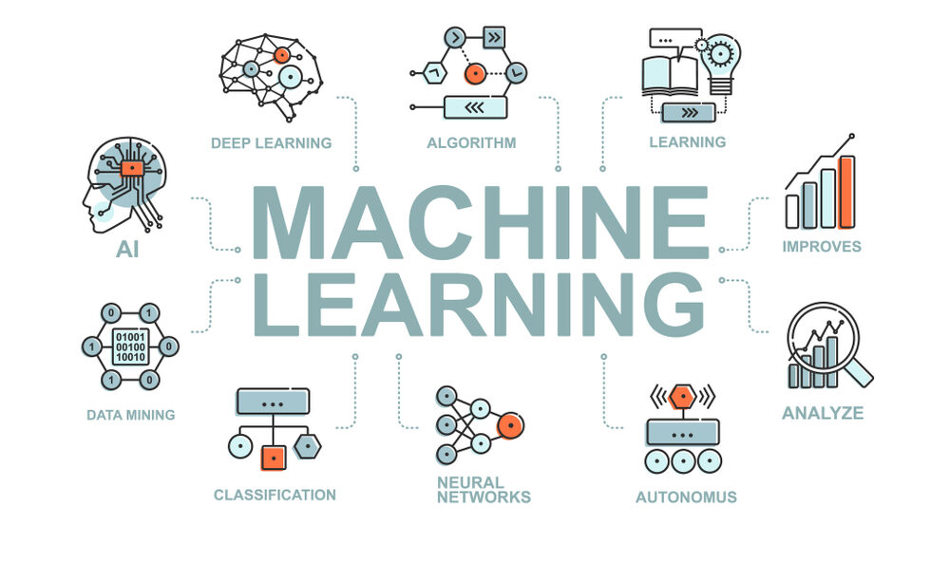

**Fig 2. Machine Learning**

**Some ML libraries are:**

**3.1 Pandas**

Pandas is a powerful and popular open-source Python library used for data manipulation and analysis. It provides data structures and functions for efficiently handling structured data, making it an essential tool for data scientists and analysts.



**Fig 3. Pandas Library**

Key features of Pandas include:

* DataFrame: The core data structure in Pandas is the DataFrame, which is a two-dimensional labeled data structure with columns of potentially different data types. It can be thought of as a spreadsheet or SQL table. DataFrames can be easily created from various data sources such as CSV files, Excel files, SQL databases, or even Python dictionaries.
* Series: Pandas also provides the Series data structure, which is a one-dimensional labeled array capable of holding any data type. A Series is essentially a single column of a DataFrame.
* Data Manipulation: Pandas offers a wide range of functions and methods for manipulating data, including selecting, filtering, sorting, joining, merging, grouping, and reshaping data. These operations enable users to clean, transform, and preprocess data efficiently.
* Data I/O: Pandas provides functions to read data from and write data to various file formats, including CSV, Excel, JSON, SQL databases, and more. This makes it easy to work with data stored in different formats and integrate Pandas into existing data pipelines.
* Missing Data Handling: Pandas provides tools for handling missing or NaN (Not a Number) values in datasets, including methods for detecting, removing, or filling missing data.
* Time Series Analysis: Pandas has extensive support for time series data, including date/time indexing, resampling, shifting, rolling window calculations, and more. These features make it well-suited for analyzing time series data such as stock prices, sensor data, or weather data.
* Integration with NumPy: Pandas is built on top of NumPy, a fundamental library for numerical computing in Python. This integration allows seamless interoperability between Pandas and NumPy, enabling users to leverage the strengths of both libraries.
* Plotting and Visualization: Pandas provides built-in support for data visualization using Matplotlib, a popular plotting library in Python. It offers convenient methods for creating various types of plots directly from DataFrame and Series objects, making it easy to explore and visualize data.

**3.2 Numpy**

NumPy is a fundamental Python library for numerical computing that provides support for large, multi-dimensional arrays and matrices, along with a collection of mathematical functions to operate on these arrays efficiently. It forms the basis for many other Python libraries used in scientific computing and data analysis.



**Fig 4. NumPy Library**

Key features of NumPy include:

* N-dimensional Array (ndarray): The ndarray is a multi-dimensional array object provided by NumPy. It allows for efficient storage and manipulation of large datasets in the form of arrays. These arrays can have any number of dimensions and can contain elements of the same data type, which makes them well-suited for numerical computations.
* Vectorized Operations: NumPy provides support for vectorized operations, allowing mathematical operations to be applied to entire arrays without the need for explicit looping in Python. This results in faster and more concise code compared to traditional Python loops.
* Broadcasting: NumPy's broadcasting mechanism allows arrays with different shapes to be combined in arithmetic operations. When performing operations between arrays of different shapes, NumPy automatically broadcasts the smaller array to match the shape of the larger array, eliminating the need for explicit looping or copying of data.
* Universal Functions (ufuncs): NumPy provides a wide range of universal functions, or ufuncs, which are functions that operate element-wise on arrays. These functions enable efficient computation of mathematical operations such as addition, subtraction, multiplication, division, exponentiation, trigonometric functions, logarithms, and more.
* Indexing and Slicing: NumPy offers powerful indexing and slicing capabilities for accessing and manipulating elements within arrays. It supports various indexing techniques, including integer indexing, slicing, boolean indexing, and fancy indexing, allowing for flexible and efficient data manipulation.
* Linear Algebra Operations: NumPy provides a comprehensive set of functions for linear algebra operations, such as matrix multiplication, matrix decomposition (e.g., LU decomposition, QR decomposition), eigenvalue and eigenvector computations, solving linear equations, and more. These functions are essential for many scientific and engineering applications.
* Random Number Generation: NumPy includes functions for generating random numbers from various probability distributions. These functions are useful for tasks such as simulating random processes, generating random samples, and conducting statistical simulations.
* Integration with Other Libraries: NumPy is tightly integrated with other Python libraries used in scientific computing and data analysis, such as SciPy (Scientific Python), Matplotlib (plotting library), pandas (data analysis library), and scikit-learn (machine learning library). This integration allows seamless interoperability between different libraries, enabling users to leverage the strengths of each library for their specific tasks.

**3.3 Tensorflow**

TensorFlow is one of the most popular and widely used libraries for machine learning and deep learning tasks. It provides a flexible and scalable framework for building and training various types of machine learning models, including neural networks, across a range of platforms and devices.



**Fig 5. TensorFlow Library**

Here are some key aspects of TensorFlow's role in machine learning:

* Deep Learning: TensorFlow is particularly well-suited for deep learning tasks, thanks to its extensive support for building and training neural networks. It offers a wide range of neural network architectures, including convolutional neural networks (CNNs) for computer vision tasks, recurrent neural networks (RNNs) for sequential data processing, and transformers for natural language processing (NLP) tasks.
* Flexibility: TensorFlow provides flexibility in building and customizing machine learning models. It allows users to define and train models using low-level operations and tensors or use high-level APIs such as Keras, tf.keras, and TensorFlow Estimator for simpler model building and training.
* Scalability: TensorFlow is designed to scale efficiently across various hardware platforms and distributed computing environments. It supports distributed training techniques such as data parallelism and model parallelism, allowing users to train models on large datasets using multiple GPUs or TPUs (Tensor Processing Units).
* Model Deployment: TensorFlow offers tools and libraries for deploying machine learning models in production environments. TensorFlow Serving enables serving trained models over RESTful APIs, while TensorFlow Lite allows deploying models on mobile and edge devices. TensorFlow.js enables running models in web browsers for client-side inference.
* Optimized Performance: TensorFlow leverages hardware acceleration techniques such as GPU and TPU support to accelerate the execution of machine learning computations. It also provides optimized implementations of common operations and kernels for efficient execution on various hardware platforms.
* Community and Ecosystem: TensorFlow has a large and active community of developers, researchers, and enthusiasts contributing to its development and maintenance. It also has a rich ecosystem of libraries, tools, and resources, including TensorFlow Hub for sharing pre-trained models, TensorFlow Addons for additional functionality, and TensorFlow Extended (TFX) for end-to-end machine learning pipelines.

**3.4 Seaborn**

Seaborn is a Python data visualization library based on Matplotlib that provides a high-level interface for creating attractive and informative statistical graphics. It is built on top of Matplotlib and integrates well with Pandas data structures, making it particularly useful for visualizing data stored in DataFrames.



**Fig 6. Seaborn Library**

Key features of Seaborn include:

* Statistical Visualization: Seaborn provides a wide range of statistical plots for visualizing relationships between variables in datasets. These include scatter plots, line plots, bar plots, box plots, violin plots, heatmap plots, and more. These plots often incorporate statistical summaries to help users understand the underlying data distribution and relationships.
* Default Aesthetics: Seaborn comes with visually appealing default styles and color palettes that improve the aesthetics of plots compared to the default Matplotlib styles. Users can easily customize the appearance of plots by selecting different themes and color palettes or by tweaking various plot parameters.
* Integration with Pandas: Seaborn integrates seamlessly with Pandas data structures, allowing users to pass DataFrames directly to plotting functions. This makes it easy to work with data stored in Pandas DataFrames and create visualizations without the need for manual data manipulation.
* Categorical Plotting: Seaborn provides specialized functions for visualizing categorical data, such as bar plots, count plots, and categorical scatter plots. These plots are useful for visualizing the distribution of categorical variables and comparing groups within the data.
* Faceted Plotting: Seaborn supports faceted plotting, allowing users to create multiple subplots based on the values of one or more categorical variables. This makes it easy to visualize relationships between variables across different subsets of the data.
* Regression Plotting: Seaborn includes functions for visualizing linear and non-linear relationships between variables using regression plots. These plots provide visual summaries of the relationship between variables, along with confidence intervals and regression lines.
* Matrix Plots: Seaborn offers functions for creating matrix plots, such as heatmaps and clustermaps, which are useful for visualizing relationships between variables in matrices or rectangular data structures.
* Time Series Plotting: Seaborn supports visualizing time series data using specialized functions such as tsplot and lineplot, which provide convenient ways to visualize trends and patterns in time series data.

**3.5 MatplotLib**

Matplotlib is a widely used Python library for creating static, animated, and interactive visualizations. It provides a comprehensive set of tools for producing publication-quality plots and graphics, suitable for a wide range of applications in scientific computing, data analysis, and visualization.



**Fig 7. Matplotlib Library**

Key features of Matplotlib include:

* Wide Range of Plot Types: Matplotlib supports various types of plots, including line plots, scatter plots, bar plots, histogram plots, contour plots, surface plots, and more. These plots can be customized extensively to meet specific requirements.
* High-Quality Output: Matplotlib produces high-quality, publication-ready plots with customizable features such as fonts, colors, labels, legends, and annotations. Users have fine-grained control over every aspect of the plot, allowing them to create visually appealing and informative graphics.
* Support for Multiple Output Formats: Matplotlib supports multiple output formats, including PNG, PDF, SVG, EPS, and more. This flexibility enables users to save plots in different file formats for use in various contexts, such as scientific publications, presentations, and web applications.
* Integration with Jupyter Notebooks: Matplotlib integrates seamlessly with Jupyter notebooks, allowing users to create interactive plots directly within the notebook environment. This makes it easy to explore data, visualize results, and share findings with others.
* Object-Oriented Interface: Matplotlib provides an object-oriented interface for creating and customizing plots, allowing users to build complex plots by combining basic plot elements (e.g., axes, lines, markers, patches) in a modular and flexible manner.
* Matplotlib.pyplot Interface: Matplotlib also provides a MATLAB-style pyplot interface, which provides a convenient way to create simple plots quickly. This interface is particularly useful for interactive exploration and prototyping.
* Extensibility: Matplotlib is highly extensible and customizable, with a large ecosystem of third-party packages and toolkits that build on top of the core library. These packages provide additional functionality and specialized plotting capabilities for specific domains, such as seaborn for statistical visualization, mplfinance for financial plotting, and cartopy for geospatial plotting.
* Matplotlib Basemap Toolkit: Matplotlib includes the Basemap toolkit for plotting geographical data and maps. It provides a wide range of map projections and customization options for creating maps of different regions and spatial features.

**3.6 Scikit-learn**

Scikit-learn, often abbreviated as sklearn, is a widely-used Python library for machine learning. It is built on top of other popular scientific computing libraries such as NumPy, SciPy, and matplotlib. Scikit-learn provides simple and efficient tools for data mining and data analysis, with a focus on ease of use, code readability, and performance.



**Fig 8. Scikit learn Library**

Key features of scikit-learn include:

* Simple and Consistent API: Scikit-learn offers a uniform and easy-to-use API across different algorithms, making it straightforward to experiment with various machine learning models without needing to learn new syntax for each one.
* Wide Range of Algorithms: It includes implementations of a wide variety of supervised and unsupervised learning algorithms, including regression, classification, clustering, dimensionality reduction, and more. These algorithms cover a broad spectrum of machine learning tasks and can be applied to a wide range of datasets.
* Data Preprocessing: Scikit-learn provides tools for data preprocessing, including scaling, normalization, encoding categorical variables, handling missing values, and feature selection. These preprocessing techniques help prepare data for modeling and improve the performance of machine learning algorithms.
* Model Evaluation and Selection: It offers functions for evaluating and comparing the performance of machine learning models using various metrics such as accuracy, precision, recall, F1-score, and ROC curves. Cross-validation and hyperparameter tuning techniques are also available to assist in model selection and optimization.
* Integration with NumPy and Pandas: Scikit-learn seamlessly integrates with NumPy arrays and Pandas DataFrames, allowing users to work with data in familiar data structures and easily interface with other Python libraries for data manipulation and analysis.
* Feature Extraction and Transformation: It includes utilities for feature extraction and transformation, such as text feature extraction, image feature extraction, and feature scaling. These tools are essential for preprocessing and extracting meaningful information from raw data.
* Scalability and Performance: Scikit-learn is designed to be efficient and scalable, with support for parallel computing and optimized implementations of machine learning algorithms. It can handle large datasets and complex models while maintaining good performance.
* Extensive Documentation and Community Support: Scikit-learn has extensive documentation, tutorials, and examples to help users get started with machine learning tasks. It also has a large and active community of developers and users who contribute to its development, provide support, and share knowledge.

**3.7 Python**

Python is a high-level, general-purpose programming language known for its simplicity, readability, and versatility. It was created by Guido van Rossum and first released in 1991. Python emphasizes code readability and a clean syntax, which makes it easy to learn and use, especially for beginners.



**Fig 9. Python**

Here are some key features and characteristics of Python:

* Simple and Readable Syntax: Python's syntax is designed to be simple and easy to read, resembling pseudo-code. It uses indentation (whitespace) to define code blocks, which enhances code readability.
* Interpreted and Interactive: Python is an interpreted language, meaning that code is executed line by line, making it suitable for interactive use in REPL (Read-Eval-Print Loop) environments. This allows users to experiment with code and get immediate feedback.
* Multi-paradigm: Python supports multiple programming paradigms, including procedural, object-oriented, and functional programming styles. This flexibility allows developers to choose the most appropriate approach for their projects.
* Dynamic Typing and Automatic Memory Management: Python uses dynamic typing, meaning that variable types are determined at runtime. It also features automatic memory management through garbage collection, which simplifies memory allocation and deallocation.
* Large Standard Library: Python comes with a large and comprehensive standard library, providing a wide range of modules and packages for various tasks such as file I/O, networking, data manipulation, web development, and more. This eliminates the need for third-party libraries in many cases.
* Extensive Ecosystem: In addition to the standard library, Python has a vast ecosystem of third-party libraries and frameworks developed by the community. These libraries cover a wide range of domains, including scientific computing, data analysis, machine learning, web development, game development, and more.
* Cross-platform: Python is cross-platform, meaning that it runs on multiple operating systems, including Windows, macOS, and various Unix-like systems (e.g., Linux). This allows developers to write code once and run it anywhere without modification.
* Community and Support: Python has a large and active community of developers and users who contribute to its development, provide support, and share knowledge through forums, mailing lists, and online communities. This vibrant community is one of Python's greatest strengths.

**3.8 Tweepy**



**Fig. 10 Tweepy**

Here are some key features and characteristics of Tweepy:

* Data Acquisition: Tweepy can be utilized to collect a large volume of tweets related to the election from Twitter's API. These tweets can serve as valuable training data for machine learning models. By gathering real-time data, researchers can capture the latest trends, discussions, and events surrounding the election, allowing for more timely analysis.
* Feature Extraction: Tweepy provides access to various metadata associated with tweets and Twitter users, such as timestamps, user profiles, retweet counts, and follower counts. These features can be extracted and incorporated into the feature set used for training machine learning models. For example, features such as the number of followers or the presence of certain keywords in the tweet can be indicative of the credibility or relevance of the content.
* Labeling Training Data: Tweepy can be used to collect labeled data for training machine learning models. Researchers can manually label tweets as either "fake" or "real" based on their content, source, or other relevant factors. This labeled data can then be used to train supervised learning algorithms for fake news detection.
* Real-Time Monitoring: By continuously streaming tweets using Tweepy, researchers can monitor the spread of misinformation in real-time during the election period. Machine learning models can be applied to classify incoming tweets as potentially fake or genuine, allowing for immediate detection and response to emerging misinformation campaigns.
* Sentiment Analysis: Tweepy can be integrated with sentiment analysis techniques to assess the sentiment of tweets related to the election. By analyzing the sentiment of tweets, researchers can identify patterns of negativity, polarization, or emotional manipulation associated with fake news dissemination.
* User Profiling: Tweepy enables access to user profiles and social network connections, allowing researchers to analyze the behavior and influence of individual users in spreading fake news. Machine learning models can be trained to detect suspicious patterns, such as bot-like behavior or coordinated disinformation campaigns orchestrated by certain user groups.
* Topic Modeling: Tweepy data can be used for topic modeling techniques such as Latent Dirichlet Allocation (LDA) or Non-negative Matrix Factorization (NMF) to identify prominent topics and themes in election-related discussions on Twitter. By analyzing the content of tweets, researchers can uncover prevalent narratives, propaganda, or misinformation tactics used during the election campaign.

In summary, while Tweepy is not a machine learning library itself, it serves as a valuable tool for data collection and preprocessing in the context of fake news detection during elections. By integrating Tweepy with machine learning techniques, researchers can develop more robust and effective models for identifying and combating misinformation on social media platforms like Twitter.

**3.9 Beautiful Soup**

"Beautiful Soup," which is a popular Python library used for web scraping and extracting data from HTML and XML files. While Beautiful Soup itself doesn't perform machine learning tasks, it can be used in conjunction with machine learning techniques for data acquisition and preprocessing in fake news detection during elections.



**Fig 11. Beautiful Soup**

Here's how Beautiful Soup can be utilized in the context of fake news detection during elections:

* Web Scraping News Articles: Beautiful Soup can be used to scrape news articles from various websites and online news sources. These articles can serve as valuable training data for machine learning models used in fake news detection. By extracting the text content, metadata, and other relevant information from news articles, researchers can build datasets for training and testing machine learning algorithms.
* Data Preprocessing: Before training machine learning models, it's essential to preprocess the scraped data to extract relevant features and clean the text. Beautiful Soup can assist in parsing and extracting structured data from HTML or XML files, including article titles, publication dates, authors, and article content. Additionally, preprocessing steps such as removing HTML tags, punctuation, and stopwords can be performed using Beautiful Soup to prepare the text data for further analysis.
* Feature Extraction: Beautiful Soup can be used to extract features from news articles that are relevant for fake news detection. These features may include word frequencies, sentiment scores, readability scores, named entities, and topic distributions. By extracting meaningful features from the text data, researchers can provide rich input to machine learning models for classification tasks.
* Source Analysis: Beautiful Soup can help in analyzing the source of news articles and identifying reputable sources versus unreliable sources known for spreading fake news. By scraping metadata such as domain names, publisher information, and website categories, researchers can assess the credibility and bias of news sources and incorporate this information into the fake news detection model.
* Combining Data Sources: Beautiful Soup can be used to scrape data from multiple sources, including news websites, social media platforms, and online forums, to create comprehensive datasets for fake news detection. By aggregating data from diverse sources, researchers can capture different perspectives, narratives, and forms of misinformation surrounding election-related topics.

While Beautiful Soup itself doesn't perform machine learning tasks, it plays a crucial role in data acquisition and preprocessing, which are essential steps in building machine learning models for fake news detection during elections. By leveraging Beautiful Soup alongside machine learning techniques, researchers can develop more robust and effective models for identifying and combating misinformation in electoral contexts.

**3.10 NLTK**

NLTK (Natural Language Toolkit) can be instrumental in various aspects of fake news detection during elections. Here's how it can be applied:



**Fig. 12 NLTK**

* Text Preprocessing: Before analyzing text data for fake news detection, preprocessing steps are crucial. NLTK offers tools for tokenization, removing stopwords, stemming, and lemmatization. By cleaning and normalizing the text data, NLTK helps in preparing it for further analysis.
* Feature Extraction: NLTK enables the extraction of relevant features from text data. These features can include word frequencies, n-grams, named entities, and parts of speech. By extracting meaningful features, NLTK aids in representing text data in a format suitable for machine learning algorithms.
* Sentiment Analysis: NLTK includes tools for sentiment analysis, which can be useful in assessing the sentiment or emotional tone of news articles, social media posts, and other textual data related to elections. Sentiment analysis can help identify biased or emotionally charged content, which may be indicative of fake news.
* Named Entity Recognition (NER): NLTK provides capabilities for named entity recognition, allowing identification and classification of named entities such as people, organizations, and locations in text data. NER can help detect key entities mentioned in news articles or social media posts, aiding in the identification of potential sources of fake news.
* Text Classification: NLTK supports text classification tasks, including techniques such as Naive Bayes classification and maximum entropy classification. Researchers can train text classification models using NLTK to classify news articles, social media posts, and other textual data as either genuine or fake based on features extracted from the text.
* Language Analysis: NLTK offers tools for analyzing the linguistic characteristics of text data, such as vocabulary richness, readability scores, and syntactic complexity. By analyzing the language patterns in news articles and social media posts, NLTK can help identify linguistic cues that may indicate the presence of fake news.
* Corpus Analysis: NLTK provides access to various text corpora and language resources, including datasets, lexicons, and linguistic resources. Researchers can use these resources to analyze language usage patterns, identify common themes or topics in news articles and social media discussions, and develop linguistic models for fake news detection.

By leveraging the capabilities of NLTK in text processing, analysis, and classification, researchers can develop robust methodologies for detecting and combating fake news during elections. Combined with other machine learning techniques and domain-specific knowledge, NLTK can play a significant role in identifying misinformation and promoting the integrity of electoral processes.

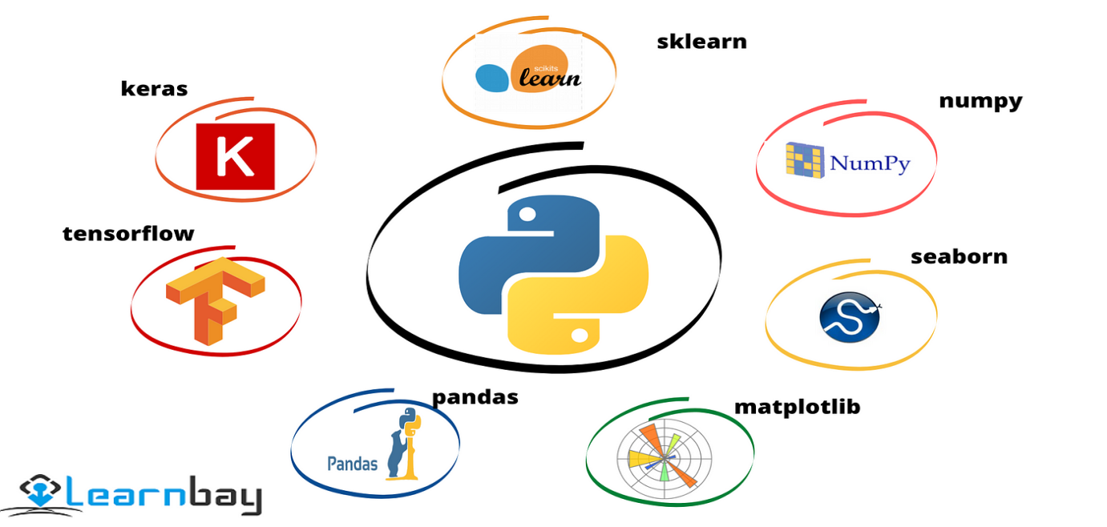

**Fig 13. ML libraries**

**CHAPTER 4: MACHINE LEARNING ALGORITHMS**

**Logistic Regression**

Logistic regression is a statistical and machine learning algorithm used for binary classification tasks, where the goal is to predict the probability that an instance belongs to one of two classes. In the context of fake news detection during elections, logistic regression can be a powerful tool for predicting whether a news article, social media post, or other textual data is fake or genuine. Here's an overview of logistic regression and its application in fake news detection:

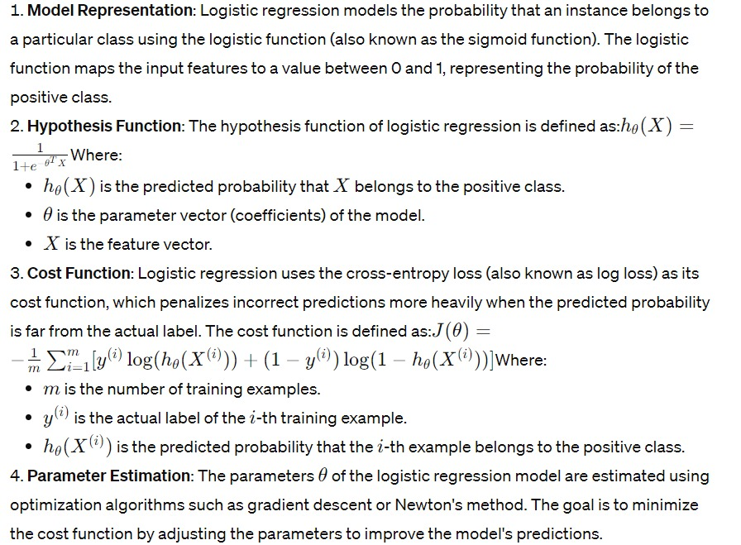

**Application in Fake News Detection during Elections**:

In the context of fake news detection during elections, logistic regression can be applied as follows:

**Feature Extraction**: Extract relevant features from news articles, social media posts, or other textual data. These features can include textual features (e.g., word frequencies, sentiment scores), metadata features (e.g., source credibility, publication date), and social network features (e.g., user engagement metrics).

**Data Labeling:** Gather a labeled dataset consisting of examples of fake and genuine news articles or social media posts. Each example is labeled as belonging to one of the two classes (fake or genuine).

**Model Training**: Train a logistic regression model using the labeled dataset, where the extracted features serve as the input variables and the binary labels (0 for genuine, 1 for fake) serve as the target variable. The model learns the relationship between the features and the likelihood of a piece of content being fake.

**Model Evaluation**: Evaluate the performance of the trained logistic regression model using appropriate evaluation metrics such as accuracy, precision, recall, F1 score, or area under the ROC curve. This step assesses how well the model generalizes to unseen data and its effectiveness in detecting fake news during elections.

**Prediction and Deployment**: Deploy the trained logistic regression model to make predictions on new, unseen news articles or social media posts related to the election. The model computes the predicted probability that each piece of content is fake and makes a binary classification decision based on a chosen threshold.

**Monitoring and Refinement**: Continuously monitor the performance of the deployed model in real-time and refine the model as needed to adapt to changing patterns of misinformation and new types of fake news during the election period.

By leveraging logistic regression in fake news detection during elections, researchers and practitioners can develop predictive models that analyze textual features to identify potential instances of fake news, thereby contributing to efforts to combat misinformation and maintain the integrity of electoral processes. However, it's essential to acknowledge the limitations of logistic regression, particularly in capturing complex relationships and interactions in textual data, and consider using more advanced machine learning techniques for improved performance.

**Linear Regression**

Linear regression is a statistical method used to model the relationship between one or more independent variables and a dependent variable by fitting a linear equation to observed data. It's a fundamental technique in statistics and machine learning, often employed for predictive modeling and understanding the association between variables. In the context of fake news detection during elections, linear regression can be applied to analyze textual features extracted from news articles, social media posts, or other sources to predict the likelihood that a piece of content is fake or genuine.

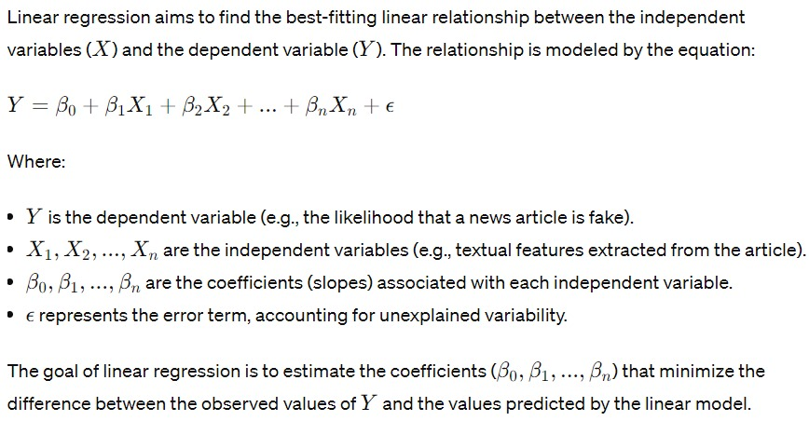

**Application in Fake News Detection during Elections**:

In the context of fake news detection during elections, linear regression can be applied as follows:

**Feature Extraction**: Extract relevant features from news articles, social media posts, or other textual data that may be indicative of fake news or genuine news. These features can include:

**Textual features**: word frequencies, sentiment scores, readability scores.

**Metadata features**: source credibility, publication date, author reputation.

**Social network features**: user engagement metrics (likes, shares, comments), user reputation.

**Data Labeling**: Gather a labeled dataset consisting of examples of fake and genuine news articles or social media posts. Each example is labeled as belonging to one of the two classes (fake or genuine).

**Model Training**: Train a linear regression model using the labeled dataset, where the extracted features serve as the independent variables and the binary labels (0 for genuine, 1 for fake) serve as the dependent variable. The model learns the relationship between the features and the likelihood of a piece of content being fake.

**Model Evaluation**: Evaluate the performance of the trained linear regression model using appropriate evaluation metrics such as accuracy, precision, recall, F1 score, or area under the ROC curve. This step assesses how well the model generalizes to unseen data and its effectiveness in detecting fake news during elections.

**Prediction and Deployment**: Deploy the trained linear regression model to make predictions on new, unseen news articles or social media posts related to the election. The model computes the predicted values, representing the likelihood that each piece of content is fake, and makes a binary classification decision based on a chosen threshold.

**Monitoring and Refinement**: Continuously monitor the performance of the deployed model in real-time and refine the model as needed to adapt to changing patterns of misinformation and new types of fake news during the election period.

By leveraging linear regression in fake news detection during elections, researchers and practitioners can develop predictive models that analyze textual features to identify potential instances of fake news, thereby contributing to efforts to combat misinformation and maintain the integrity of electoral processes.

**Random forest**

Random Forest is a powerful ensemble learning technique that combines the predictions of multiple individual decision trees to produce a robust and accurate prediction. It is widely used in various fields, including classification and regression tasks. In the context of fake news detection during elections, Random Forest can be a valuable tool for analyzing textual features extracted from news articles, social media posts, or other sources to classify whether a piece of content is fake or genuine.

Introduction to Random Forest:

Random Forest is a supervised learning algorithm that operates by constructing a multitude of decision trees during training and outputting the class that is the mode of the classes (classification) or the mean prediction (regression) of the individual trees. Here's an overview of how Random Forest works:

**Bootstrap Sampling (Bagging):** Random Forest employs bootstrap sampling to create multiple subsets of the original dataset. Each subset (called a bootstrap sample) is used to train a separate decision tree.

**Feature Randomness**: For each decision tree in the ensemble, Random Forest selects a random subset of features at each split point. This introduces randomness and diversity among the trees, leading to more robust predictions.

**Decision Tree Construction**: Each decision tree is constructed by recursively partitioning the feature space based on the selected subset of features, aiming to maximize the information gain or minimize impurity at each split.

**Voting or Averaging:** For classification tasks, the class predicted by each decision tree is tallied, and the majority class becomes the final prediction. For regression tasks, the predicted values of all trees are averaged to obtain the final prediction.

**Ensemble Prediction**: The final prediction is the aggregation of predictions from all individual decision trees in the Random Forest ensemble.

**Application in Fake News Detection during Elections:**

Random Forest can be applied to fake news detection during elections in the following manner:

**Feature Extraction**: Extract relevant textual features from news articles, social media posts, or other sources that may indicate whether a piece of content is fake or genuine. These features can include:

**Textual features**: word frequencies, sentiment scores, readability scores.

**Metadata features**: source credibility, publication date, author reputation.

**Social network features**: user engagement metrics (likes, shares, comments), user reputation.

**Data Labeling**: Gather a labeled dataset consisting of examples of fake and genuine news articles or social media posts. Each example is labeled as belonging to one of the two classes (fake or genuine).

**Model Training**: Train a Random Forest classifier using the labeled dataset, where the extracted features serve as input variables and the binary labels (0 for genuine, 1 for fake) serve as the target variable. The Random Forest learns to classify whether a piece of content is fake or genuine based on the provided features.

**Model Evaluation**: Evaluate the performance of the trained Random Forest classifier using appropriate evaluation metrics such as accuracy, precision, recall, F1 score, or area under the ROC curve. This step assesses how well the model generalizes to unseen data and its effectiveness in detecting fake news during elections.

**Prediction and Deployment**: Deploy the trained Random Forest classifier to make predictions on new, unseen news articles or social media posts related to the election. The classifier predicts the likelihood that each piece of content is fake or genuine based on the learned patterns in the training data.

Monitoring and Refinement: Continuously monitor the performance of the deployed model in real-time and refine the model as needed to adapt to changing patterns of misinformation and new types of fake news during the election period.

By leveraging Random Forest in fake news detection during elections, researchers and practitioners can develop robust and accurate predictive models that analyze textual features to identify potential instances of fake news, thereby contributing to efforts to combat misinformation and maintain the integrity of electoral processes.

**SVM**

Support vector Machine (SVM) is a supervised learning algorithm used for classification and regression tasks. In the context of fake news detection during elections, SVM can be applied to classify news articles, social media posts, or other textual data as fake or genuine based on extracted features. SVM aims to find the optimal hyperplane that separates the data points of different classes with the maximum margin.

Introduction to Support Vector Machine (SVM):

Support Vector Machine is a discriminative classifier that works by finding the hyperplane that best separates the data points of different classes in the feature space. Here's an overview of how SVM works:

**Linear Separability**: SVM assumes that the data points of different classes can be separated by a hyperplane in the feature space.

**Margin Maximization**: SVM aims to find the hyperplane that maximizes the margin, i.e., the distance between the hyperplane and the nearest data points of each class (called support vectors). This maximization of margin helps improve the generalization ability of the classifier.

**Kernel Trick:** SVM can efficiently handle non-linearly separable data by mapping the input features into a higher-dimensional space using a kernel function. This allows SVM to find a hyperplane in the transformed feature space that effectively separates the data points.

**Regularization Parameter (C):** SVM includes a regularization parameter (C) that controls the trade-off between maximizing the margin and minimizing the classification error. A smaller value of C allows for a larger margin but may lead to misclassification of some data points, while a larger value of C reduces the margin but may improve classification accuracy.

**Kernel Functions**: SVM supports various kernel functions, such as linear, polynomial, radial basis function (RBF), and sigmoid kernels, which allow for flexibility in modeling complex relationships in the data.

**Application in Fake News Detection during Elections:**

Support Vector Machine can be applied to fake news detection during elections in the following manner:

**Feature Extraction**: Extract relevant textual features from news articles, social media posts, or other sources that may indicate whether a piece of content is fake or genuine. These features can include:

**Textual features**: word frequencies, sentiment scores, readability scores.

**Metadata features**: source credibility, publication date, author reputation.

**Social network features**: user engagement metrics (likes, shares, comments), user reputation.

**Data Labeling**: Gather a labeled dataset consisting of examples of fake and genuine news articles or social media posts. Each example is labeled as belonging to one of the two classes (fake or genuine).

**Model Training**: Train a Support Vector Machine classifier using the labeled dataset, where the extracted features serve as input variables and the binary labels (0 for genuine, 1 for fake) serve as the target variable. The SVM learns to classify whether a piece of content is fake or genuine based on the provided features.

**Model Evaluation**: Evaluate the performance of the trained SVM classifier using appropriate evaluation metrics such as accuracy, precision, recall, F1 score, or area under the ROC curve. This step assesses how well the model generalizes to unseen data and its effectiveness in detecting fake news during elections.

**Prediction and Deployment**: Deploy the trained SVM classifier to make predictions on new, unseen news articles or social media posts related to the election. The classifier predicts the likelihood that each piece of content is fake or genuine based on the learned patterns in the training data.

**Monitoring and Refinement**: Continuously monitor the performance of the deployed model in real-time and refine the model as needed to adapt to changing patterns of misinformation and new types of fake news during the election period.

By leveraging Support Vector Machine in fake news detection during elections, researchers and practitioners can develop accurate and robust predictive models that analyze textual features to identify potential instances of fake news, thereby contributing to efforts to combat misinformation and maintain the integrity of electoral processes.

**Naive Bayes**

Naive Bayes is a simple yet powerful probabilistic classifier based on Bayes' theorem, which assumes that the presence of a particular feature is independent of the presence of other features. Despite its "naive" assumption of feature independence, Naive Bayes classifiers often perform well in text classification tasks, making them popular for tasks like spam detection, sentiment analysis, and, relevantly, fake news detection during elections.

Introduction to Naive Bayes:

Naive Bayes classifiers are based on Bayes' theorem, which calculates the probability of a hypothesis given the evidence. In the context of fake news detection, Naive Bayes calculates the probability that a given piece of content is fake (or genuine) given its observed features. The classifier is called "naive" because it assumes that the presence of each feature is independent of the presence of other features, which is often not true in practice. Despite this simplification, Naive Bayes can still perform well in many cases, especially when dealing with high-dimensional data like text.

**Application in Fake News Detection during Elections:**

Naive Bayes classifiers can be applied to fake news detection during elections in the following manner:

**Feature Extraction**: Extract relevant textual features from news articles, social media posts, or other sources that may indicate whether a piece of content is fake or genuine. These features can include word frequencies, n-grams, sentiment scores, or metadata features like publication date or source credibility.

**Data Labeling**: Gather a labeled dataset consisting of examples of fake and genuine news articles or social media posts. Each example is labeled as belonging to one of the two classes (fake or genuine).

**Model Training**: Train a Naive Bayes classifier using the labeled dataset, where the extracted features serve as input variables and the binary labels (0 for genuine, 1 for fake) serve as the target variable. The Naive Bayes classifier learns to estimate the probability that a piece of content is fake or genuine based on the observed features.

**Model Evaluation**: Evaluate the performance of the trained Naive Bayes classifier using appropriate evaluation metrics such as accuracy, precision, recall, F1 score, or area under the ROC curve. This step assesses how well the model generalizes to unseen data and its effectiveness in detecting fake news during elections.

**Prediction and Deployment**: Deploy the trained Naive Bayes classifier to make predictions on new, unseen news articles or social media posts related to the election. The classifier predicts the probability that each piece of content is fake or genuine based on the learned patterns in the training data.

**Monitoring and Refinement**: Continuously monitor the performance of the deployed model in real-time and refine the model as needed to adapt to changing patterns of misinformation and new types of fake news during the election period.

**CHAPTER 5: DATASET**

The Fake News Detection During Elections Dataset aims to provide a comprehensive collection of data related to the spread of misinformation, disinformation, and fake news during electoral periods. This dataset includes various types of information sources, including news articles, social media posts, fact-checking reports, user comments, and expert annotations.

Using a comprehensive approach that involves crafting a tailored dataset from trusted fact-checking sources and social media sites like Instagram and Twitter.

We’re using Instagram & tools to help us gather information quickly, X(Twitter) API and web scraping like tools to achieve this.

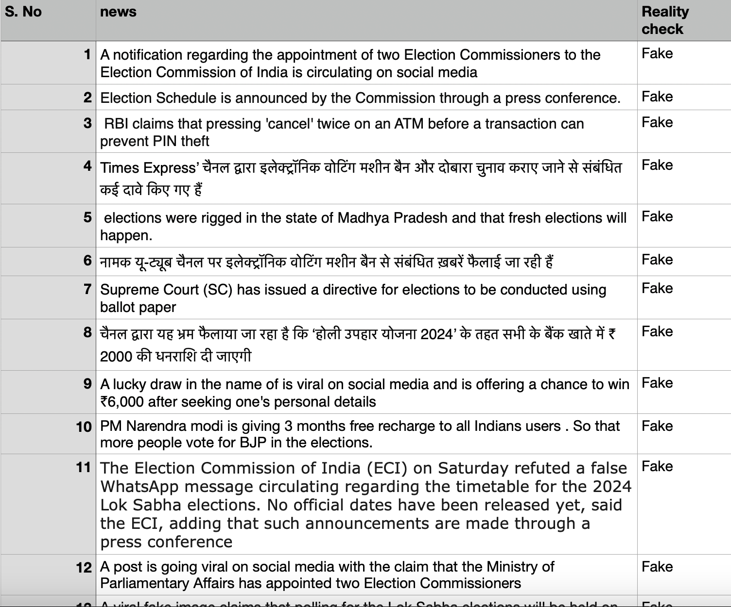

**Fig.14. Collected Data**



**Fig.15. Data Cleaning**

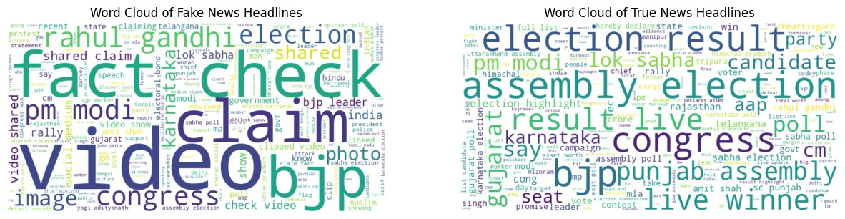

**Fig.16. Word Cloud**



**Fig.17. Uploaded Data on Kaggle**

**CHAPTER 6: METHODOLOGY**

Detecting fake news during the 2024 election involves a multifaceted approach that combines human expertise, automated algorithms, and technological tools. Here's a methodology for detecting fake news during the 2024 election:

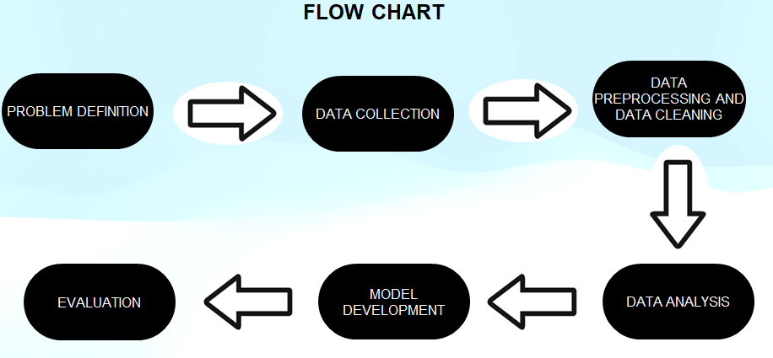

**Fig.18. Flowchart**

**Data Collection**

Collecting data for fake news detection during the 2024 election involves gathering information from various sources, including news articles, social media platforms, fact-checking organizations, and expert annotations. Here's a detailed methodology for data collection:

* **Identify Relevant Sources:**

Compile a list of reputable news outlets, social media platforms, fact-checking websites, and academic repositories that are likely to cover election-related topics.

Include mainstream media sources, independent journalists, political blogs, and official social media accounts of candidates and political parties.

* **Web Scraping and APIs:**

Utilize web scraping techniques to extract data from news websites, social media platforms (e.g., Twitter, Facebook, Reddit), and fact-checking organizations.

Leverage APIs provided by platforms like Twitter, Facebook, and Reddit to access real-time or historical data related to election discussions and news coverage.

* **Fact-Checking Reports:**

Collect fact-checking reports from reputable organizations such as PolitiFact, Snopes, FactCheck.org, and others.

Access fact-checking databases or APIs to retrieve information about verified claims, debunked rumors, and misleading statements related to the election.

* **User-Generated Content:**

Capture user-generated content such as comments, posts, and discussions on social media platforms and online forums.

Monitor hashtags, keywords, and trending topics related to the election to identify relevant user-generated content.

* **Expert Annotations:**

Engage domain experts, journalists, and researchers to annotate the collected data and identify instances of fake news, misinformation, and disinformation.

Use expert annotations as ground truth labels for training machine learning models and evaluating the performance of fake news detection algorithms.

* **Multimodal Data:**

Collect multimedia content such as images and videos related to election news and propaganda.

Analyze multimedia content for signs of manipulation, alteration, or misleading information.

* **Metadata Collection:**

Gather metadata associated with news articles, social media posts, and fact-checking reports, including timestamps, sources, user profiles, engagement metrics, and geographic location (if available).

Metadata provides additional context and insights for analysing the spread and impact of fake news during the election.

* **Ethical Considerations:**

Adhere to ethical guidelines and legal regulations regarding data collection, privacy, and consent.

Respect user privacy and data usage rights when collecting and analysing user-generated content from social media platforms.

Ensure transparency and accountability in the data collection process and disclose any potential biases or limitations.

* **Continuous Monitoring:**

Establish mechanisms for continuous monitoring of news coverage, social media activity, and fact-checking reports throughout the election period.

Update the dataset regularly to capture emerging trends, new sources of misinformation, and evolving tactics used by misinformation actors.

* **Documentation and Versioning:**

Document the data collection process, including sources, methodologies, and any preprocessing steps applied to the collected data.

Maintain version control to track changes and updates to the dataset over time, ensuring reproducibility and transparency in research findings.

By following this comprehensive data collection methodology, researchers and practitioners can build a robust dataset for fake news detection during the 2024 election, enabling the development of effective detection algorithms and strategies to combat misinformation.

**Data Preprocessing**

Preprocessing the data for fake news detection during the 2024 election is essential for cleaning and preparing the collected information for analysis. Here's a step-by-step guide to preprocessing the data:

* **Text Cleaning:**

Remove HTML tags, special characters, punctuation, and non-alphanumeric characters from the text data.

Convert text to lowercase to ensure consistency in word representation.

Handle encoding issues and normalize text encoding to UTF-8 format.

* **Tokenization:**

Tokenize the text into individual words or tokens to break down sentences into meaningful units.

Use word tokenization techniques to split text based on whitespace or punctuation.

Consider using more advanced tokenization methods for handling special cases like URLs, email addresses, and emojis.

* **Stopword Removal:**

Remove common stopwords (e.g., "the," "is," "and") that do not carry significant meaning for fake news detection.

Utilize predefined lists of stopwords or custom lists tailored to the specific domain of election-related news and social media posts.

* **Stemming and Lemmatization:**

Apply stemming or lemmatization techniques to reduce words to their root forms and normalize variations of words.

Stemming algorithms like Porter Stemmer or Snowball Stemmer can be used to remove prefixes and suffixes from words.

Lemmatization algorithms map words to their base or dictionary forms, considering grammatical variations.

* **Spell Checking and Correction:**

Perform spell checking and correction to address typos, misspellings, and grammatical errors in the text data.

Use spell-checking libraries or algorithms to identify and correct common spelling mistakes.

* **Remove Rare and Infrequent Words:**

Remove words that occur infrequently in the dataset or have low document frequency to reduce noise and dimensionality.

Set a threshold for minimum word frequency or document frequency to filter out rare terms.

* **Handling Imbalanced Classes:**

Address class imbalance issues by oversampling minority classes, under sampling majority classes, or using techniques like SMOTE (Synthetic Minority Over-sampling Technique).

Ensure a balanced distribution of fake and genuine news samples to prevent bias in the classification model.

* **Vectorization:**

Convert text data into numerical representations using vectorization techniques such as bag-of-words (BoW), TF-IDF (Term Frequency-Inverse Document Frequency), or word embeddings.

BoW represents documents as vectors of word counts, while TF-IDF assigns weights to words based on their importance in the corpus.

Word embeddings like Word2Vec, GloVe, or fastText capture semantic relationships between words in dense vector representations.

* **Feature Engineering:**

Extract additional features from the text data, such as sentiment scores, readability metrics, and named entities (e.g., people, organizations, locations).

Incorporate metadata features such as timestamps, source credibility scores, and engagement metrics for enhanced fake news detection.

* **Data Splitting:**

Split the preprocessed data into training, validation, and test sets for model training, tuning, and evaluation.

Ensure stratified sampling to preserve the distribution of classes across the different datasets.

By following these preprocessing steps, you can clean and prepare the data effectively for fake news detection during the 2024 election, enabling the development of accurate and reliable classification models to identify misinformation and disinformation.

**Feature Extraction**

Feature extraction plays a crucial role in fake news detection during the 2024 election, as it involves transforming raw data into meaningful features that capture the characteristics of fake and genuine news articles, social media posts, and other sources of information. Here are some key feature extraction techniques for fake news detection during the 2024 election:

* **Bag-of-Words (BoW):**

Represent documents as vectors of word counts, where each feature corresponds to the frequency of a particular word in the document.

Build a vocabulary of words from the corpus and construct feature vectors based on the occurrence or absence of words in each document.

BoW ignores the order and structure of words but provides a simple and effective representation of text data.

* **Term Frequency-Inverse Document Frequency (TF-IDF):**

Calculate TF-IDF scores to weigh the importance of words in a document relative to the entire corpus.

TF-IDF incorporates both term frequency (TF), which measures how often a word appears in a document, and inverse document frequency (IDF), which penalizes words that occur frequently across the corpus.

TF-IDF helps highlight terms that are unique or discriminative for individual documents.

* **Word Embeddings:**

Utilize pre-trained word embedding models such as Word2Vec, GloVe, or fastText to represent words as dense vector representations in a continuous vector space.

Capture semantic relationships between words and phrases, allowing for more nuanced representations of text data.

Fine-tune word embeddings on election-specific text corpora to capture domain-specific semantics and context.

* **Named Entity Recognition (NER):**

Extract named entities such as people, organizations, and locations from text data using NER techniques.

Identify entities mentioned in news articles and social media posts to understand the key actors and entities involved in election-related discussions.

Use named entities as features to capture the relevance and prominence of specific entities in fake news detection.

* **Sentiment Analysis:**

Analyze the sentiment or emotional tone of text data using sentiment analysis techniques.

Determine whether a news article or social media post conveys positive, negative, or neutral sentiment toward election-related topics and entities.

Use sentiment scores or polarity labels as features to capture the emotional context of fake news content.

* **Readability Metrics:**

Compute readability metrics such as Flesch-Kincaid Grade Level, Gunning Fog Index, and Coleman-Liau Index to assess the complexity and readability of text data.

Measure the ease with which readers can understand and comprehend election-related content, which may differ between fake and genuine news articles.

* **Metadata Features:**

Include metadata features such as timestamps, publication sources, user profiles, and engagement metrics (likes, shares, retweets) associated with news articles and social media posts.

Analyze metadata to capture temporal dynamics, source credibility, and virality patterns of fake news during the election period.

* **Graph-Based Features:**

Construct graphs representing relationships between entities, topics, and sources in the data.

Extract graph-based features such as centrality measures, community detection, and network structures to analyze the propagation and dissemination of fake news within social networks and online communities.

* **Topic Modeling:**

Apply topic modeling techniques such as Latent Dirichlet Allocation (LDA) or Non-Negative Matrix Factorization (NMF) to identify latent topics and themes in the text data.

Discover clusters of words and topics that frequently co-occur in election-related content, which may reveal underlying narratives and agendas.

* **Combination of Features:**

Combine multiple types of features, including textual, semantic, metadata, and graph-based features, to capture diverse aspects of fake news content and its dissemination dynamics.

Use feature engineering techniques to create composite features or feature interactions that enhance the discriminative power of the detection model.

By extracting informative features from the data, researchers and practitioners can build effective models for detecting fake news during the 2024 election, helping to mitigate the spread of misinformation and safeguard the integrity of the electoral process.

**Supervised Learning Models**

For fake news detection during the 2024 election, supervised learning models can be effective in classifying news articles and social media posts as either fake or genuine based on labeled training data. Here are some popular supervised learning models that can be used for this task:

**Logistic Regression:**

Logistic regression is a simple and interpretable linear model that predicts the probability of a binary outcome (fake or genuine).

It's particularly useful when the relationship between features and the target variable is linear or when interpretability is important.

**Decision Trees:**

Decision trees partition the feature space into regions based on feature values and make predictions by traversing the tree from the root to a leaf node.

They can capture non-linear relationships and interactions between features, making them suitable for complex classification tasks.

**Random Forest:**

Random forest is an ensemble learning method that combines multiple decision trees to improve performance and robustness.

It mitigates overfitting by averaging predictions across a collection of trees trained on different subsets of the data.

**Gradient Boosting Machines (GBM):**

GBM builds an ensemble of weak learners (usually decision trees) sequentially, with each new learner focusing on the errors made by the previous ones.

It achieves high predictive accuracy by iteratively optimizing a loss function, such as binary cross-entropy.

**Support Vector Machines (SVM):**

SVM constructs a hyperplane that separates data points into different classes while maximizing the margin between the classes.

It's effective in high-dimensional spaces and can handle non-linear decision boundaries using kernel tricks.

**Naive Bayes:**

Naive Bayes classifiers are based on Bayes' theorem and assume that features are conditionally independent given the class label.

Despite their simplicity and the "naive" assumption, they often perform well in practice, especially for text classification tasks like fake news detection.

**Neural Networks:**

Deep learning models such as feedforward neural networks, convolutional neural networks (CNNs), and recurrent neural networks (RNNs) can be used for fake news detection.

CNNs are effective for capturing spatial relationships in text data, while RNNs are suitable for modeling sequential dependencies.

**Ensemble Methods:**

Ensemble methods like AdaBoost, XGBoost, and LightGBM combine multiple weak learners to create a stronger classifier.

They often outperform individual models by reducing bias and variance and improving generalization performance.

When using supervised learning models for fake news detection during the 2024 election, it's essential to:

* Preprocess the data appropriately by encoding text features, handling missing values, and balancing class distributions.
* Split the data into training, validation, and test sets to assess model performance and generalization.
* Tune hyperparameters using techniques like grid search, random search, or Bayesian optimization to optimize model performance.
* Evaluate models using appropriate metrics such as accuracy, precision, recall, F1-score, and ROC-AUC to assess their effectiveness in detecting fake news.
* Interpret model predictions and analyze feature importance to gain insights into the factors influencing the classification decisions.

By leveraging supervised learning models, researchers and practitioners can develop robust and scalable systems for detecting fake news during the 2024 election, thereby helping to combat misinformation and uphold the integrity of the electoral process.

**Unsupervised Learning Models and clustering**

Unsupervised learning models can be used for fake news detection during the 2024 election to identify patterns and anomalies in the data without the need for labelled training examples. Here are some unsupervised learning models that can be applied to this task:

**Clustering Algorithms:**

**K-means**: Cluster documents into k groups based on similarity in feature space. Documents within the same cluster are more similar to each other than to those in other clusters. Anomalous clusters may indicate potential fake news.

**DBSCAN**: Density-based clustering algorithm that groups together points that are closely packed, while marking points in low-density regions as outliers. It can identify dense regions of news articles or social media posts that deviate from the norm.

**Hierarchical Clustering**: Builds a tree-like hierarchy of clusters by recursively merging or splitting clusters based on similarity measures. It can reveal hierarchical structures in the data and detect outliers at different levels of granularity.

**Anomaly Detection Algorithms:**

**Isolation Forest**: An ensemble method that isolates anomalies by randomly selecting features and partitioning data points. Anomalies are likely to require fewer partitions to be isolated and can be indicative of fake news.

**One-Class SVM**: Trains a model on a single class (e.g., genuine news) and identifies instances that deviate significantly from the majority class. It can detect unusual patterns or outliers in the data, potentially indicating fake news articles or posts.

**Association Rule Mining:**

**Apriori Algorithm**: Identifies frequent itemsets (e.g., co-occurring words or phrases) in the data and generates association rules based on their support and confidence. It can uncover patterns of words or phrases that frequently appear together in fake news content.

**FP-Growth**: Builds a compact representation of frequent itemsets using a frequent pattern tree (FP-tree) and efficiently discovers association rules. It can handle large datasets and is particularly useful for mining frequent itemsets in text data.

**Topic Modeling:**

**Latent Dirichlet Allocation (LDA):** A generative probabilistic model that identifies topics in a collection of documents and assigns words to topics based on their probability distributions. It can reveal underlying themes or topics in news articles and social media posts, potentially uncovering topics associated with fake news narratives.

**Non-Negative Matrix Factorization (NMF):** Decomposes the term-document matrix into non-negative matrices representing topics and document-topic distributions. It can identify coherent topics and document clusters, aiding in the discovery of fake news-related themes.

**Word Embedding Clustering:**

**Word Embedding Similarity and Clustering**: Embed words or phrases into a dense vector space using pre-trained word embeddings (e.g., Word2Vec, GloVe) and cluster them based on similarity measures (e.g., cosine similarity). It can group together words with similar semantic meanings, potentially identifying clusters of words associated with fake news topics or narratives.

**Graph-Based Algorithms:**

**Community Detection**: Identify communities or clusters of nodes (e.g., news articles, social media users) in a graph representing relationships between entities. Communities with anomalous structures or behaviors may indicate the presence of fake news dissemination networks.

**Anomaly Detection in Graphs:** Detect anomalous nodes or edges in a graph by analyzing structural properties, connectivity patterns, or node attributes. Anomalies in the graph may correspond to fake news sources or propagators.

By applying unsupervised learning models to fake news detection during the 2024 election, researchers and practitioners can uncover hidden patterns, anomalies, and clusters in the data, facilitating the identification of potentially misleading or false information without the need for labeled training examples.

**Natural Language Processing**

Natural Language Processing (NLP) plays a critical role in fake news detection during election projects by enabling the analysis of textual data from news articles, social media posts, and other sources. Here's how NLP can be applied in such a project:

**Text Preprocessing:**

Tokenization: Splitting text into individual words or tokens.

Stopword Removal: Removing common words (e.g., "the," "is," "and") that do not carry much meaning.

Lemmatization and Stemming: Reducing words to their base or root form to normalize variations.

Spell Checking and Correction: Identifying and correcting misspelled words.

**Feature Extraction:**

Bag-of-Words (BoW): Representing text as vectors of word counts.

TF-IDF (Term Frequency-Inverse Document Frequency): Weighing the importance of words based on their frequency in documents.

Word Embeddings: Representing words as dense vectors in a continuous vector space to capture semantic relationships.

Named Entity Recognition (NER): Identifying and classifying named entities such as people, organizations, and locations.

**Semantic Analysis:**

Sentiment Analysis: Determining the sentiment or emotional tone of text (positive, negative, neutral).

Topic Modeling: Identifying latent topics or themes in the text data using techniques like Latent Dirichlet Allocation (LDA) or Non-Negative Matrix Factorization (NMF).

Word Sense Disambiguation: Resolving the meaning of ambiguous words based on context.

**Text Classification:**

Supervised Learning: Training classifiers to classify text as fake or genuine based on labeled training data.

Unsupervised Learning: Clustering similar documents together or identifying anomalies that may indicate fake news.

Ensemble Methods: Combining multiple classifiers or clustering algorithms to improve classification performance.

**Named Entity Analysis:**

Entity Linking: Identifying and linking named entities mentioned in text to knowledge bases such as Wikipedia.

Entity Salience: Determining the importance or prominence of named entities in the text.

Information Extraction:

Extracting Facts and Claims: Identifying factual statements and claims made in news articles and social media posts.

Event Detection: Detecting events and occurrences mentioned in text data related to the election.

**Contextual Analysis:**

Contextual Understanding: Analyzing the context surrounding words and phrases to infer meaning and intent.

Co-reference Resolution: Resolving references to the same entity across different parts of the text.

**Multimodal Analysis:**

Image and Video Analysis: Analyzing multimedia content associated with news articles and social media posts to detect manipulations or misleading information.

**Ethical Considerations:**

Bias Mitigation: Addressing biases in data and models to ensure fairness and accuracy in fake news detection.

Privacy Preservation: Protecting user privacy and sensitive information when analyzing text data from social media and other sources.

By leveraging NLP techniques in fake news detection during election projects, researchers and practitioners can analyze large volumes of textual data, extract meaningful insights, and develop effective strategies for combating misinformation and promoting electoral integrity.

**Ensemble Methods**

Ensemble methods can significantly enhance fake news detection during elections by combining multiple base models to improve overall performance and robustness. Here are some ensemble methods commonly used in fake news detection projects:

**Voting Classifier:**

In a voting classifier, multiple base classifiers make predictions independently, and the final prediction is determined by a majority vote (hard voting) or weighted average of individual probabilities (soft voting).

Different types of classifiers, such as logistic regression, decision trees, and support vector machines, can be combined in a voting ensemble to leverage their diverse strengths.

**Bagging (Bootstrap Aggregating):**

Bagging involves training multiple instances of the same base model on different random subsets of the training data (bootstrap samples).

Each model learns from a slightly different perspective of the data, reducing variance and improving generalization performance.

Random Forest is a popular bagging ensemble method that combines multiple decision trees trained on bootstrapped samples and aggregates their predictions.

**Boosting:**

Boosting sequentially trains a series of weak learners (e.g., decision trees) and assigns higher weights to misclassified instances in subsequent iterations.

Each weak learner focuses on correcting the mistakes made by its predecessors, resulting in a strong ensemble model with improved predictive accuracy.

AdaBoost (Adaptive Boosting) and Gradient Boosting Machines (GBM) are widely used boosting algorithms for fake news detection.

**Stacking:**

Stacking combines predictions from multiple base models using a meta-model (or blender) to make the final prediction.

Base models' predictions serve as input features for the meta-model, allowing it to learn how to best combine their predictions.

Stacking can capture complex interactions between base models and often achieves superior performance compared to individual models.

**Random Forest:**

Random Forest is not only a bagging ensemble method but also a standalone classifier that combines multiple decision trees.

Each decision tree is trained on a random subset of features, reducing correlation between trees and improving ensemble diversity.

Random Forest is robust to overfitting and performs well on high-dimensional data like text.

**Gradient Boosting Machines (GBM):**

GBM builds an ensemble of weak learners (e.g., decision trees) sequentially, with each new learner focusing on the errors made by the previous ones.

It achieves high predictive accuracy by iteratively optimizing a loss function, such as binary cross-entropy.

GBM is effective in capturing complex relationships in data and has been successfully applied to fake news detection tasks.

Ensemble methods offer several advantages for fake news detection during elections, including improved predictive performance, robustness to overfitting, and the ability to capture diverse aspects of the data. By combining multiple base models, ensemble methods can mitigate individual model weaknesses and provide more reliable predictions, helping to combat misinformation and promote electoral integrity.

**Evaluation and Validation**

Evaluation and validation are crucial steps in fake news detection during the 2024 election to assess the performance of detection models and ensure their effectiveness in identifying misinformation. Here's how evaluation and validation can be conducted in such projects:

**Data Splitting:**

Split the dataset into three subsets: training, validation, and test sets.

Typically, a large portion of the data (e.g., 70-80%) is used for training, while smaller portions are reserved for validation (10-15%) and testing (10-15%).

Ensure that the distribution of fake and genuine news samples is balanced across all subsets to prevent biased evaluation.

**Model Training:**

Train fake news detection models on the training data using appropriate machine learning or deep learning algorithms.

Hyperparameters may be tuned using the validation set to optimize model performance.

**Validation:**

Evaluate the trained models on the validation set to assess their performance before finalizing the model selection.

Compute evaluation metrics such as accuracy, precision, recall, F1-score, and area under the ROC curve (AUC) to quantify model performance.

Additionally, analyze other relevant metrics such as confusion matrices and calibration curves to gain deeper insights into model behavior.

**Hyperparameter Tuning:**

Conduct hyperparameter tuning using techniques like grid search, random search, or Bayesian optimization to find optimal model configurations.

Tune hyperparameters based on performance metrics observed on the validation set while avoiding overfitting.

**Cross-Validation:**

Perform k-fold cross-validation to assess model robustness and generalization performance.

Split the training data into k folds, train the model on k-1 folds, and validate it on the remaining fold.

Repeat this process k times, each time using a different fold as the validation set, and average the performance metrics across all folds.

**Final Evaluation on Test Set:**

After selecting the best-performing model based on validation results, evaluate its performance on the held-out test set.

Use the test set as an unbiased measure of the model's ability to generalize to unseen data.

Compute the same evaluation metrics used during validation and compare the results to those obtained on the validation set.

**Interpretation of Results:**

Analyze evaluation metrics and performance curves to understand the strengths and weaknesses of the fake news detection models.

Interpret the results in the context of the specific objectives and requirements of the project.

Identify areas for improvement and potential strategies for enhancing model performance.

**Ethical Considerations:**

Ensure that the evaluation process adheres to ethical guidelines and respects user privacy and data usage rights.

Mitigate biases in the evaluation process and consider the potential societal impact of the fake news detection models.

By rigorously evaluating and validating fake news detection models using appropriate methodologies and metrics, researchers and practitioners can develop reliable systems for identifying misinformation during the 2024 election, contributing to the integrity of the electoral process and the promotion of informed public discourse.

**Human-in-the-loop**

Incorporating a human-in-the-loop approach is essential for effective fake news detection during the 2024 election. Human expertise can provide valuable insights, validate model predictions, and address the limitations of automated algorithms. Here's how the human-in-the-loop process can be integrated into fake news detection efforts:

**Annotation and Labeling:**

Engage human annotators, such as domain experts, journalists, and fact-checkers, to label data as fake or genuine.

Provide guidelines and training to annotators to ensure consistency and accuracy in labelling.

Use annotated data as ground truth for training and evaluating fake news detection models.

**Model Evaluation:**

Involve human evaluators in assessing the performance of fake news detection models.

Have evaluators manually review a subset of predicted results to validate model predictions and identify false positives and false negatives.

Collect feedback from evaluators to refine models and improve their performance.

**Curated Datasets:**

Curate datasets of fake and genuine news articles specifically for model training and validation.

Incorporate human judgment to select high-quality and representative samples for inclusion in the dataset.

Continuously update and expand the dataset based on emerging fake news trends and evolving misinformation tactics.

**Adjudication:**

Implement an adjudication process where disputed or ambiguous cases are reviewed by human adjudicators.

Adjudicators make final decisions on the classification of news articles or social media posts based on their expertise and judgment.

Adjudication helps resolve disagreements between automated algorithms and provides authoritative labels for challenging cases.

**Fact-Checking:**

Integrate fact-checking organizations and experts into the detection pipeline to verify the accuracy of news articles and social media posts.

Flag suspicious content for fact-checking and verify claims using credible sources and evidence.

Provide users with fact-checked information to counteract misinformation and promote media literacy.

**Feedback Mechanisms:**

Establish feedback mechanisms for users to report suspected fake news and provide feedback on model predictions.

Monitor user feedback to identify emerging fake news stories and adapt detection algorithms accordingly.

Use user feedback to improve the accuracy and relevance of fake news detection systems over time.

**Ethical Considerations:**

Ensure transparency and accountability in the human-in-the-loop process, disclosing the involvement of human annotators, evaluators, and adjudicators.

Safeguard user privacy and data confidentiality during human annotation and evaluation tasks.

Mitigate biases and conflicts of interest among human participants to maintain the integrity of the fake news detection process.

By integrating human expertise into the fake news detection pipeline, researchers and practitioners can develop more robust and trustworthy systems for identifying and combating misinformation during the 2024 election. Human-in-the-loop approaches leverage the complementary strengths of automated algorithms and human judgment to address the complex challenges of fake news detection in real-world settings.

**Deployment and Monitoring**

Deployment and monitoring are critical phases in the fake news detection process during elections to ensure the effectiveness, scalability, and reliability of detection systems. Here's how deployment and monitoring can be approached:

**Deployment:**

* Infrastructure Setup: Establish a robust and scalable infrastructure to deploy fake news detection systems, including servers, databases, and network infrastructure.
* Model Deployment: Deploy trained detection models to production environments, ensuring they are accessible via APIs or web interfaces for real-time or batch processing of news articles and social media posts.
* Integration with Platforms: Integrate fake news detection capabilities into existing platforms and services, such as social media platforms, news aggregators, and fact-checking websites, to reach a broader audience and maximize impact.
* User Interface Design: Design user-friendly interfaces for accessing and interacting with fake news detection tools, making it easy for users to submit content for analysis and view detection results.
* Automation: Implement automated pipelines for data ingestion, preprocessing, model inference, and result visualization to streamline the fake news detection workflow and minimize manual intervention.

**Monitoring:**

* Performance Monitoring: Monitor the performance of fake news detection models in production environments, tracking key performance metrics such as accuracy, precision, recall, and false positive rate.
* Real-time Alerts: Set up alerts and notifications to alert administrators and stakeholders in case of anomalies or degradation in model performance, allowing for prompt investigation and mitigation.
* Data Quality Monitoring: Monitor the quality and integrity of input data sources, detecting changes in data distribution, format, or volume that may affect the performance of detection models.
* Feedback Loop: Establish a feedback loop to collect user feedback, flagged content, and model predictions, incorporating this information into model updates and improvements.
* Adversarial Monitoring: Monitor for adversarial attacks and manipulation attempts aimed at bypassing or evading fake news detection systems, continuously updating detection algorithms to counter new threats.
* Ethical Considerations: Monitor for ethical considerations such as biases, fairness, and privacy violations in fake news detection systems, ensuring compliance with ethical guidelines and regulations.

**Evaluation and Iteration:**

* Continuous Evaluation: Continuously evaluate the performance of fake news detection systems using real-world data and feedback from users and stakeholders.
* Iterative Improvement: Iterate on detection algorithms, features, and models based on performance feedback and emerging challenges in fake news detection during the election period.
* A/B Testing: Conduct A/B testing to compare the performance of different detection algorithms or model configurations, identifying the most effective approaches for mitigating misinformation.

**Scalability and Resilience:**

* Scalability: Ensure that fake news detection systems can scale to handle increasing volumes of data and user traffic, leveraging cloud-based infrastructure and distributed computing technologies.
* Resilience: Design systems with built-in resilience to withstand failures, outages, and cyber attacks, implementing redundancy, failover mechanisms, and disaster recovery plans.
* By deploying robust fake news detection systems and implementing effective monitoring mechanisms, researchers and practitioners can detect and mitigate misinformation during elections, safeguarding the integrity of democratic processes and promoting informed public discourse**.**

**DistilBert**

DistilBERT is a variant of the BERT (Bidirectional Encoder Representations from Transformers) model, which is a state-of-the-art transformer-based model for natural language understanding tasks. DistilBERT is designed to be smaller and faster than the original BERT model while maintaining competitive performance. It achieves this by using a technique called knowledge distillation, where a larger pre-trained model (such as BERT) is used to train a smaller model (DistilBERT) to mimic its behavior.

Here are the key details of DistilBERT and its application in fake news detection during elections:

**Architecture**:

DistilBERT follows the same transformer architecture as BERT, consisting of multiple layers of self-attention mechanisms and feed-forward neural networks.

However, DistilBERT uses a smaller number of layers and hidden units compared to BERT, resulting in a more compact model.

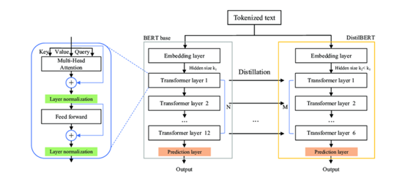

**Fig.19. Architecture of DistilBert**

**Pre-training:**

DistilBERT is pre-trained on large corpora of text data using unsupervised learning objectives, such as masked language modeling (predicting masked words) and next sentence prediction (determining whether two sentences follow each other).

Pre-training allows DistilBERT to learn general language representations that capture semantic and syntactic features of text.

**Fine-tuning:**

After pre-training, DistilBERT can be fine-tuned on downstream tasks such as fake news detection during elections.

Fine-tuning involves training DistilBERT on labeled data specific to the target task, adjusting its parameters to optimize performance on the task at hand.

**Features:**

DistilBERT generates contextualized embeddings for input text, capturing rich semantic information and context dependencies.

These embeddings can be used as features for downstream classification tasks, such as distinguishing between fake and genuine news articles.

**Performance:**

Despite its smaller size, DistilBERT achieves competitive performance compared to larger transformer models like BERT on various NLP tasks, including text classification and sentiment analysis.

DistilBERT's smaller size allows for faster inference and lower computational resource requirements, making it suitable for deployment in resource-constrained environments.

**Application in Fake News Detection:**

DistilBERT can be applied to fake news detection during elections by fine-tuning it on labeled datasets containing both fake and genuine news articles.

The model learns to extract relevant features from the text data and classify articles as fake or genuine based on the learned representations.

DistilBERT's contextualized embeddings capture nuanced linguistic cues and contextual information, enabling it to identify subtle signals of misinformation in news articles.

**Evaluation and Validation:**

DistilBERT's performance in fake news detection during elections can be evaluated using standard evaluation metrics such as accuracy, precision, recall, F1-score, and area under the ROC curve (AUC).

The model can be validated on held-out test datasets and compared against baseline models or other state-of-the-art approaches to assess its effectiveness.

Overall, DistilBERT offers a promising approach to fake news detection during elections, leveraging transformer-based architectures to capture complex linguistic patterns and improve the accuracy and reliability of detection systems. Its compact size and competitive performance make it a practical choice for deployment in real-world applications where efficiency and effectiveness are paramount.

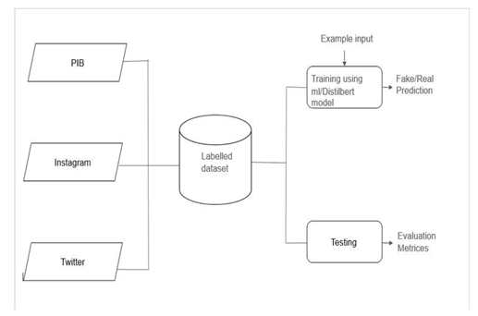

**Fig.20. Proposed Methodology**

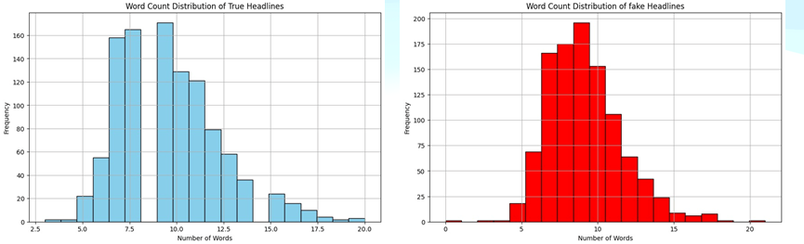

**Fig.21. Exploratory Data Analysis**

**CHAPTER 7: IMPLEMENTATION**

**CHAPTER 8: CONCLUSION**

## In conclusion, our project proposing the pressing challenge of fake news during the 2024 election through a meticulous and innovative approach. By curating a bespoke dataset from reputable fact-checking sources and social media platforms, we ensure a diverse and reliable foundation for our analysis. Leveraging advanced technologies, including Instagram’s API and transformer-based models like Distil BERT, we streamline data acquisition and enhance language comprehension for effective fake news detection. Our methodology incorporates diverse machine learning algorithms such as Logistic Regression, Random Forest, DigitilBERT, and SVM, showcasing a comprehensive and sophisticated analytical framework. The careful data cleaning and pre-processing stages underscore our commitment to data quality and model robustness. Through this synergistic convergence of technology and analytical methodologies, our project aims to contribute substantively to the ongoing discourse on combating misinformation, fostering a more informed electorate during the critical 2024 election and beyond.

## The detection of fake news during the 2024 election is a critical endeavour to uphold the integrity of the electoral process, foster informed public discourse, and mitigate the spread of misinformation. Through the utilization of advanced machine learning techniques, such as supervised and unsupervised learning models, along with natural language processing (NLP) algorithms, researchers and practitioners can develop robust systems for identifying and combating fake news. The methodology outlined involves data collection from diverse sources like press releases, social media platforms, and news articles, followed by preprocessing, feature extraction, model training, and evaluation using metrics like accuracy, precision, recall, and F1-score. Ensemble methods, including DistilBERT, offer efficient and effective approaches to fake news detection by leveraging the strengths of multiple models and architectures. Additionally, the integration of human-in-the-loop approaches ensures the validation of model predictions and addresses the nuanced complexities of misinformation. Ultimately, the deployment and monitoring of fake news detection systems during the 2024 election require continuous evaluation, iteration, and ethical considerations to safeguard democratic principles and promote transparency and accountability in the electoral process.

## CHAPTER 9: REFERENCES

1. Baarir, N. F., & Djeffal, A. (2021, February). Fake news detection using machine learning. In 2020 2nd International workshop on human-centric smart environments for health and well-being (IHSH) (pp. 125-130). IEEE.
2. Rodríguez, Á. I., & Iglesias, L. L. (2019). Fake news detection using deep learning. arXiv preprint arXiv:1910.03496.
3. Ahmed, H., Traore, I., & Saad, S. (2017). Detection of online fake news using n-gram analysis and machine learning techniques. In Intelligent, Secure, and Dependable Systems in Distributed and Cloud Environments: First International Conference, ISDDC 2017, Vancouver, BC, Canada, October 26-28, 2017, Proceedings 1 (pp. 127-138). Springer International Publishing.
4. Kaur, S., Kumar, P., & Kumaraguru, P. (2020). Automating fake news detection system using multi-level voting model. Soft Computing, 24(12), 9049-9069.
5. ISKANDAR, D., SURYAWATI, I., SURATNO, G., LILIYANA, L., MUHTADI, M., & NGIMADUDIN, N. (2023). Public Communication Model In Combating Hoaxes And Fake News In Ahead Of The 2024 General Election. International Journal of Environmental, Sustainability, and Social Science, 4(5), 1505-1518.
6. Raza, S., Khan, T., Paulen-Patterson, D., Chatrath, V., Rahman, M., & Bamgbose, O. (2024). FakeWatch: A Framework for Detecting Fake News to Ensure Credible Elections. arXiv preprint arXiv:2403.09858.
7. Abeel, T., Van de Peer, Y., & Saeys, Y. (2009). Java-ml: A machine learning library. Journal of Machine Learning Research, 10, 931-934.
8. Sanh, V., Debut, L., Chaumond, J., & Wolf, T. (2019). DistilBERT, a distilled version of BERT: smaller, faster, cheaper and lighter. arXiv preprint arXiv:1910.01108.
9. Grefenstette, J. J. (1993, August). Genetic algorithms and machine learning. In Proceedings of the sixth annual conference on Computational learning theory (pp. 3-4).
10. Sen, P. C., Hajra, M., & Ghosh, M. (2020). Supervised classification algorithms in machine learning: A survey and review. In Emerging Technology in Modelling and Graphics: Proceedings of IEM Graph 2018 (pp. 99-111). Springer Singapore.