Linux Foundation Course (LFS101)

Basic Linux Command: (CAMMAND OPTIONS ARGUMENTS)

Command | Flag | Description
sudo (MORE) | -l : List command with sudo permission | Executes a command with root / admin privileges  Allows you to execute the command as a superuser / admin  SUDO SETUP (MORE)
sudo apt update |  | To update system
sudo apt upgrade |  | To upgrade the packages
Managing Services and Startup
sudo systemctl stop gdm  sudo telinit 3 | FN + ALT + F2 | To switch GUI from CLI
sudo systemctl start gdm  sudo telinit 5 |  | To switch CLI from GUI
sudo systemctl start service-name |  | Start a service
sudo systemctl stop  service-name |  | Stop a service
sudo systemctl restart service-name |  | Restart a service
sudo systemctl status service-name |  | Shows service status (start/stop)
sudo systemctl enable service-name |  | Starts and enable the service to run at boot
sudo systemctl disable  service-name |  | disable
sudo systemctl –failed |  | List services that have failed to start
sudo systemctl | grep running |  | List all running services
Package Installation
sudo apt install package_name |  | To install a package
sudo apt remove package_name |  | To remove a package
package_name --version |  | To check existency of package
which package_name |  | Locate application in the system
whereis package_name |  | Locate application in the system
Service Control
service bluetooth stop |  | Turn-ON bluetooth
service bluetooth start |  | Turn-OFF bluetooth
nmcli radio wifi on |  | Turn-ON WiFi
nmcli radio wifi off |  | Turn-OFF WiFi
nmcli device wifi connect "SSID_NAME" password "PASSWORD" |  | To connect specific wifi
nmcli device status |  | To list network interface in LInux
Linux Basic and Documentation
cat /proc/version  uname -r  neofetch |  | Info about the linux system
help <CMD>  help | cmd --help  cmd -h | Provides information about on built-in commands
man <CMD> | -f / whatis.  -k / apropos.  -a | Display the manual page
yelp man:CMD  yelp info:CMD |  | Information of command in graphical format
Info |  | GNU Info
echo “HI” |  | To show output
exit |  | To close the terminal
history | - c : Clear | To show history of the cmd  ^ : Up Arrow  v: Down Arrow  CTRL - R (Reverse search) + ENTER  ! ! : Execute prev CMD  !$ : last ARG  !n : nth CMD  !string: Most Recent CMD
whatis <CMD> |  | About command in one line
Environment Variable
echo $<var_name> |  | Shows the value of a specific variable
export VARIABLE=VALUE |  | Export a new variable value (TEMP)
set | grep HIST | HISFILE  HISFILESIZE  HISSIZE  HISCONTROL | History EecNV var
alias |  | Create shortcut
unalias |  | Withdraw shortcut
Basic Navigation
pwd | -L : Symbolic Link  -P : Target Link | Print Working Directory  $PWD varaible holds path  Types of Path (Absolute & Relative)
tree | -d : directory  -a - P - p – device - t | Show directory structure
ls  ls <file_path>  dir  dirs | - l : long listing format  - a : hidden file  - h :human readable  -ld: check permission of directory  - t : Sort by time  - 1: list in new line  - i : inode  -R: Recursive file | List directory contents
cd  pushd  popd | . current  .. previous  - previous  / root  ~ user home directory | Change directory
pushd <Dir_name> |  | Push path in stack and navigate
popd |  | Pop path from stack and navigate
Directory Management
mklsdir folder_n1 folder_n2  mkdir -p parent/child  mkdir folder_n1{1,2,3…} | - p : make parent d  - v : log for create d  - m : Set permission | Make new directory
TEMPDIR=$(mktemp -d PATH/XXXXX) |  | Make temporary directory  (Manual removal)
touch file_name , file_name , ...  touch file_name  echo (data) > file_name  echo (data) >> file_name  echo $null >> file_name | - a : change access time  - m : change modification time  - c : Do not create new  -r : copy both access and modification time  - t : custom timestamp | Create an empty file  Used to set / update the access, Change and modify times of files
TEMP = $(mktemp /tmp/tempfile.xxxx…..x) |  | Make temporary file  (Manual removal)
stat file_name |  | Verification of file details
namei |  | To check the file path through layer of folder's path
cp <source> <destination> | - r : recursive  - i : interactive  - f : force  - p : preserve | Copy files / directories  cp folder_name folder_name -r  cp file_name folder_name
mv <source> <destination> | - u : move only if source is newer  - i : interactive  - f : force | To Move / rename files / directories  mv <file_name> <new_file_name>  mv <folder_name> <folder_name>  (rename)  mv <file_name> <new_folder_name>  (move)
rm | - r : recursive  - f : force deletion  - i : interative deletion | Remove file or directory  rm folder_name -r  rm file_name
rmdir | - p : remove directory and ancestors  - v : show message on terminal | To remove an empty directory
ln | -s: soft link creation | hard link creation
Trash Management
trash-list |  | List the files
trash-empty |  | Empty trash
gio trash file_name |  | Move to trash files
Text View and Edit
cat | - n : number of o/p line | To display content of the file (U-B)
cat file_name  cat file_name file_name  cat file_name file_name > new  cat file1 >> existing_file  cat > file (Overwrite)  cat >> file (Append)  cat << EOF > file  >  >  > EOF | - b : add number to the test line  - E : add $ at the end of each line | Create an insert content  cat >> file.txt  cat > file.txt + text + Ctrl D  Copy content of one file to another  cat file_name > file_new_name
tac |  | To display content of the file (B-U)
less | -N : number of o/p line | To display content terminal wise
more |  | To view the contents of a text file one screen at a time
head | - n <number> | Display first few line of file (Default 10)
tail | - n <number>  - | Display last few line of file (Default 10)
nl | Ignore Space | Number the lies of our text data
diff [opt] <file1> <file2>  cmp [opt] <file1> <file2>  patch | -c: show 3 result  -r:  -i: ignore case  -w: ignore white space | Compare files and directory  GUI (diffuse, vimdiff, meld)
sort <file_name> (More) | - r: Reverse order  - k n :  - u: unique line | Sort the lines in the files
uniq (More) | -c : count duplicate | Remove duplicate consecutive lines in text file
paste | - d: separator  - s: | Concatenate data from different file
join |  | Concatenation of data from different file based on common filed
split (More) |  | Break file into equal size segment
tr (More) |  | To translate char into other char
tee |  | To save output stream data into file
wc file_name (More) | - l : No. of lines  - c: No. of bytes  - w: No. of words | Count information in a file  Line Words Char <file_name>
cut (More) |  | To extract specific section from file
nano / pico / emacs / ed / gedit | - B : backup previous file | Text editor
vim |  | Text editor
nautilus |  | Open file Manager
open . |  | To open file into GUI
code . |  | Open file in VS code
lsof |  | List open files
Search and FIlter
grep (More)  (Global Regular Expression Print) | - i : ignore case  - r : recursive  - n : number of lines  - v : Not match | To search pattern into file  grep -i " " file1.txt  grep -r " " file1.txt  grep -n " " file1.txt
find (More) | - name : search by name  - iname  - delete : delete file  - type (d/f/l)  - exec  - ok  - ctime / atime / mtime  - cmin / amin / nmin  - size (+/-) | Search for files in a directory  find <path> -delete  ls
locate <file_name> (More)  updatedb |  | Fast file searching  Path are stored here
strings file_name |  | To extract all printable char strings found in the file or files given as arg
sed (More) (stream editor) |  | To search, filter and replace operation on our data  To modify the contents of file or input stream  (Placing the contents into a new file / output stream)
sed -e CMD <file_name> |  | Specify editing commands at the command line, process input from a file, and put the output on standard out
sed -f scriptfile <file_name> |  | Specify a script file containing sed commands, operate on file, and put output on standard out
sed s/word1/word2 file |  | Filter standard input, putting output on standard out
sed s/pattern/replace_string file (One) |  | Substitute first string occurrence in every line
sed s/pattern/replace_string/g  file (All) |  | Substitute all string occurrences in every line
sed 1,3s/pattern/replace_string/g  file (Range) |  | Substitute all string occurrences in a range of lines
sed -i s/pattern/replace_string/g file  (Save) |  | Save changes for string substitution in the same file
awk (More) |  | To extract and then print specific contents of a file
awk “CMD” file |  | Specify a command directly at the command line
awk -f scriptfile file |  | Specify a file that contains the script to be executed
awk ‘{print $0}’ file |  | Print entire file
awk -F: ‘{print $1}’ file |  | Print first field of every line separated by a colon
awk -F: ‘{print $1 $7}’ file |  | Print first and seventh field of every line
Wildcards | *: String of Char  ?: Single Char  [set]: Any  [!set]: Not Any  |:  .: SIngle char | To search using pattern
File I/O Management
CMD < input-file |  | Change Input Source  (Take From FIle)
CMD > output-file  CMD 1 > output-file |  | Change Output Stream  (Give To FIle)
CMD < input-file > output-file |  | Take from file and give to file
CMD 2 > error-file |  | Change Error Stream (Give To FIle)
CMD > all-output-file > 2&1  CMD >& all-output-file |  | Send error and output to same file
File Compression
zip (.zip) (MORE) | - r : recursive  -e : encryption  -u : update  -d : delete  -m: move | To compress a directory  zip <flag> arch_name.zip folder_name  zip [options] fipfile files/directories
unzip (.zip) | -l : list content of file without zip  -d : unzip to specific directory | To expand a directory  unzip arch_name.zip  unzip <flag> arch_name.zip  unzip arch_name.zip -d path
tar (.tar / .tar.gz / .tar.bz2)  Tape Archive (Tool for create, view and extract file from archives) | - cvf : Create (.tar)  - xvf : Extract (.tar)  - tvf : list content without extract  - rvf : append file to  tar file  - C: extract tar to specific directory  -czvf: Create (.tar.gz)  -xzvf: Extract (.tar.gz)  -cjvf: Create (.tar.bz2)  -xjvf: Extract (.tar.bz2)  -cJvf: Create (.tar.xz)  -xJvf: Extract (.tar.xz) | Archive files and directories  tar -cvf name.tar file_path / file  tar -xvf name.tar file_path / file  tar -czvf archive.tar.gz file_path / file  tar -xzvf archive.tar.gz  tar -cjvf archive.tar.bz2 file_path / file  tar -xjvf archive.tar.bz2  tar [options] [archive-file] [file or directory to be archived]
gzip (.gz) (MORE) | (Single file required)  -d : decompress file  -k : Keep file as it is  -v : Verbose Mode | Compress and Decompress  gzip file_name  gzip *  gzip -rf <directory_name>
gunzip (.gz) | (SIngle file required)  - c / - k / - f / - r / - v / - t / - l / - h / - a / - L | Decompress  gunzip file_name.gz
bzip2 (.bz2) (MORE) | -z / - k / - d / - t / - v | Compress and Decompress  bzip2 *  bunzip2 *.bz2
xz (.xz) (MORE)  unxz file_name |  | xz *  xz * .xz  xz [options] file_name
zcat / xzcat / bzcat |  | To view a compressed file
zless / xzless / bzless |  | To page through a compressed file
zmore / xzmore |  | To page through a compressed file
zgrep / xzgrep |  | To search inside a compressed file
zdiff / xzdiff / bzdiff |  | To compare two compressed file
File Permission
chmod | (u/g/o) (+/-/=) (r/w/x) | Change file permissions  chmod [permission] [file]
chown |  | Change file owner and group  chown [user] [file]
chgrp |  | Change group ownership of file  chgrp [group] [file]
Mount and Unmount FIlesystem
mkdir /mnt/<mount_point_name> |  | Create directory as the mount point with mount_point_name
sudo mount <partition> <mount_point_directory> |  | Mount
sudo umount <mount_point_directory> |  | Unmount
System ON / OFF
reboot  shutdown -r | - f : force | To reboot the system
sudo shutdown <flag> now | - r : restart  - h: shutdown | To restart/ shutdown PC
Sudo poweroff  sudo halt  reboot -p |  | To shutdown PC
shutdown -h <time> “msg” |  | To shutdown at specific time
login |  | Login to system
last -n <number> |  | Show last login to system
Process Management (MORE)
echo $$ | PID (Process ID) | To show current process id
echo $PPID | PPID (Parent Process ID) | To show parent process id of current id
 | RUID (Real UID) | Used to identify the user who started the process
 | EUID (Effective UID) | Determines the access rights of the user
 | RGID (Real Group ID) | Identifies the group that started the process
 | EGID (Effective Group ID) | Determines the access rights of the group
pgrep |  | Shows the PID of a process through its name
pidof | - s : return one pid | Finds PID of running process based on its name
pstree [options] [PID] | -a: Show command line arguments  -p: Show PIDs  -c: Disable compaction  -n: Sort process  -u: Show UID  -h :  -g : | To display process tree
ps -elf | - f : full-format result  - e : Display all process | Static snap short of running process
ps (process status) | - aux : show all process with detail information  - axo : show specific info  - l : priority and nice  - f : PPID  - u : username | Static snap short of running process
nice [-nice value] |  | Start new process and assigns priority value at the same time
renice (+/-) n <PID> |  | Change Priority of the process  nice value (Priority)
top (More) | - H : threads | Dynamic real time view of system process
w |  | See who is logged in and what they are doing right now.
uptime (More) |  | To find out how long the system is active (running)
htop / atop / btop |  | Colorful UI
jobs | - l | List background and suspended process
Oneko & | Fun command ( & used for background process)
Fg %[job_id] |  | Send back to ahead
Bg %[job_id] |  | Send ahead to back
nohup |  | Continue process even user logout from system
kill [option] pid  kill -SIGKILL <pid>  kill -9 <pid>  killall  pkill | - 9 : force kill  - s : Specify signal | To terminate process
at |  | To execute any non-interactive command at specific time
cron | /etc/crontab | Time-based scheduling utility program
crontab | -e | To open crontab editor to edit existing jobs / to create new jobs
anacron | /etc/ancrontab | Modern Linux Distro
sleep |  | Delays execution for a specific period
Fun Command
cowsay | Fun command
nyancat | Fun command
sl | Fun command
lolcat | Fun command
figlet | Fun command
cmatrix | Fun command
cal | Show calender
System Information and Monitoring
uname | -a | System details (Kernel version, machine type, OS name)
hostnamectl |  | System information
lscpu [options]  (More) | - b:  - c:  - p: info in parsable format  - a / –all: display both online and offline CPU  –online: online CPU  offline: offline CPU  - x:  - y:  –bytes: Info in bytes  -e: info in human readable format  –json  –caches  –hex | CPU information
lsblk | - l : list partition | To show disk, partition and mount point
sudo fdisk | - l : list partition | To show disk partition
free | - h : human-readable format  - m : machine-readable format | Show memory usage
Real-TIme Monitoring
vmstat n |  | Display system stats updated every n sec
iostat -xz 1 |  | Shows how busy your disks are and if any are overloaded.
iftop |  | Display real-time network usage
Check Hardware and Devices
lspci | Graphics card, network | Lists all PCI devices
lsusb |  | Lists USB devices
sudo dmidecode -t system |  | Shows hardware details like manufacturer, model and BIOS
View Logs and System Events (More)
journalctl -xe |  | Shows recent system errors and warnings
journalctl -u servicename |  | Displays logs related to particular service
dmesg -T |  | Shows kernel message
logger |  | Custom Log
Checking Disk and File Usage
df | - i : display inode usage  - k : display disk use  - h : disk usage in the human-readable format  - T: | Display inode usage of filesystems  Display used and available disk space  Shows filesystem usage and type
cat /proc/meminfo |  | To display memory info
du | - sh : | Display disk space usage
User Management (More)
cat /etc/passwd  cat /etc/shadow  getent passwd |  | To view user
su -  su - <user_n> |  | To switch user by using password
sudo vipw |  | To edit passwd file
whoami |  | Returns username of the current user
who | -a: | To list the current logged-on users
id <user_name>  id |  | Check user information
sudo finger [user] |  | Check user information
last |  | Show last login in system
groups <user_name> |  | Check Group Memberships
sudo passwd [user_name] | -l : Lock User Account  -u : Unlock User Account | Set / Reset user password
sudo useradd <user_name>  sudo adduser <user_name> | -M :Without / directory  -c : Comment to user  -s : Terminal  -d : Directory_Path  -u : UID  -g : GID  -e : Expiry Date  -p : Unexcrypted Pass | To create user  (n_us):(us.pass.holder):UID:GID::us_home_dir:shell_to_user
sudo usermod <CHG> <user_n> | -u <new_id>-<user_n>  -c <Cmmnt> <user_n>  -g <new_id><user_n>  - U: unlock account  - L: lock account  -l <new_log><user_n>  -d <new_path><user_n>  -e <Date> <user_n> | To rename user_name
sudo userdel -r <user_name>  sudo deluser -r <user_name> |  | To delete user
su [user_name]  ssh <user_name>@localhost |  | Switch to another user
exit |  | Back to home
Group Management
cat /etc/group  cat /etc/gshadow  getent group |  | To view group  (n_grp):(grp.pass.holder):GID:Mem_grp
sudo vigr |  | Edit group file
sudo groupadd <user_name>  sudo addgroup <user_name> |  | To create group
sudo groupmod -n <N_> <O_> |  | To rename group_name
sudo groupdel <user_name> |  | To delete group
sudo usermod -aG <g_n> <u_n>  sudo adduser <u_n> <g_n>  sudo gpasswd -a <u_n> <g_n> | -a : append mode | To add existing user in a group
sudo usermod -G <g_n> <u_n> |  | To add new user in a group
sudo usermod -g <new_pg> <u_n> |  | Change primary group of a user
sudo gpasswd -d <u_n> <g_n>  sudo deluser <u_n> <g_n> |  | To delete user from group
sudo chage -l <user_n> |  | See change in password
Networking Command (NetworkManager)
ifconfig | - a show all interface | Configure network interfaces
iwconfig |  | Configure wireless network interface
ip  ip addr show  ip addr | - a : show all address  - link : display link layer info | Display or configure network interface  (cat /proc/net/dev/)  (cat /sys/class/net/)
netstat  ss | -r  -i | To display all active connections and routing tables
ping <hostname>  (PACKET INTERNET GROPER) (MORE) | - c : count of packet | Send ICMP ECHO_request to network host
traceroute <address> |  | To inspect the route
route (MORE)  ip route show  ip route  route -n  route -Cn | -n :  route [-n] [add|del] [-net|-host] <destination> [netmask <mask>] [gw <gateway>][metric <value>] [dev <interface>] | Show current routing table
route add -net address  ip route add |  | Add static route
route del -net address  ip route del |  | Delete static route
ethtool |  | Queries network interface and can also set various parameter such as the speed
nmap | -sP : ping scan  - O : OS detection | Network exploration and security auditing
tcpdump |  | Dumps network traffic for analysis
iptraf |  | Monitors network traffic in text mode
mtr |  | Combines functionality of ping and traceroute
dig (Domain INformation Groper) |  | Tests DNS workings
nslookup |  | Information about DNS server
host | - p : specific server port  - t : type of DNS | DNS lookup utility
whois | - b : brief IP ranges | Display LinQuery domain registration informationux tasks
wget |  | To download files and downloads
curl <URL>  curl -o saved.html <URL> | - O : save name with same name | To transfer data from or to a server  To obtain information about a URL
mapscii |  | To show world Map on Terminal

Short Cut

Ctrl + D | Close terminal
Ctrl + Alt + T | Open terminal
Ctrl + L | Clears the screen
Ctrl + C | Kills the current process
Ctrl + Shfit + + | Zoom out
Ctrl + - | Zoom in
Alt + Tab | To change current task
Ctrl + r | Search and execute command
Window + L | Lock the screen
Ctrl + 1 / Ctrl + 2 | Toggle from icon to list and list to icon
Ctrl + H | Show hidden files
Ctrl + F | Search Box
Ctrl + S | Temporarily halt output to the terminal window
Ctrl + Q | Resume output to the terminal window
Ctrl + Z | Puts the current process into suspended background and back to prompt

Linux

- UNIX based operating system / Multiuser / Multitasking / Free / Open-Source
- High performance / Strong security and stability / Cross platform / Flexible
- Built-in networking and service processes (Daemons)
- File system, User interface, System utilities, Application programs
- Combines wide range of open-source tools and components

---------------------------------------------------------------------------------------------------------------------------

Linux History

---------------------------------------------------------------------------------------------------------------------------

Linux Community

---------------------------------------------------------------------------------------------------------------------------

Basic T erms

Kernel
- Brain / core of the LInux operating system used to control hardware
- Make interaction between hardware and application
- Manage hardware resource, Control system processes, Handle memory management
- Ex. Linux Kernel

System Libraries and Utilities
- Used to run programs and executing system calls effectively
- Provides standard function and APIs
- Ex. GNU C Library

Distribution
- Collection of programs combine with linux kernel to make linux based OS
- Ex. Red Hat Enterprise Linux, Fedora, Ubuntu and Gentoo

Boot Loader
- Program that boots the operating system
- Ex. GRUB, ISOLINUX

Service
- Program that runs as a background process
- Ex. httpd, nfsd, ntpd, ftpd and named

File System
- Method for storing and organizing files
- Ex. ext3, ext4, FAT, XFS, NTFS and Btrfs

X-Window System
- Standard toolkit and protocol to built GUI for linux system

Desktop Environment
- Graphical user interface on top of the operating system
- Ex. GNOME, KDE, XFCE and Fluxbox

Command Line
- Interface for typing commands on top of the operating system

Shell
- Command line interpreter that interprets the command line input and instructs
the operating system to perform any necessary tasks and commands
- Ex. bash, tcsh and zsh

---------------------------------------------------------------------------------------------------------------------------

Linux Distribution

- Linux is combined with a collection of software packages and utilities, which are together called Linux distributions.
- Linux distribution is an operating system that is made up of a collection of software packages and utilities based on Linux kernel or you can say distribution contains the Linux kernel and supporting libraries and software
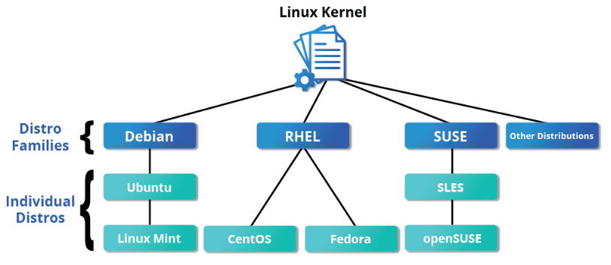

Red Hat Family System (CentOS, Fedora)

- Ex. CentOS, CentOS Stream, Fedora and Oracle Linux.
- dnf or RPM-based package manager
- RHEL is widely used by enterprises that host their own systems

Fedora

- Close to RHEL contains more software than Red Hat’s enterprise version
- Large community is working for development of Fedora
- Fedora serves as an upstream testing platform for RHEL.

CentOS / CentOS stream

- Used for various activity, demonstrations and labs
- No cost to end user and longer release cycle
- CentOS is a close clone of RHEL
- Most popular Linux distribution in enterprise environments
- Quick update receives before RHEL for CentOS stream and CentOS receives them after

SUSE Family Systems (openSUSE)

- Ex. openSUSE (Reference distribution for the SUSE family)
- RPM- based zypper package manager
- SUSE Linux Enterprise Server (SLES) is upstream for openSUSE.
- SUSE Linux Enterprise Server (SLES) has no cost to end users
- YaST (Yet Another Setup Tool) application for system administration purposes.
- SLES is widely used in retail and many other sectors

Debian Family Systems (Ubuntu, LInux Mint, Kali)

- Ex. Ubuntu > Linux Mint
- DPKG-based APT package manager (apt, apt-get, apt-cache)
- Debian distribution is upstream for several other distributions
- Common use on server, cloud deployment and desktop computers
- Community based open-source project
- Stability / Security / Popular / Long Term Support (LTS) / Easy to Use /GNOME
- Free / Open-Source / Community-driven / High reliable

---------------------------------------------------------------------------------------------------------------------------
Architecture of Linux
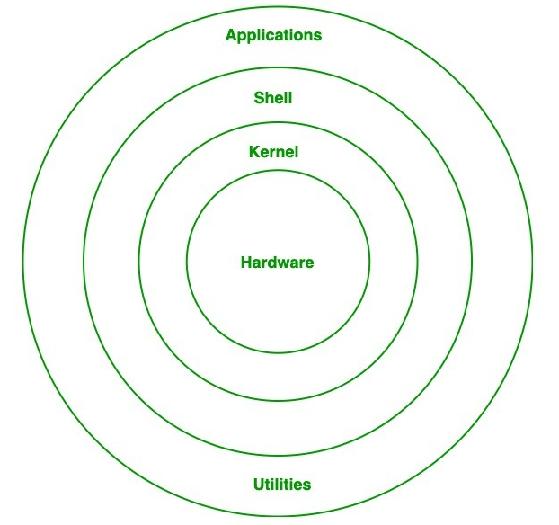

Kernel
- Core part of the operating system.
- Manages system resources and communication with hardware.
- Types: Monolithic, Microkernel, Hybrid, Exokernel.
- Provides low-level services like memory, process and device management.
- Acts as a bridge between hardware and system software.

System Library / Shared Library
- Collection of pre-written code used by programs.
- Provides standard functions (e.g., file handling, math, I/O).
- Helps in implementing OS functionality without rewriting code.
- Reduces program size by sharing common routines.
- Interfaces between application programs and the kernel.

Shell
- User interface for interacting with the OS.
- Accepts user commands and translates them for the kernel.
- Can be command-line (e.g., Bash) or graphical.
- Provides scripting capability for task automation.
- Acts as a bridge between the user and system.

Hardware Layer
- Physical components of the computer system.
- Includes CPU, RAM, storage devices, and I/O peripherals.
- Executes machine-level instructions.
- Provides the foundation on which OS and software run.
- Directly managed by the kernel for resource allocation.

System Utility
- Tools to manage and configure the computer system.
- Includes software installation, user management, and networking.
- Monitors and optimizes system performance.
- Provides security via permissions and access control.
- Helps in maintaining and troubleshooting the system.

---------------------------------------------------------------------------------------------------------------------------
Computer Startup: (Booting process)

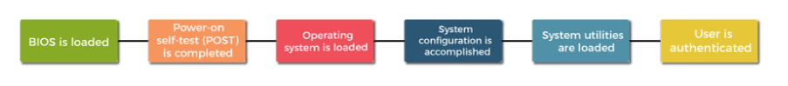
- Whenever any computing device is in dummy state (without power) its Operating system remain stored in secondary storage (computer architecture – storage unit – two types – 1) Primary (Ex. RAM, ROM) 2) Secondary (hard disk, SSD) after device gets started the operating system must be in the main memory of the device and our computing device is in active state (with power)
- This task is done by the hardware and firmware (specific type of software that is embedded into hardware device to control operation/ pieces of software that get all the main parts of your PC / software that provides low-level control of computing device hardware / Types: Embedded Firmware, BIOS/UEFI Firmware etc.) in the CPU / processor in the computer system

---------------------------------------------------------------------------------------------------------------------------

BOOTING PROCESS:

- It is a process of initializing the system / switching on the computer (start with button press/software command) and loading the operating system from a secondary memory to the main memory, initializes its components and prepares to execute user application
- BIOS and Setup Program, The Power-On-Self-Test (POST), The OS loads, System configuration, system Utility and user authentication
- Process of returning a computer from a state of sleep does not involve booting all data gets restored by state of hibernation.

Boot Loader/ Bootstrap loader

- It is a program which resides in the MBR and it’s function is to load the OS kernel into the memory
- Program with functionality to load the operating system from bootable device into main memory
- Load other software for the operating system to start
- Primary function to provide the user with a choice of operating system to boot into
- there are two type of boot loader 1) GRUB 2) LILO
- Window (Windows Boot Manager/Bootmgr.exe), Linux System (GRUB), MAC (boot.efi)

SEQUENCE OF BOOTING:

- It contains set of operations that computer performs when it is switched on

---------------------------------------------------------------------------------------------------------------------------

Boot Devices:

- It is the device from which the OS is loaded
- BIOS supports booting from various devices
- Ex. Hard disk drive / Optical drive / floppy drive / NIC / USB

---------------------------------------------------------------------------------------------------------------------------

Boot Sequence:

- BIOS (Basic Input output system)

- BIOS is a firmware stored on a ROM chip on the motherboard
- It allows access to and setup of computer system at most basic hardware level
- UEFI (Unified Extensible Firmware Interface) is the modern replacement for BIOS.
- Firmware program to testing, initiating and detecting computer hardware component (Keyboard, Hard drives, Mouse, Screen, Processor and Memory)
- It contains start-up programs such as Device detection, Hardware initialization and Preparing the system to load the operating system
- It is the first program executed in the boot process and runs directly from ROM.
- POST (Power on Self Test: firmware checks the system hardware components and ensure that they are correctly in working condition before passing control to the boot loader / to check that device of computer is functionally stable / functionality test for Processors, Memory, Storage, keyboard, System timer)
- If POST test gets failed then it show error message on screen
- Check for bootable device (Pendrive / USB / CD / DVD / Network / Hard disk) and allow the user to configure a boot order in BIOS setup
- BIOS looks for a boot sector (MBR – Master Boot Record) at the beginning of the disk to get bootloader
- Search for boot loader to find kernel image on the disk and loads the operating system into main memory (RAM) to start system (FOUND IN MBR)
- Once control is passed to the bootloader, BIOS’s role is completed.

- MBR (Master Boot Loader)/ EFI system partition

- First sector of bootable device with size of 512 bytes
- It contains partition table (446 byte), boot loader code (64 byte) which is responsible for loading the operating system into memory and starting its execution and Error checking (2 bytes)
- boot loader is usually stored on one of the system’s storage devices, such as a hard disk or SSD drive, either in the boot sector (for traditional BIOS/MBR systems) or the EFI partition (for more recent (Unified) Extensible Firmware Interface or EFI/UEFI systems).
- It contains IMP info for the boot loader to locate and load the operating system
- Once boot loader program is detected (found in MBR) then it will perform its task and further control will pass to it.

- Boot Loader (MORE)

- Linux boot loaders can present a user interface for choosing alternative options for booting Linux and even other operating systems that might be installed.
- Boot loader is responsible for loading the kernel image and the initial RAM disk or filesystem (which contains some critical files and device drivers needed to start the system) into memory.
- Displays a simple GUI menu to select available OS or kernel images (default last image is selected)
- It allows the user to choose a kernel and proceed with the booting process
- Once you selected the kernel image, it locates that kernel image
- Provides boot instructions including kernel location, root file system, and kernel parameters
- GRUB (Grand UNified Boot Loader), ISOLINUX (For booting from removable media), DAS U-Boot (For booting on embedded devices) are the most widely used on modern Linux system
- The grub configuration file is present at /boot/grub/grub.cfg directory
- Used to boot various operating systems windows / Linux
- The LILO configuration file is present at /etc/ lilo.conf directory
- Used to boot Linux-based operating system

- KERNEL (MORE)

- The boot loader loads the kernel along with initrd (initial RAM Disk) / initramfs (initial RAM file system) into memory to begin system initialization.
- The kernel starts initializing and configuring the system hardware, system memory and attached devices (Processors, I/O subsystems, storage devices)
- initramfs filesystem image contains a temporary minimal filesystem with essential programs, binaries and kernel modules.
- It provides filesystem support and device drivers required to access the real root filesystem, especially for mass storage controllers.
- The kernel uses the udev system from initramfs to detect available hardware devices and load the appropriate drivers dynamically.
- Using the tools in initramfs, the kernel locates, checks, and mounts the real root filesystem at the correct mount point.
- The mount process informs the OS that the root filesystem is ready and integrates it into the filesystem hierarchy.
- If special hardware drivers are required before accessing storage, they must be present in the initramfs image.
- After the root filesystem is successfully mounted, initramfs is cleared from RAM to free memory.
- Then, kernel executes /sbin/init from the real root filesystem.
- Control is finally passed to the init system, which completes initialization and continues the normal boot process
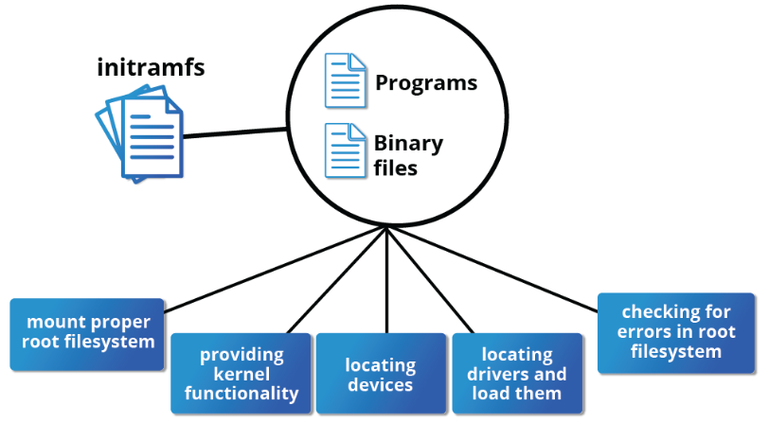

- INIT (MORE)

- /sbin/init runs as Process ID (PID) 1, making it the parent of all user-space processes.
- Init is responsible for starting all required system services and processes to bring the system to a usable state.
- Most processes in the system trace their origin back to init, except kernel processes, which are started directly by the kernel
- Init manages the entire system lifecycle: startup, continuous operation, and clean shutdown.
- It monitors non-kernel processes, cleans up after terminated processes, and restarts services when needed (e.g., login services).
- Init launches text-mode or graphical login prompts for user authentication (username/password).
- It determines the system startup mode (runlevel or target), which controls which services and processes are started.
- Traditionally, initialization followed a sequential startup model (SysVinit) using startup scripts grouped by runlevels.
- Modern systems use event-driven and parallel startup mechanisms, allowing faster boot times.
- The primary Linux initialization systems are SysVinit (traditional, sequential), Upstart (event-based, now deprecated) and systemd (modern, dominant init system)
- In systemd-based systems, /sbin/init is a symbolic link to /lib/systemd/systemd.
- systemd replaces complex shell scripts with unit configuration files that define dependencies and execution rules.
- systemd improves performance by starting multiple services in parallel, utilizing multi-core CPUs.
- A single command, systemctl, is used to manage services (start, stop, restart, enable, disable, status).
- systemd has been adopted by all major Linux distributions, simplifying system administration across platforms.

- RUNLEVELS

- Runlevels define different operational states of the Linux operating system.
- Each runlevel determines which system services and processes are started or stopped during boot.
- Traditional SysVinit systems use runlevels numbered from 0 to 6.
- Each runlevel corresponds to a specific mode of operation (shutdown, single-user, multi-user, reboot, etc.).
- During system startup, init switches the system to the configured default runlevel.
- Within each runlevel, services can be configured to start, stop, or remain inactive.
- Modern systemd-based systems replace runlevels with targets, while still maintaining backward compatibility.
- Runlevels (or targets) allow flexible system configuration for maintenance, networking, multi-user, or graphical environments.

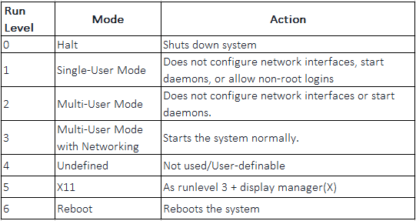

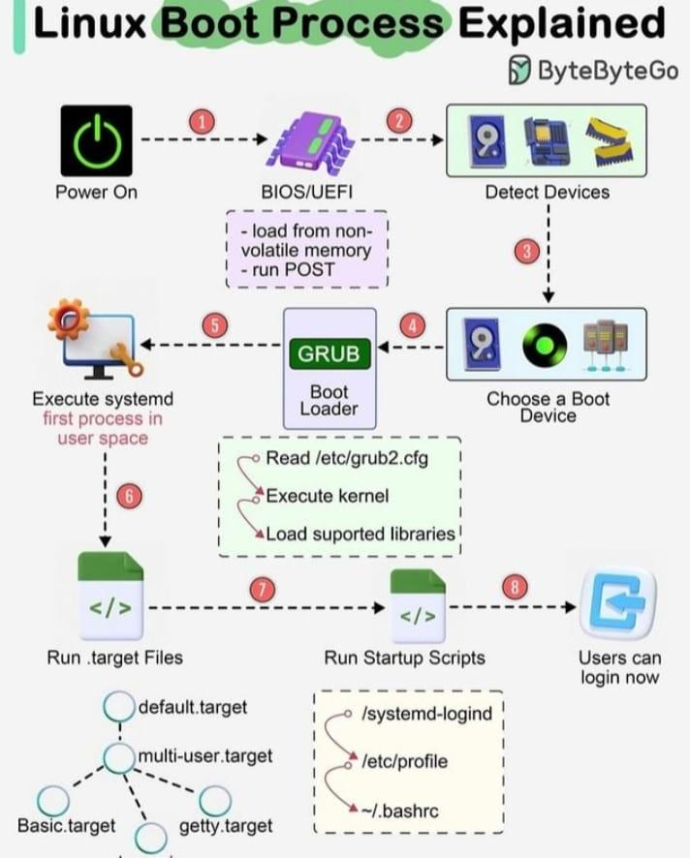

Summary:

- The BIOS stage is the first stage of the boot process, and it involves detecting and initializing hardware devices. It then looks for the MBR on the boot device.

- The boot loader is responsible for loading the operating system kernel into memory and passing control to the kernel. GRUB is the most widely used boot loader on modern Linux systems, due to its flexibility, reliability, and compatibility.

- The kernel initialization stage involves initializing hardware devices, setting up system memory, mounting the root file system, and starting the init process.

- The init system initializes system services and processes, such as daemons, and prepares the system for user interaction and application execution.

TYPES OF BOOTING:

Based on Starting:

- Cold booting (start/soft)
- When computer starts for the first time/starts from shut-down state and switch on the power button to start the system
- System reads all the instructions from the ROM (BIOS) and Operating system automatically gets loaded into the system
- Requires more time
- ram is clear to zero

- Warm booting (restart/hard)
- When computer systems come to no response/hang state and then system needs restart
- Required when install a new software/ to set software/hardware configuration changes / system is behaving abnormally / not responding well
- less time is required
- RAM is not clear to zero

---------------------------------------------------------------------------------------------------------------------------

Linux File System

- File system is method of storing and organizing arbitrary collections of data in a human-usable form

FIle System
- Method of storing and accessing files

Types of FIle System

- Conventional Disk Filesystem (ext3,ext4,XFS,JFS,NTFS,vfat,exfat)
- Flash Storage Filesystem (ubifs,jffs2,yaffs)
- Database Filesystem
- Special purpose Filesystem (procfs, sysfs,tmpfs,fuse)

Partitions
- Dedicated subsection of physical storage media / Physical contiguous portion of hard disk / Logical part of the disk
- It is a container having file system

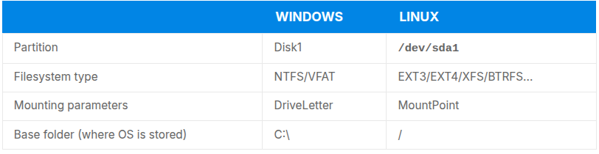
---------------------------------------------------------------------------------------------------------------------------

Filesystem Hierarchy Standard (FHS)

- Linux system stores files according to standard layout called the FHS
- In Linux, everything is treated as a file (including devices and processes).
- All files and directories exist under a single root directory /.
- FHS defines the structure and purpose of each directory.
- Specifies what types of files go into which directories (e.g., /bin, /etc, /home).
- Derived from the UNIX filesystem design principles.
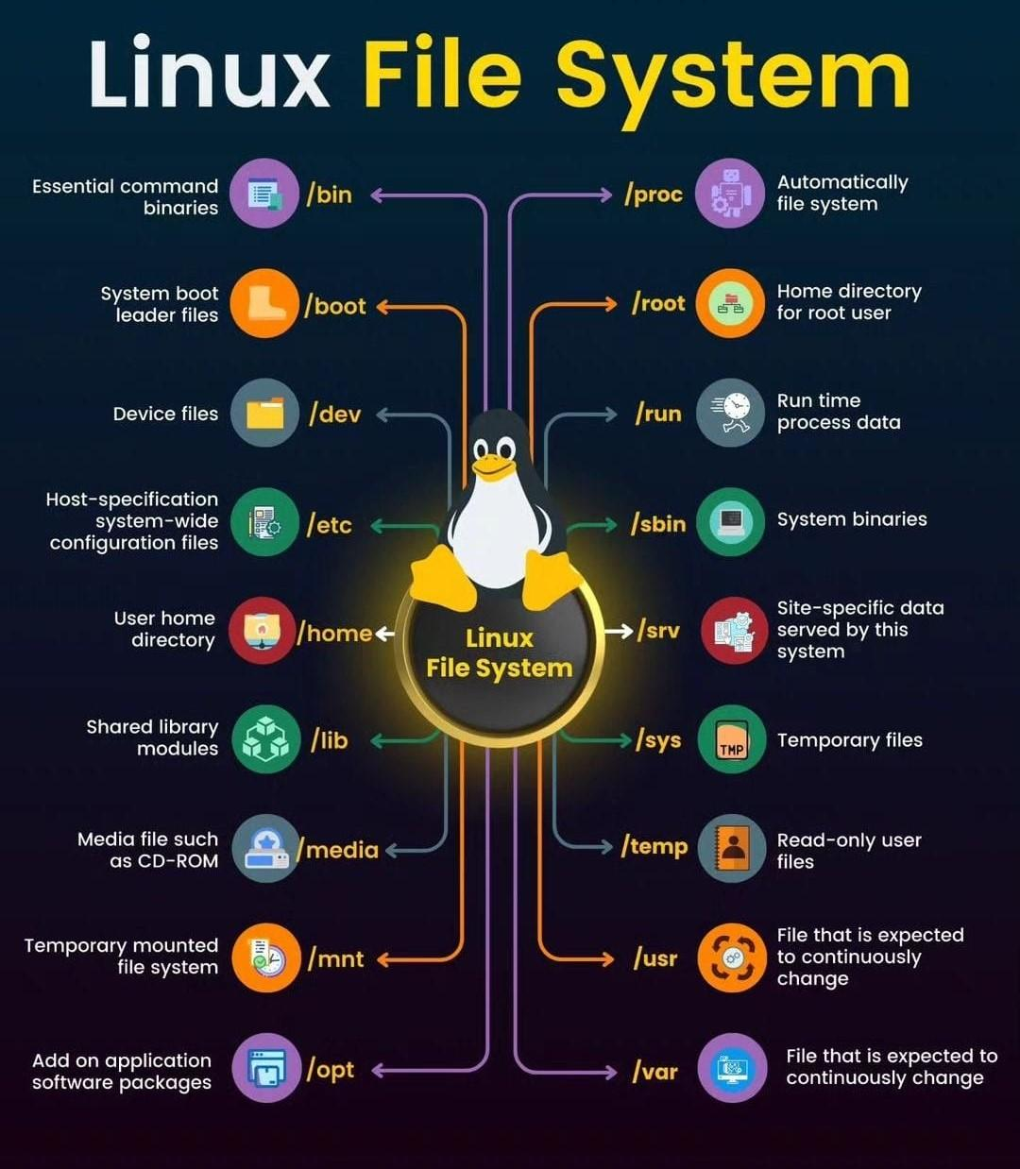

---------------------------------------------------------------------------------------------------------------------------

Standard File Streams / Descriptors

Standard Input (standard in / stdin / 0 ) - Keyboard
Standard Output (standard out / stdout / 1 ) - Terminal
Standard Error (stderr / 2) - Terminal

---------------------------------------------------------------------------------------------------------------------------

I/O Redirection

---------------------------------------------------------------------------------------------------------------------------

Graphical User Interface (GUI)

Graphical Desktop / X Window System

- Loading the graphical desktop is one of the final steps in the boot process of a linux desktop which is called as X window System / X
- Display Manager (Keep track of the display being provided and loads the X server / Handle graphical login and start the appropriate desktop environment after a user logs in)
- Display management, Loads Graphical Desktop (X or Wayland) and Manage graphical logins are the major role of display manager
- Ex. GNOME-gdm, KDE-kdm
- Session Manager (Start and maintain the components of graphical session)
- Window manager (Controls the placement and movement of windows, window title-bars and controls)
- Display Manager, Session Manager, WIndow Manager and Utilities provides a seamless desktop environment

Desktop Environment

GNOME

- Popular / Easy to Use / Default desktop environment / Menu-based navigation
- Different look for different Distro (RHEL, Fedora, CentOS, SUSE, Debian)

KDE

- Common desktop environment / Widely used

---------------------------------------------------------------------------------------------------------------------------

Command Line Interface (CLI)

Advantage

- No extra load from graphical interface (faster and lightweight).
- Almost all tasks can be done using commands.
- Scripts can automate repeated tasks.
- Remote systems can be accessed easily.
- Applications can be started directly using commands.
- Command line works the same across all Linux distributions.

---------------------------------------------------------------------------------------------------------------------------
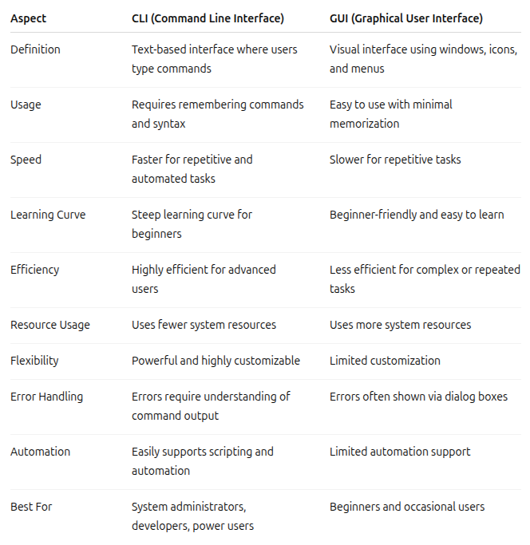

---------------------------------------------------------------------------------------------------------------------------

Hard LInk

- A hard link is an additional name for an existing file.

Key Points:
- Both the original file and the hard link share the same inode number.
- They point to the same data on disk.
- Deleting one name does not delete the file data as long as another hard link exists.
- Changes made through one name appear in the other.
- Hard links cannot span different filesystems.
- Hard links cannot be created for directories (to prevent filesystem loops).

Advantages:
- Saves disk space.
- File remains safe until all hard links are removed.

Disadvantages:
- Can cause confusion if one name is deleted.
- Difficult to manage across filesystems.

Soft Link / Symbolic LInk / Symlinks Link

- A soft link is a special file that points to another file by its path name.

Key Points:
- Has a different inode number from the original file.
- Acts like a shortcut or reference.
- Can link to directories.
- Can span different filesystems or disks.
- If the original file is deleted, the link becomes a dangling (broken) link.

Advantages:
- Very flexible.
- Easy to move or redirect.
- Commonly used for shortcuts.

Disadvantages:
- Breaks if the target file is removed or renamed.
---------------------------------------------------------------------------------------------------------------------------

Environment Variables

- Quality that have specific values which may be utilized by the command shell or other utilities and applications

PS1 Variable

- Special shell variable that defines the primary command prompt
- PS1 (Prompt String 1)
- It controls how your command prompt looks
- Used mainly in Bash shell

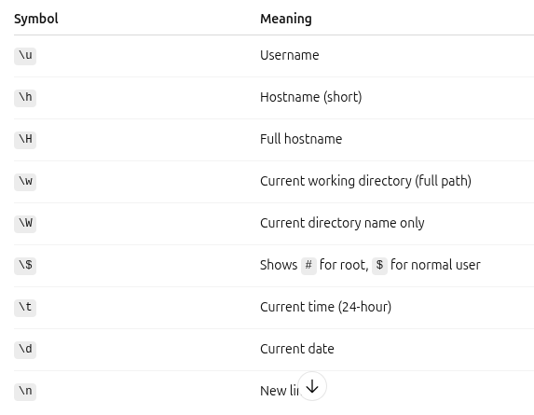

---------------------------------------------------------------------------------------------------------------------------

Package Management Systems on LInux

- Packages contains the files and other instructions needed to make one software component work well and cooperate with the other components that comprise the entire system.
- Low-level package manager (Dpkg, RPM) used to unpack individual packages, running scripts and getting the software installed correctly
- HIgh-level package manager (apt, dnf,zypper) used to groups of packages, downloads packages from the vendor and fingures out dependency

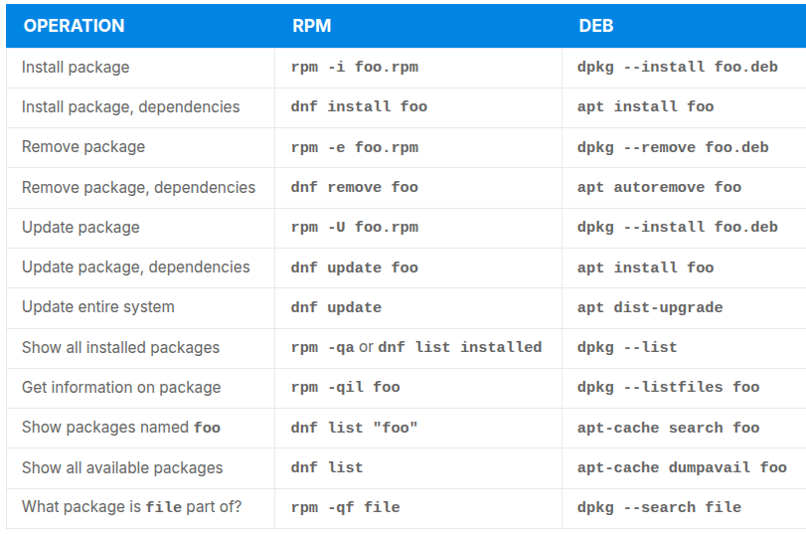

---------------------------------------------------------------------------------------------------------------------------

Application:

- Servers and Hosting
- Development
- Desktop and Personal Use
- Cybersecurity
- Embedded Systems
- Supercomputers

---------------------------------------------------------------------------------------------------------------------------

Installation:

---------------------------------------------------------------------------------------------------------------------------

LInux Installation on Virtual Machine

---------------------------------------------------------------------------------------------------------------------------

Disk Partitioning and Operation

Attach disk to port > Create disk partitions > Create file system on the partition > Mounting the file system

---------------------------------------------------------------------------------------------------------------------------

Dual-Booting:

Download ISO > Create Bootable USB > Boot from USB > Install Linux > Complete installation

STEP 1: Disable secure boot (disable / enable)

Right click on Window icon > setting > system > recovery > advance startup > (BLUE SCR) > Troubleshoot > advance option > UEFI Firmware setting > Restart > (BIOS) > Secure Boot > disable > F10 (Save) > Restart > bitlocker key > ( if there is a problem then move to BIOS and enable key will enter into the window ) > enter bitlocker key > enter into window

STEP 2: Turn off bitlocker

Open Powershell > CMD: manage-bde -status > Other CMD (Chatgpt) / Click on GUI

STEP 3: Create a partition (Disk Partition)

Right click on Window icon > Disk management > Choose drive > right click > shrink volume > give space in mb > shrink > ( X GB unallocated space created > right click > new simple volume > next > next > ……..> Vol label (rename)

STEP 4: Create bootable device

Browser > ubuntu download > download ubuntu desktop > Browser > Rufus > rufus 4.4.exe > coonect pendive (8GB) > open rufus > yes > boot selection (select > ubuntu) > choose distro > start > ok > yes > warning > ok

STEP 5: Boot with bootable device

Right click on Window icon > setting > system > recovery > advance startup > (BLUE SCR) > use a device > choose USB device > click > GRUB > try and install ubuntu > ubuntu installation page > select language> INSTALL UBUNTU > continue > minimal installation > continue > option one, two, three >install now > continue > add credential > install > restart >

---------------------------------------------------------------------------------------------------------------------------

GRUB Customization:
Platform: Gnome.org
Download > Extract > cd to that directory

sudo mkdir -p /boot/grub/themes
sudo cp -r /path/to/your/theme /boot/grub/themes/
sudo nano /etc/default/grub
GRUB_THEME="/boot/grub/themes/your-theme-directory/theme.txt"
sudo update-grub
sudo reboot

---------------------------------------------------------------------------------------------------------------------------

GNOME-tweaks

Platform: Gnome.org

sudo apt install gnome-tweaks
gnome-tweaks
sudo apt install gnome-shell-extension-manager

---------------------------------------------------------------------------------------------------------------------------

FILE Permission:

- Ask for something
- Data security / user control / Access restriction / System integrity (Need)
- r / w / x (Type)
- Read: Read the content from folder Write: Write content Execute: Run

ls -l
(folder /file) (user) (group) (other) code owner group size modification date (file / folder name)
folder: d socket file: s link file: l Normal: -
file: -
code: number of hard links to the directory.
user: u
group: g
other: o

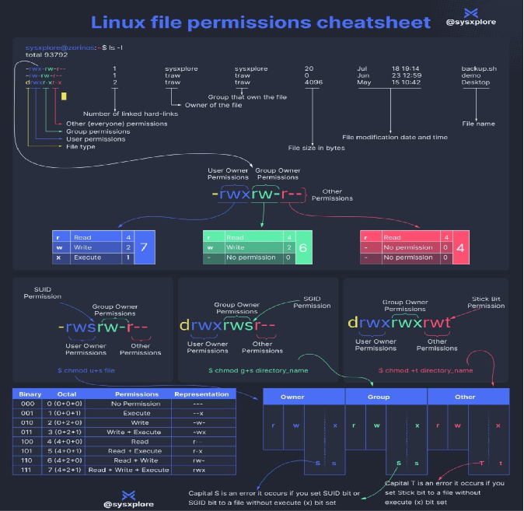

Linux and Networking

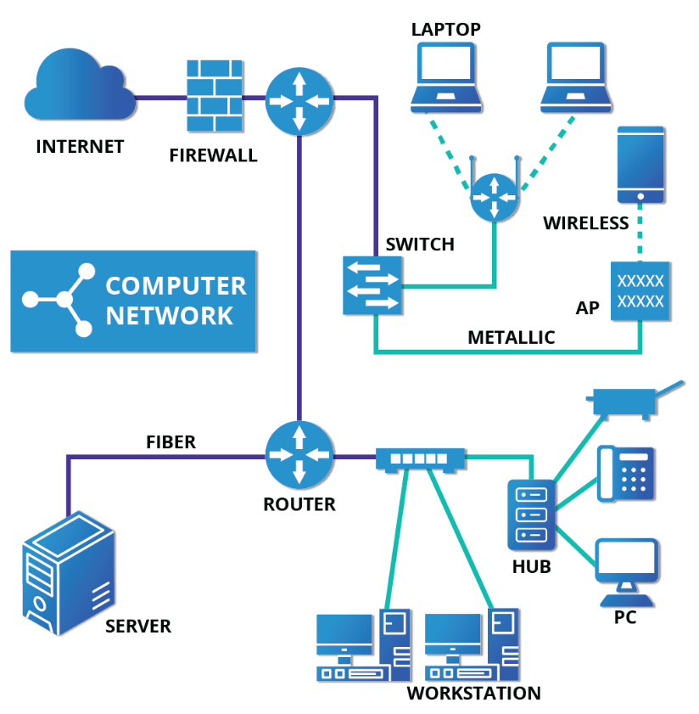

Network Manager

- Network Manager establish your connections and keep track of your settings
- Used to list all available network (wired and wireless) and allow the choice of a wired, wireless and mobile broadband network, handle passwords and setup VPNs

Wired connections (Ethernet):
When you connect a network cable to your computer, it usually works automatically. The computer detects the cable and the network by itself. Network Manager then gets the required network settings automatically using DHCP, so you don’t have to do anything.

If the network does not use DHCP, you can still set the network details manually using Network Manager. You can also change the MAC address if your network card allows it. The MAC address is a unique number that identifies your network card.

Wireless connections (Wi-Fi):
Wi-Fi does not connect automatically in most cases. You need to choose a wireless network from the list of available networks. Network Manager shows all nearby Wi-Fi networks and also shows which one you are currently connected to.

You can save Wi-Fi networks, edit their settings, delete them, and choose which network should connect automatically when it is available.

Protocol

Network TIme Protocol (NTP)

Dynamic Host Configuration Protocol (DHCP)

Internet Message Access Protocol (IMAP)

Post Office Protocol (POP)

FIle Transfer Protocol (FTP)

---------------------------------------------------------------------------------------------------------------------------

User Management

- Core function of Linux system administration
- Control system access, Ensure security and privileges for task
- Used to create multi-user environment
- Linux system supports up to 60000 users
- UID 0 (Super user), UID 1-999 (System accounts), UID 1000+ (Regular Users)

Key Benefits

- Secures the system from unauthorized access
- Ensures users can perform their roles without interfering with others
- Helps in auditing and tracking user activity
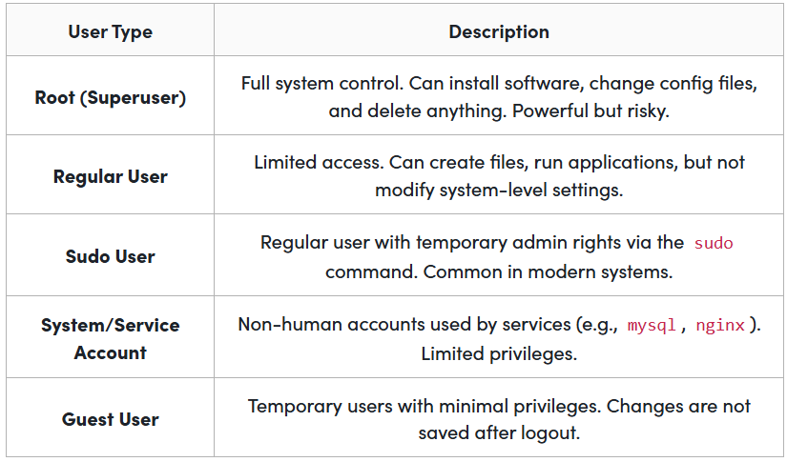

User Groups

- It is a collection of users
- Used to manage file and system permission for many users at once

Types of User Groups

Primary Group (Default)

- Every Linux user is assigned one primary group.
- By default, this group usually has the same name as the user.
- It helps manage file ownership cleanly without much extra configuration

Secondary Group

- A user can be a part of multiple secondary groups.
- These groups provide extra access to files, folders, or services.
- They are commonly used for team-based access or system-level permissions (e.g., accessing Docker, video devices, or running sudo).

Text Editor:

Text editors are software applications used to create, view, and edit plain text files. They are an essential tool for programming, writing, and editing configuration files. Here’s a simple explanation of text editors, including their types and features

What is a Text Editor?

A text editor is a program that allows you to write and modify text. Unlike word processors (such as Microsoft Word), text editors do not typically include advanced formatting options like bold or italic text. Instead, they focus on plain text, which is useful for coding and scripting.

Types of Text Editors
- Basic Text Editors:
Examples: Notepad (Windows), TextEdit (macOS in plain text mode), Nano (Linux).
Features: Simple interface, basic text editing functionalities (cut, copy, paste, find, replace).
- Advanced Text Editors:
Examples: Sublime Text, Visual Studio Code, Atom, Notepad++, Vim, Emacs.
Features: Syntax highlighting, code completion, plugins/extensions, version control integration, multiple cursors, and more.
Key Features of Text Editors
- Syntax Highlighting:
What it is: Color-coding of text according to the syntax of the programming language being used.
Benefit: Makes code easier to read and understand.
- Code Completion:
What it is: Suggests possible completions for partially typed words or phrases.
Benefit: Speeds up coding and reduces typing errors.
- Plugins and Extensions:
What it is: Additional tools or functionalities that can be added to the editor.
Benefit: Enhances the capabilities of the editor, such as adding support for more languages, themes, or tools like linters and debuggers.
- Version Control Integration:
What it is: Integration with version control systems like Git.
Benefit: Allows you to manage code changes and collaborate with others directly within the editor.
- Search and Replace:
What it is: Tools to find specific text within files and replace it if needed.
Benefit: Saves time when making widespread changes to a document or codebase.
- Multi-Cursor and Multi-Selection:
What it is: Allows editing of multiple lines or sections of text simultaneously.
Benefit: Increases efficiency when making repetitive changes.
- Customization:
What it is: Ability to customize the look and behavior of the editor (themes, keybindings).
Benefit: Makes the editor more comfortable and efficient to use according to personal preferences.

- Atom
Platform: Windows, macOS, Linux
Features:
- Hackable: Known as a "hackable text editor for the 21st century," Atom is highly customizable and extendable.
- Built-in Package Manager: Easily search for and install new packages or create your own.
- Smart Autocompletion: Provides suggestions as you type, helping speed up coding.
- File System Browser: Browse and open files and projects in one window.
- Multiple Panes: Split your interface into multiple panes to compare and edit code across files.
- Find and Replace: Powerful search and replace feature within files, across projects.
- Integration with Git and GitHub: Seamless integration with Git version control and GitHub.

- Sublime Text
Platform: Windows, macOS, Linux
Features:
- Performance: Fast and responsive, even with large files.
- Multiple Selections: Edit multiple lines or instances of text at once.
- Command Palette: Access functions via a searchable palette.
- Split Editing: View and edit multiple files or locatioAns within the same file side-by-side.
- Goto Anything: Quickly navigate to files, symbols, or lines.
- Package Control: Easily manage plugins and extensions to enhance functionality

- Installation:

1) subl –version
2) sudo apt update
3) sudo apt install sublime-text
4) sudo apt remove sublime-text

- Vim
Platform: Windows, macOS, Linux (widely used on Linux)

Features:
- Keyboard-Centric: Efficient editing with minimal mouse use, relying heavily on keyboard shortcuts.
- Modes: Different modes for inserting text, editing, and command execution (e.g., normal mode, insert mode).
- Customization: Highly configurable through .vimrc and plugins.
- Remote Editing: Excellent for remote work via terminal over SSH.
- Lightweight: Low resource usage, making it suitable for various environments, including servers.
- Extensibility: Large ecosystem of plugins for additional functionalities.

Command | Desciption
vim –version
sudo apt install vim
sudo apt remove vim
Vim | About vim
vimtutor | About tutorial
Open Editor and Modes
vim file_name | Start the editor and edit file_name
i | Enter to Insert Mode from Command Mode
: | Enter to Line Mode from Command Mode
esc | Exit from Insert Mode and Enter to Command Mode  Exit from Line MOde and ENter to Command Mode
Basic Navigation
vim -r file_name | Start and edit myfile in recovery mode from a system crash
:r file_name | Read in file and insert at current position
:w | Write to the file
:w file_name | Write out to file
:w! file_name | Overwrite file
:wq / :x | Save and exit
cat / open file_name | To show content of file
:q | Quit
:q! | Exit without save
Changing Cursor Position
Shfit g | To move bottom
gg | To move top
Searching for Text in vi
/ word | Search from start
? word | Search from last
:%s/word1/word2/g | Replace word
U | undo
Ctrl + R | redo

- Visual Studio Code (VS Code)
Platform: Windows, macOS, Linux
Features:
- Extensible: Rich extension marketplace for additional functionalities.
- Integrated Terminal: Access a command-line interface directly within the editor.
- Git Integration: Built-in support for version control with Git.
- IntelliSense: Advanced code completion and error checking.
- Debugging: Powerful debugging capabilities.
- Customization: Highly customizable with themes, keybindings, and settings.

- Nano
Platform : Linux , macOS,Windows
Features:

- User-Friendly Interface:
Simple and Intuitive:
- Nano offers a straightforward and easy-to-use interface, making it accessible to new users.
On-Screen Shortcuts:
- All essential commands are displayed at the bottom of the screen, so users don't need to memorize complex key bindings.
Basic Text Editing:
- Basic Operations: Nano supports basic text editing operations like cut, copy, paste, and delete.
- Line Numbering: It can display line numbers for easier navigation and editing.
Search and Replace:
- Nano includes a simple search and replace functionality, which can be used to find and modify text in the document.
Syntax Highlighting:
- It offers syntax highlighting for various programming languages and file types, making it easier to read and write code.
Undo/Redo:
- Nano supports multiple levels of undo and redo, allowing users to revert or reapply changes easily.
Configurable Settings:
- Customizable Key Bindings: Users can customize key bindings to suit their preferences.
- Configuration Files: Nano can be configured using .nanorc files, where users can set preferences like tab size, syntax highlighting, etc.
File Management:
- File Browser: Nano includes a simple file browser for opening and saving files.
- Backup Files: It can automatically create backup files, which is helpful in case of accidental data loss.
Internationalization and Localization:
- Nano supports multiple languages, making it accessible to a broader audience.
Lightweight and Fast:
- It has a small footprint and is fast, making it suitable for use on systems with limited resources.

Command | Desciption
Nano –version
sudo apt install nano
sudo apt remove nano
Nano file_name | Create file and write into it
Ctrl G | Display the help screen
Ctrl X | Save permission > give file name > Exit
Ctrl O | Write to a file
Ctrl R | Insert contents from another file to the current buffer
Ctrl C | Show cursor position
Ctrl K | Cut
Ctrl U | Paste
Ctrl W | Search the word
Ctrl T | Spell Check

- gedit

Platform : Linux, macOS,Windows

- emacs

Platform : Linux, macOS,Windows
About:

Command | Desciption
emacs file_name | Create file and write into it
Ctrl-x i | Insert prompted for file at current position
Ctrl-x s | Save all files
Ctrl-x Ctrl-w | Write to a file giving a new name when prompted
Ctrl-x Ctrl-s | Saves the current file
Ctrl-x Ctrl-c | Exit after being prompted to save ant modified field

---------------------------------------------------------------------------------------------------------------------------

Course

- INTRODUCTION TO LINUX (LFS101)
- GFG
---------------------------------------------------------------------------------------------------------------------------

Project

- Create users and set permissions
- Schedule backups using cron
- Archive logs automatically
- Host a basic web page using Nginx
- Secure the system with firewall rules
- Review key commands from all days
- Final system cleanup and optimization techniques
---------------------------------------------------------------------------------------------------------------------------

Documentation:

- Linux
- Ubuntu
- Commands (man,help)
- GNU Info
- Other (Gentoo Handbook, Ubuntu Documentation, Fedora Documentation)
- Document

---------------------------------------------------------------------------------------------------------------------------

Extension

Dock to Dash
Arc Menu
Extension List
Add to Desktop
Forge
GNOME Fuzzy app search
Desktop Icon NG
Removable Driver Menu
Custom window

---------------------------------------------------------------------------------------------------------------------------

Important Links

- 01 Course Introduction
- Course
- Class Forum
- Support

02 Linux Foundation
Linux Foundation
Events
Education
Linux Distro

03 Linux Philosophy and Concepts
Installation
Kernel

04 Linux Basic and System Startup
FHS

05 Graphical Desktop
Wayland
GNOME
TRY_IT_1
TRY_IT_2

07 Common Applications
libreoffice

08 Command LIne Operation
TRY_IT_1
TRY_IT_2
TRY_IT_3
TRY_IT_4

09 Finding Linux Documentation
Document
Man Pages
More

11 File Operations
Document
NFS
TRY_IT_1
TRY_IT_2

12 Text editor
VScode
Tutorial

13 User Environment
TRY_IT_1

14 Manipulating Text
TRY_IT_1
TRY_IT_2
TRY_IT_3
TRY_IT_4
TRY_IT_5
TRY_IT_6

15 Network Operations
Wikimedia
Octets
TRY_IT_1
TRY_IT_2
TRY_IT_3
TRY_IT_4

17 More On Bash Shell Scripting
FIPS 140-2

18 Printing
CUPS
GitLab
TRY_IT_1
TRY_IT_2

19 Local Security Principles
John The Ripper
GRUB2 Password Protection

20 Course Completion
FeedBack

---------------------------------------------------------------------------------------------------------------------------

LAB

03 Linux Philosophy and Concepts
Lab_3.1

04 Linux Basic and System Startup
Lab_4.1

05 Graphical Desktop
Lab_5.1
Lab_5.2
Lab_5.3

06 System Configuration from the Graphical Interface
Lab_6.1
Lab_6.2
Lab_6.3
Lab_6.4

07 Common Applications
Lab_7.1

08 Command LIne Operation
Lab_8.1
Lab_8.2
Lab_8.3
Lab_8.4
Lab_8.5

09 Finding Linux Documentation
Lab_9.1
Lab_9.2
Lab_9.3
Lab_9.4

10 Processes
Lab_10.1
Lab_10.2
Lab_10.3
Lab_10.4

11 File Operations
Lab_11.1
Lab_11.2
Lab_11.3

12 Text editor
Lab_12.1
Lab_12.2
Lab_12.3
Lab_12.4

13 User Environment
Lab_13.1
Lab_13.2
Lab_13.3
Lab_13.4

14 Manipulating Text
Lab_14.1
Lab_14.2
Lab_14.3
Lab_14.4
Lab_14.5

15 Network Operations
Lab_15.1
Lab_15.2

16 The Bash Shell And Basic Scripting
Lab_16.1
Lab_16.2
Lab_16.3
Lab_16.4
Lab_16.5
Lab_16.6

17 More On Bash Shell Scripting
Lab_17.1
Lab_17.2
Lab_17.3

18 Printing
Lab_18.1
Lab_18.2

19 Local Security Principles
Lab_19.1
Lab_19.2

---------------------------------------------------------------------------------------------------------------------------

QUIZ

02 Linux Foundation
Chap_2

03 Linux Philosophy and Concepts
Chap_3

04 Linux Basic and System Startup
Chap_4

05 Graphical Desktop
Chap_5

06 System Configuration from the Graphical Interface
Chap_6

07 Common Applications
Chap_7

08 Command LIne Operation
Chap_8

09 Finding Linux Documentation
Chap_9

10 Processes
Chap_10

11 File Operations
Chap_11

12 Text Editor
Chap_12

13 User Environment
Chap_13

14 Manipulating Text
Chap_14

15 Network Operations
Chap_15

16 The Bash Shell And Basic Scripting
Chap_16

17 More On Bash Shell Scripting
Chap_17

18 Printing
Chap_18

19 Local Security Principles
Chap_19

20 Course Completion
Chap_20

---------------------------------------------------------------------------------------------------------------------------

