Scania Truck Failure

# Project Architecture

Version 0.1

07/05/2024

Atiq Mansoori

## Scania Truck Failure (Architecture)

Architecture of Project:

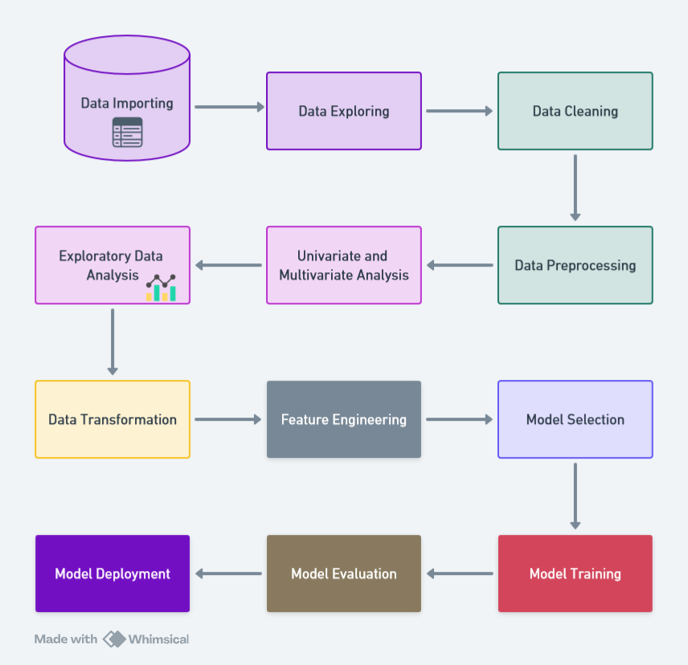

## Scania Truck Failure (Architecture)

Workflow of Project:.

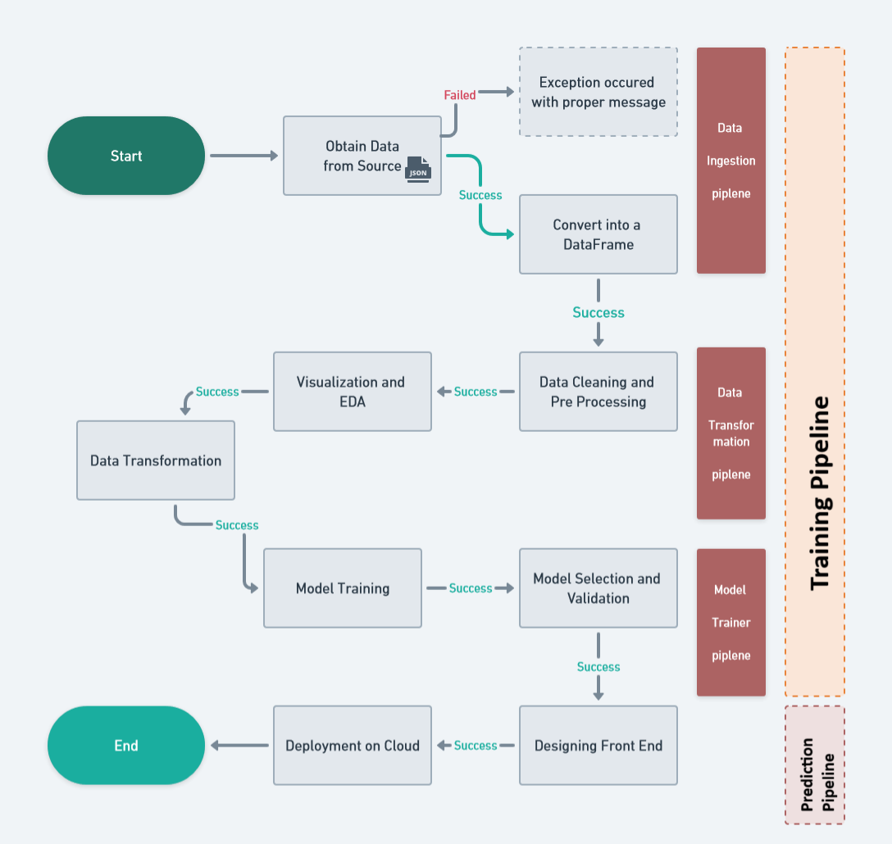.

## Scania Truck Failure (Architecture)

1. User input-output workflow:
2. 