**ESD Lab Assignment No.1**

Name : Ashutosh Rajendra karve

Bits-ID : 2024ht01021

Mail : [2024ht01021@wilp.bits-pilani.ac.in](mailto:2024ht01021@wilp.bits-pilani.ac.in)

Contact : +91 9765541324

Data : 05/09/2024

Place : Pune, Maharashtra

Q.1. Assembly Language Program (ALP) for an LPC2378 processor to implement following IF-ELSE statement are given below:

If ( a<b )  
{  
 x=5;  
 y=c+d;  
}  
else  
 y=c-d

Code-1 >>

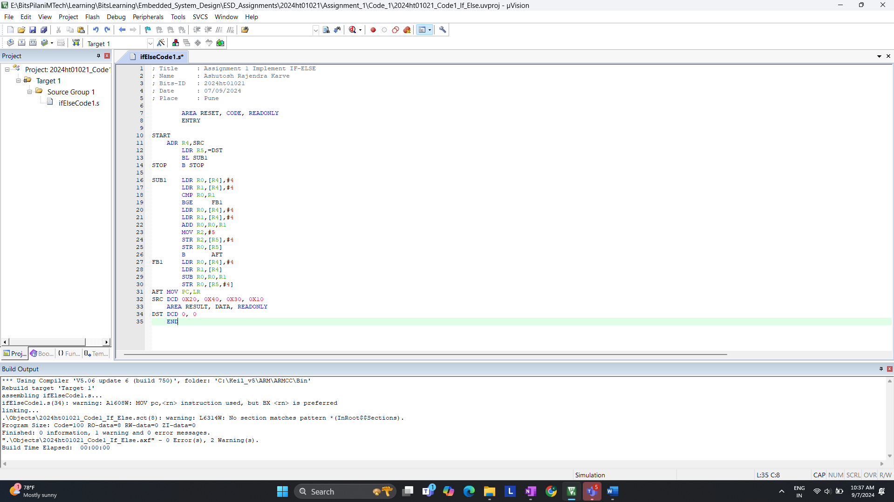

Code- 2 >> For now replace this below ss after taking ss



a. On reset what is the LPC2378 processor’s state and mode of operation?

**CODE 1 >>**

Start of debugging for code 1.  
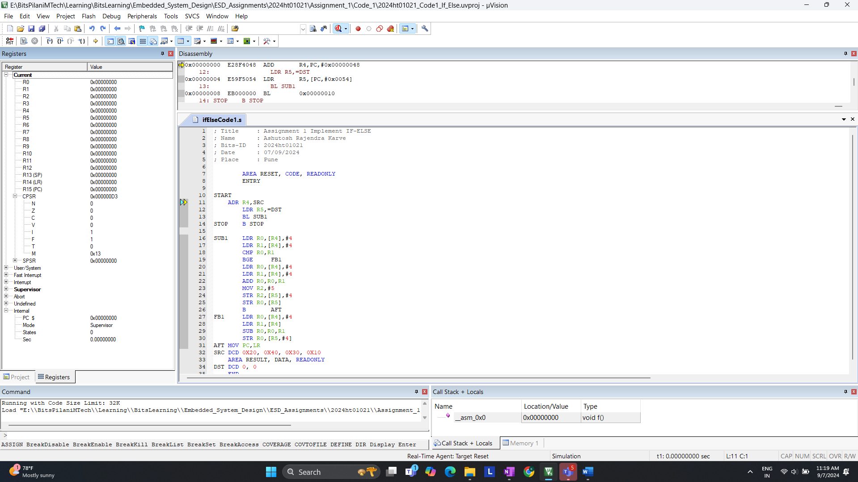

After >> Step

Observation of Code 1.

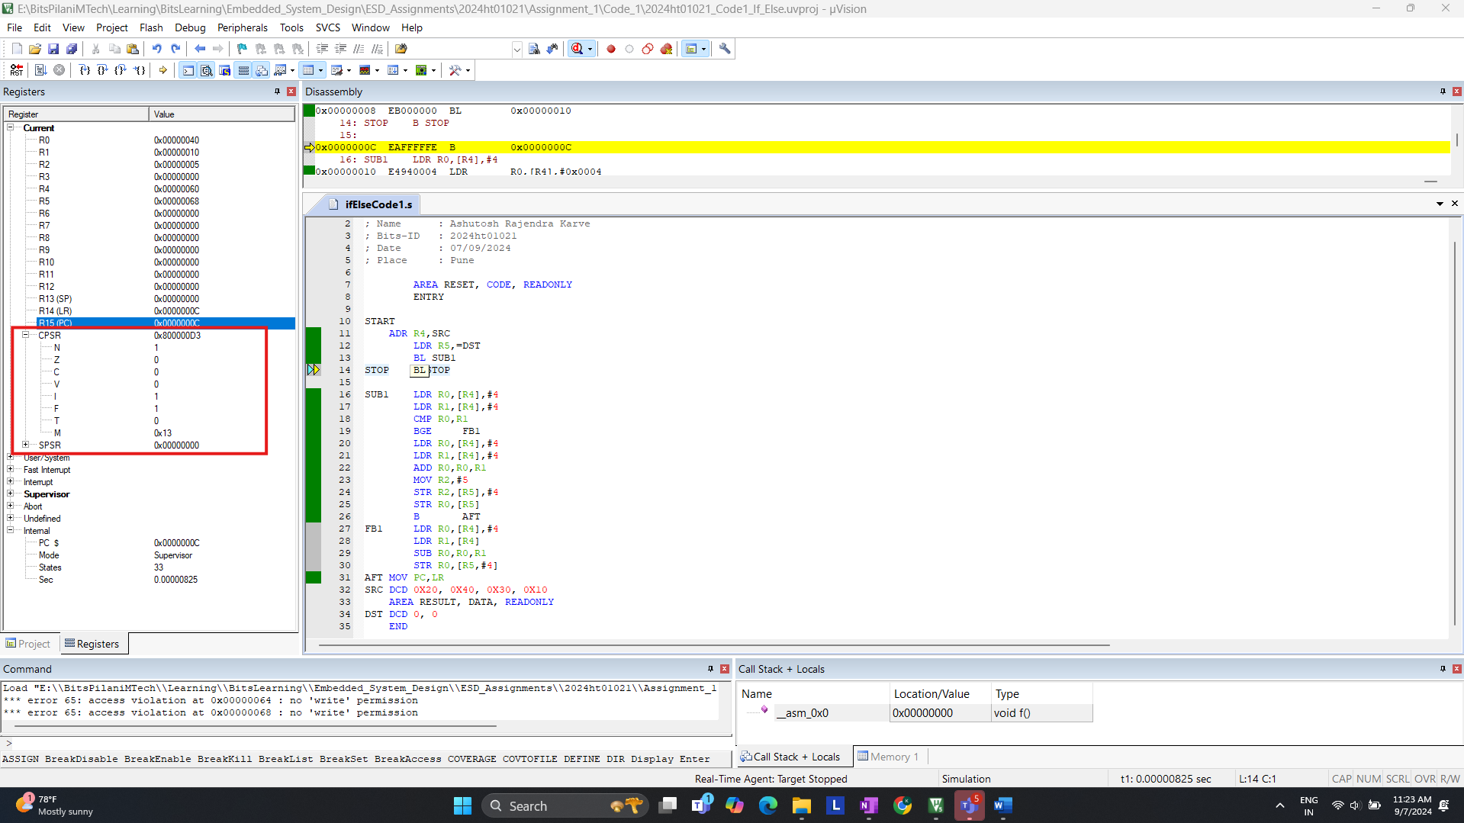

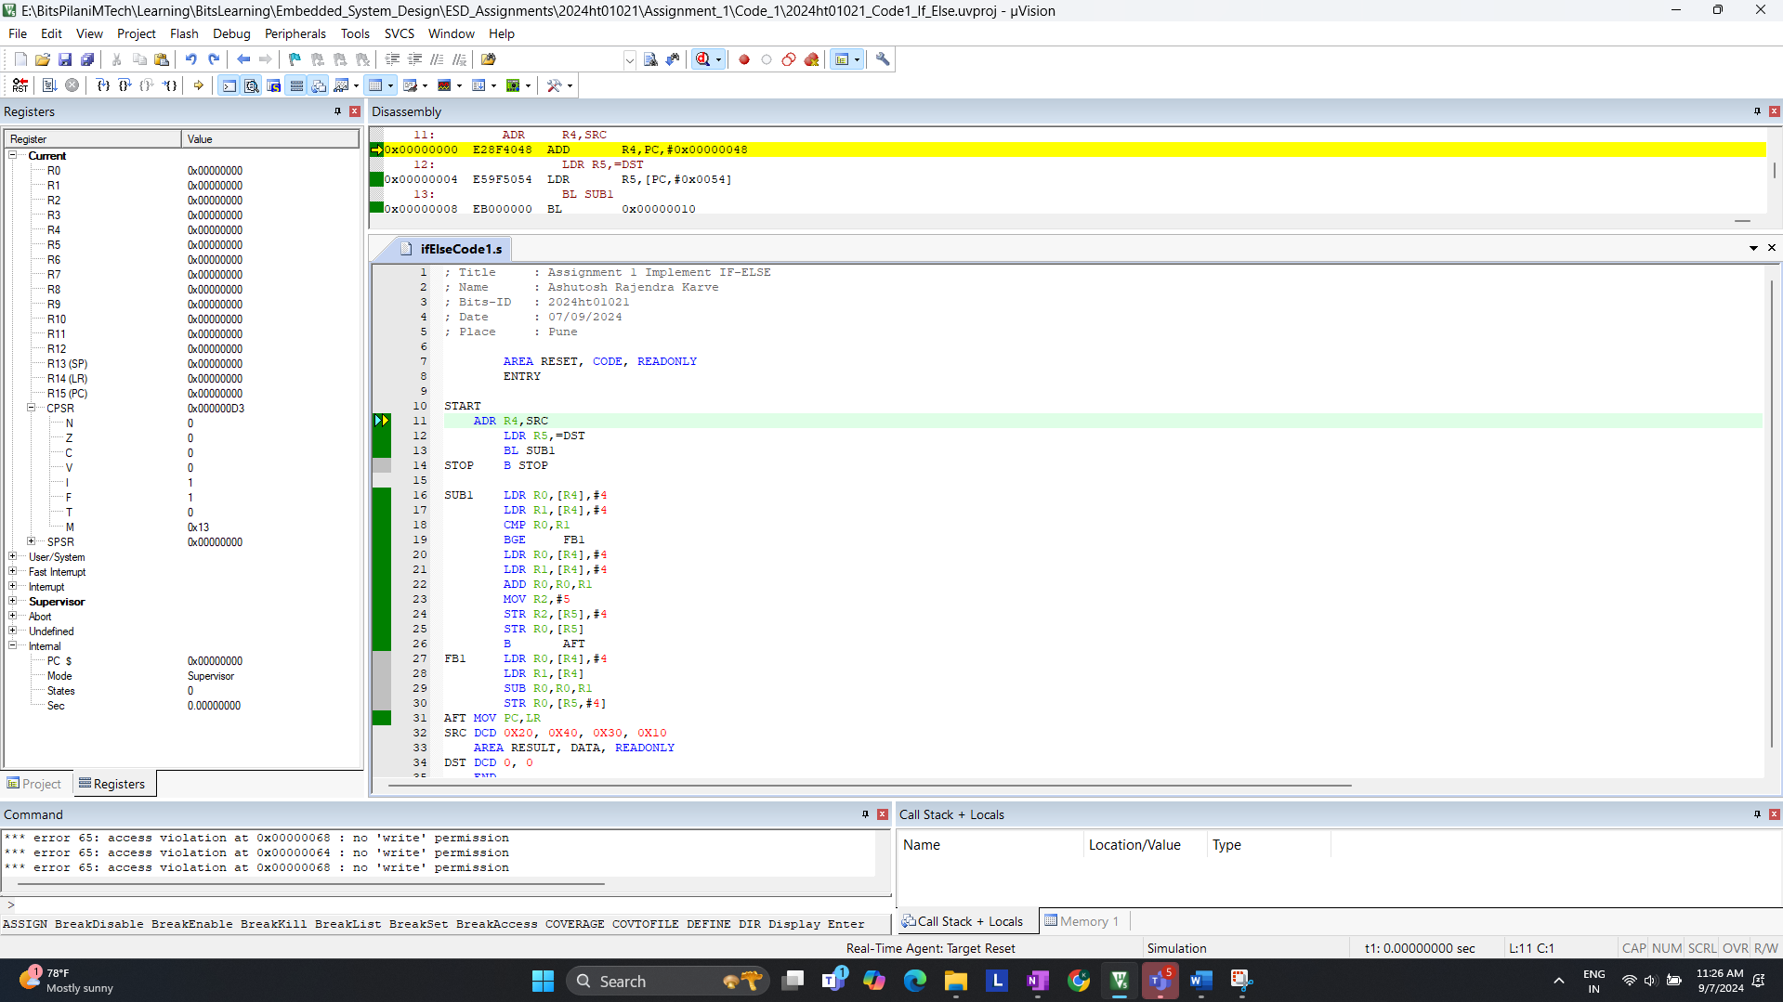

Answer:

* Looking at CPSR. You will see that the processor is in **Supervisor Mode** after reset
* The Processor starts in **ARM State** (32-bit mode) on reset

b. How many states are taken for the execution of an Arithmetic instruction, Load and Store instruction respectively (For Code-1)?

Example for LDR >> Code 1.

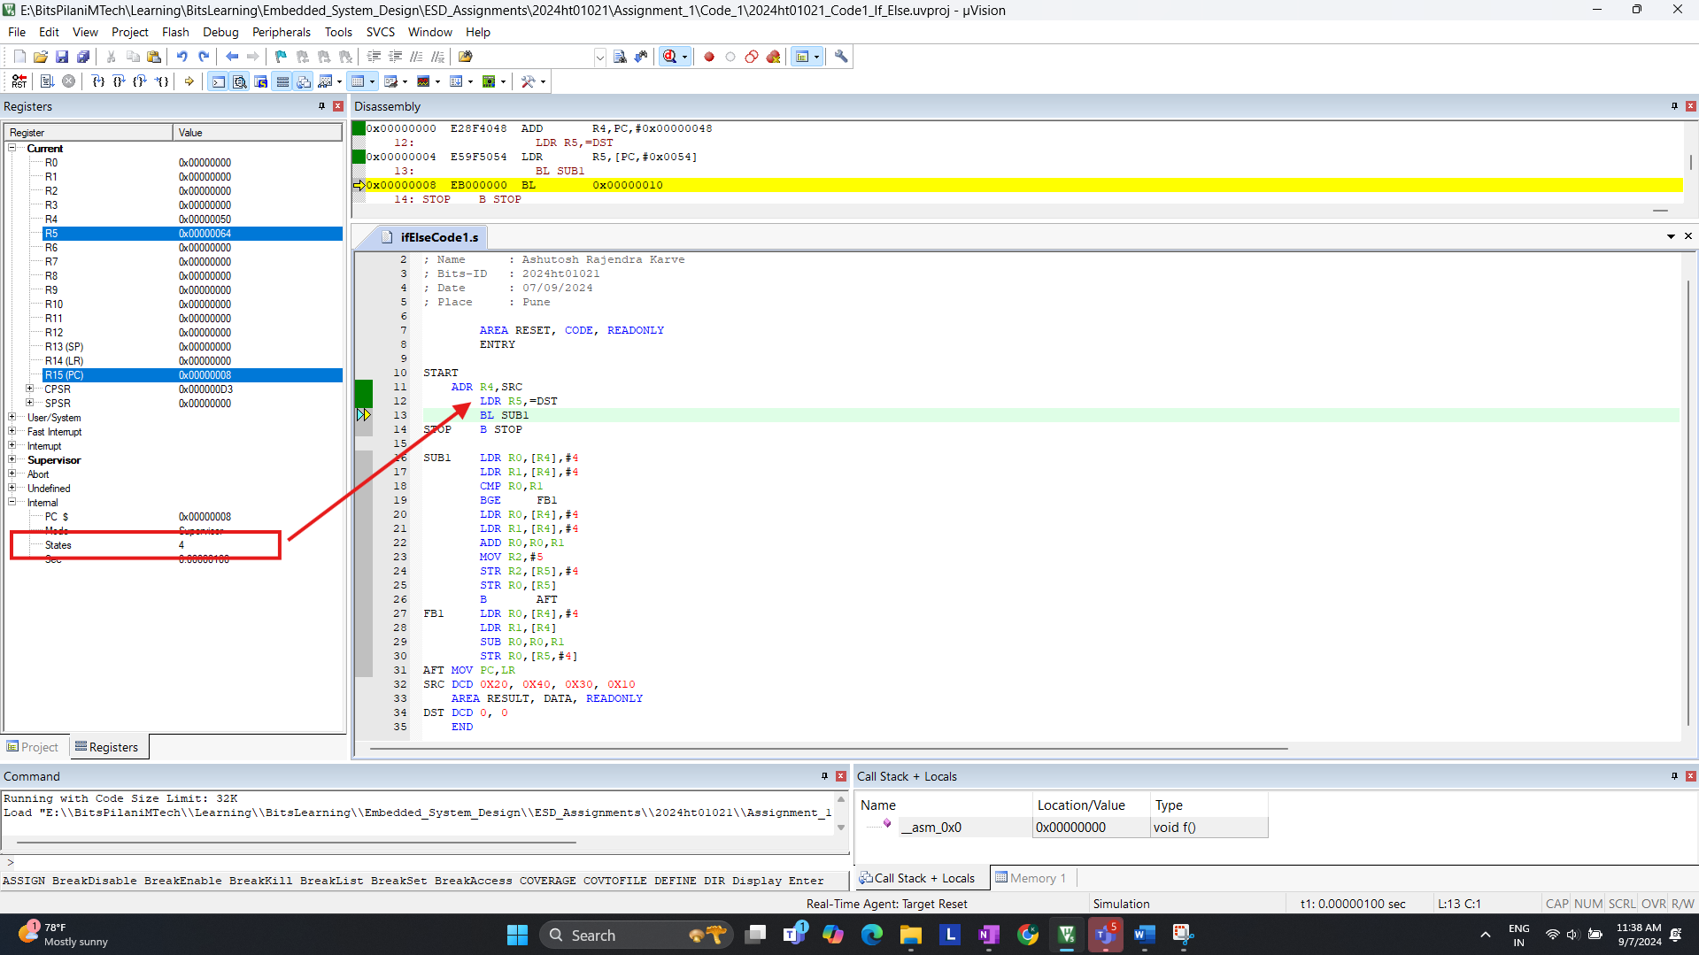

Answer:

* Observing : Load (LDR) , Store (STR) & Arithmetic (ADD)
  + **LDR** instruction takes **3 Cycles**.
  + **STR** instruction takes **2 Cycles**.
  + **ADD** instruction takes **1 Cycles**.
* Total Cycle takes place is **33 Cycles.** We canin above screen shot.

c. Are the number of states taken for completion same for BGE instruction if the branch (1) is taken (2) not taken? Please give the states are taken for each. (For Code – 1)

We Need to determine the number of states for the BGE instruction when:  
1. Branch is taken  
2. Branch is not taken

Update code : SRC DCD 0x40, 0x30, 0x30, 0x10

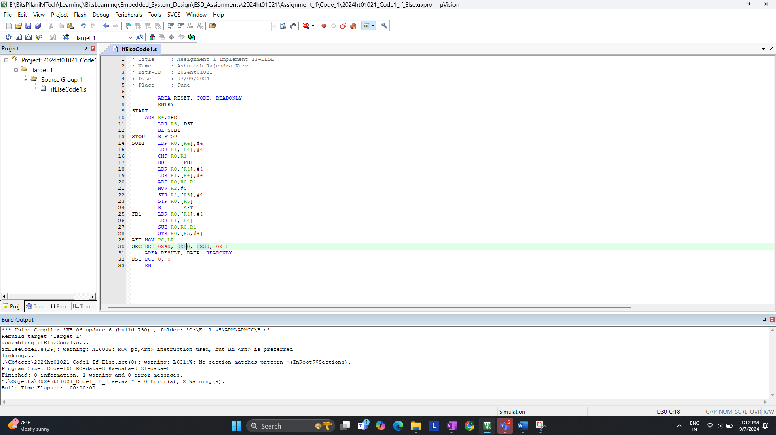

Debugging and added breakpoints

Branch Taken  
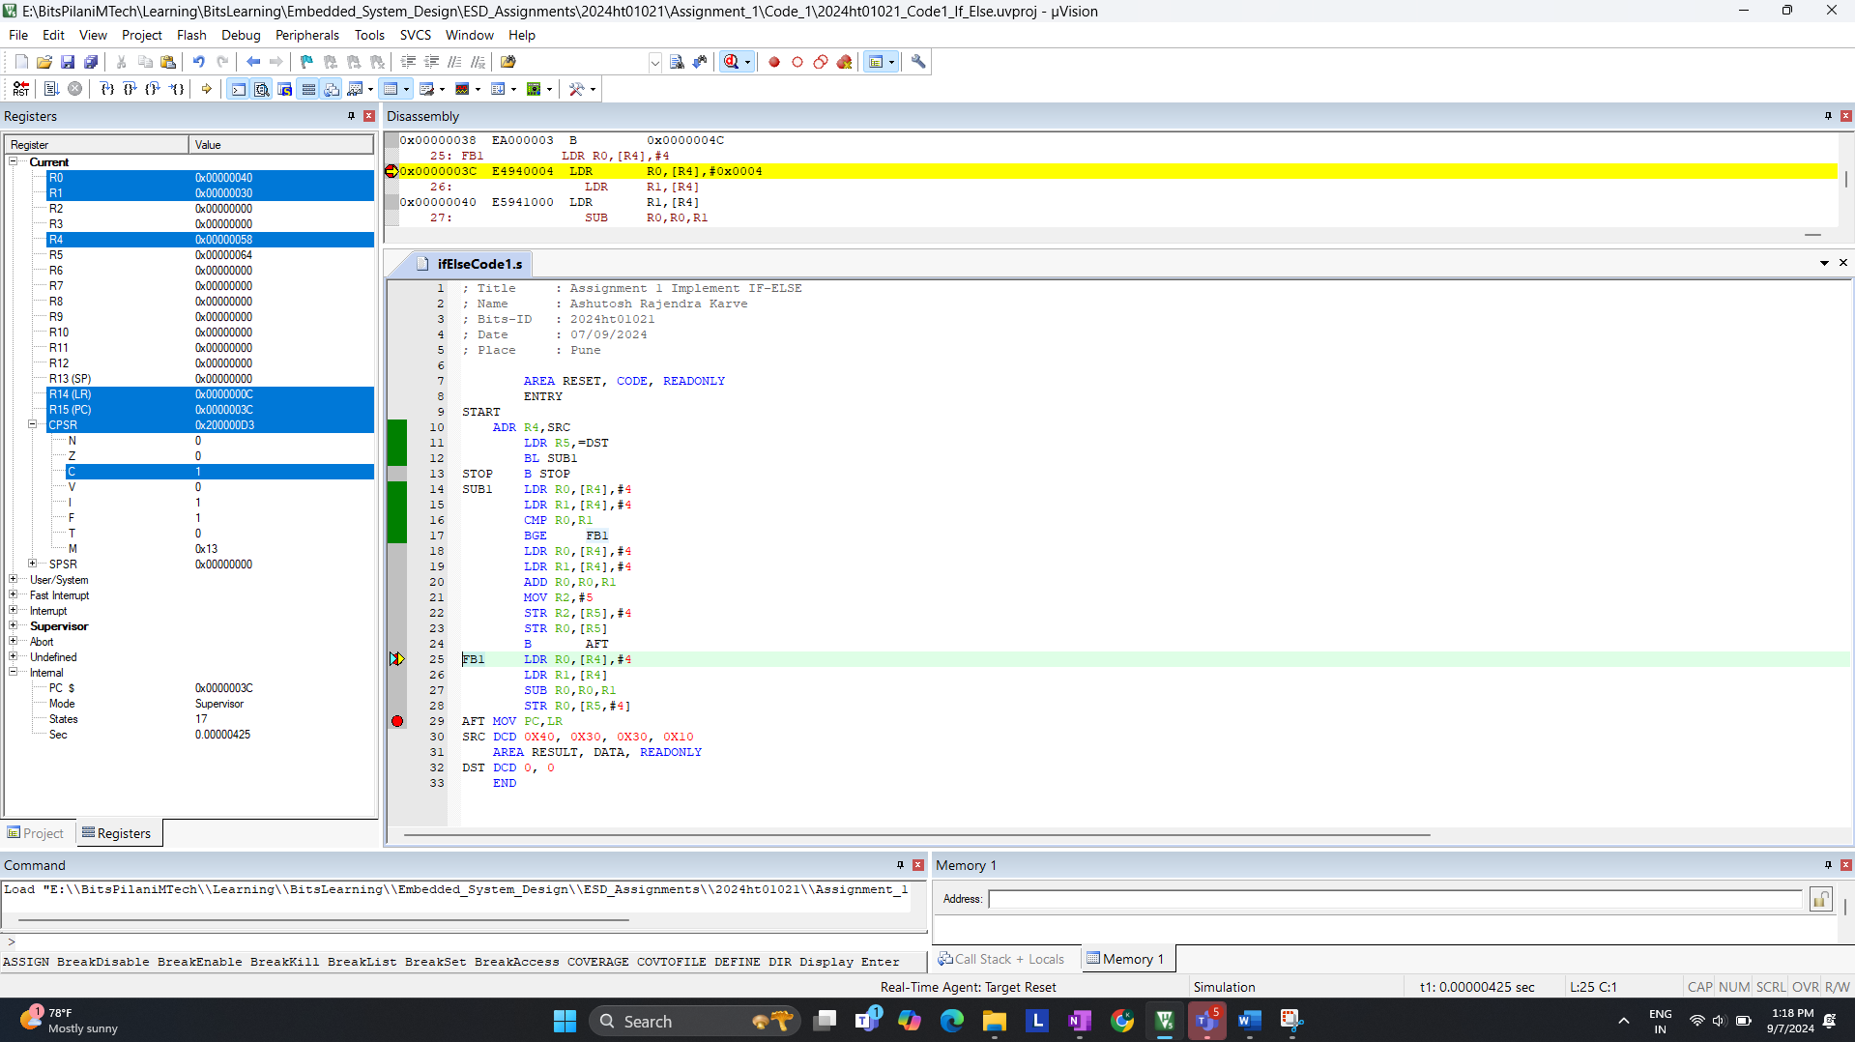

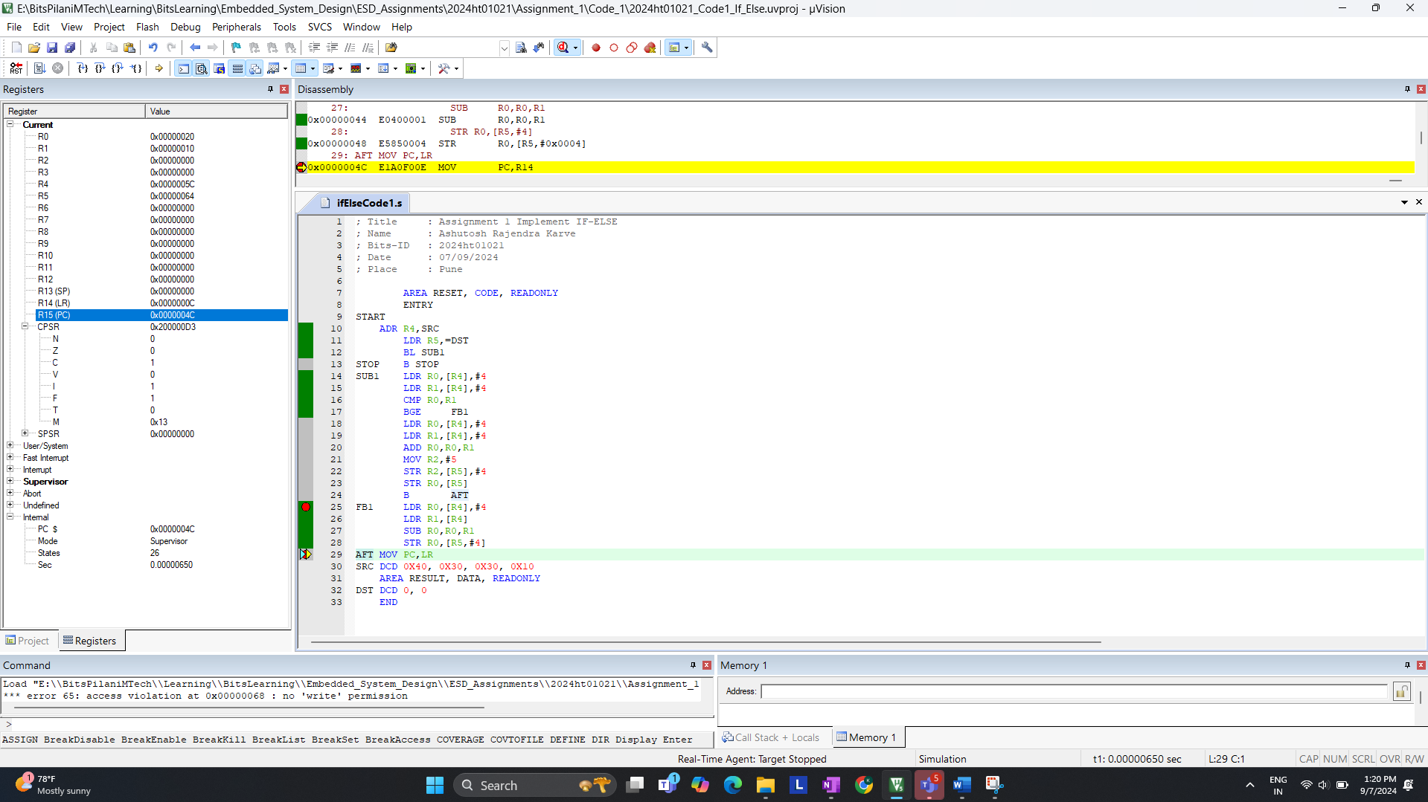

Branch not taken

Answer:

* Branch Taken: The instruction takes 29 cycles when the branch is taken.
* Branch not Taken: The instruction takes 33 cycles when the branch is not taken.