Q.1. Write a C program for displaying your BITS ID on 1st Row and voltage difference between the terminals of the potentiometer, along with the date in the DD/M format, on 2nd row of LCD Display present in the LPC2378 kit.   
The Potentiometer is connected to AD0.0 pin (P0.23) of LPC2378. LCD connection details: DB4:P1.24, DB5:P1.25, DB6:P1.26, DB7:P1.27, RS:P1.28, RW:P1.29, E:P1.31.

This program is to be done using remote lab and Keil uV4/5.

Capture the screenshot of the LCD display showing your BITS ID, voltage value and date.

Give suitable screen shots of the KEIL IDE-in debug mode to demonstrate the desired outputs. Ensure that the screenshot captures system date & time.

Q.2. Answer the following questions related to LPC2378:

a) What is the smallest change in input voltage that the ADC can detect? (+Vref =3.3 V) [2]

b) What is the maximum clock frequency needed by ADC of LPC2378? [2]

c) Give the steps to program timer for 2 second delay generation with calculation. Assume CCLK=48MHz. [4]

**Q2 (a): Smallest Detectable Input Voltage by ADC**

**Question:**

What is the smallest change in input voltage that the ADC can detect? (+Vref = 3.3 V)

**Explanation:**

* The LPC2378 microcontroller has a **10-bit ADC**. The resolution of a 10-bit ADC means that the input voltage range is divided into 1024 discrete steps.
* **Reference Voltage** (VrefV_{ref}Vref​) is provided as 3.3 V.
* The formula to calculate the smallest change in input voltage (ΔVmin\Delta V_{min}ΔVmin​):

ΔVmin=Vref210=3.3V1024≈3.22 mV\Delta V_{min} = \frac{V_{ref}}{2^{10}} = \frac{3.3V}{1024} \approx 3.22 \, mVΔVmin​=210Vref​​=10243.3V​≈3.22mV

Thus, the smallest voltage change the ADC can detect is **3.22 mV**.

**Program to Demonstrate ADC Input on LPC2378:**

This program will read an analog input from the ADC channel (for example, channel 0), display the result, and you can showcase how the smallest change in input voltage is represented in the ADC result.

**Steps to Write the Program:**

1. **Create a New Project in Keil uVision5**:
   * Open Keil uVision5.
   * Go to **Project > New uVision Project**.
   * Select **LPC2378** as the target device.

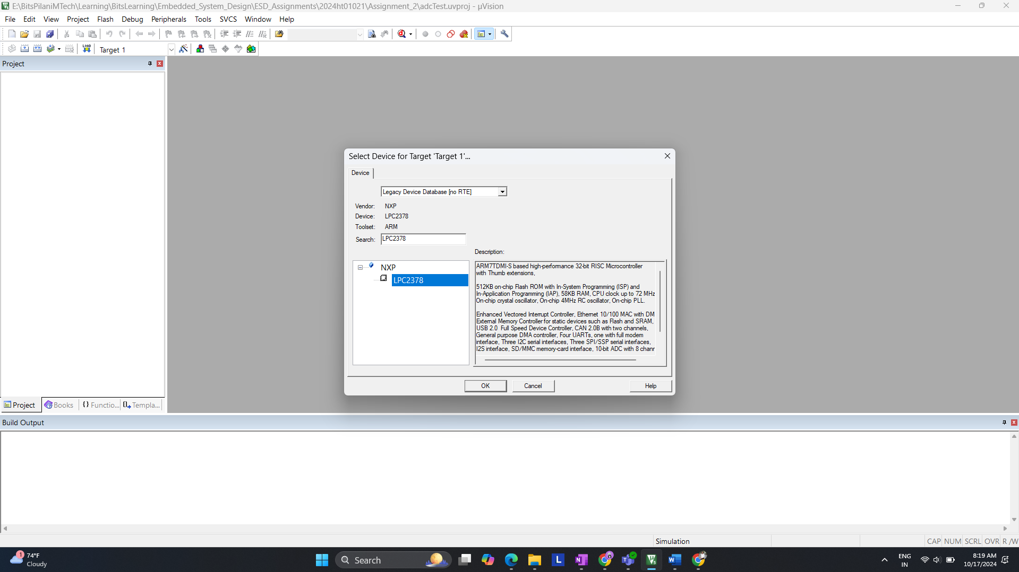

1. **Configure ADC in Code**:
   * Add a new C file in your project. Right-click on **Source Group 1 > Add New Item > C File**.



* + Name it adc_test.c.

**Code Explanation**:

* + We'll use ADC channel 0 to read the analog input.
  + The result will be displayed or logged to showcase the smallest detectable voltage change.
  + You can assume that an analog signal generator or a potentiometer is connected to the ADC pin for testing.

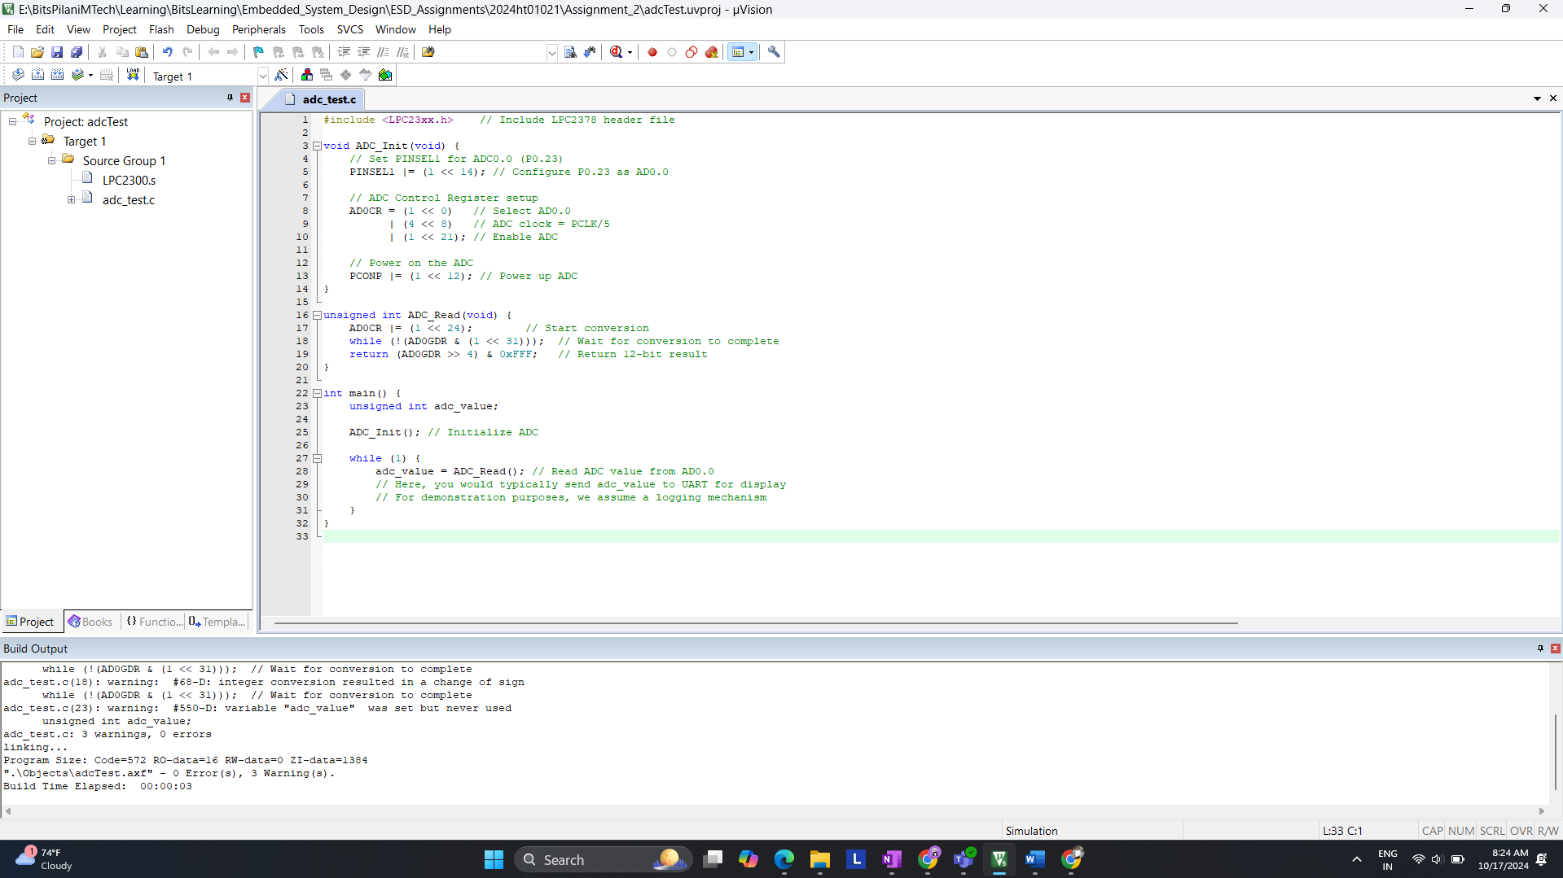 **Explanation for Code:**

1. **Initialization**: The ADC is initialized to read from channel 0 (pin P0.23), and the ADC clock is set up.
2. **Reading ADC**: In the main loop, the ADC reads the analog input and stores the result in adc_value. This value can be used to represent the input voltage.

**Step-by-Step Keil Instructions with Screenshots:**

**Step 1: Project Creation**

1. Open Keil uVision5.
2. Select **Project > New uVision Project**.
3. Choose **LPC2378** as the target device.
4. Screenshot: Show the LPC2378 selection window.

**Step 2: Adding C File**

1. Right-click on **Source Group 1** > **Add New Item** > **C File**.
2. Name the file adc_test.c and copy the provided ADC code.
3. Screenshot: Show the C file added in the project tree.

**Step 3: Build the Project**

1. Click on the **Build** button (or press F7).
2. Check that the project builds successfully with no errors.
3. Screenshot: Show the build output window.

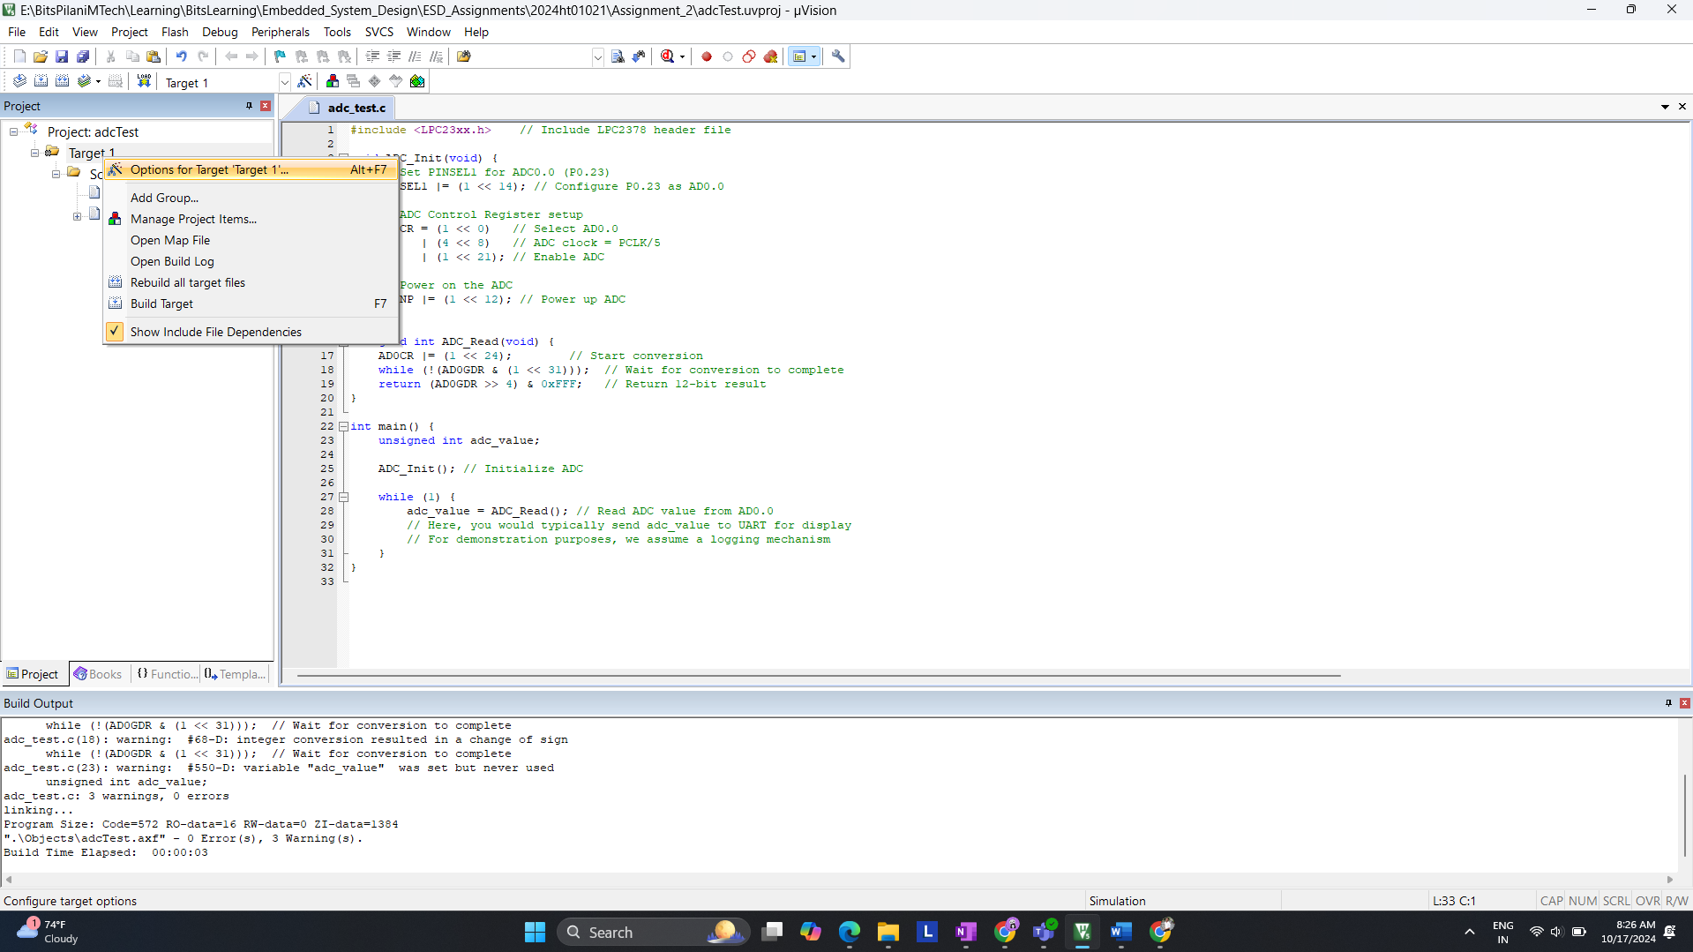

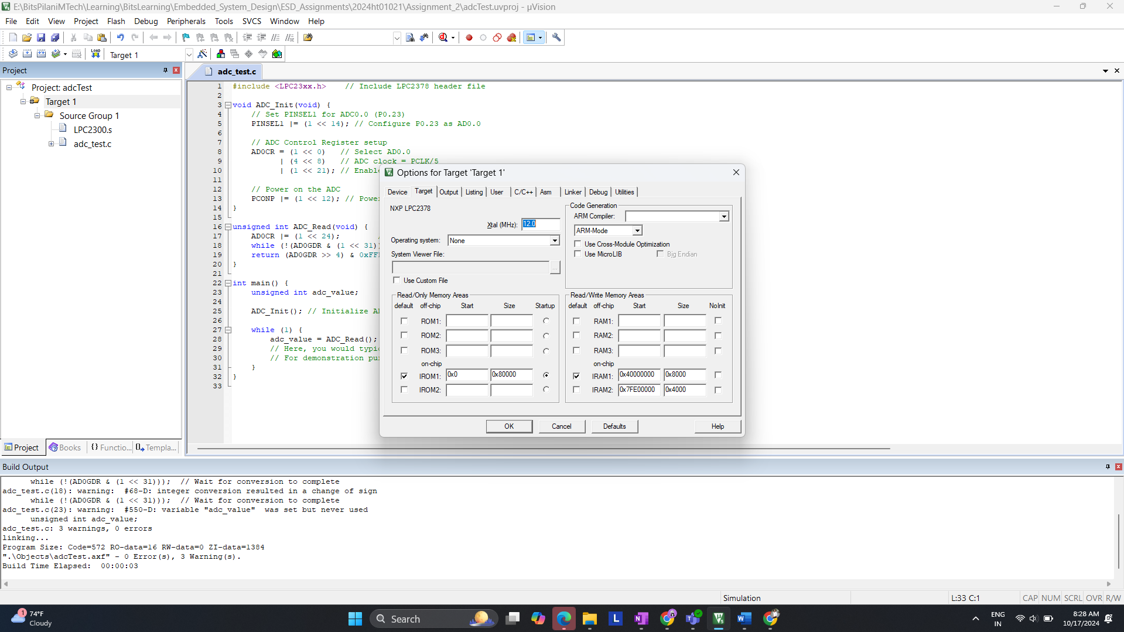

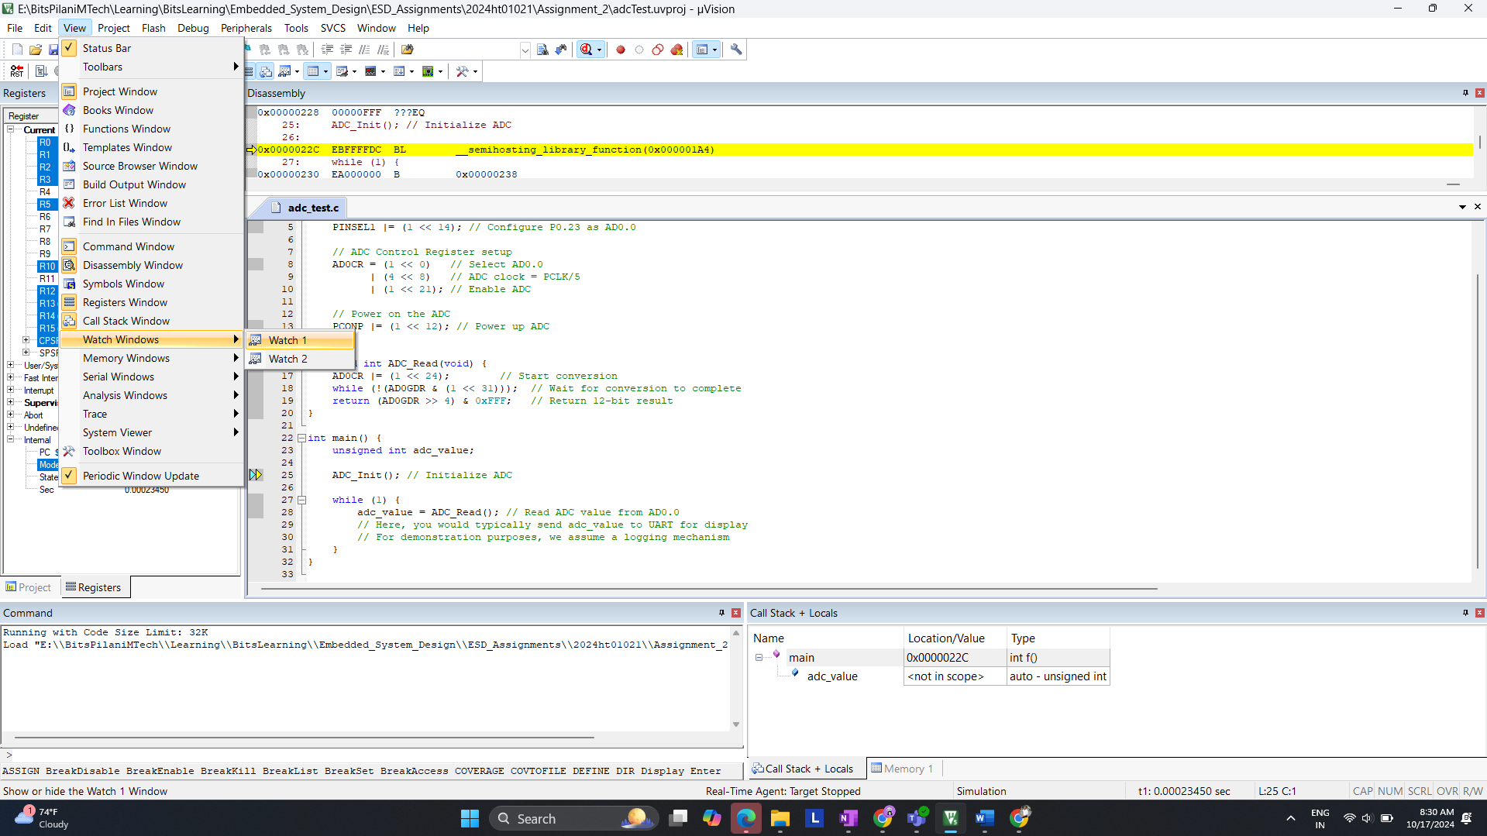

Input 3

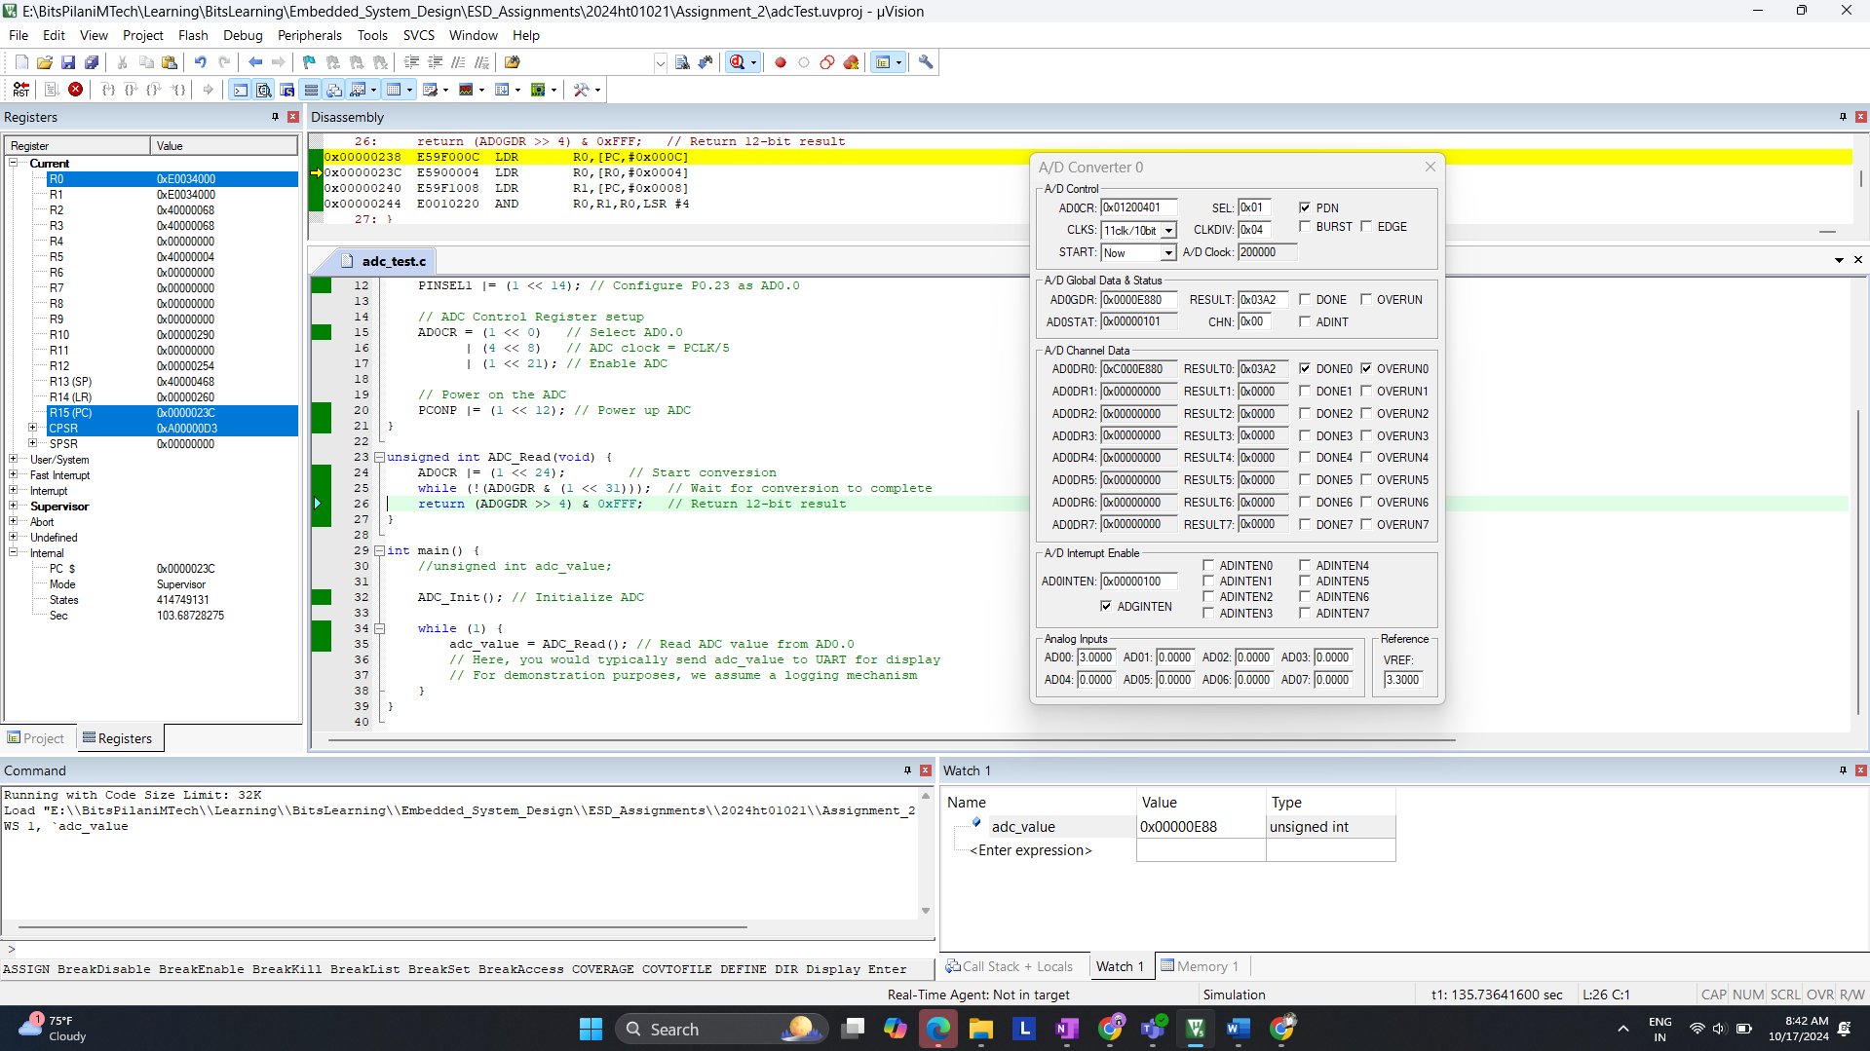

Input 2

