RTS Assignment 01

PART A

Question 1: Rate Monotonic Scheduling (RMS) Analysis
Calculate the CPU utilization for each task and determine if the set is schedulable using RMS.

Given task set:
- T1: Period = 4 ms, Execution time = 1 ms >> Utilization UT1 = 0.25
- T2: Period = 5 ms, Execution time = 2 ms >> Utilization UT2 = 0.4
- T3: Period = 10 ms, Execution time = 3 ms >> Utilization UT3 = 0.3
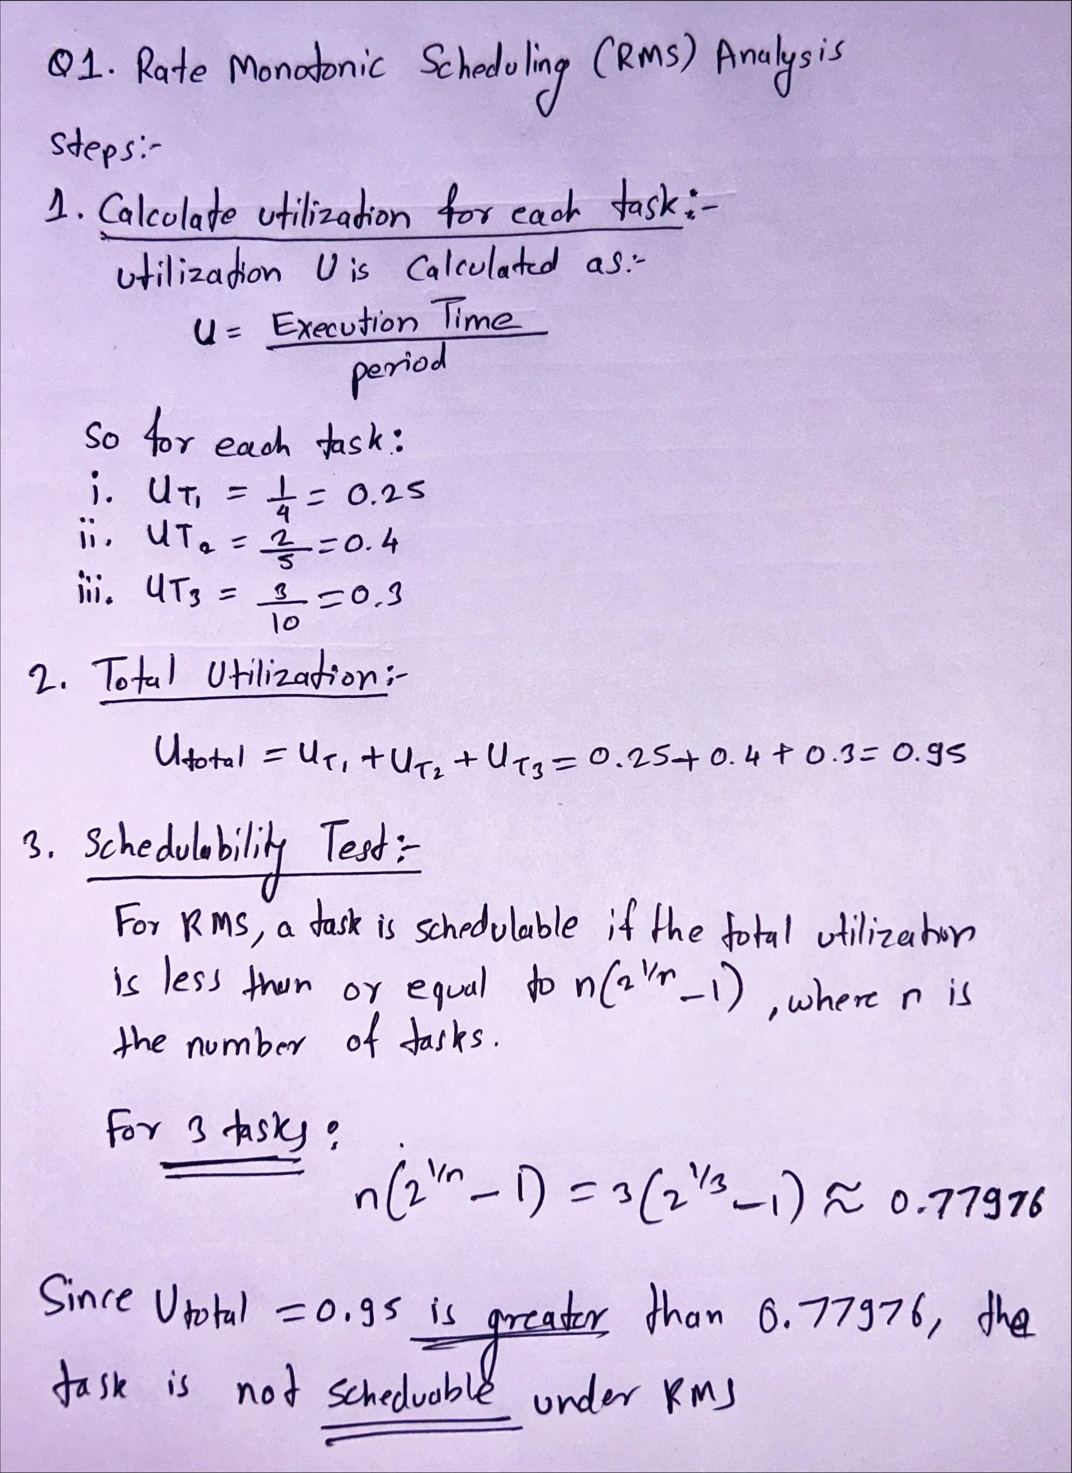
Question 2: Earliest Deadline First (EDF) Scheduling
Calculate the response time for each task and determine if they are schedulable under EDF.

Task Set Description:
In this task set, we are given three periodic tasks, each with its own period, execution time, and deadline:
Task | Period (ms) | Execution Time (ms) | Deadline (ms)
T1 | 4 | 1 | 4
T2 | 5 | 2 | 5
T3 | 6 | 1 | 6

Cheddar real-time scheduling simulator to schedule the task set using EDF.
The task parameters (period, execution time, and deadlines) were input into the simulator, and the processor was configured to use the Earliest Deadline First (EDF) scheduling policy. The simulation was run over a hyperperiod of 60 ms (the least common multiple of the task periods).
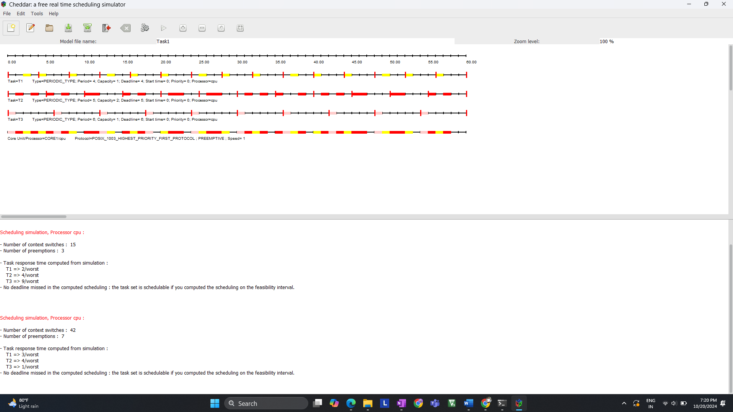

Gantt Chart:
Below is the Gantt chart generated by the Cheddar simulator for the EDF scheduling:
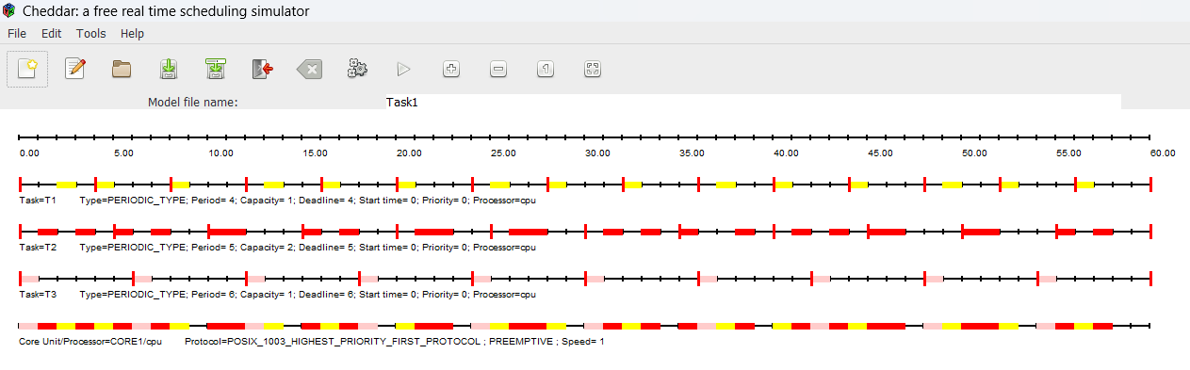
The Gantt chart shows how the tasks are scheduled over time based on their deadlines:
- Task T1: Since it has the shortest period (4 ms), it is scheduled frequently and completes its execution before its 4 ms deadline.
- Task T2: T2 is scheduled less frequently than T1 but still completes its execution before its 5 ms deadline.
- Task T3: T3 has the longest period (6 ms) but is scheduled in between T1 and T2 as per its deadline.
Response Time and Schedulability:
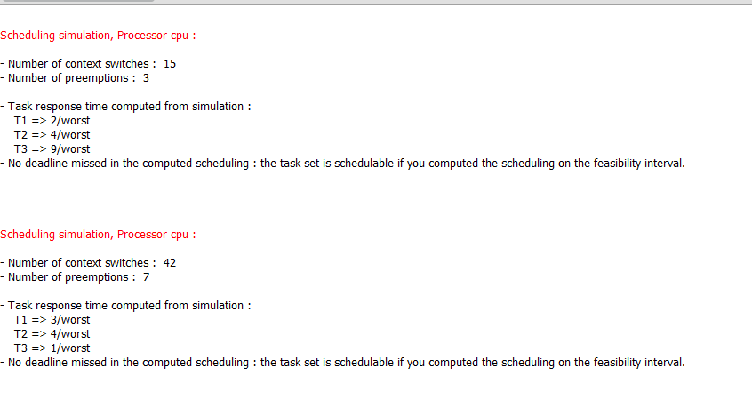
The simulator calculated the worst-case response times for each task. The response time is defined as the time from the task’s release to the time when it completes its execution. The worst-case response times observed are as follows:
Task | Worst-Case Response Time (ms)
T1 | 3
T2 | 4
T3 | 9 (in one run) / 1 (in another run)

- T1: The worst-case response time for T1 is 3 ms, which is less than its deadline of 4 ms, meaning T1 meets its deadline.
- T2: T2’s worst-case response time is 4 ms, less than its deadline of 5 ms, so it also meets its deadline.
- T3: T3's response time varies between 9 ms and 1 ms, depending on the scheduling scenario, but it still meets its deadline of 6 ms in both cases.
No deadlines were missed in the computed scheduling, confirming that the task set is schedulable under EDF.
The task set was successfully scheduled under EDF without missing any deadlines, as confirmed by the Gantt chart and the response time analysis. Despite the dynamic nature of EDF, which results in context switches and preemptions, the scheduling algorithm was able to meet all task deadlines, proving that the task set is schedulable under EDF.

Question 3 Calculate the worst-case response time for each task using a priority scheduling algorithm.

Given Task Set:
Task | Priority (Higher number = Lower priority) | Period (ms) | Execution Time (ms) | Response Time (ms)
T1 | 1 (Highest Priority) | 6 | 2 | 2
T2 | 2 | 8 | 3 | 5
T3 | 3 (Lowest Priority) | 10 | 1 | 6

We need to calculate the worst-case response time for each task, considering the given priorities. The higher the priority number, the lower the task priority.
We will use the response-time analysis (RTA) method, which accounts for the interference from higher-priority tasks. The worst-case response time (Ri) for a task iii is calculated iteratively using:
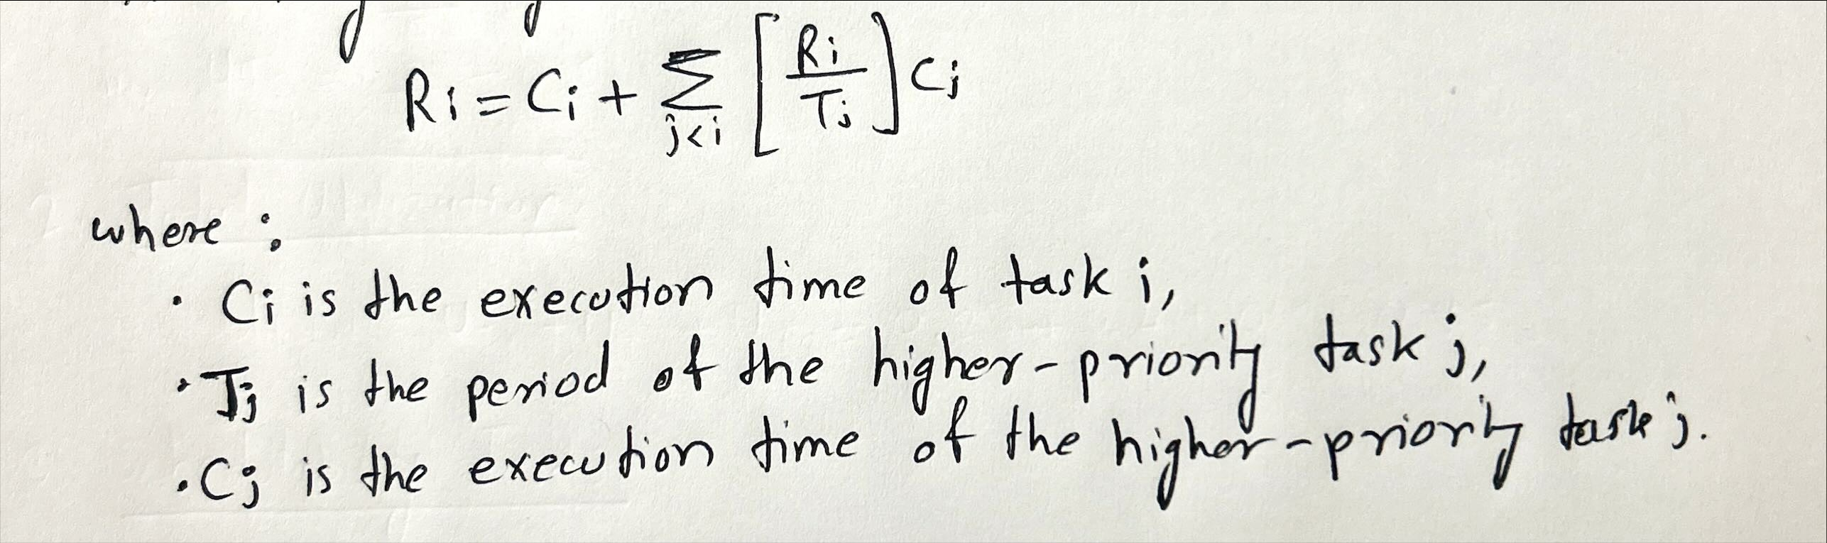

Step 1: Calculate Response Time for Task T1 (Highest Priority)
- T1 has the highest priority (priority = 1), so it is not delayed by any other tasks.
- Therefore, the response time for T1 is simply its execution time:
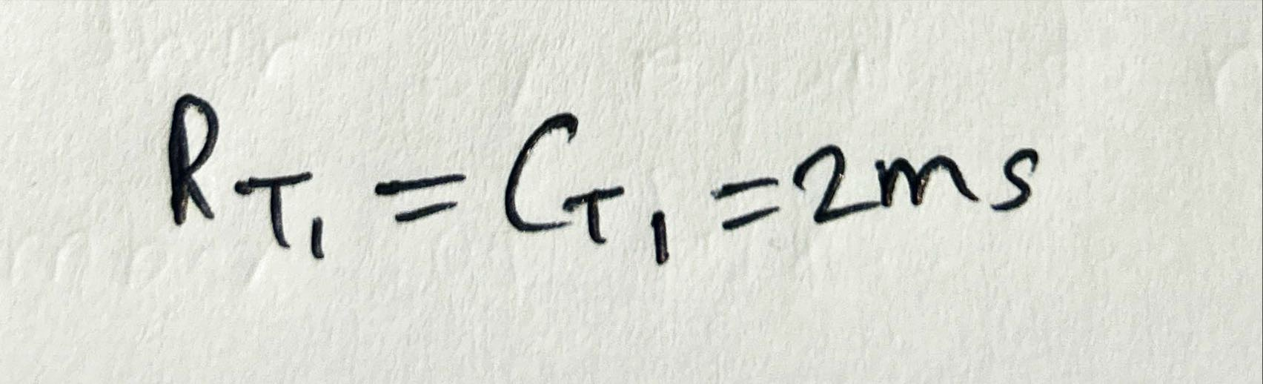

Step 2: Calculate Response Time for Task T2
- T2 has lower priority than T1, so it can be delayed by T1.
- We calculate the worst-case response time for T2 using the iterative formula.
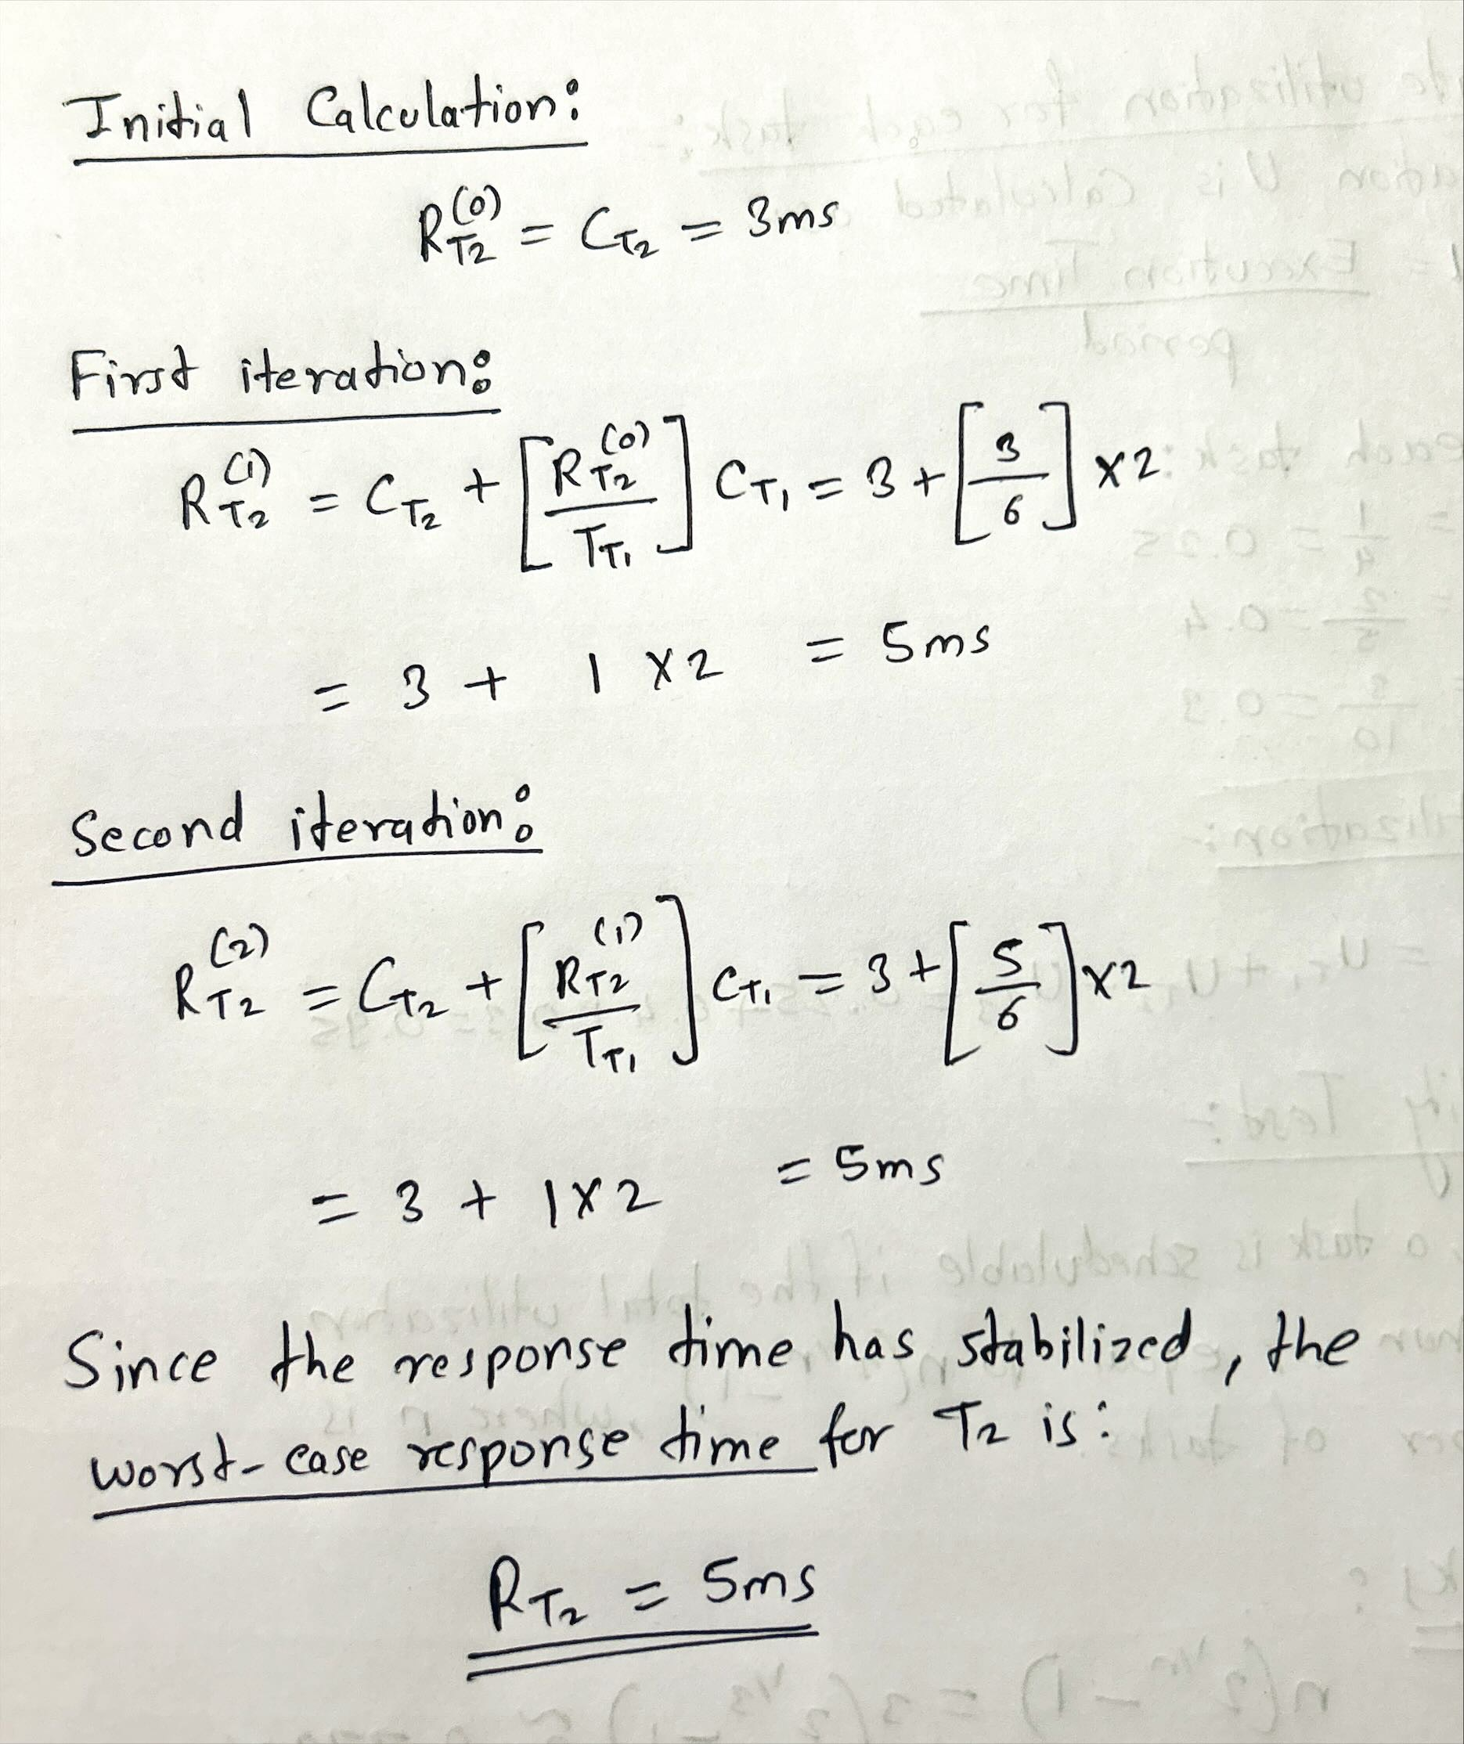

Step 3: Calculate Response Time for Task T3
- T3 has the lowest priority, so it can be delayed by both T1 and T2.
- We calculate the worst-case response time for T3.
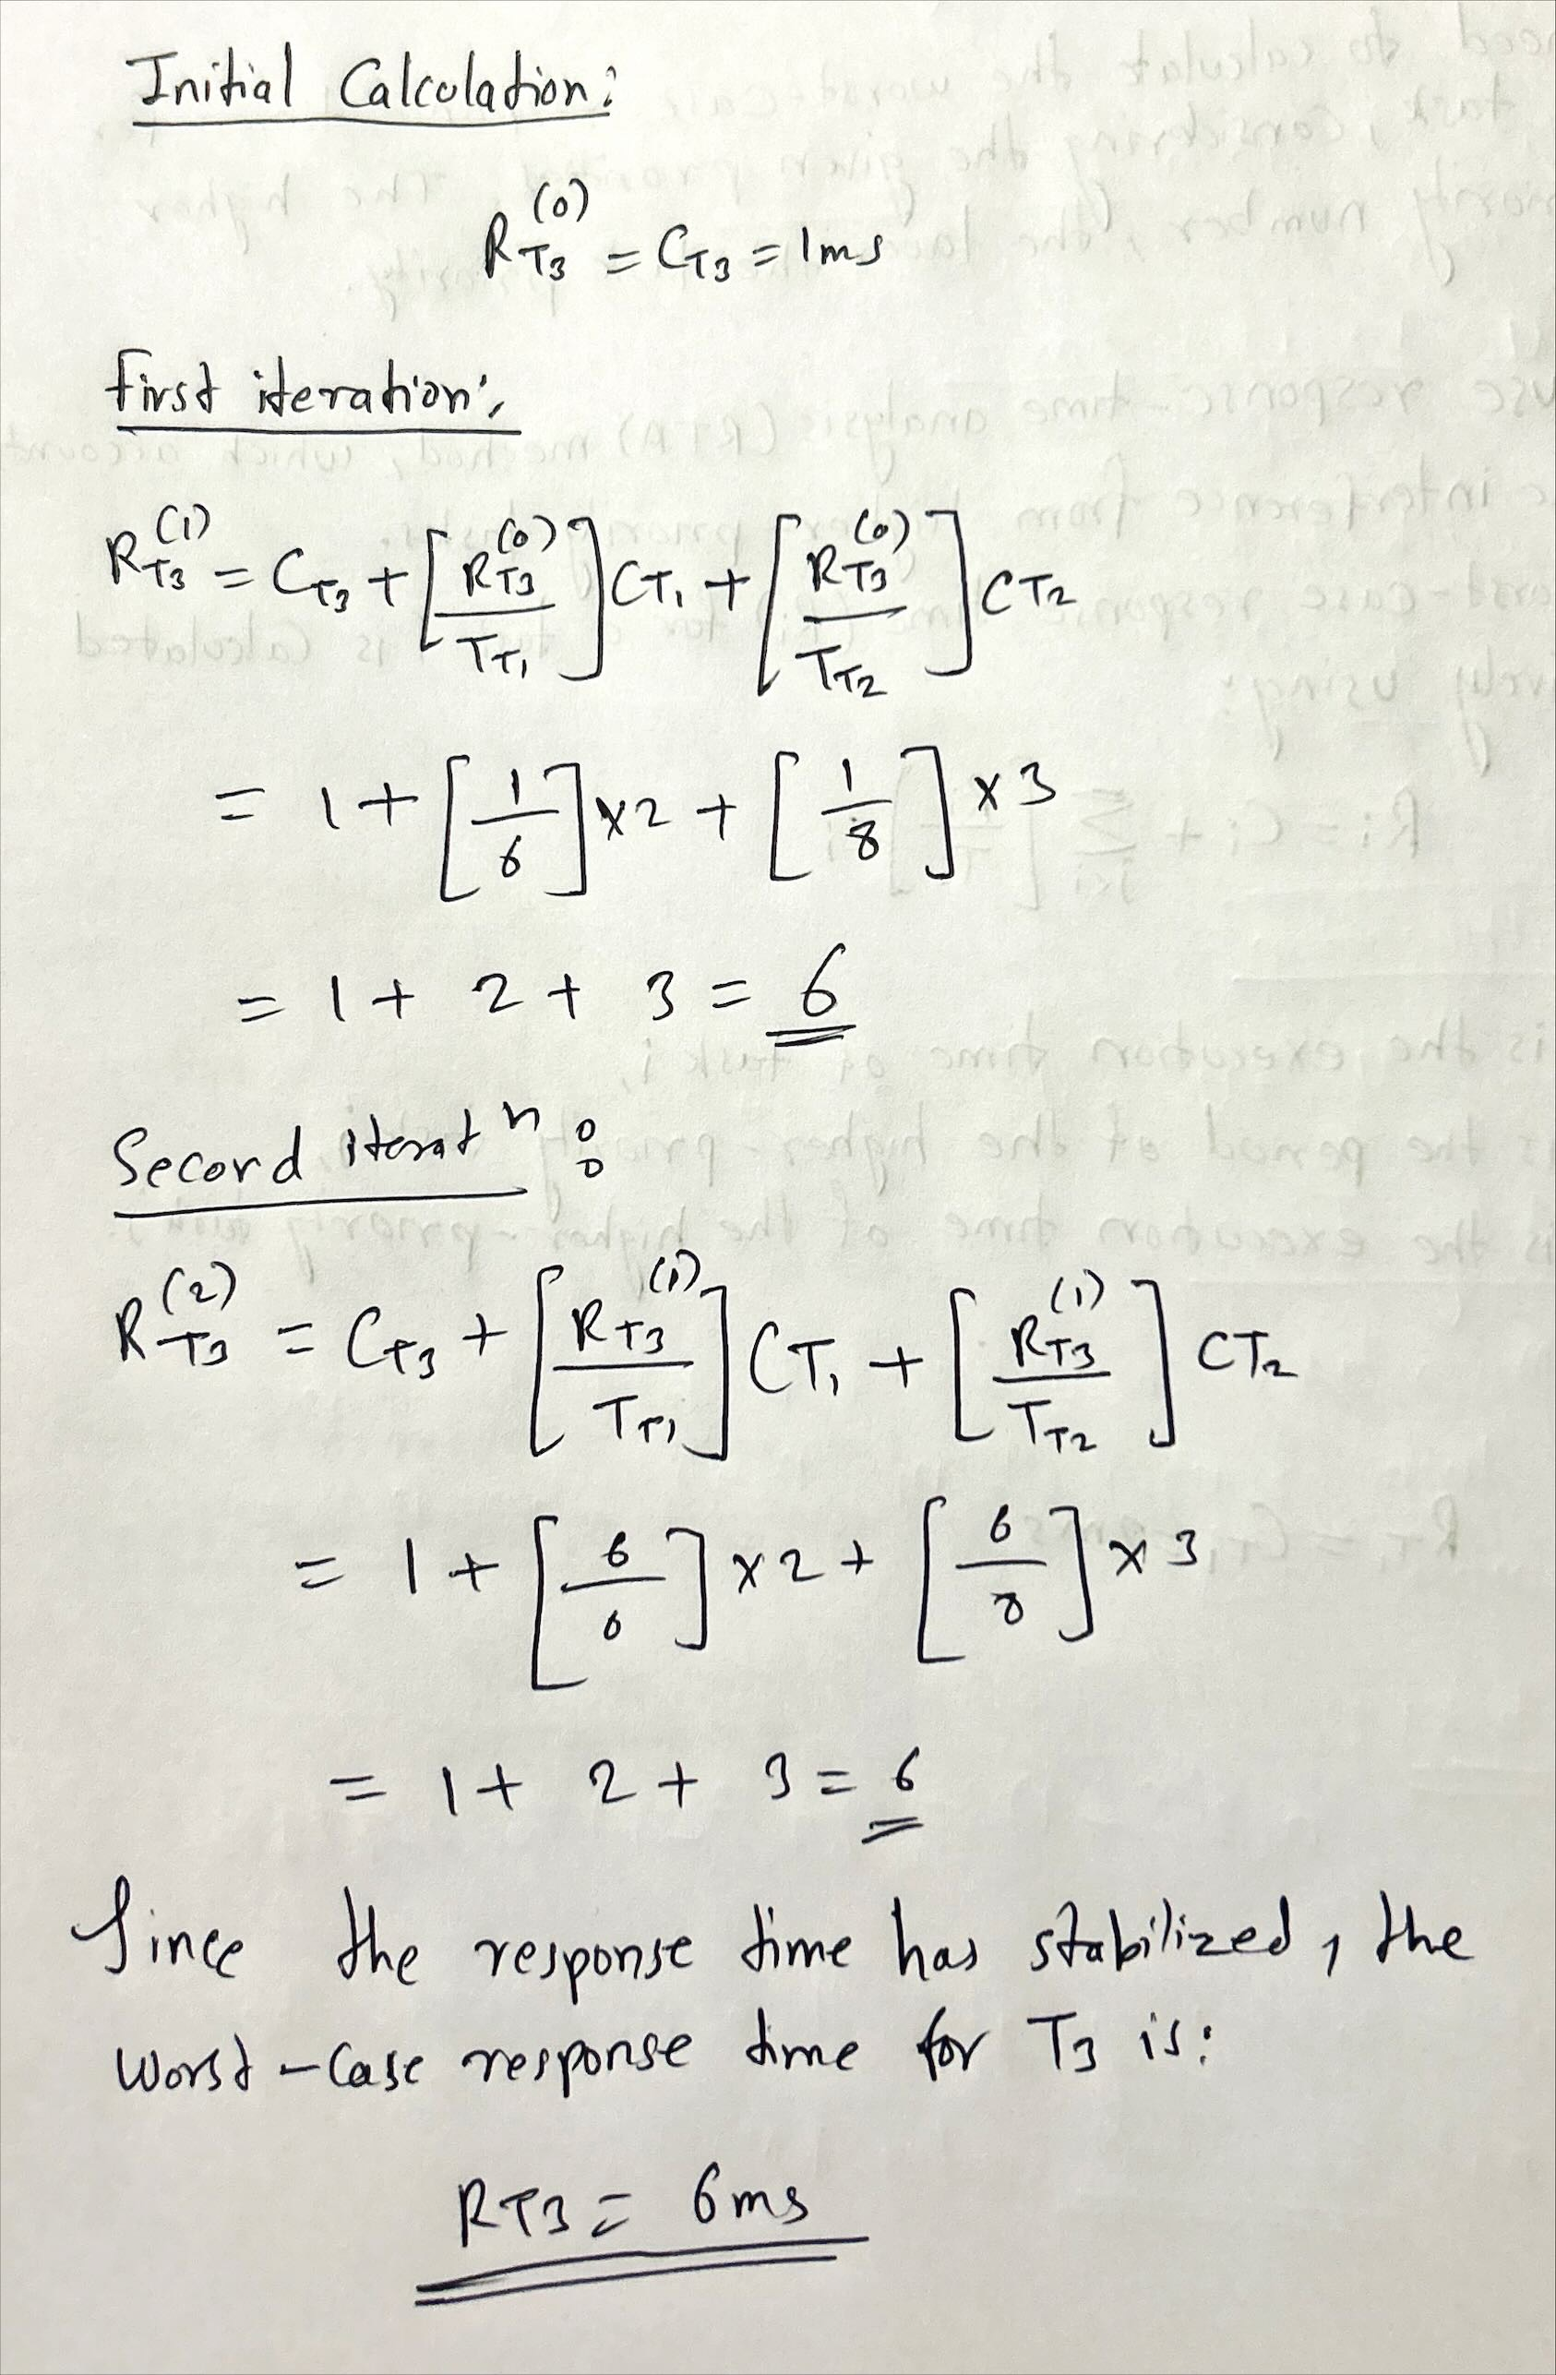
Final Worst-Case Response Times:
Task | Worst-Case Response Time (ms)
T1 | 2
T2 | 5
T3 | 6

- T1 completes its execution in 2 ms, which is less than its period of 6 ms.
- T2 completes its execution in 5 ms, which is less than its period of 8 ms.
- T3 completes its execution in 6 ms, which is less than its period of 10 ms.
Since all tasks complete within their periods, the task set is schedulable using the given priority scheduling.

Question 4: Context Switching Impact.
Given Task Set:
Task | Period (ms) | Execution Time (ms) | Context Switches | Effective Execution Time (ms)
T1 | 5 | 2 | 1 | 3
T2 | 10 | 3 | 1 | 4
T3 | 15 | 4 | 2 | 6

calculate the effective execution time for each task, which is the task's execution time plus the overhead caused by context switching.
For each task, the effective execution time is the sum of the task's execution time and the product of the context switch time and the number of context switches.
Given that the context switch time is 1 ms, the formula becomes:
Effective Execution Time=Execution Time+(Context Switches×Context Switch Time)
Where the Context Switch Time is 1 ms.
Calculation:
- For Task T1:
  - Execution Time = 2 ms
  - Context Switches = 1
  - Effective Execution Time:
Effective Execution Time = 2 + ( 1 × 1 ) = 2 + 1 = 3 ms
- For Task T2:
  - Execution Time = 3 ms
  - Context Switches = 1
  - Effective Execution Time:
Effective Execution Time = 3 + ( 1 × 1 ) = 3 + 1 = 4 ms
- For Task T3:
  - Execution Time = 4 ms
  - Context Switches = 2
  - Effective Execution Time:
Effective Execution Time = 4 + ( 2 × 1 ) = 4 + 2 = 6 ms

- The effective execution time for each task is the sum of the actual execution time and the overhead caused by context switching.
- T1 has an effective execution time of 3 ms, T2 has 4 ms, and T3 has 6 ms, considering the 1 ms context switch overhead for each context switch.

Question 5: Missed Deadlines in a Hyperperiod.
Given Task Set:
Task | Period (ms) | Execution Time (ms) | Number of Deadlines in Hyperperiod (30 ms) | Deadlines Missed
T1 | 6 | 2 | ? | ?
T2 | 10 | 3 | ? | ?
T3 | 12 | 4 | ? | ?
We need to calculate the number of deadlines missed for each task in a hyperperiod of 30 ms.
Step 1: Number of Deadlines in the Hyperperiod:
The number of deadlines for each task within the 30 ms hyperperiod can be calculated by dividing the hyperperiod by the task's period.
Number of Deadlines=Hyperperiod/Task Period

- For Task T1:
  - Period = 6 ms
  - Hyperperiod = 30 ms
Number of Deadlines for T1 = 30 / 6 = 5
- For Task T2:
  - Period = 10 ms
  - Hyperperiod = 30 ms
Number of Deadlines for T2 = 30 / 10 = 3
- For Task T3:
  - Period = 12 ms
  - Hyperperiod = 30 ms
Number of Deadlines for T3 = 30 / 12 = 2.5 ⇒ 2 deadlines
Step 2: Check for Missed Deadlines:
We will check whether any deadlines are missed by considering whether the task can finish execution before its next deadline, assuming no preemption for this calculation.
- For Task T1:
  - Execution Time = 2 ms
  - Since T1 has a period of 6 ms and an execution time of 2 ms, it will easily meet each of its 5 deadlines in the 30 ms hyperperiod.
  - Deadlines Missed = 0

- For Task T2:
  - Execution Time = 3 ms
  - T2 has a period of 10 ms and an execution time of 3 ms. It will also meet all 3 of its deadlines within its periods without missing any deadlines.
  - Deadlines Missed = 0
- For Task T3:
  - Execution Time = 4 ms
  - T3 has a period of 12 ms and an execution time of 4 ms. Since it completes execution before each deadline within its period, it will meet both of its deadlines within the 30 ms hyperperiod.
  - Deadlines Missed = 0

Final Table:
Task | Period (ms) | Execution Time (ms) | Number of Deadlines in Hyperperiod (30 ms) | Deadlines Missed
T1 | 6 | 2 | 5 | 0
T2 | 10 | 3 | 3 | 0
T3 | 12 | 4 | 2 | 0
- No deadlines are missed for any of the tasks in the 30 ms hyperperiod.
- All tasks complete their execution within their periods, ensuring they meet their deadlines.

PART B

Question 1 and set up the tasks in Cheddar step by step for both non-preemptive and preemptive priority-driven scheduling.

Task Graph:
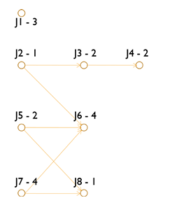
The task graph includes 8 tasks (J1 to J8) with the following characteristics:
- We have eight aperiodic tasks (J1 to J8) with a deadline of 12 ms.
- All tasks except J5 are released at 0 ms, while J5 is released at 4 ms.
- Tasks have descending priority from J1 (highest) to J8 (lowest).
- The scheduling is done on a processor with dual identical cores, and jobs can migrate between cores at any time.
- The goal is to compare non-preemptive priority-driven scheduling and preemptive priority-driven scheduling and determine which performs better.

Core and Processor Configuration:
I first set up the cores and then assigned them to the processor. Below are the detailed steps with screenshots.
Step 1: Core Setup
- Core1 Configuration:
  - Name: CORE1
  - Scheduler Type: Posix 1003 Highest Priority First Protocol
  - Preemptive Type: Set to Non-Preemptive
  - Quantum: 0
  - Speed: 1
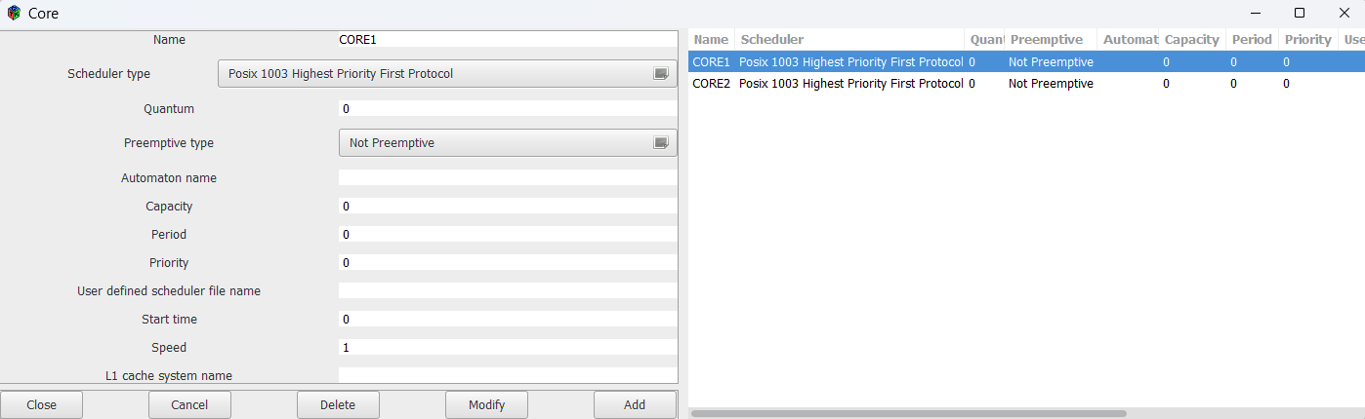
- Core2 Configuration:
  - Name: CORE2
  - Scheduler Type: Same as CORE1: Posix 1003 Highest Priority First Protocol
  - Preemptive Type: Set to Non-Preemptive
  - Quantum: 0
  - Speed: 1
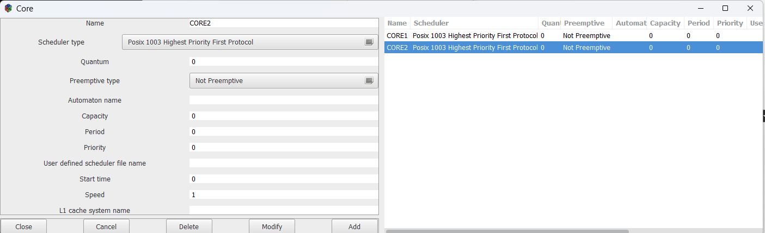

Step 2: Processor Setup
Once both cores are created, we configure the processor to manage these cores.
- Processor Name: cpu
- Processor Type: Set to Identical Multicores Type (dual-core).
- Migration Type: Set to Job Level Migration Type (allows jobs to migrate between the two cores).
- Cores Added: Both CORE1 and CORE2 were added to the processor.
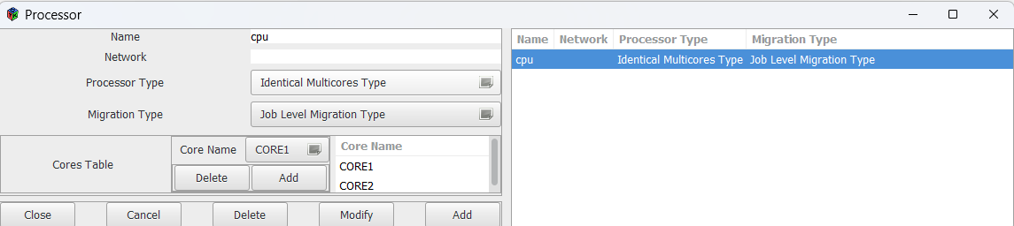
This setup ensures that tasks can run on dual cores with non-preemptive scheduling and can migrate between cores if necessary.

Step 3: Address Space Configuration:
I have configured the address space for the processor. The current configuration is as follows:
- Processor Name: cpu
- Scheduler Type: Set to No Scheduling Protocol since no specific memory-related scheduling is required for this task.
- Preemptive Type: Since we are using Non-Preemptive Scheduling for this part of the task, ensure the Preemptive Type is set to Not Preemptive (to match the core settings).
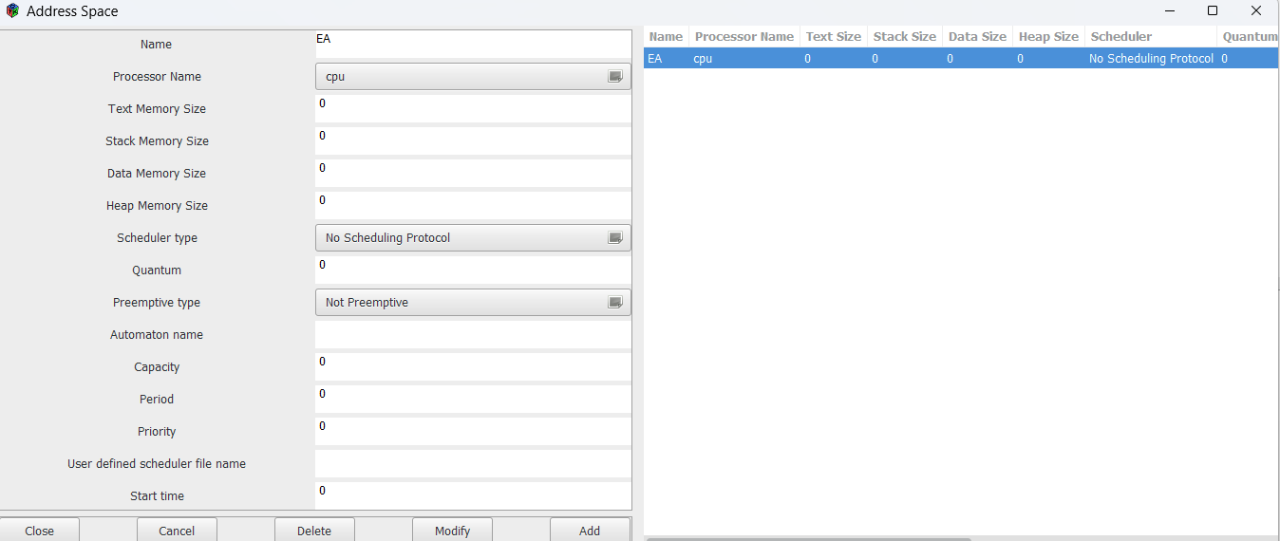
This configuration ensures that the address space settings are aligned with the processor's non-preemptive priority scheduling.

Step 4: Task Setup
In this step, the tasks J1 to J8 were configured with the following parameters:
- Task Type: Aperiodic
- Processor: CPU
- Address Space: EA
- Priority Levels: Based on their respective dependencies (J1 with the highest priority, J8 with the lowest)
- Policy: FIFO (First-In, First-Out)
- Capacity and Deadlines: The capacity and deadline values were set based on the task graph provided, ensuring the deadlines were achievable.
Tasks were configured using the FIFO scheduling policy to avoid the invalid priority error encountered with other policies.
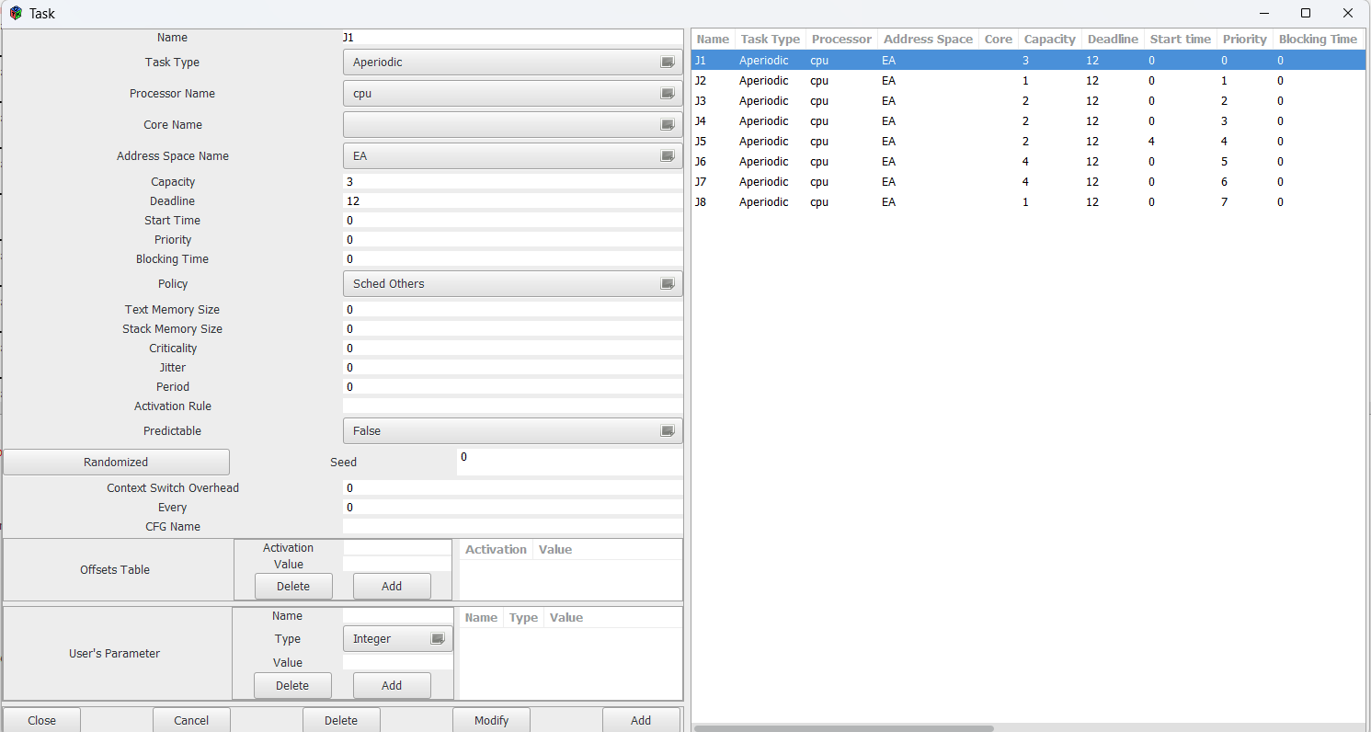
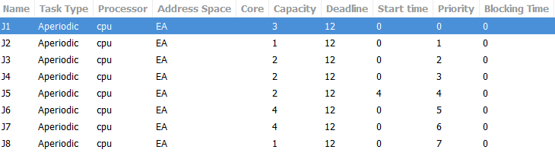

Step 5: Running the Scheduling Simulation
- Scheduling Setup: Before running the simulation, we defined the time interval for scheduling (in this case, from 0 to 12).
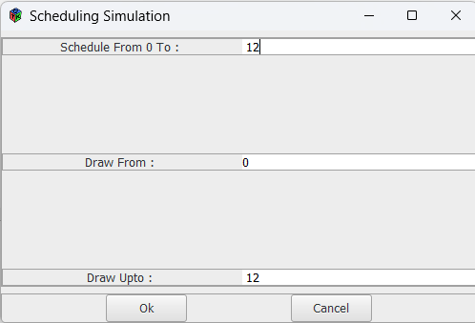
- Executing the Simulation: The Cheddar simulation tool was used to analyze task scheduling, showing the tasks distributed across the two cores (Core1 and Core2). The results of the simulation were displayed in the form of task Gantt charts for each task.
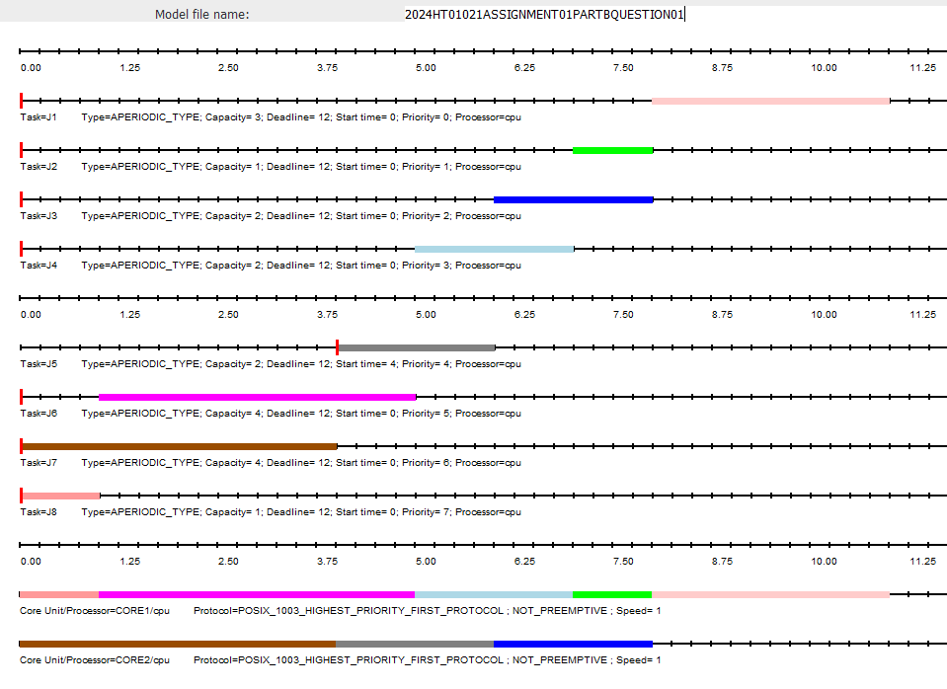
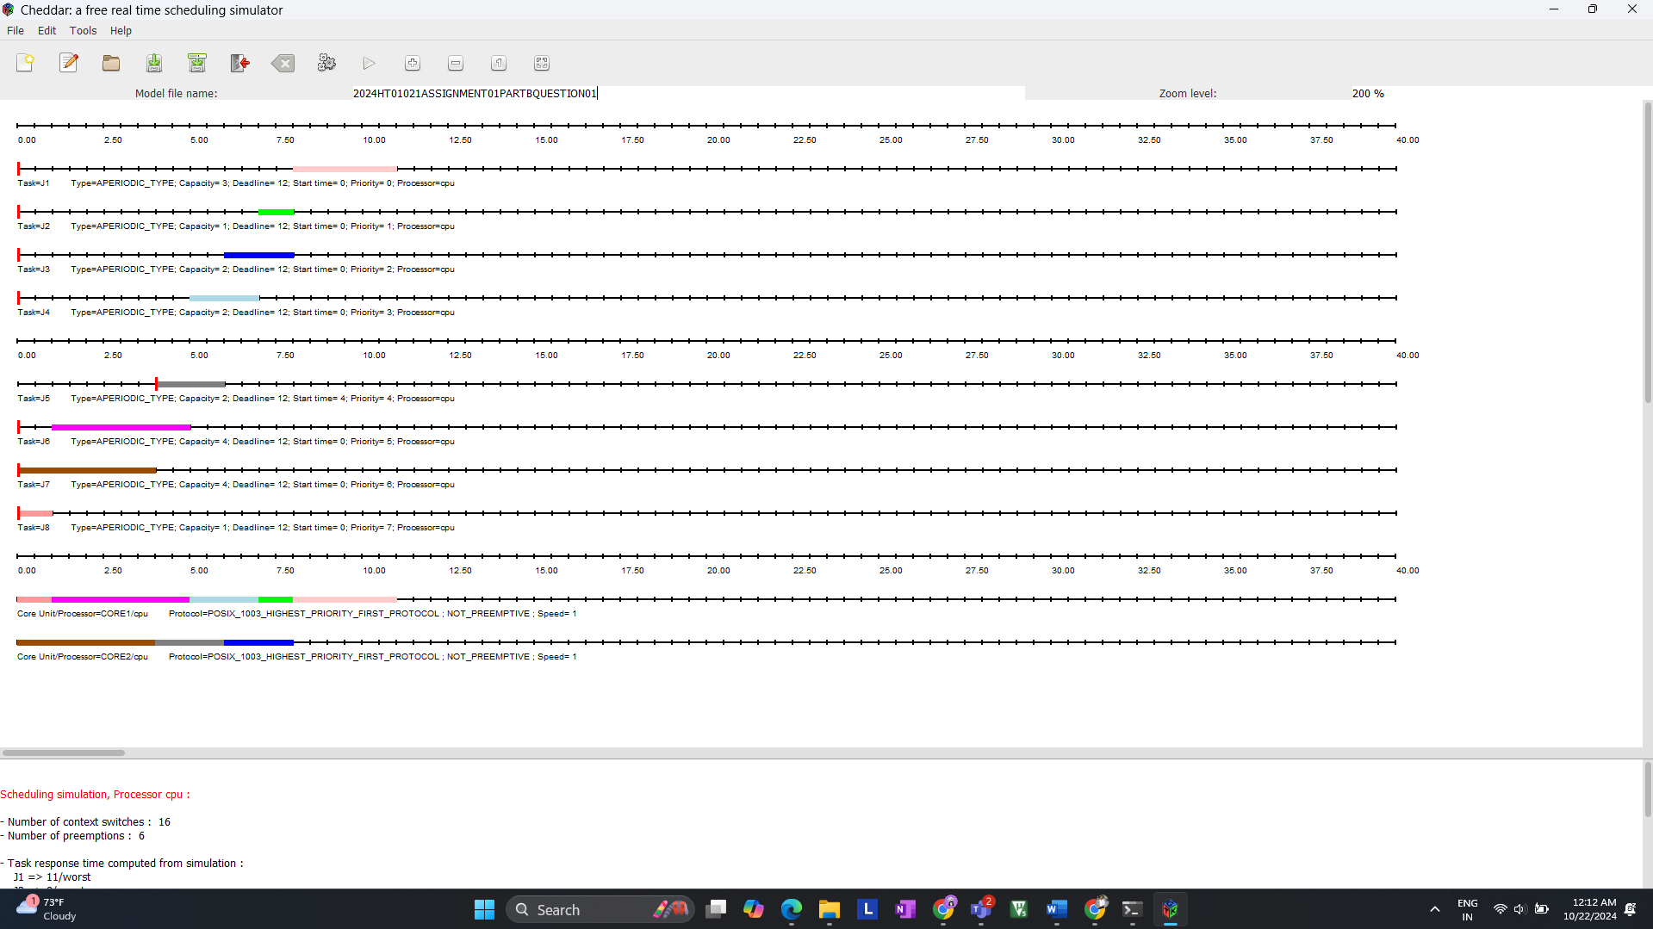

- Results and Analysis:
  - Number of context switches: 16
  - Number of preemptions: 6
  - Worst-case response times for each task were recorded. These results showed that no deadlines were missed, indicating that the task set is schedulable.
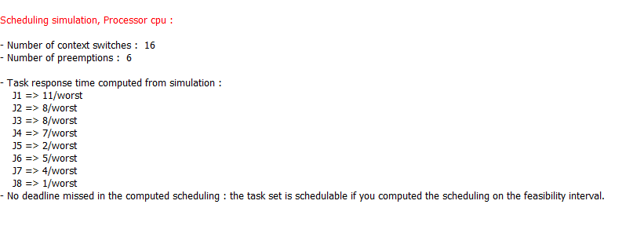
Step 6: Analyze and Interpret the Results
- Gantt Chart Review: After running the simulation, review the Gantt chart to ensure the tasks are scheduled without missing deadlines. Tasks should be divided appropriately between CORE1 and CORE2.
- Response Time Analysis: Analyze the worst-case response times of each task:
  - J1: 11ms
  - J2: 8ms
  - J3: 8ms
  - J4: 7ms
  - etc.
No deadlines were missed in this simulation.
- Conclusion: Conclude that the system is schedulable within the given deadline using the FIFO policy and non-preemptive protocol. Suggest improvements, such as exploring different scheduling policies or priority adjustments.

Q2: Show that the following tasks table is schedulable using EDF on a mono-core processor, if pre-emption is allowed but is not schedulable if pre-emption is not allowed. All tasks are aperiodic.
J1 | J2 | J3
r = 0 | r = 2 | r = 4
e = 3 | e = 6 | e = 4
d = 10 | d = 14 | d = 12

Step 1: Create Core and Processor for EDF
- Core Setup: Configure the core to use EDF (Earliest Deadline First) scheduling. We will set this up in both preemptive and non-preemptive modes.
Setup for FIRST SIMULATION
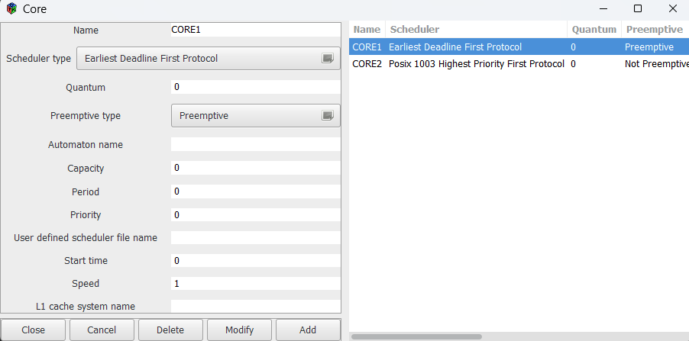
- Processor Setup: Configure the processor as a mono-core processor, so only one core will handle the tasks.
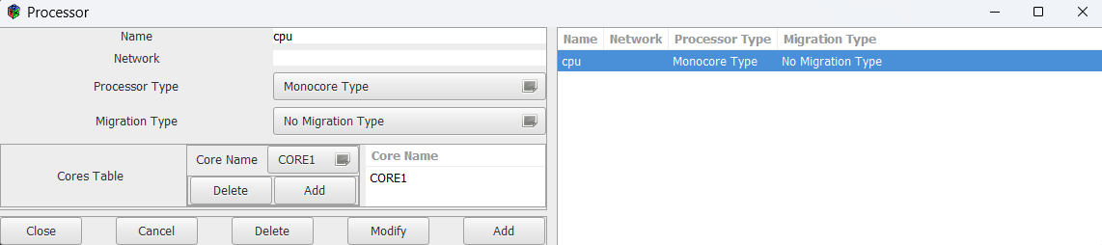

Step 2: Task Setup in Cheddar
We need to input the values for each task (J1, J2, J3). The values for each are as follows:
- J1:
  - Release Time = 0
  - Execution Time = 3
  - Deadline = 10
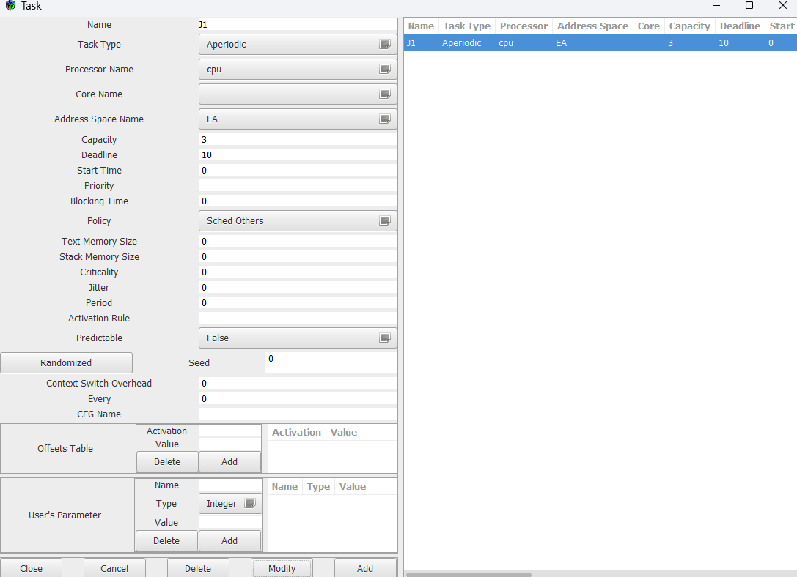
- J2:
  - Release Time = 2
  - Execution Time = 6
  - Deadline = 14
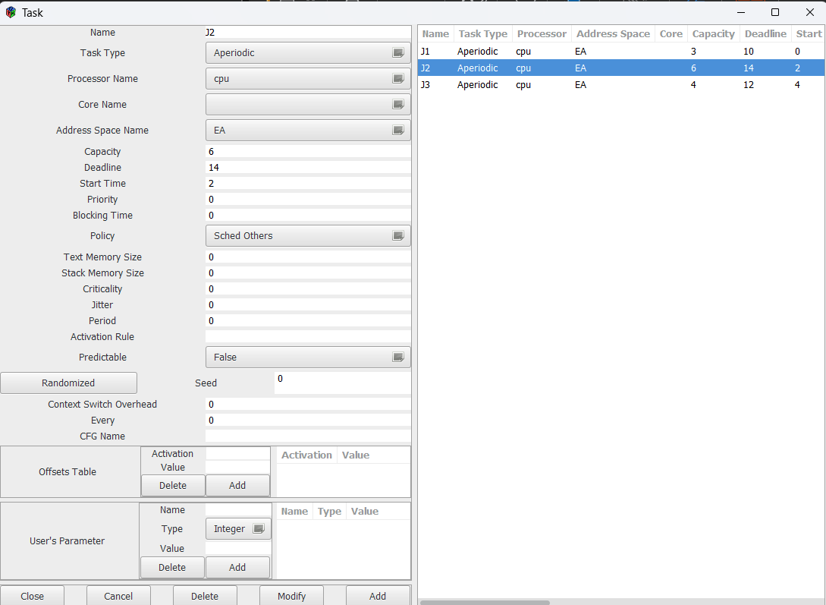
- J3:
  - Release Time = 4
  - Execution Time = 4
  - Deadline = 12
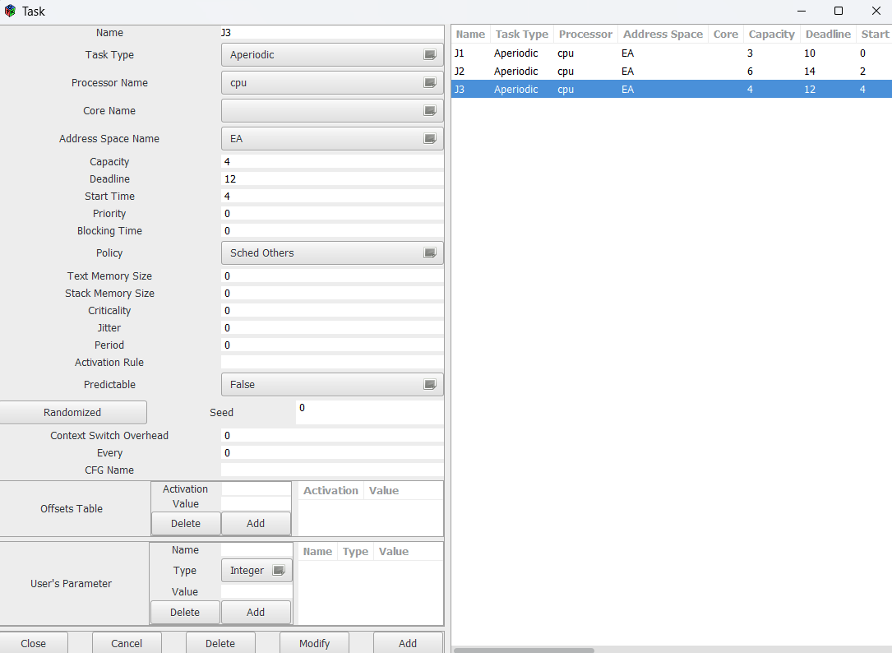

Step 3: Preemptive EDF Scheduling Simulation
- Simulation Setup:
  - Schedule from 0 to the latest deadline (14 in this case).
  - Use preemptive scheduling (EDF with preemption).
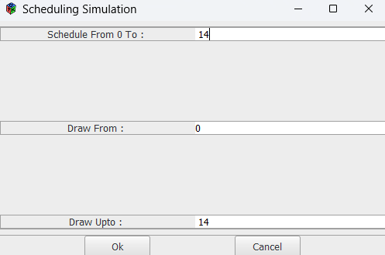
- Run Simulation: Once the tasks are configured, run the simulation and check if all deadlines are met.
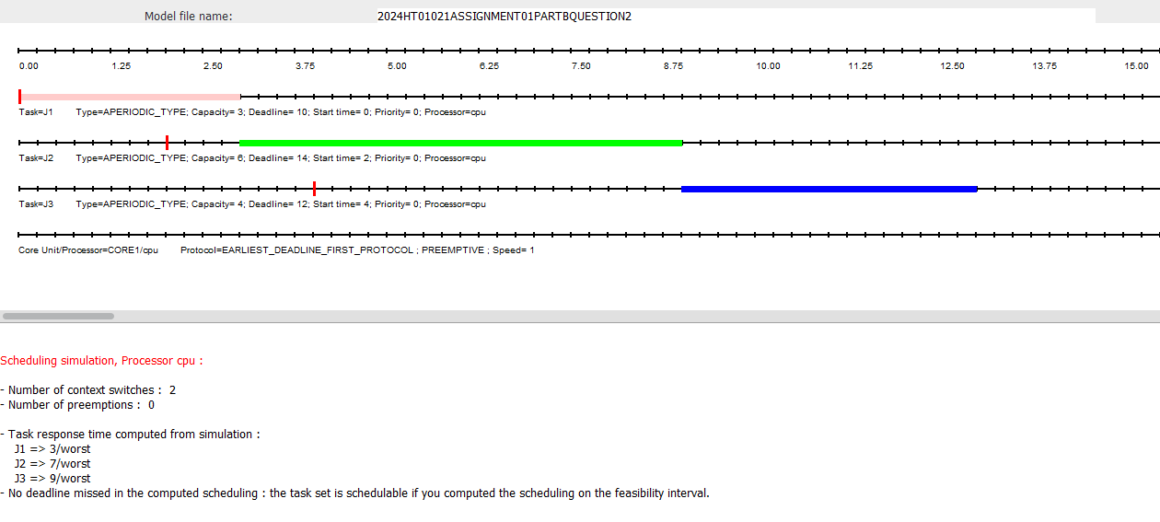
All tasks completed within their deadlines, showing that the EDF scheduling worked perfectly with preemption allowed.

Step 4: Non-Preemptive EDF Scheduling Simulation
- Switch to Non-Preemptive Mode:
  - Change the scheduler to non-preemptive EDF for the same core and processor setup.
Core Configuration:
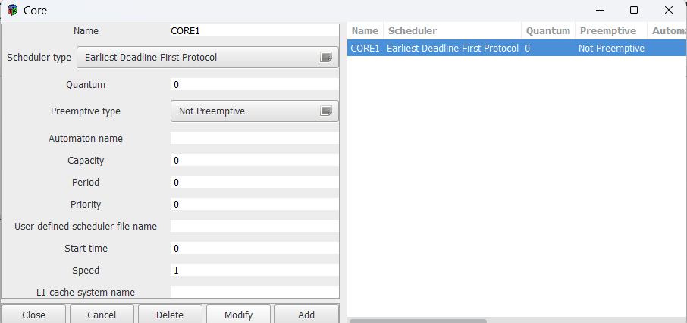
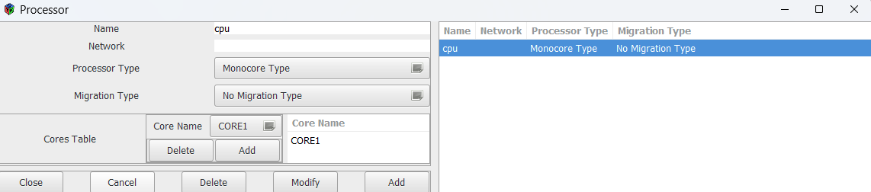
- Task Configuration:
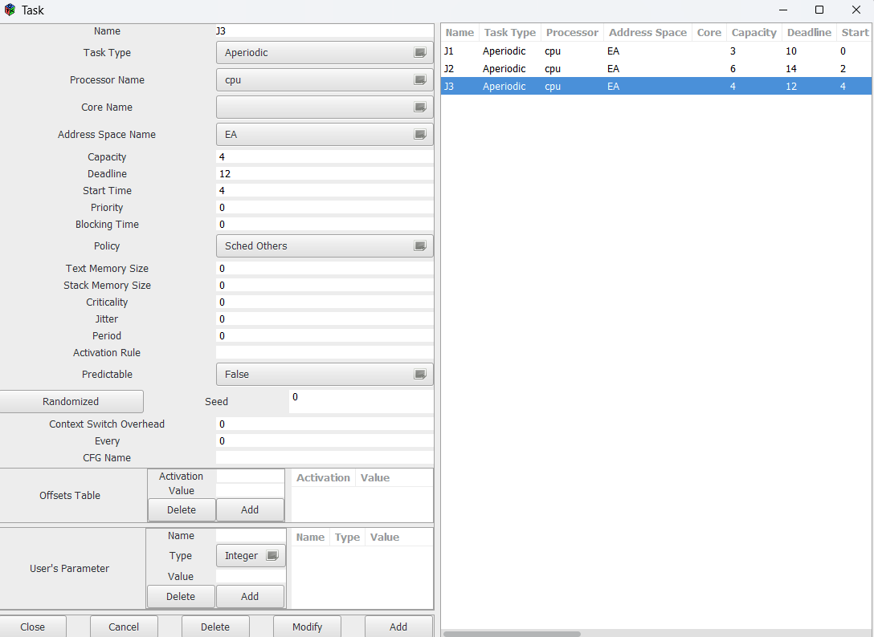
- Run Simulation: Run the simulation again and see if any deadlines are missed. In this case, some tasks may miss their deadlines since preemption is not allowed.
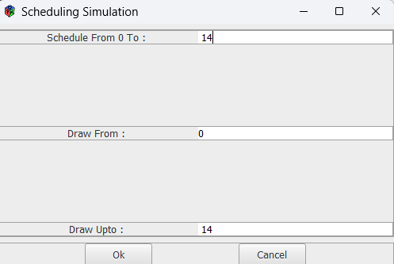
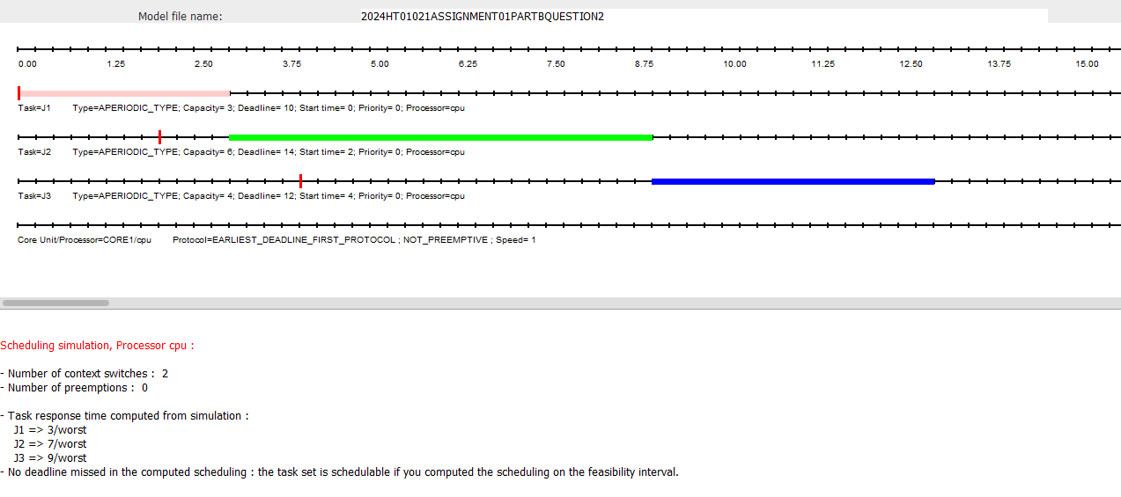
Step 6: Simulation Results
- Number of Context Switches: 2
- Number of Preemptions: 0 (since preemption is not allowed in this case)
- Task Response Times (Worst-Case Scenario):
  - J1: 3 units
  - J2: 7 units
  - J3: 9 units
- No Deadline Missed: The task set is schedulable under the feasibility interval, meaning that the tasks completed their execution within their deadlines without missing any deadline.
This shows that the task set can be scheduled using the Earliest Deadline First (EDF) protocol, even without preemption.
Conclusion:
- Schedulable Without Preemption: The simulation demonstrates that the tasks can meet their deadlines without requiring preemption. This is an ideal outcome since non-preemptive scheduling reduces the complexity of context switches.

Question 3
Show that the given task set is schedulable using LLF (Least Laxity First) but not using EDF (Earliest Deadline First) on a dual-core processor. All tasks are aperiodic.
The task parameters are as follows:
Task | Arrival Time (r) | Execution Time (e) | Deadline (d)
J1 | 0 | 1 | 1
J2 | 0 | 1 | 2
J3 | 0 | 5 | 5

Step 1: Processor and Core Setup
- Core Setup:
- Both Core 1 and Core 2 are initially configured to use Earliest Deadline First (EDF) for this part of the simulation.
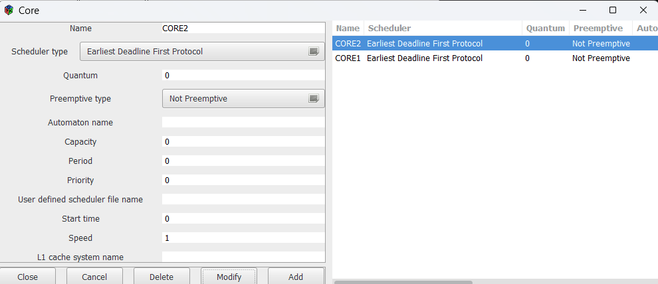

- Processor Setup
- Processor Type: Identical Multicore Type
- Migration Type: No Migration
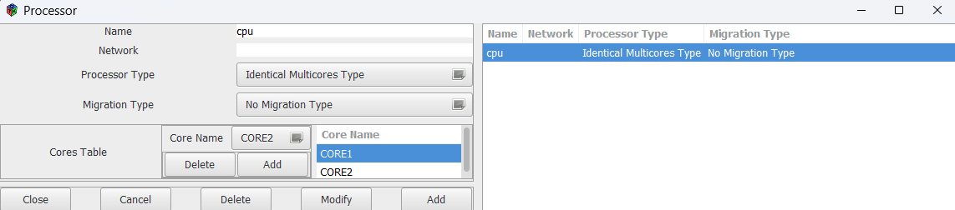

Step 2: Task Setup
Now, configure the tasks J1, J2, and J3 in the Cheddar tool.
Task Configuration:
- Task J1:
  - Arrival Time (r): 0
  - Execution Time (e): 1
  - Deadline (d): 1
- Task J2:
  - Arrival Time (r): 0
  - Execution Time (e): 1
  - Deadline (d): 2
- Task J3:
  - Arrival Time (r): 0
  - Execution Time (e): 5
  - Deadline (d): 5
Procedure:
- In the Software section of Cheddar, create three tasks (J1, J2, J3) under the Task option.
- Set the Arrival Time, Execution Time, and Deadline for each task as provided in the question.
- Assign the tasks to the dual-core processor created in Step 1.
- Set the scheduling policy as Aperiodic for each task.
- Save the task setup.
Screenshot: Task Setup for J1, J2, and J3
- Display the task configuration for each task.

Step 3: Simulation with EDF Scheduler
After the core and task configuration, run the scheduling simulation using Earliest Deadline First (EDF) scheduling to determine whether the task set is schedulable.
Procedure:
- In Cheddar, go to Tools > Scheduling Simulation.
- Set the scheduling simulation period to 5 (since the maximum deadline is 5).
- Click OK to run the simulation with EDF.
- Observe the results and note that Task J3 misses its deadline.
Expected Result:
- EDF Simulation Result:
  - Task J3 misses its deadline due to the earlier deadlines of J1 and J2, forcing J3 to start late.
Conclusion:
- With EDF scheduling, Task J3 misses its deadline, and thus the task set is not schedulable with EDF on a dual-core processor.
Screenshot: EDF Simulation Results
- Display the EDF simulation showing Task J3 missing its deadline.

Step 4: Change to LLF Scheduler
Next, change the scheduler to LLF (Least Laxity First) on both cores to verify whether the task set is schedulable under LLF.
Procedure:
- Open the Core Configuration for Core 1 and Core 2.
- Change the scheduler type from EDF to LLF (Least Laxity First).
- Save the updated core configuration.
Screenshot: Core Setup with LLF Scheduler
- Display both cores with LLF scheduler settings.

Step 5: Simulation with LLF Scheduler
Now, re-run the simulation using LLF and analyze the results.
Procedure:
- In Cheddar, go to Tools > Scheduling Simulation.
- Set the simulation period to 5, as done before.
- Click OK to run the simulation.
- Observe the results and note that all tasks (J1, J2, and J3) meet their deadlines under LLF scheduling.
Expected Result:
- LLF Simulation Result:
  - All tasks (J1, J2, and J3) meet their deadlines without any issues.
Conclusion:
- With LLF scheduling, the task set is schedulable on a dual-core processor as LLF efficiently schedules tasks based on their laxity.
Screenshot: LLF Simulation Results
- Display the LLF simulation showing all tasks meeting their deadlines.

Step 6: Analysis and Conclusion
In this analysis, we demonstrated that Earliest Deadline First (EDF) scheduling fails to meet the deadline of Task J3 because it prioritizes J1 and J2, both of which have shorter deadlines. As a result, J3’s execution is delayed beyond its deadline, making the task set unschedulable under EDF.
On the other hand, Least Laxity First (LLF) successfully schedules all tasks because it prioritizes tasks with the least slack, ensuring that Task J3’s long execution time is accounted for without it missing its deadline.
Conclusion:
- The task set is schedulable using LLF but not using EDF on a dual-core processor.
Final Screenshots:
- Include the final screenshots for both EDF and LLF simulations for comparison.

