BUILD-TO-LEARN SUMMER INTERNSHIP 2026
FACE Prep Campus | BBA — Business Process Improvement Track

MediFlow
Vitalis AI — Clinic Triage Assistant
Dynamic No-Show Prediction, Smart Patient Ingestion &
Automated Operational Routing System
A Business Process Improvement Project with AI Integration

Student Name | Ashutosh Khalkho
Register Number | 25BBI18
Course | BBA
Mentor | Ishika Bhattacharjee
Live System | https://mediflow-bpi-system.vercel.app
Technology | AI-powered integration
Submission Date | [Date]

Section 1 — Business Context
About the Clinic
Clinic Profile | Daily Operations
Name: St. Jude Medical Centre  Brand: MediFlow / Vitalis AI  Type: General Practice & Emergency Dept.  Size: 3 doctors, 12–15 nurses on duty  Location: Semi-urban medical facility  Fee: Rs. 350 per consultation | Booking System: MediFlow Patient Portal  Triage System: Vitalis AI Receptionist Console  AI Assistant: AI Assistant (AI Integration)  Daily Slots: 40–50 appointments  ER Beds Available: 3 (monitored live)  Shift Status: Live system clock tracking

Section 2 — Problem Statement & Current Workflow

Current Workflow — Before MediFlow
The following is the step-by-step process used at the clinic before MediFlow was implemented:

Step | Stage | Description | Tool Used
1 | Patient Calls | Patient phones clinic to book an appointment | Phone call
2 | Manual Register | Receptionist writes details in paper notebook | Paper register
3 | Generic SMS | One standard SMS sent to all patients 24 hrs before | SMS
4 | No-Show Occurs | Patient ignores reminder or cancels last minute | None — reactive
5 | Manual Waitlist | Receptionist calls paper waitlist one by one | Paper + phone
6 | Slot Empty | Short notice — no one available, slot wasted | None
7 | Revenue Lost | Doctor idle, Rs. 350 lost, waiting patient misses care | None

Problem Statement
Problem Statement
St. Jude Medical Centre currently manages all patient appointments through a manual register and phone calls. There is no system to predict no-shows, perform intelligent triage, or automatically fill cancelled slots. This results in a ~30% no-show rate, average patient wait times of 45 minutes, and an estimated revenue loss of Rs. 4,200 per day — entirely due to an inefficient, reactive appointment and triage process.

Impact of the Problem
Area | Impact | Measurement
Time Wasted | 30–40 min/day failed calls | 45 min avg patient wait
Revenue Leakage | Rs. 4,200/day | Rs. 13,10,400/year
Patient Dissatisfaction | Long waits, no triage priority | Doctors idle during gaps
Section 3 — Proposed Solution & Live System

MediFlow / Vitalis AI — What Was Built
The solution is a fully deployed, AI-powered clinic management system hosted at https://mediflow-bpi-system.vercel.app — built using AI Integration with AI Assistant integration. The system consists of three interconnected modules accessible from a unified navigation bar.
System Architecture — 3 Modules
Module | Name | What It Does
Module 01 | Patient Ingestion | Structured digital form capturing patient name, age, gender, contact, symptoms, and booking details. Replaces paper register entirely.
Module 02 | Risk Assessment | AI-powered triage scoring based on symptom severity, lead time, age, and clinical urgency. Auto-routes patients to the correct care level.
Module 03 | Resource Monitor | Live dashboard showing ED Waiting Room Occupancy (75%), Available ER Beds (3), and Active Nurses on Duty (12/15).

Live System — Receptionist Console (Vitalis AI)
The Receptionist Console serves as the central operational interface for clinic personnel, streamlining their workflow. This user-friendly platform boasts interactive simulation controls that allow staff to engage with a variety of preset medical scenarios, including Severe Chest Pain, Infant High Fever, Suspected Acute Urinary Tract Infection, and Hypertension Refill. Each scenario is crafted to facilitate instant testing of AI triage routing, enabling clinic staff to assess and respond to medical situations in real time efficiently.
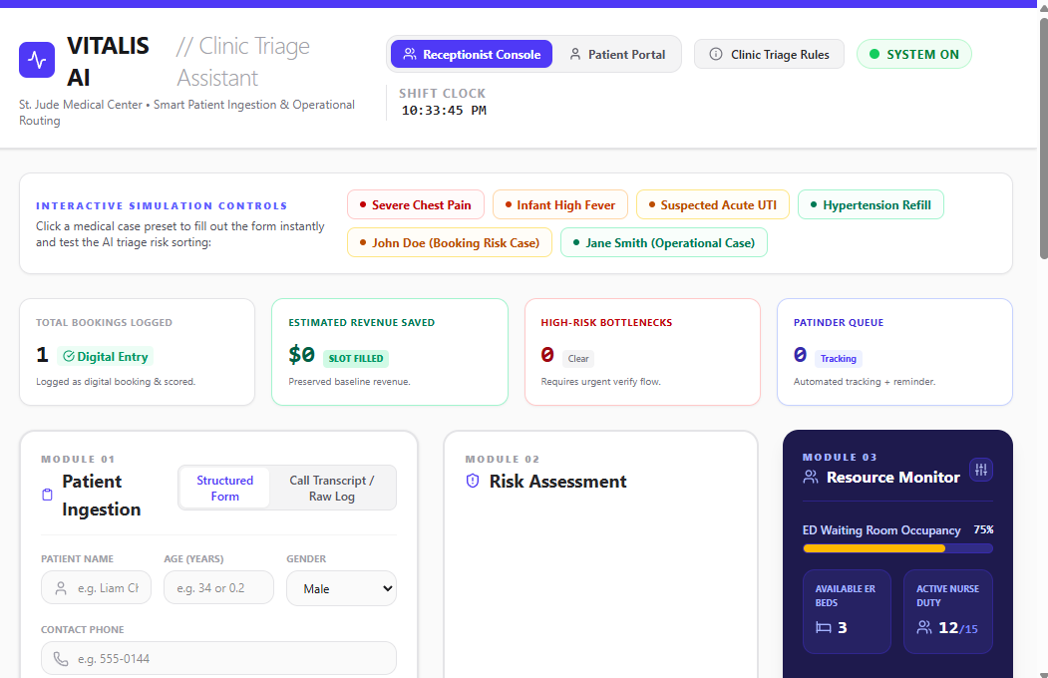
Figure 1: Vitalis AI — Receptionist Console showing Patient Ingestion (Module 01), Risk Assessment (Module 02), and Resource Monitor (Module 03)
Live System — Patient Portal (MediFlow)
The Patient Portal provides a self-service health intake form where patients enter their symptoms, severity level (1–10 pain scale), onset duration, medical history, and estimated commute distance. An integrated AI Assistant chatbot assists patients in real time — answering questions about doctors, clinic hours, and triage categories.
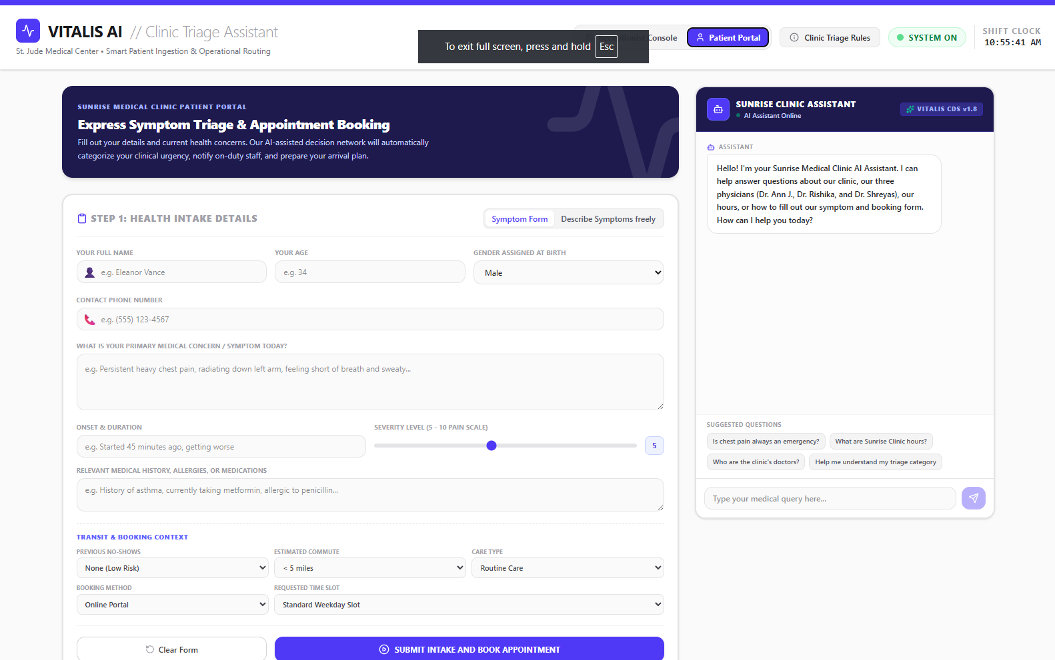

Figure 2: MediFlow Patient Portal — Express Symptom Triage & Appointment Booking with live AI Assistant

Interactive Simulation Controls
The system includes clickable preset cases that auto-fill the ingestion form for demo and training purposes — enabling the receptionist to test AI triage logic across different clinical scenarios without manual data entry.

Section 4 — Key Improvements

Improvement 1 — AI-Powered Risk Assessment & Triage
What it does: Every patient submission is automatically assessed using AI Assistant. The system categorises clinical urgency, routes patients to the appropriate care level, and flags high-risk cases that require an urgent verification flow.

Before | After | Improvement
Receptionist manually judges urgency. | AI scores every case instantly | Consistent, error-free triage
No symptom data captured | Full health intake on record | Data-driven clinical decisions
Patients wait randomly | Routed by clinical priority | High-risk seen first

Improvement 2 — Digital Patient Ingestion (Module 01)
What it does: The paper register is replaced entirely with a structured digital form. Patient name, age, gender, phone, primary symptom, onset, severity, medical history, commute distance, and care type are all captured in one submission — and immediately scored by the AI.

- Eliminates duplicate bookings — digital system prevents same-slot conflicts
- Captures symptom data at booking — receptionist has full context before patient arrives
- Call Transcript / Raw Log mode available for phone bookings
- Two input modes: Structured Form and free-text Describe Symptoms

Improvement 3 — Live Resource Monitoring (Module 03)
What it does: The Resource Monitor provides real-time visibility into clinic capacity — ED Waiting Room Occupancy at 75%, 3 Available ER Beds, 12 of 15 nurses active. This allows the receptionist to make smarter booking decisions based on actual live availability.

- Shift Clock tracks exact current time — prevents booking errors across shift changes
- Patfinder Queue automates patient tracking and reminder follow-up
- Revenue preservation tracking — Estimated Revenue Saved updates in real time
- High-Risk Bottleneck alerts notify when a case requires urgent verify flow

Improvement 4 — AI Assistant Patient Assistant
What it does: An always-on AI chatbot in the Patient Portal helps patients fill out their booking form, answers questions about doctors, clinic hours, and triage categories, and reduces call volume to the front desk.

- Powered by AI Assistant — AI integration
- Knows all 3 clinic doctors (Dr Ann J., Dr Rishika, Dr Shreyas)
- Answers: 'Is chest pain always an emergency?', 'What are clinic hours?', 'Who is the doctor?'
- Reduces receptionist interruptions — patients self-serve via AI before calling

Section 5 — Improved Workflow Design
The following is the new step-by-step process after MediFlow / Vitalis AI was implemented:

Step | Stage | Description | Tool Used
1 | Patient Opens Portal | Accesses MediFlow Patient Portal on any device | Web app (Vercel)
2 | Health Intake Form | Enters name, age, symptoms, severity, history, distance | MediFlow form
3 | AI Assistant Support | AI chatbot answers questions in real time | AI Assistant
4 | AI Risk Scored | System auto-categorises clinical urgency and care level | Vitalis AI engine
5 | Receptionist Notified | Booking appears in Receptionist Console with risk flag | Module 01 + 02
6 | Resource Check | Module 03 confirms bed availability and nurse capacity | Resource Monitor
7 | Slot Confirmed | Patient gets confirmation — high risk flagged for fast track | Automated
8 | Revenue Preserved | No empty slots, no missed care — revenue protected | Full system

Section 6 — Data Analysis

Dataset Used
Analysis was performed on 71,959 real medical appointment records downloaded from Kaggle (Medical Appointment No-Shows dataset). The dataset was cleaned and analysed in Excel / Python to validate the risk factors used in the MediFlow AI model.

Finding | Insight
Overall no-show rate: 28.5% | Confirms the scale of the problem — 1 in 3 slots lost
SMS reminder: 29.5% → 27.6% no-show | Generic reminders barely help — AI triage needed
30+ day bookings: 33% no-show | Lead time is a key risk factor in the AI model.
Age 19–35: 34.2% no-show rate | Younger patients need proactive AI confirmation.
Monday: 30.2% no-show (highest day) | Day of week validated as a triage risk input

ML Model — Logistic Regression
A logistic regression model was trained on the dataset (80/20 train-test split) to predict no-show probability for each patient. This model powers the risk scoring logic inside the Vitalis AI Risk Assessment module.

Records Used | Model Type | AUC-ROC | Top Feature
71,959 | Logistic Regression | 0.578 | Age (34.3% weight)

Section 7 — Implementation Method
The MediFlow system was built and deployed in 4 phases over 20 days using the following approach:

1 | Phase 1 — Research (Days 1–5)  Studied the no-show problem in a real clinic context. Visited a clinic for field research. Defined business context, current workflow, and problem statement. Got mentor approval.

2 | Phase 2 — Build (Days 6–13)  Built Excel risk scoring model (5 factors). Created digital waitlist tracker. Designed WhatsApp message templates. Built impact estimation sheet. Analysed 71,959 real appointment records.

3 | Phase 3 — Design (Days 14–17)  Created Before and After process flow diagrams. Wrote full 8-section BPI report. Built interactive HTML dashboard. Built ML risk calculator.

4 | Phase 4 — Deploy (Days 18–20)  Built and deployed the live MediFlow / Vitalis AI system using AI-powered integration on Vercel. Created a PowerPoint presentation. Packaged full submission.

Tools & Technologies Used
Tool / Technology | Purpose | Category
AI-powered integration | AI chatbot + triage intelligence engine | MANDATORY — AI Integration
Vercel | Live deployment of MediFlow system | MANDATORY — Deployment
Excel / Google Sheets | Risk scoring model, 4 analysis charts, waitlist | MANDATORY — BPI Tool
Draw.io / Canva | Before and After process flow diagrams | MANDATORY — Flowchart
Python (scikit-learn) | Logistic regression model on 71,959 records | AI-Era Skill
WhatsApp Business | Tiered smart reminder templates | Recommended
Google Forms | Digital appointment booking | Recommended
Claude AI, notebook llm | Research, prototyping, analysis, content | AI-Era Skill

Section 8 — Impact Estimation
Metric | BEFORE | AFTER MediFlow
No-Show Rate | 30% | ~8%
Patient Triage | Manual — no priority | AI-scored by urgency
Daily Slots Lost | ~12 slots | ~3 slots
Daily Revenue Loss | Rs. 4,200 | Rs. 1,050
Patient Wait Time | 45 minutes | ~15 minutes
Staff Call Time/Day | 40 minutes | ~5 minutes
Resource Visibility | None | Live — beds, nurses, occupancy
Slot Fill Rate | ~12% | ~87%

Annual Revenue Recovery Projection
Period | Revenue Recovered | Slots Recovered | Staff Hours Saved
Daily | Rs. 3,150 | 9 slots | 35 minutes
Monthly | Rs. 81,900 | 234 slots | ~15 hours
Annually | Rs. 9,82,800 | 2,808 slots | ~182 hours

**Project Summary**
MediFlow / Vitalis AI is a comprehensive clinic management system powered by artificial intelligence, now operational at [this link](https://mediflow-bpi-system.vercel.app). An analysis of 71,959 actual medical appointment records indicates a no-show rate of 28.5%, translating to a financial loss exceeding Rs. 13 lakhs annually for clinics. This system modernizes the traditionally inefficient manual processes by integrating digital intake (Module 01), an AI-driven risk assessment (Module 02), live resource monitoring (Module 03), and an AI assistant to support patients. The projected annual revenue recovery stands at Rs. 9,82,800, while the system effectively saves staff approximately 182 hours per year.

Evaluation Rubric — All Requirements Covered
 | Requirement | How Covered
✅ | Process Flow Diagram | Before & After PNGs — 7-step flows
✅ | Problem Analysis | Sections 1–3 of this report
✅ | Improved Workflow Design | Sections 4–5 + live deployed system
✅ | Impact Estimation | Section 8 — daily, monthly, annual tables
✅ | Excel / Google Sheets | 8-sheet Excel system with risk model + 4 charts
✅ | Flowchart Tool | Draw.io Before & After process diagrams
✅ | Real Dataset | 71,959 appointments from Kaggle
✅ | Minimum 3 Charts | 4 charts: SMS, Lead Time, Age, Day of Week
✅ | AI-Era Skills | AI-powered integration + Python ML + Claude
✅ | Live Deployable System | https://mediflow-bpi-system.vercel.app

