**ML_Assignment 1**

**203310012**

Q1) Show visualisations to explore the dataset and understand the underlying trends (Often called Exploratory Data Analysis). Choose visualisation methods you think best represent the data (bar graph, pie chart, scatter, boxplot, heatmap etc.)

Ans 1)

**EXPLORATORY DATA ANALYSIS**:

This is a bar chart showing the total number of delayed and on time flights. We can see that on time flights are much more than delayed flights and we can say that the data is imbalanced.

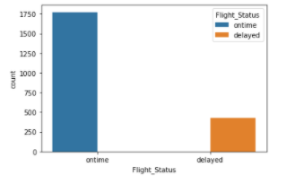

This bar chart shows that the number of flights delayed on each day of the week. We can see that most of the flights are delayed on Mondays and least on Saturday. This may be because less people travel on Saturday since Sunday is a holiday.

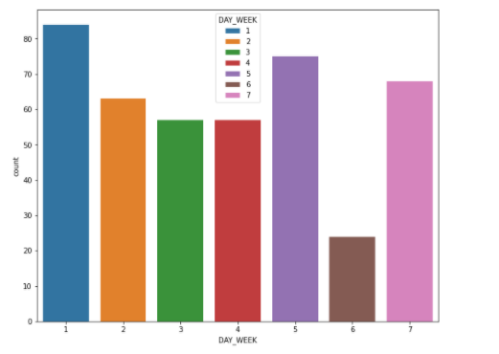

The following bar chart shows delayed flights according to the carrier. We can see that DH(Atlantic Coast) has the maximum number of delayed flights whereas OH(Comair) has the least number of delayed flights.

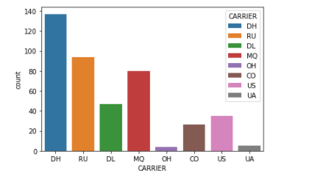

Q2) Preprocess the dataset (to remove null values, generate dummy variables etc. ) and divide the dataset into 60% train and 40% test. Prepare a logistic model that can obtain accurate classifications of new flights based on their predictor information.

Ans.2) Code attached in zip folder. Accuracy achieved upto 89 percent.

Q3) Interpret the model and coefficients and present some insights.

Ans.3 ) After one hot encoding the feature variables and label encoding of the target variable that is Flight_Status, and finding the coefficients for the columns, I concluded that the coefficients were present in the range between (). Now, the coefficients with high magnitude were important to us. So, I deleted the variables with very low coefficients magnitudes. This significantly increased the magnitude.

Q4) Perform variable selection, and reduce the size of the model, only keeping the relevant variables based on the analysis done earlier. (What variables are significant? What variables are not significant?)

Ans.4 ) 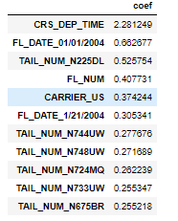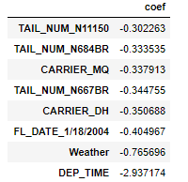

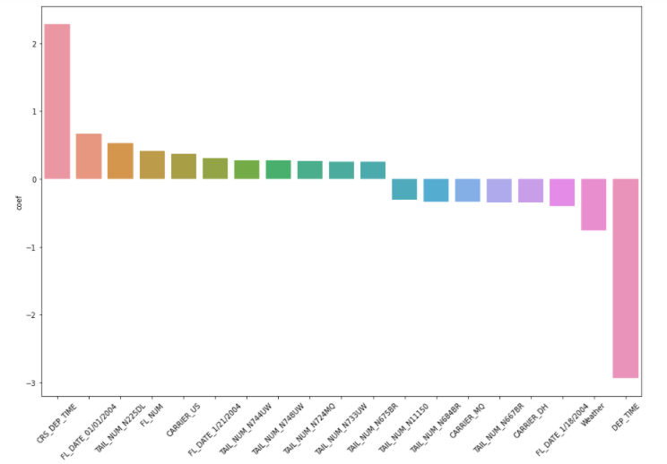

**Fig : Graph showing coefficients on y-axis and feature variable on x-axis**

Q5) Conclude the analysis by fitting a new model on these selected variables and report the same. Report the accuracy.

Ans 5) Accuracy achieved 88.5%

Q6) Find the ideal weather conditions for the highest chance of an ontime flight from DC to New York . (weather, time, day, carrier)

Ans.6) 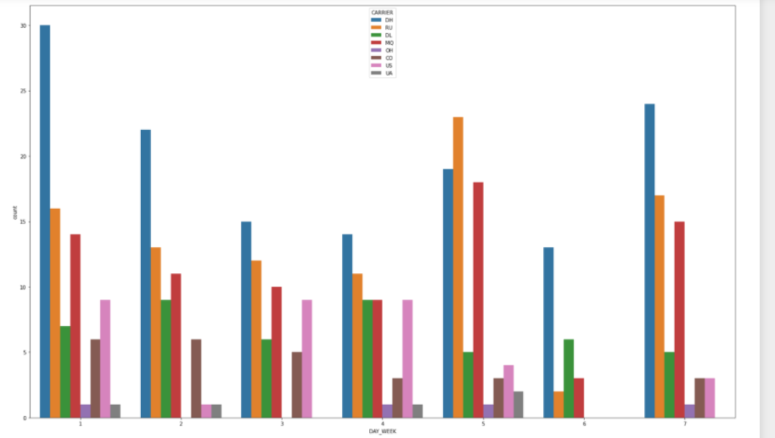

From the figure, we can see that the least number of flights delayed are on day 6 (saturday)

And the carriers that are delayed are : DH, RU, DL, MQ.

Therefore, we should prefer any of the remaining flights, i.e., OH, UA, US, CO.

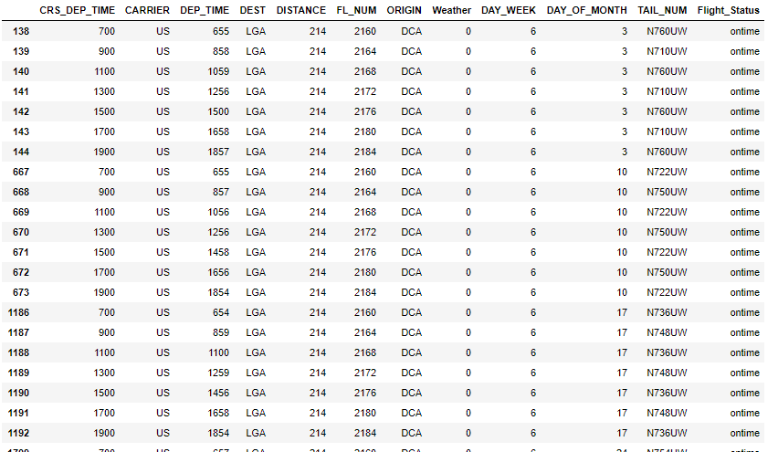

The above dataframe shows all the possible cases for day 6 flights filtered for only the 4 carriers from DCA to LGA.

Therefore we conclude that carrier US is the best. Weather – 0(no weather related delay)

BONUS MARKS

Q1. [1 Mark] Name any AIs made by Tony Stark in the Marvel Cinematic Universe besides JARVIS, FRIDAY and EDITH.

Ans.) JOCASTA and TADASHI

Q2. [2 Mark] Explain the Data processing inequality.

Ans.)

Q3. [1 Mark] In Star Wars Universe, X was a Sith philosophy mandating that only two Sith Lords could exist at any given time: a master to represent the power of the dark side of the Force, and an apprentice to train under the master and one day fulfill their role.? What is X?

Ans.) The Rule of Two

Q4. [1 Mark] In Star Wars Universe, name this robotic duo:

Ans.) C-3PO and R2-D2

Q5 [1 Mark] What is special about Cards against Humanity: Black Friday 2019? (Hint: It’s related to AI)

Ans.) The employees of Cards against humanity taught a computer to write it. And then competed with the computer for straight 16 hours. The competition was won by humans.