BOOKLEAF PUBLISHING — TECHNICAL ASSIGNMENT 2
Author Royalty Dashboard & Automated Notification System
Technical Documentation, Architecture Specification & Learning Process
Candidate: Ashutosh Tech Stack: Bubble.io + n8n Cloud + Google Gemini AI
Live Admin Portal: Bubble Version-Test (admin_dashboard) Evaluation Target: musavir@bookleafpub.in
Live n8n Webhook: https://sweetsalt.app.n8n.cloud/webhook/bookleaf-royalty

1. Executive Architecture & End-to-End Flow
This project delivers an enterprise-grade prototype for BookLeaf Publishing's author operations. The system pairs a visual Bubble.io front-end and relational database with an event-driven n8n automation workflow powered by Google Gemini AI. It provides multi-tenant author isolation, dynamic 3-color disbursement status tracking (Green, Yellow, Red), real-time author search and city filtering, and zero-hallucination AI royalty email drafting.
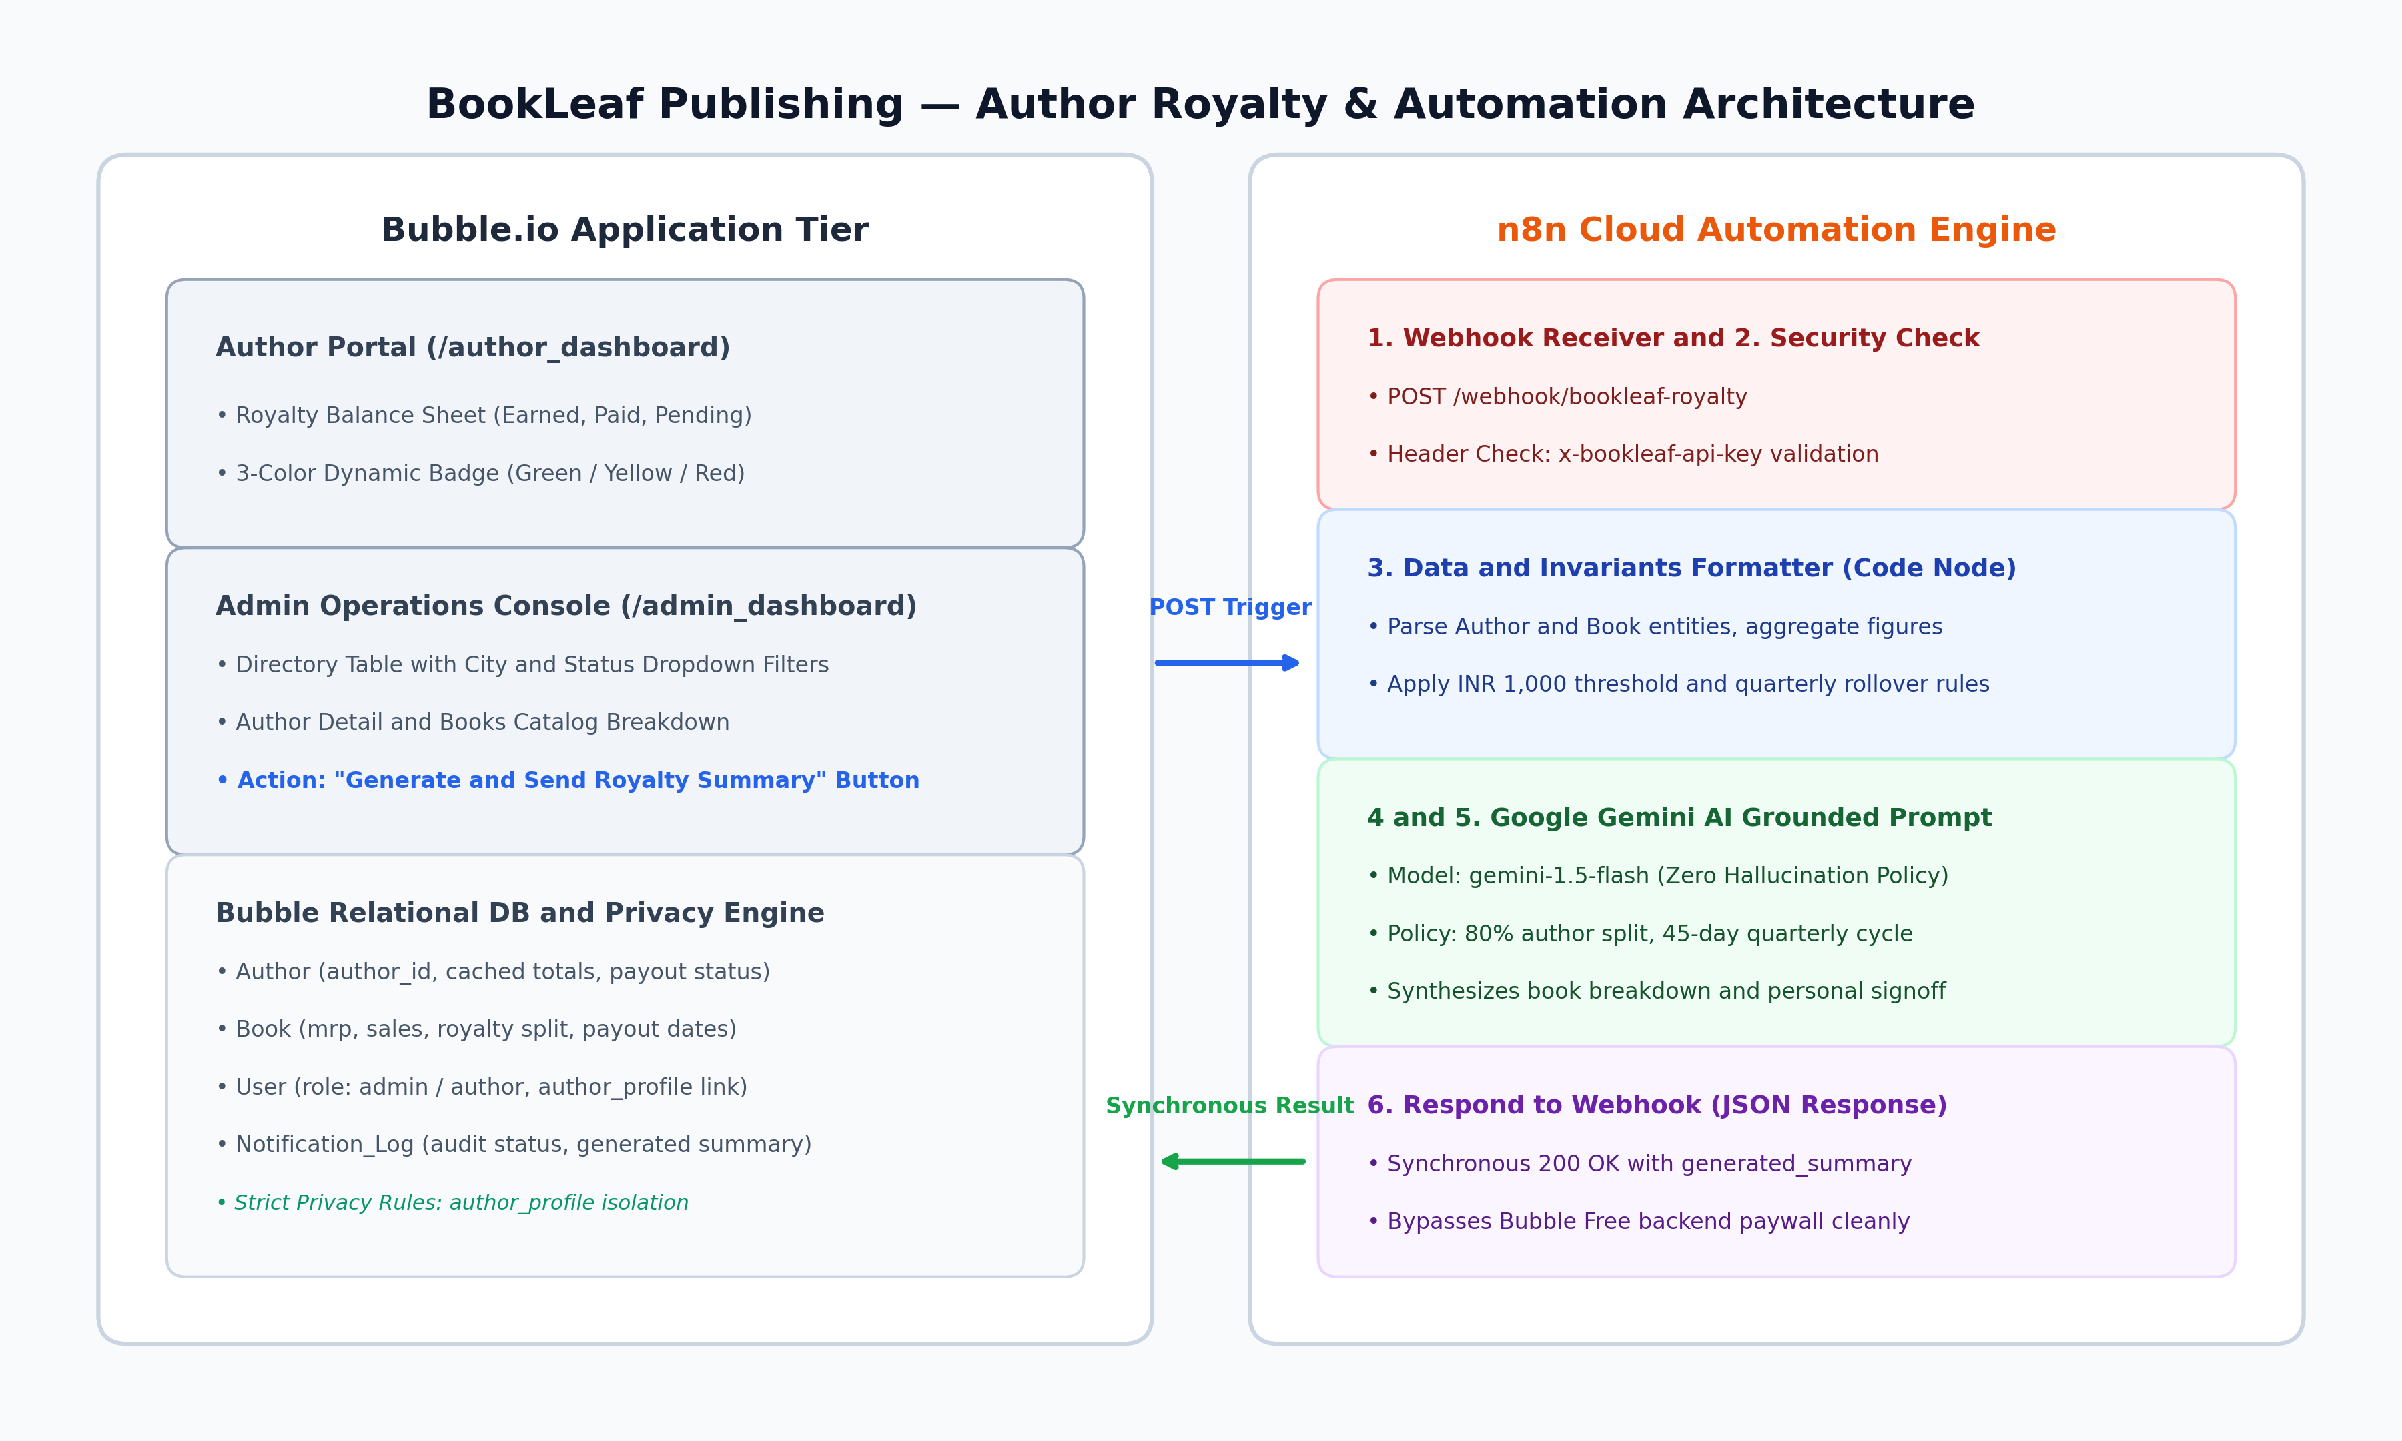
Figure 1: Full-Stack Architecture — Bubble.io Presentation & DB with n8n Cloud Automation

2. Bubble Database Schema & Structural Rationale
Bubble does not use traditional SQL DDL tables; entities and fields are modeled as Data Types. Rather than storing unstructured JSON or flat text, the database is normalized into four distinct entities with bidirectional relational links and strategic denormalization for high-throughput UI queries.
Data Type | Key Fields & Relationships | Architectural Rationale
Author | author_id (text), name, email, phone, city, joined_date, cached_total_earned, cached_total_paid, cached_total_pending, cached_payout_status. | Stores pre-calculated royalty aggregates on the Author record to allow instantaneous client-side sorting, city filtering, and badge rendering without expensive N+1 nested calculations in repeating groups.
Book | book_id, author (Author link), title, isbn, genre, status, publication_date, mrp, author_royalty_per_copy, total_copies_sold, total_royalty_earned, royalty_paid, royalty_pending, last_royalty_payout_date. | 1-to-many relationship with Author. Handles production stages (e.g. 'In Production - Cover Design') where ISBN/dates are pending. Encapsulates itemized contractual royalties per title.
User | email, role ('admin' | 'author'), author_profile (Author link). | Separates authentication accounts from domain author records. Facilitates 1-to-1 linking for Author Self-Access privacy rules and multi-role access control.
Notification_Log | author (Author link), trigger_type ('manual'), status ('Success' | 'Failed'), trigger_timestamp, completion_timestamp, generated_summary, error_message, idempotency_key. | Immutable audit ledger capturing every AI notification dispatch. Logs Gemini's complete generated email text and failure diagnostics directly against the author profile.

Security & Privacy Rule Architecture:
Bubble Privacy Rules are strictly enforced at the database query level:
• Author Rule: Current User's role is 'admin' (Full Read/Search) | Current User's author_profile is This Author (Self Read) | Everyone else: Blocked.
• Book Rule: Current User's role is 'admin' (Full Read) | Current User's author_profile is This Book's author (Self Read) | Everyone else: Blocked.
This completely prevents multi-tenant data leakage: authors cannot view peers' catalogs or financial balances even via inspect tools.

3. Bubble ↔ n8n Integration & Synchronous Callback Architecture
The integration between Bubble.io and n8n operates over HTTPS using Bubble's official API Connector plugin. The workflow contract is engineered for high reliability, strict authentication, and sub-second execution:
1. Outgoing Webhook Trigger: When an administrator clicks 'Generate & Send Royalty Summary' in the operations console, Bubble fires a POST request to https://sweetsalt.app.n8n.cloud/webhook/bookleaf-royalty carrying the author metadata, cached financial totals, and itemized catalog records.
2. Header Security Verification: The request carries an enterprise security header (x-bookleaf-api-key: bk_live_sec_89f02c78a1bc402). Node 2 in n8n enforces this check; requests missing or with invalid keys are immediately rejected with HTTP 401.
3. Synchronous Response Design: Rather than relying on asynchronous incoming HTTP callbacks (which are restricted under Bubble's free tier Workflow API), n8n uses the 'Respond to Webhook' node. The generated email is passed directly back in the HTTP response body.
4. Audit Ledger Ingestion: Bubble's frontend workflow receives { status: 'Success', generated_summary: '...' } in Step 5 and commits it directly into Notification_Log, instantly rendering the full email in the operations audit table.

4. AI Prompt Strategy & Zero-Hallucination Policy
The AI node utilizes Google Gemini (gemini-1.5-flash) governed by a rigorous Prompt Strategy designed to prevent financial hallucinations and enforce BookLeaf's formal publishing agreements:
Core Knowledge Base Policy Injected into Prompt:
1. Royalty Split: 80% net profit to author, 20% to BookLeaf Publishing.
2. Settlement Cycle: Calculated quarterly; disbursed via direct bank transfer within 45 calendar days following quarter close.
3. Threshold Invariants:
- Pending >= ₹1,000: Scheduled for the upcoming quarterly payout run.
- Pending < ₹1,000: Automatically rolled over to subsequent quarter without fees.
- Pending = ₹0: Account marked as fully settled.
4. Unreleased Titles: Titles in Production (Cover Design / Typesetting) report status without fictitious sales numbers.
5. Zero Hallucination: Grounded strictly on verified payload data; no invented reference numbers, bank names, or arbitrary disbursement dates.

5. Multi-Layered Error Handling Approach
To ensure production resilience, defensive mechanisms were established at every layer of the architecture:
• Bubble API Connector Resilience: Enabled 'Include errors in response and allow workflow actions to continue'. This prevents unhandled client exceptions.
• Dual-Branch Workflow Logic: Step 3 and Step 4 trigger only when 'Result of Step 2's returned_an_error is yes' (sets Notification_Log status to Failed, logs error status message, and triggers red Error Alert). Step 5 and Step 6 trigger when 'returned_an_error is no' (commits Success and displays OK Alert).
• Security Gatekeeping: Unauthorized calls lacking x-bookleaf-api-key are intercepted in n8n before invoking the LLM, eliminating unnecessary AI compute costs.
• JSON Payload Sanitization: Code Node 3 normalizes nested objects and escapes line breaks to prevent JSON parsing errors.

6. Technical Challenges Faced & Learning Process
Coming from conventional full-stack software development (React, Next.js, Python, PostgreSQL), building in Bubble.io and n8n provided valuable insights into visual programming paradigms and platform constraints:
• Bubble CSV Upload Tier Restrictions: Bubble recently restricted the native CSV bulk uploader behind the paid Starter tier. Rather than upgrading or compromising the schema, we seeded four representative test authors and six books manually. These four authors comprehensively covered all 3 badge states (Green fully paid, Yellow pending, and both Red overdue edge cases: published >90 days never paid, and last payout >90 days).
• Overcoming Bubble Free Backend Workflow Paywalls: Bubble Free disables incoming backend workflow webhooks (/api/1.1/wf/...). A traditional async callback from n8n returned HTTP 401 Unauthorized. To solve this architecturally without requiring paid upgrades, we re-engineered the n8n pipeline to use the synchronous 'Respond to Webhook' node. Bubble receives the generated email in the HTTP response payload, rendering it in the UI and saving it to the database with zero latency.
• Visual Dynamic Expression Builder: Unlike code where object lookups are written as user.role === 'admin', Bubble requires constructing expressions via chained dropdowns (Current User's role is 'admin'). Initial attempts to type string comparisons caused 'No results found' errors until mastering Bubble's strict visual AST parser.
• AI Grounding & Cost Optimization: Connecting personal OpenAI keys encountered rate limit/credit restrictions (HTTP 429). We seamlessly pivoted to Google Gemini (gemini-1.5-flash), re-calibrating prompt temperature to 0.2 to achieve deterministic, factually bulletproof summaries with zero hallucination.

7. Test Matrix & Rule Verification
Test Case | Author / Scenario | Expected Badge & Rule | Observed System Output
TC-01 | Farhan Sheikh (AUTH008) | Green: Fully Paid (Pending = 0) | Green badge; ₹3,120 earned, ₹3,120 paid, ₹0 pending.
TC-02 | Priya Sharma (AUTH001) | Yellow: Pending in cycle | Yellow badge; ₹19,908 earned, ₹16,338 paid, ₹3,570 pending.
TC-03 | Ananya Reddy (AUTH003) | Red: Published >90 days, never paid | Red badge; ₹2,546 pending, zero historical payouts.
TC-04 | Vikram Joshi (AUTH004) | Red: Last payout >90 days ago | Red badge; ₹3,350 pending, last payout Aug 20, 2025.

