**MODULE – 1**



ASSIGNMENT

**Q.1 What is software? What is software engineering?**

Answer :-

Software Refers to a collection of program, data, and instructions that enable a computer system to perform specific tasks or operations. It includes both the applications that users interact with and the underlying system software that supports these applications. Software engineering, on the other hand, is the systematic and disciplined approach to designing, developing, testing, and maintaining software systems. It involves applying engineering principles and practices to create high-quality, reliable, and efficient software solutions.

1. **Analysis & Design Environment**
   * The analysis and design environment is aligned to the planning and analysis phases of the SDLC. In this environment, the main processes that take place include carrying out an in-depth examination of the current system and the proposed system. The system architecture is also defined and includes developing the design of the hardware, software, and network requirements for the system. Within this environment, systems and business analysts work closely with software engineers.
2. **The development environment**
   * The development environment can also be a physical space where development takes place and where software engineers interact. Another example of the development environment is the integrated development environment (IDE). The IDE provides a platform where tools and development processes are coordinated in order to provide software engineers a convenient way of accessing the resources they require during the development process.
3. **The common build environment**
   * The common build environment is closely aligned to the development phase of the SDLC. In this environment, software engineers merge the work done in the development environment. Within this environment, software engineers build systems. These are used to automate the process of software compilation.
4. **The testing environment**
   * The test environment is where testing teams evaluate the application/quality. program’s This also allows computer programmers to find out and solve any defects that may interfere with the

application’s smooth operation

1. **The production environment**
   * When the end-user use a web/mobile application, the program is operating on a production server. It’s been created in the production environment.

**★ Software Diagram :-**



# Q.2 Explain types of software?

Answer:-

Software can be categorized into several types based on its functionality and purpose. Here are some common types of software:

**a) System Software:** This type of software provides essential services and functions to support the operation of a computer system. Examples include operating systems (e.g., Windows, macOS), device drivers, and utility programs.

**b) Application Software:** Application software is designed to perform specific tasks or applications for end-users. It includes word processors, spreadsheets, web browsers, video players, and more.

**c) Programming Software:** Programming software assists programmers in writing, debugging, and maintaining software programs. Compilers, integrated development environments (IDEs), and debuggers fall into this category.

**d) Embedded Software:** Embedded software is programmed to control and manage specific hardware devices or systems. It is commonly found in various devices such as automobiles, medical devices, and consumer electronics.

**e) Web Applications:** Web-based software applications run on web servers and are accessed through web browsers. They include online shopping websites, social media platforms, and email clients.

## What is SDLC? Explain each phase of SDLC? Answer:-

SDLC stands for Software Development Life Cycle. It is a structured approach used in software engineering to guide the development process from initiation to deployment. The following are the phases of the SDLC:

1. **Requirements Gathering:**

In this phase, project stakeholders collaborate to identify and document the software requirements, including functionality, performance, and constraints.

1. **System Design:**

The system design phase involves creating a high-level architecture and detailed design specifications based on the gathered requirements. This includes defining the system components, data structures, and interfaces.

1. **Implementation:**

During the implementation phase, the software is developed based on the design specifications. This involves writing code, testing individual components, and integrating them into a complete system.

1. **Testing:**

In the testing phase, the software is systematically tested to uncover defects, errors, and deviations from the requirements. Different testing techniques such as unit testing, integration testing, and system testing are employed to ensure quality and reliability.

1. **Deployment:**

Once the software has passed the testing phase, it is deployed in the production environment. This includes installation, configuration, and making the software available to end-users.

1. **Maintenance:**

The maintenance phase involves addressing issues reported by users, making enhancements, and performing regular updates and bug fixes to ensure the software remains functional and up-to-date .

**★ Phase of SDLC:-**

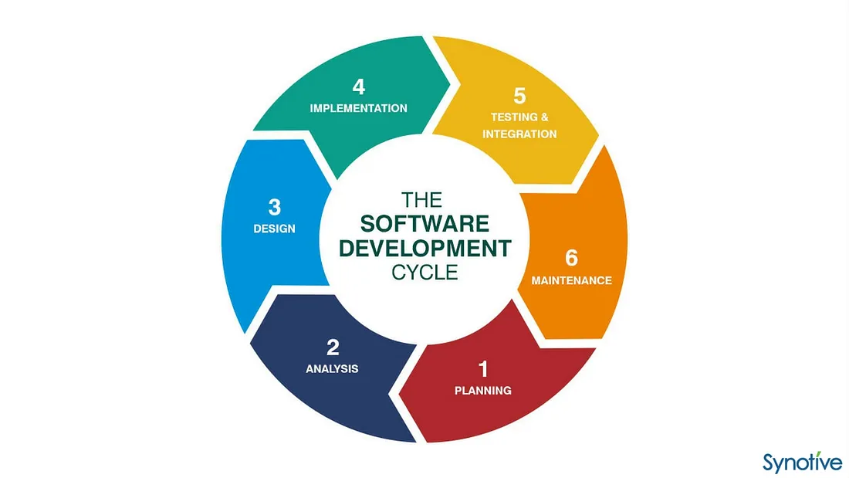

# What is DFD? Create a DFD diagram on Flipkart Answer:-

A data flow diagram (DFD) is a graphical or visual representation using a standardized set of symbols and notations to describe a business's operations through data movement. **They are often elements of a formal methodology such as Structured Systems Analysis and Design Method (SSADM).**

# ★ DFD diagram on Flipkart:-

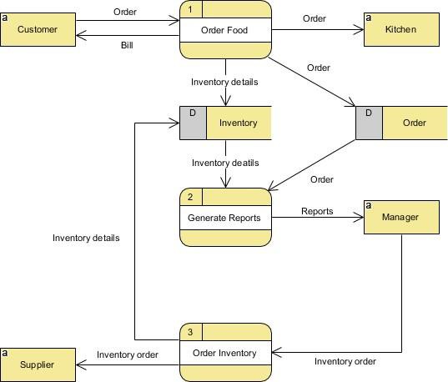

## What is Flow chart? Create a flowchart to make addition of two numbers.

**Answer:-**

A flowchart is a diagram that depicts a process, system or computer algorithm. They are widely used in multiple fields to document, study, plan, improve and communicate often complex

processes in clear, easy-to-understand diagrams. Flowcharts, sometimes spelled as flow charts, use rectangles, ovals, diamonds and potentially numerous other shapes to define the type of step, along with connecting arrows to define flow and sequence. They can range from simple, hand-drawn charts to comprehensive computer-drawn diagrams depicting multiple steps and routes. If we consider all the various forms of flowcharts, they are one of the most common diagrams on the planet, used by both technical and non-technical people in numerous fields. Flowcharts are sometimes called by more specialized names such as [Process Flowchart](https://www.lucidchart.com/pages/process-flow-diagrams), Process Map, Functional Flowchart, Business Process Mapping, Business Process Modeling and Notation (BPMN), or Process Flow Diagram (PFD). They are related to other popular diagrams, such as Data Flow Diagrams (DFDs) and Unified Modeling Language (UML) Activity Diagrams.

**★ Flowchart to make addition of two numbers** :-

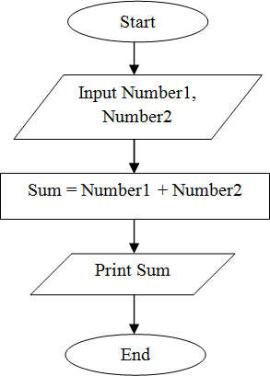

* 1. **What is Use case Diagram? Create a use-case on bill payment on paytm.**

**Answer:-**

Use-case diagrams describe the high-level functions and scope of a system. These diagrams also identify the interactions between the system and its actors. The use cases and actors in use-case diagrams describe what the system does and how the actors use it, but not how the system operates internally.

## ★ Use-case on bill payment on paytm :-

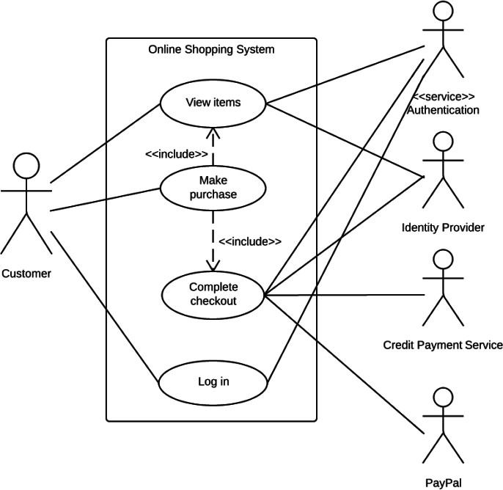

Done By Ashish Patel