**MOVIE SUCCESS PREDICTION APPLICATION**

**ABSTRACT**

In this project, we developed a mathematical model to predict the success and failure of the upcoming movies based on several attributes. Some of the criteria in calculating movie success included budget, actors, director, producer, set locations, story writer, movie release day, competing movie releases at the same time, music, release location and target audience. The number of movies produced in the world is growing at an exponential rate and success rate of movie is of utmost importance since billions of dollars are invested in the making of each of these movies. In such a scenario, prior knowledge about the success or failure of a particular movie and what factor affect the movie success will benefit the production houses since these predictions will give them a fair idea of how to go about with the advertising and campaigning, which itself is an expensive affair altogether. So, the prediction of the success of a movie is very essential to the film industry. The success prediction of a movie plays a vital role in movie industry because it involves huge investments. The market for movies is still big with hundreds of new movies created every year. Lately, as the growth of the film industry, a variety of studies for the prediction of market demand is being performed. The product life cycle of film is relatively short cultural goods. Therefore, in order to produce stable profits, marketing costs before opening as well as the number of screen after opening need a plan. To fulfill this plan, the demand for the product and the calculation of economic profit scale should be preceded. Understanding the stakes involved with a movie release that can affect its success or a failure, before-hand can be a great step towards the expansion of the film industry business. Therefore, this study proposes an ensemble learning strategy as a solution to analyze such understanding where predictions from previously guided attribute calculations can be used to enhance future success/failure accuracy.

**TITLE:**

LEISURE CINEMAS - YOUR INSTANT SEROTONIN BOOST

**AIM:**

The main aim of movie success prediction is to propose a system that helps to predict the success of movies prior release.

**TOOLS USED:**

* Back End language-Python
* Front End Language-HTML,CSS
* Machine learning algorithms
* Database-Mysql
* Framework-Django

**SCOPE:**

* The focus of movie success prediction is to formulate a method of how to preprocess the data set and evaluate which attributes are the most useful, by evaluating the correlation between the attributes and the success rate of the machine learning.
* We can achieve a viable success rate when trying to predict the budget and box office revenue.

**ADVANTAGES:**

* It removes human errors that commonly occur during manual analysis.
* The system provides an unbiased result.
* the system excludes human efforts and saves time and resources
* This application helps to find out the review of the new movie.
* It can be very useful for the production to have an early prediction.

**APPLICATIONS:**

* This application can be used by all the movie production houses.
* The system can also be implemented in different organizations that conduct regular review and ratings for books, leaders etc.

**FLOW DIAGRAM:**

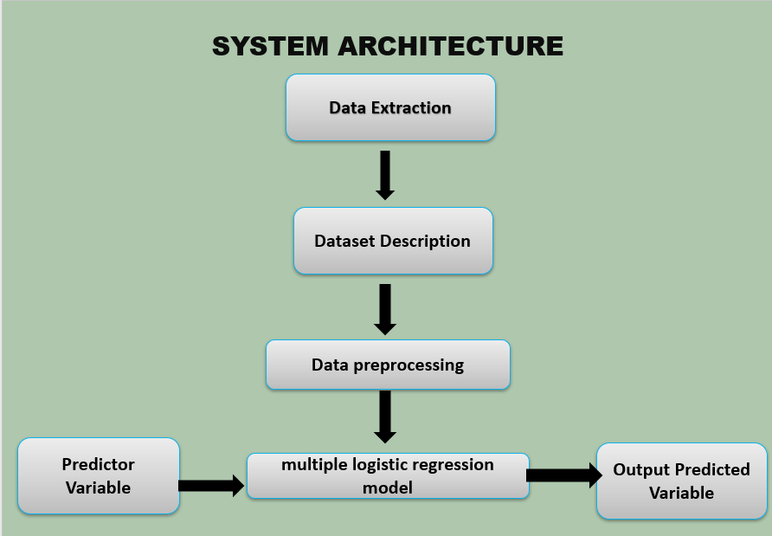

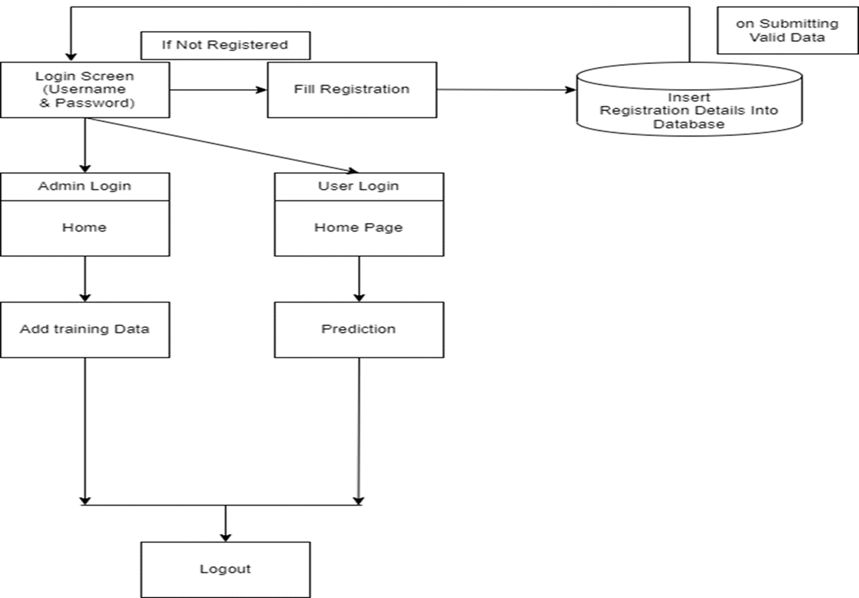

**IDEATION MAP:**

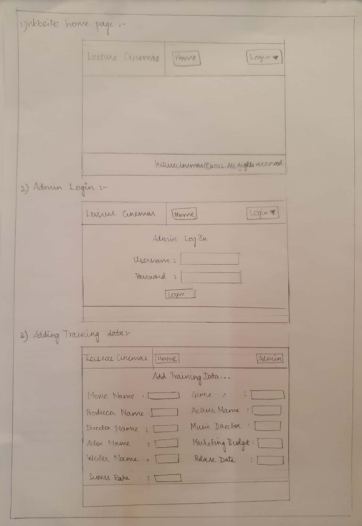

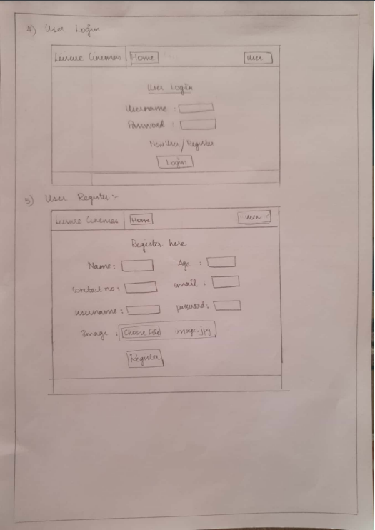

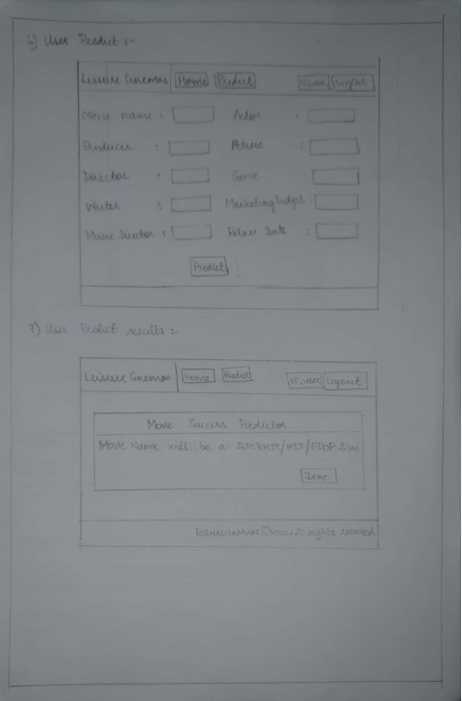

**DESCRIPTION:**

**ADMIN MODULE:**

Login: admin will login

Add and train data: admin can add data here with keywords and accordingly whatever

the user chooses,an output will be generated using confidence score

**USER MODULE:**

sign in: user will sign up(Name,number,email,password,username,your photo,your age)

Login in: User will login

Detect: User will fill in a texts like "actor name","actress name","movie name",

"movie budget","producer name" and get the output if the movie is "flop","hit" or "superhit"