Data representation
We will learn here how raw data is processed to create an information system, which is primary input for machine learning algorithm.
- Information System: The Data Table Structure
An information system is primarily represented as a data table (like a spreadsheet), often called D.
- Rows (Instances/Observations): Each row represents a single measurement, observation, record, instance, sample, or example. In the example, each row is a "Patient index."
- The set of all possible instances is denoted as S. The total number of instances is N.
- Columns (Attributes/Features): Each column represents an attribute or feature ($x_{j}$). These describe the properties of the instances.
- The total number of features is n.
- A single instance $s^{(i)}$ is characterized by vector of its feature values: $x^{(i)}$= [$x_{1}^{(i)}$, $x_{2}^{(i)}$,…. $x_{n}^{(i)}$]
- The set of all feature vectors forms the representation space X

- Types of Attributes
Attributes (features) are classified based on the nature of the values they can hold:
- Nominal Attributes (Categorical/Discrete):
- These take values from a prespecified finite set of possibilities (a finite set of discrete values).
- Examples from Table 1.1: "Headache" (no, yes), "Muscle-pain" (yes, no), "Temperature" (high, very high, normal), and "Flu" (yes, no).
- This is often the linguistic form of knowledge representation.
The table given below represent categorical variables in the given data
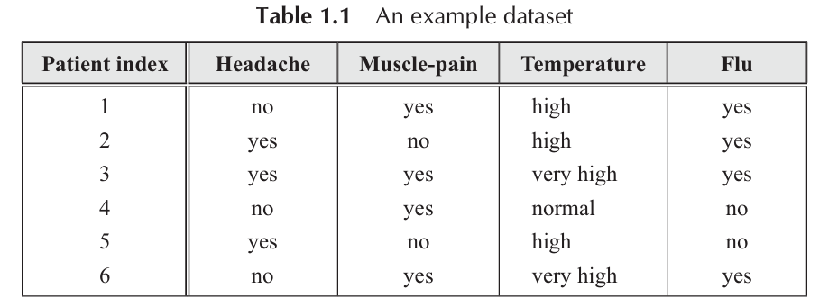
- Numeric Attributes (Continuous/Integer):
- These adopt values that are real numbers or integer values.
- Note for Class: The term 'continuous' is often used but is technically only correct for real-valued attributes, not integer-valued ones.
The table given below represents continuous real value attributes as well as integer values
Student_ID | Age (Integer) | Height_cm (Real) | Attendance (%) (Real) | Number_of_Projects (Integer)
1 | 19 | 160.5 | 85.75 | 2
2 | 18 | 158.2 | 92.50 | 1
3 | 20 | 172.8 | 78.00 | 3
4 | 19 | 165.0 | 88.25 | 2
Height and Attendance % → Continuous (real-valued)
There are infinitely many possible values between two numbers.
Age and Number_of_Projects → Integer-valued numeric
Values are numeric but discrete.

- Decision System: Supervised Learning Input
A Decision System is a special type of Information System used for directed or supervised learning problems.
- Key Feature: It includes a distinguished attribute called the Decision Attribute (or output, y).
- Purpose: The decision attribute holds the known outcome or class label for each observation.
- Example from Table 1.1: The column "Flu" is the Decision Attribute. The other columns (Headache, Muscle-pain, Temperature) are the Condition Attributes. The task is to learn the relationship between the condition attributes and the decision attribute.
- The system is a tuple (S, X, Y) where X is the set of condition features and Y is the decision attribute.

- Decision Attribute Outcomes (Y)
The values the decision attribute (y) can take define the machine learning task:

- Classification problem (Two class classification)

Example: Predicting if a patient has flu (Yes/No
Here, the decision attribute (Y) takes finite discrete values.

Patient_ID | Temperature | Cough | Flu (Y)
1 | 101.2 | Yes | Yes
2 | 98.4 | No | No
3 | 100.5 | Yes | Yes
4 | 97.8 | No | No

Here,
- Vy​={Yes,No}
- Finite classes (M = 2)
- Task = Classification

- Classification Problem (Multi-class classification Problem)
Example: Predicting type of fruit
Sample_ID | Weight | Color_Intensity | Fruit_Type (Y)
1 | 120 | 0.8 | Apple
2 | 150 | 0.9 | Mango
3 | 100 | 0.7 | Orange
4 | 130 | 0.5 | Apple

Here,
- Vy={Apple,Mango,Orange}
- Finite set with M = 3 classes
- Task = Multi-class classification

- Regression (Y= Real Number)
Example: Predict house price
House_ID | Area_sqft | Bedrooms | Price (Y)
1 | 1200 | 2 | 45.6
2 | 1500 | 3 | 60.2
3 | 900 | 2 | 30.8
4 | 1800 | 3 | 75.1
Here,
- Vy=R
- Price can be any real number
- Task = Regression (numeric prediction)
Students immediately see that Y is numeric, continuous, unlike labels in classification

- State Space Visualization
For features with numerical values, an instance $x^{(i)}$ can be visualized as a point in an n-dimensional state space
When you have n numeric features, each instance becomes a point in an n-dimensional space:
- 1 feature → line
- 2 features → 2D plane
- 3 features → 3D space
- n features → n-dimensional space (cannot visualize directly, but concept is same)

Example 1: 2 Features (2D State Space)
Dataset:
Student_ID | Height (cm) | Weight (kg)
1 | 160 | 55
2 | 165 | 60
3 | 170 | 62
4 | 172 | 65

Each instance becomes a point:
$x^{(i)}$=($x_{1}$, $x_{2}$)=(Height, weight)
Points in 2D space:
- Student 1 → (160, 55)
- Student 2 → (165, 60)
- Student 3 → (170, 62)
- Student 4 → (172, 65)
Example 2: 3 Features (3D State Space)
Dataset:
Car_ID | Engine_Size | Mileage | Price
1 | 1.2 | 18 | 7.5
2 | 1.5 | 15 | 8.2
3 | 2.0 | 12 | 10.1
Each instance:
$x^{(i)}$=($x_{1}$, $x_{2}$, $x_{3}$)
- Car 1 → (1.2, 18, 7.5)
- Car 2 → (1.5, 15, 8.2)
- Car 3 → (2.0, 12, 10.1)
Here the state space is 3D (ℝ³).
We cannot draw it easily on paper, but conceptually, each car is a point in 3D.

Diversity of data: Structured/Unstructured
Generally, digital information can be categorized into two classes—structured and unstructured.
1. Structured Data
This is the traditional data that most initial machine learning algorithms are designed to handle.
- Definition: Data that has a predefined format and fits neatly into a fixed schema or data table (like Table 1.2 discussed previously). It is unambiguous and organized.
- Analogy: Think of a meticulously organized library catalog where every book has a title, author, and ISBN in the exact same format.
- Characteristics:
  - Predefined Format: Follows a strict order and data type (e.g., date in MM/DD/YYYY, account number as a 12-digit integer).
  - Fixed Fields: Every piece of information has a designated, labelled column.

Examples:
- Relational Databases (SQL): Customer records with distinct columns for Name, Address, Age, Order_ID.
Example: Customer Records
Customer_ID | Name | Address | Age | Order_ID
101 | Amit Sharma | Panaji, Goa | 25 | ORD1001
102 | Neha Verma | Mapusa, Goa | 30 | ORD1002
103 | Ravi Kumar | Margao, Goa | 22 | ORD1003

Spreadsheets: Financial data where each column is clearly defined (e.g., Stock Symbol, Closing Price, Volume).
Example: Stock Market Sheet

Stock_Symbol | Closing_Price (₹) | Volume
TCS | 3520.50 | 120000
INFY | 1495.75 | 98000
RELIANCE | 2450.00 | 150000

2. Unstructured Data
This type of data is dominant in the digital world and presents the core challenge for "next-generation" machine learning.
- Definition: Data that does not have a predefined format or schema. We have very little control over its organization.
- Analogy: Think of a large collection of notes, letters, and random photos thrown into a box—there is no fixed structure or order.
- Characteristics:
  - No Fixed Format: Users or systems don't follow specific grammar, ordering, or vocabulary standards (e.g., social media text).
  - "Capture Everything" Approach: Data is collected as-is, and structure/meaning must be extracted later.
- Examples:
  - Text: Emails, social media posts, news articles, open-ended survey responses.
  - Media: Images, audio files, videos.
  - Web Data: Content from websites.
3. The Big Data Challenge
The combination of massive volume and the high proportion of unstructured data is what defines Big Data problems.
- Research Focus: A major research challenge is how to process and mine complex unstructured data, including:
  - Mining sequence data (e.g., time series, gene sequences).
  - Mining graphs and networks (e.g., social connections).
  - Mining multimedia data (text, image, audio combined).

- Machine Learning Evolution:
  - First-Generation ML: Works well on structured data (or structured patterns extracted from unstructured data).
  - Next-Generation ML: Required to effectively analyze and derive insights from the full complexity of unstructured Big Data.

4. Strategic Importance
Even though unstructured data is difficult, organizations cannot ignore it because of its strategic value when combined with their traditional, structured data.
- Cohesive Strategy: Successful organizations must have a cohesive data strategy that integrates both structured and unstructured data, rather than treating Big Data as a separate "stand-alone" concept.

