Fisher’s Linear Discriminant
Fisher’s Linear Discriminant (FLD) is a dimensionality reduction technique used to:
Convert high-dimensional data → 1D line
While keeping classes as separable as possible
Core Idea (Intuition)
We project data using:
z =$w^{T}$x
- x: original n-dimensional data
- w: projection vector
- z: projected 1D value
Goal: Find best direction w such that:
- Same class points are close together
- Different class points are far apart

1. The Mapping: From Many Dimensions to One
Imagine you have data points defined by many features (like height, weight, age, etc.). This is represented as a vector x
FLD wants to transform this multi-dimensional vector into a single number z. This is done using a linear combination:
Z=$w_{1}x_{1}$+$w_{2}x_{2}$+………..+ $w_{n}x_{n}$= $w^{T}$x
W: This is the "projection vector." It tells us the direction of the line we are projecting onto.
Z: This is the resulting 1D coordinate of your data point on that line.

You have:
- Data points in n-dimensional space (many features)
- Two classes:
  - Class $y_{1}$​ → dataset $X_{1}$
  - Class $y_{2}$ → dataset $X_{2}$
Goal: Convert this complex data into 1D (a single line) for easier classification.
2. How do we convert n-D data to 1D?
We project data using:
z =$w^{T}$x
- x: original n-dimensional data
- w: projection vector
- z: projected 1D value
This means:
- Each point becomes just one number (z)
3. What happens after projection?
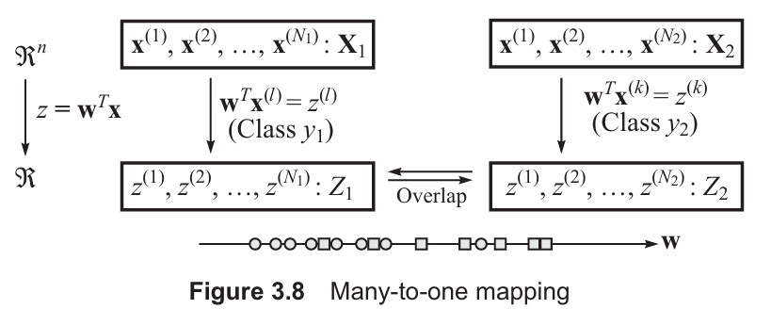
- All the points from class $y_{1}$ becomes $z_{1}$
- All the points from class $y_{2}$ becomes $z_{2}$
$$X_{1}→Z_{1}$$
$$X_{2}→Z_{2}$$

4. Important idea: Many-to-One Mapping
- Many-dimensional points → mapped to one number
- This is called many-to-one mapping
Problem:
- Different points may map to similar values → overlap can happen
5. Geometrical Meaning (Very Important)
- Imagine a line in space
- Each point is projected onto that line
Like casting a shadow of points onto a line
- That shadow = z

6. Role of vector w
- w decides direction of the line
- Only direction matters, not its size
Why?
- Changing magnitude only scales values
- It does NOT change separation

7. What is the main goal?
We want to find the best direction w such that:
✔ Points of same class → close together
✔ Points of different classes → far apart
8. Simple Intuition
Imagine:
- Red dots (Class 1)
- Blue dots (Class 2)
Now draw a line:
- Some lines mix colors ❌
- Some lines separate them nicely ✅
FLD tries to find that best line
9. Final Understanding
- Convert high-dimensional data → 1D
- Choose direction w carefully
- Project data using z =$w^{T}$x
- Try to separate classes as much as possible

After projecting data to 1D:
- Class 1 → values in $Z_{1}$
- Class 2 → values in ${ Z}_{2}$
👉 Now we need a way to measure how well these two classes are separated
2. Step 1: Find Mean of Each Class
We calculate average (mean) of projected values:
In order to find a good projection vector w, we need to define a measure of separation between the projections. The means of data subsets $Z_{1}$ and $Z_{2}$ are given by
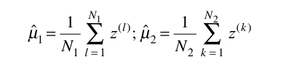
First Idea (Simple but Not Enough)
We may think:
👉 “If means are far apart, classes are well separated”
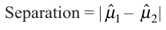
Bigger distance = better separation
Problem:
- This ignores how spread out the data is!
4. Why Mean Alone is Not Enough?
Imagine:
- Case 1 → tight clusters → good separation ✅
- Case 2 → very spread data → overlapping ❌
Even if means are same distance, spread matters
5. Step 2: Measure Spread (Variance)
For each class:
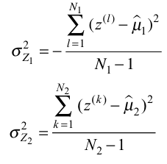
This tells:
- How much data is scattered
Why divide by N−?
- Using N → biased result ❌
- Using N−1→ correct (unbiased) estimate

Step 3: Combine Both Variances
We calculate pooled variance:
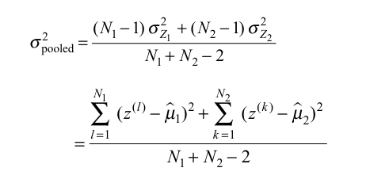
Meaning:
- Overall spread of both classes together

Final Measure (MOST IMPORTANT)
Now we combine both ideas:
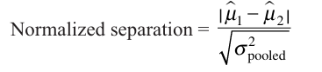

Good separation happens when:
- Means are far apart ↑
- Variance is small ↓
✔️ Large value → classes well separated
❌ Small value → overlap

Thresholding
Classification Using FLD
After projection:
- Data becomes 1D
- Now we just choose a threshold t
Decision Rule:
- If $w^{T}$x≥ t → class $y_{1}$
- Else → class $y_{2}$

How to Choose Threshold?
If both classes are equally likely:
t=$\frac{m_{1}+m_{2}}{2}$
Midpoint between projected means
If not equal:
- Shift threshold toward smaller class
- Or choose t that minimizes training error
FLD is trying to:
- Stretch distance between classes
- Compress spread within classes
👉 Best separation happens when:
- Means are far apart
- Variance is small

