Introduction to Machine Learning
Humans have always aimed to create machines with human-like traits and extraordinary abilities (e.g., robots in manufacturing, medicine, space). Current machines are often "enslaved by commands." i.e. Most machines, including conventional robots and early AI systems, operate solely based on explicit, pre-defined instructions (algorithms) given by a human programmer.
The ultimate goal in robotics and systems science is to create intelligent machines that truly emulate human intelligence. Human Intelligence is complex, involving sensory (vision, hearing, etc.), control, affective (emotional), and cognitive (thought, learning, reasoning) aspects. The 100 biological neurons in the Central Nervous System (CNS) are key. They acquire, integrate, interpret (cognitive computing), and process information for actions.
Cognitive Machines and New Computing
Traditional computers are mainly used for storing processing numerical data. To emulate human cognitive functions (learning, reasoning, perceiving), we need to generalize the definition of information and develop new mathematical tools. A challenging field attempting to capture the mathematical aspects of our thinking process and the hardware aspects of neurons. While our understanding of complex biological neuronal processes is limited, it has fuelled the development of systems that emulate certain human learning behaviours. Neuronal information processing involves complex mathematical operations and mapping functions acting together in a parallel-cascade structure.
Objective: To use this limited understanding to create intelligent cognitive systems to assist humans in decision-making.
Key Computing theories for machine Learning
New computing theories evolving with a neural network architecture as the basis, aiming to create a "thinking machine" or a low-level cognitive machine.
Fuzzy Logic: A theory based on the notion of graded membership (relative grades of information), which contrasts with the absolute measure of information used by conventional mathematics (deterministic or probabilistic).
Cognitive Function: The brain and its natural sensors deal with information and perceptions in relative grades (e.g., "hot," "very fast"), which fuzzy logic can model mathematically.
The Union: A combination of Neural Networks and Fuzzy Logic is considered a powerful way to push the theory of cognitive information processing.

Motivation and Applications in the Information Age
Information is Power: The combination of computing and communication has led to an information age where vast amounts of data are collected daily (terabytes).
- Categories of Stored Information:
- Experimental Data: Examples, samples, measurements, records, patterns (e.g., patient records, MRI scans, engine logs).
- Structured Human Knowledge: Experience, expertise, heuristics expressed as linguistic IF-THEN rules (e.g., an experienced operator's control strategy).
- The Challenge: The industry needs to perform something useful with this data.
- Examples: Detecting credit card fraud, identifying effective medical treatments, providing early warnings for automobile malfunctions, or replacing process operators with intelligent machines.
- Rationality: Machine intelligence research is driven by the need for rationality: a machine that does the "right thing" to achieve the best outcome (or best expected outcome) given what it knows.
Well posed machine learning problem
ML is about constructing computer programs that improve their performance at a task through experience. A well-defined learning problem must clearly identify the learning task, the measure of performance, and the task experience. The "learning from experience" behaviour embedded in ML, similar to animal learning, includes remembering, adapting, and generalizing.
The key concept that we will need to think about for our machines is learning from experience. Important aspects of ‘learning from experience’ behaviour of humans and other animals embedded in machine learning are remembering, adapting, and generalizing.
• Remembering and Adapting: Recognizing that last time in a similar situation, a certain action (that resulted in this output) was attempted and had worked; therefore, it should be tried again or this same action failed in the last attempt in a similar situation, and so something different should be tried.
Example: Imagine you are trying to open a door.
- Last time you pushed the door, but it did not open.
- You then pulled the door, and it opened.
Next time you reach the same door:
- You remember that pulling worked.
- You adapt your action and pull the door immediately.
This is how a robot or machine learns too:
If an action works in a situation, store that experience.
If it fails, try something else next time.
• Generalizing: This aspect is regarding recognizing similarity between different situations. This makes learning useful because we can use our knowledge in situations unseen earlier.
Suppose you learned that:
- Pulling opens the library door.
Later you see a new door at the cafeteria. It looks similar:
- It has the same type of handle.
- The signboard is in the same place.
You try pulling even though you never used this cafeteria door before.
Generalization:
Using your earlier experience with a different but similar door.

Types of learning tasks
There are four primary types of learning tasks
- Classification: Learning a technique to assign observations to a discrete class (e.g., classifying an email as 'Spam' or 'Not Spam').
- Regression: Predicting a continuous numeric quantity (e.g., predicting house price).
- Association: Finding any relationship between observations (e.g., market basket analysis).
- Clustering: Grouping observations that belong together based on similarity.
There are two major types of learning
Supervised learning | Unsupervised learning
Models are trained using labelled data | Models are trained using unlabelled data
The goal of supervised learning is to train the model so that it can predict the output when new data is given to it. | The goal of unsupervised learning is to find the hidden patterns and useful insights from the unknown dataset
It is typically used for regression (predicting continuous values) and Classification (predicting categorical values) | used for clustering (grouping similar items), association (finding relationships between variables), and dimensionality reduction (reducing the number of variables).
The output is typically a specific prediction or classification based on the labelled data. | The results are generally more exploratory and descriptive.
How Machine learns (The Input)
The machine (computer program) learns from experience, which is the data you give it:
- Data Formats
- The Best Format is Numbers: Most data, whether it's simple measurements or complex things like images and audio, is converted into a fixed-length vector of numerical values (a list of numbers).
- Why Numerical Data? Using numbers lets the machine use geometry and algebra to "see" patterns in the data (like plotting points in a space).
- Measuring Similarity: When data is numerical, the similarity between two pieces of data is measured by the distance between their vectors (e.g., using Euclidean distance).
- The Trade-off: Converting complex data (like an image) into simple vectors causes a loss of information, but it's necessary for the learning process.

- Alternative Data Inputs
- Nominal/Categorical Data: This is non-numerical data described using words (e.g., color: 'Red', 'Blue'). Since there are no numbers, similarity is found using nonmetric methods.
- Human Knowledge (IF-THEN Rules): Sometimes, the machine is trained not on data, but on human expertise given as structured knowledge, such as a list of IF-THEN rules. This can be used instead of, or in addition to, a dataset.

What the Machine Produces (The Output)
After being trained, the machine generates a model that represents the knowledge it has gained.
1. The Output: The Model
- The output is the learned knowledge, which is called a Model.
- The model captures the structural patterns hidden within the training data.
2. The Model's Purpose (Prediction/Decision)
- The user uses this model for decision-making.
- When you feed the model a piece of new data (an observation not seen during training), the model provides a prediction or decision based on what it learned.
3. The Goal: Generalization
- A good model must be able to generalize well—meaning it can make accurate predictions for new, unseen data, not just the data it was trained on.

A block diagrammatic representation of a learning machine is shown in Fig. 1.1
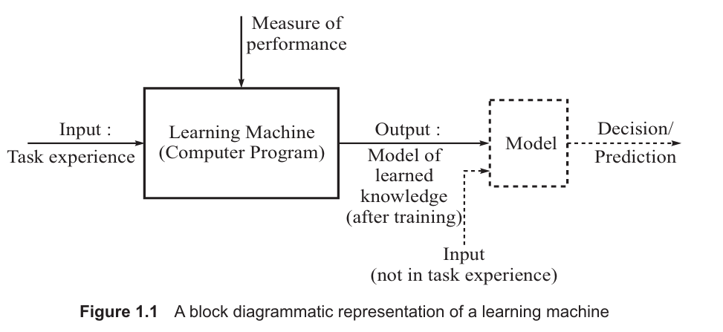

Component | Description
Input: Task Experience | The data (numerical vectors, rules, etc.) used to train the machine.
Learning Machine | The computer program (algorithm) that processes the input.
Measure of Performance | The way we check if the machine is learning well (used during training).
Output: Model of Learned Knowledge | The final model created after training.
New Input | New, unseen data fed to the final model.
Decision/Prediction | The result provided by the model for the new input.

