Statistical Learning
Statistical analysis saw the development of two branches in the 18th century—Bayesian and classical statistics. In case of the approach that originated from the mathematical works of Thomas Bayes, analysis is based on the concept of conditional probability: the probability of an event taking place considering that another event has already taken place.
1. Bayesian vs. Classical Statistics
The text highlights two different ways to look at probability:
- Bayesian Statistics (Subjective): Starts with a "prior belief" (what you already know) and updates it with new data.
Examples: Medical Diagnosis
Imagine that doctor already knows that patient is young and healthy and we know that healthy person can rarely has heart disease. New data is patient reports mild chest pain. Even though you see a mild chest pain you might bet against the heart diseases as your prior belief (young and healthy is strong)
Classical Statistics (Objective): Focuses strictly on the data at hand without using past "beliefs."
Example: A coin flip. A classical statistician doesn't care if the coin "felt" lucky yesterday; they only care about the results of the 100 flips happening right now.
Deductive vs. Inductive Reasoning
This is the fundamental difference between "old school" statistics and Machine Learning.
- Deductive (Conventional Statistics): You start with a rule (theory) and apply it to data to see if it fits.
Example: "All humans need water. John is a human. Therefore, John needs water."
- Inductive (Machine Learning): You look at thousands of examples and "induce" (discover) a pattern you didn't know existed.
Example: A baby touches a hot stove, a hot iron, and a hot soup bowl. After three painful experiences, the baby induces a rule: "Glowing/steaming things shouldn't be touched." The baby discovered the rule from the data.
Descriptive vs. Inferential Statistics
- Descriptive: Summarizing what has already happened.
Example: A fitness app showing you that you walked 10,000 steps yesterday and your average heart rate was 75 bpm. It’s just "describing" the past.
- Inferential: Using a small sample of data to make a "guess" or prediction about a larger group.
Example: A political poll. Researchers ask 1,000 people who they will vote for to infer (predict) how 30 million people will vote on election day.
Dealing with "Noisy" Data
The text notes that real-world data is often "noisy, incomplete, and inconsistent."
- What is "Noise"? Random errors or irrelevant data that distract from the pattern.
- Day-to-Day Example: Imagine you are trying to listen to a friend talk at a loud, crowded concert. Your friend's voice is the signal (the data you want), and the loud music and other people shouting is the noise. Machine learning algorithms are designed to "filter out" that music so they can understand the message.

Descriptive Statistics in Learning Technique
Hard Computing (Analytical Models): This is like following a strict recipe. You use specific mathematical equations to get an exact answer. If you have the right formula and the right input, you get the 100% correct output every time.
- Day-to-Day Example: A Calculator. When you type 567×432, the computer uses a "hard" mathematical rule. There is no guesswork; the answer is either right or wrong.
Soft Modeling (Machine Learning): This is more like a human learning to recognize a face. There isn't one single equation for "what a face looks like." Instead, the computer looks at thousands of photos and builds a "soft" model that says, "This is probably a face."
- Day-to-Day Example: Netflix Recommendations. There is no "hard" rule that says if you liked Stranger Things, you will definitely like Wednesday. The computer uses a "soft model" to guess your preferences based on patterns.
Dealing with "Messy" Data (Uncertainty)
In a perfect world, data is clean. In the real world, data is incomplete, noisy, and inconsistent. * Noise: Extra, irrelevant information that makes it hard to see the truth.
- Missing Values: Gaps in the data.
- Inconsistencies: Data that contradicts itself.
Day-to-Day Example: Your Phone's GPS Imagine you are tracking a run.
- Noise: Sometimes the GPS "jitters," making it look like you suddenly jumped 20 feet to the left and back. That "jump" is noise.
- Missing Values: You run through a tunnel, and the GPS loses signal for 30 seconds. That is a missing value.
- The Solution: The app uses probability to "smooth out" the jitter and "guess" your path through the tunnel. It handles the uncertainty so the final map looks correct.
Most popular uncertainty management paradigms are based on probability theory.
A. The Sample Space (D)
This is the "world" of all possible outcomes. In Machine Learning, your entire dataset (the Data Matrix) is your Sample Space.
- Example: If you are analyzing a deck of cards, the Sample Space is all 52 cards.
B. Sample Points (x)
This is a single "event" or a single row in your data. It is one specific instance from the Sample Space.
- Example: Drawing the 7 of Hearts is a "sample point." In a medical study, one single patient’s records would be a sample point.
C. Random Variables (Features/Attributes)
These are the specific things we are measuring (the columns in your data). We call them "random" because we don't know their value until we observe them.
- Example: If you are buying a house, the Random Variables are the number of bedrooms, the square footage, and the price. You don't know these numbers until you look at a specific house (a sample point).

Probability Mass Function
1. Discrete Random Variables: Things You Can Count
A random variable (x) is just a symbol for an outcome that is uncertain. The text focuses on discrete variables, meaning the outcomes have clear, separate values.
- Day-to-Day Example: Think of a standard six-sided die. The outcome can be 1, 2, 3, 4, 5, or 6. You cannot roll a "2.5" or a "4.7." Because the values are separate and countable, they are discrete.
- Other examples: The number of children in a family, the number of cars in a parking lot, or a "Yes/No" survey response.

2. Finding the Probability (Frequency Point of View)
To find the probability of a specific value ($V_{lx}$):

P($V_{lx}$)=$\lim_{n→∞}{\frac{ΔN}{N}}$
Where,
N = number of sample points, and
$ΔN$ = number of times x= $V_{lx}$
The probabilities of all possible values of x are expressed as a probability mass function:
In plain English, this means if you perform an experiment a huge number of times ($ΔN$), the probability is simply how many times your specific outcome happened divided by the total number of tries.
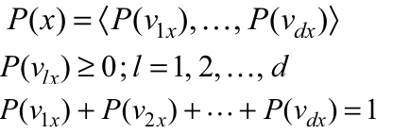

3. The Rules of a PMF
A Probability Mass Function is essentially a "map" or a list of all possible outcomes and their chances. To be a valid PMF, it must follow two strict rules:
- No Negative Chances: Every individual probability must be 0 or greater (P($V_{lx}$≥0)You can't have a "-10% chance" of something happening.
- The 100% Rule: When you add up the probabilities of all possible outcomes, the total must equal 1 (which represents 100%).
4. Visualizing the PMF (Figure 3.1)
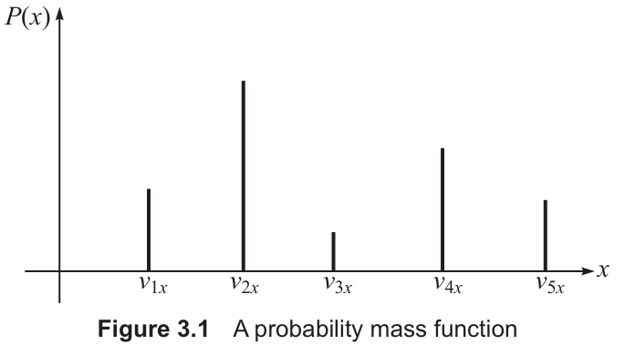
The graph in the image shows "spikes" or vertical lines at specific points ($V_{1x}, V_{2x},…etc$)
Why spikes? Because in a discrete system, there is no probability for the space between the values.
Example: If you are counting the number of "Heads" in two coin flips, you can get 0, 1, or 2. Your graph would have three spikes. There would be no line at "1.5" because you can't get one-and-a-half heads.

Probability Density Function
A PDF is used for continuous random variables, which can take an infinite number of values within a certain range
The "Zero" Problem: Because there are infinite possible values (like 1.1, 1.11, 1.111...), the probability of hitting one exact point is mathematically zero.
How it works: Instead of looking at a single point, we look at the probability of a value falling within a range (between $V_{1x}$ and $V_{2x}$)

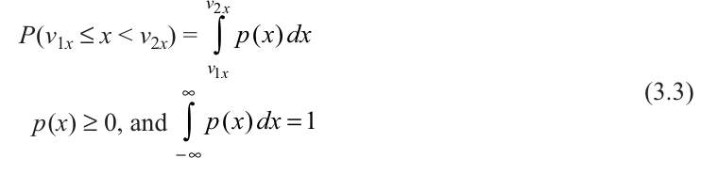

The Calculation: We find the area under the curve for that specific range using integration.
The Rules:
- The density (p(x)) must be zero or higher.
- The total area under the entire curve must equal 1.
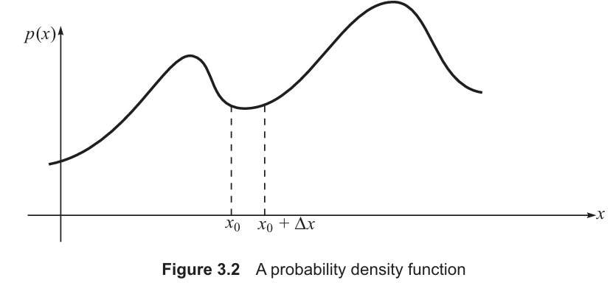

If we look at a very tiny range $Δx$ starting at $x_{0}$, the probability of a value falling in that range is approximately the density at that point multiplied by the width of the range:
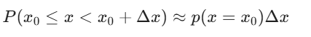
Data Perspective: From a data scientist's view, the density p(x) is the limit of the relative frequency ($ΔN/N$) divided by the width of the interval ($Δx$) as that interval becomes infinitely small:
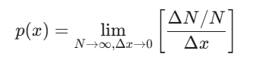
Where N= Number of sample points, and
$Δ$N= number of times the random variable x lies in the range $x_{0}$≤x<$x_{0}$+ $Δx$
Visualizing it: This looks like a smooth, continuous wave.
Day-to-Day Example: Your Morning Commute If you say your commute takes "20 minutes," it might actually take 20.1234... minutes. The probability of it taking exactly 20.00000 minutes is zero. However, there is a very high probability that your commute will fall in the range of 18 to 22 minutes.
Example:
When a self-driving car "thinks," it uses these functions. It might use a PMF to decide if a light is Red, Green, or Yellow (discrete categories). However, it uses a PDF to calculate its exact distance from the car in front (a continuous measurement).

3.2.2 Descriptive Measures of Probability Distributions Expected (mean or average) Value
One of the most important descriptive values of a random variable is the point around which distribution is centered, known as measure of central tendency. The expected (mean or average) value is the best measure for central tendency. For a scalar random variable x, the expected value, denoted as E [x] (or µ), is
For Continuous Data (Smooth curves): You use calculus (integration). You multiply every possible value (x) by its likelihood (p(x)) and add them all up.
E [x]= µ= $\int_{-∞}^{∞}{xp(x)}$dx
where p(x) is the probability density function.
For Discrete Data (Countable steps, like a dice roll): You use simple addition. You multiply each outcome by its probability and sum them up.
E [x]=$µ=\sum_{x€S}{xp(x)}$
where P(x) is probability mass function
The following results immediately follow:
1. Constants stay the same: The "average" of a constant number (like 5) is always 5.
E [C] = C; C = constant
2. Scaling: If you multiply all your data by 10, your average also multiplies by 10.
E [Cx] = C E [x]
3. Additivity: The average of a bunch of things added together is the same as adding their individual averages.
E$[\sum_{j=1}^{n}{x_{j}}$]= $\sum_{j=1}^{n}{E[x_{j}]}$
4. Joint Variables: When dealing with two variables at once (like height and weight), you use their "joint" probability to find the average of their product.
If there are two random variables x1 and x2 defined on a sample space, then
E [$x_{1 }x_{2}$ ] = $\iint_{-∞}^{∞}{x_{1 }x_{2}}$p($x_{1 }x_{2})$ d$x_{1 }{ dx}_{2}$
where p($x_{1 }x_{2}$) is joint probability density function.
5. Functions: If you want the average of $x^{2}$ you just plug $x^{2}$ into the formula where x used to be.
E [f(x)] = µ= $\int_{-∞}^{∞}{f\left(x\right)p(x)}$dx
6. Vectors: If your data is a list of numbers (a vector) rather than a single value, the math works exactly the same way—you just do it for the whole list at once.
For a vector random variable x,
E [x]= µ= $\int_{-∞}^{∞}{xp(x)}$dx
In discrete case,
E [x]=$µ=\sum_{x€S}{xp(x)}$

Variance
The expected value or mean is used more than any other single number to describe a random variable. Usually, it is also desired to know the ‘spread’ of the random variable about the mean. The most convenient measure used for this purpose is variance, denoted as Var[x] or , defined below:
Var[x]= σ² = E [${(x - μ)]}^{2}$=$\int_{-∞}^{∞}{{(x - μ)]}^{2}p(x)}$dx
It may be noted that variance is simply the weighted average of squared deviations from the mean value,
In discrete case,
Var[x]= σ² = E [${(x - μ)]}^{2}$=$\sum_{xϵS}{{(x - μ)}^{2}}$P(x)

A more convenient measure of dispersion is the square root of variance, called the standard deviation, σ, i.e.,
σ = $\sqrt{Var[x]}$
The following results immediately follow:
- Var[x]=E${[(x- E\left[x\right])]}^{2}$
= E( $x^{2}$-2xE(x) +${(E(x) }^{2}$)
Applying linearity and simplifying
the derivation uses the Linearity of Expectation, which allows us to distribute the E operator across the terms:
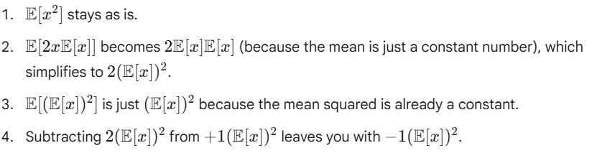
=E($x^{2}$)-(${E[x])}^{2}$
E[${x]}^{2}$is called the second moment (E[x]) is the first moment) of the random variable
The moments of difference between a random variable and its mean value are called central moments. Variance is thus a second central moment.
For two random variables $x_{1}$ and $x_{2}$ defined on a sample space, E[$x_{1}$ $x_{2}$] is the joint second moment of $x_{1}$ and $x_{2}$.

Covariance
Covariance tells us:
Do two variables move together or in opposite directions?
Mathematically
Cov [$x_{1}$, $x_{2}$] = $σ_{12}$ = E[($x_{1}-μ_{1}$) ($x_{2}-μ_{2}$)]
Covariance Value | Meaning
Positive (+) | Both increase together
Negative (−) | One increases, other decreases
Zero (0) | No linear relationship
Real-Life Example (Computer Engineering)
Example 1: CPU Usage vs Temperature
CPU Usage (%) | Temperature (°C)
20 | 40
40 | 55
60 | 70
80 | 85
When CPU usage increases, temperature increases.
So,
Covariance > 0 (Positive)

Example 2: Internet Speed vs Download Time
Speed (Mbps) | Download Time (min)
10 | 20
20 | 10
40 | 5
When speed increases, download time decreases.
Covariance < 0 (Negative)
Why Covariance Alone is Not Enough?
Problem:
Covariance depends on units.
Example:
- Marks in range 0–100
- Salary in range 0–10,00,000
Their covariance numbers will look very different and hard to compare.
So we use…
Correlation Coefficient (ρ)
ρ= $\frac{Cov [x_{1}, x_{2}]}{σ_{1}σ_{2}}$
Correlation is normalized covariance
It always lies between:
−1≤ρ≤1
Interpretation
ρ Value | Meaning
+1 | Perfect positive relationship
−1 | Perfect negative relationship
0 | No linear relation

Real-Life ML Example
Example: Study Hours vs Marks (Student Performance Prediction)
If:
ρ = 0.85
Strong positive relationship
Good feature for ML model
If:
ρ = 0.02
Almost no relationship
Useless feature
Covariance Matrix – When We Have Multiple Features
In Machine Learning, we don’t have just 2 variables.
We may have:
- Age
- Salary
- Experience
- Working hours
- Productivity
Now we want to know:
How every feature relates to every other feature?
That is where Covariance Matrix comes.

Normal Distributions
Suppose you conduct a test for 200 students.
- Most students score around 50–60 marks
- Few students score very low (10–20)
- Few students score very high (90–100)
If you draw a graph, it forms a bell-shaped curve.
That is called a Normal Distribution.
- μ (Mean) → Average marks
- σ (Standard Deviation) → Spread of marks
- Most students lie near μ
- Very few students lie far from μ

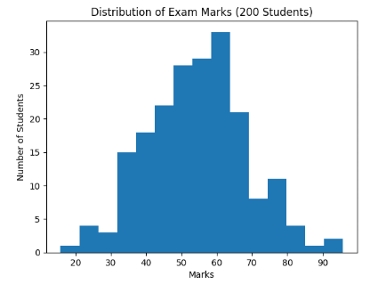
- The histogram forms a bell-shaped curve.
- Most students are clustered around 50–60 marks.
- Very few students scored:
  - Below 20 marks
  - Above 90 marks
- This confirms the data approximately follows a Normal Distribution.

Now the graph shows:
- Histogram (bars) → Actual student marks
- Smooth curve → Density curve (KDE – Kernel Density Estimation)
- The curve clearly forms a bell shape

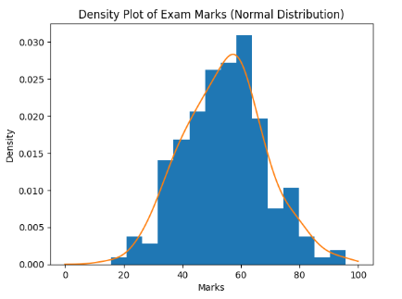
Why Normal distribution is important in ML?
If we take:
- Many small random effects
- Add them together
The result becomes approximately normal distribution.
Example:
Final exam marks depend on:
- Study time
- Sleep
- Health
- IQ
- Question difficulty
- Stress
All combined → Final score ≈ Normal distribution
This is why ML models assume normality.

What is Normal distribution?
The Normal Distribution, also known as the Gaussian distribution, is a continuous probability distribution that is symmetrical about its mean and characterized by a bell-shaped curve. According to standard statistics textbooks, it describes a distribution in which most observations cluster around the central value (mean, μ), and the probabilities for values further away from the mean decrease equally in both directions. The shape and spread of the distribution are completely determined by two parameters: the mean (μ), which locates the center of the distribution, and the standard deviation (σ), which measures the dispersion or spread of the data around the mean. In a normal distribution, the majority of data points lie close to the mean, and fewer observations occur as we move farther away from it, creating a symmetric, bell-shaped curve.
Mathematical Formula
P(x)=$\frac{1}{σ\sqrt{2 π}}exp\left[\frac{-1}{2}\left(\frac{x-µ}{σ}\right)\right]$
Where:
- μ = Mean
- σ = Standard Deviation
- x = Data value
The conventional description of normal density is a bell-shaped curve, totally controlled by the numerical values of the two parameters, the mean μ and the variance $σ^{2}$. The distribution is symmetrical about the mean; the peak occurring at x = μ, and the width of the bell is proportional to the standard deviation $σ$.
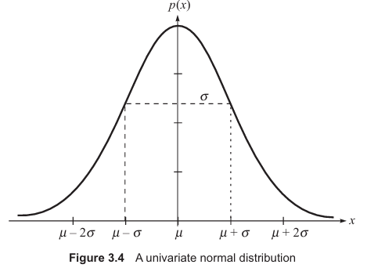

Standard Normal Distribution
If we convert:
$$z=\frac{x-μ}{σ}$$
Then:
- Mean = 0
- Standard deviation = 1
- Used in probability tables
Multivariate normal distribution
When we have multiple variables:
Example:
- Exam Marks
- Study Hours
- Attendance %
Then we use:
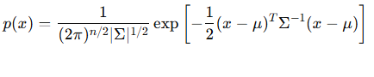
Where:
- μ = Mean vector
- Σ = Covariance matrix
Why Covariance Matrix?
It tells:
- How variables move together
- Positive correlation
- Negative correlation
- Independence

Data Similarity
Machine Learning works by answering one basic question:
"How similar are two data points?"
If two items are similar → group them together
If very different → keep them separate
Real Life Example 1: Choosing Friends
Suppose you compare two students based on:
- Age
- Marks
- Attendance
If values are close → they are similar
If values are far → they are different
This “closeness” is measured using Distance Measures
Why We Need Distance Measures?
Computers do not understand:
- “Close”
- “Similar”
- “Almost same”
They only understand numbers.
So we convert similarity into a mathematical distance.
Smaller distance → More similar
Larger distance → Less similar
Properties of a Good Distance Measure
A valid distance must satisfy:
- Non-negativity → Distance ≥ 0
- Symmetry → Distance(A,B) = Distance(B,A)
- Triangle Inequality → Direct path is shortest
Real-Life Example:
Distance from Goa to Mumbai:
- Cannot be negative
- Same both ways
- Direct flight is shortest

Euclidean Distance
This is straight-line distance.
$$d=\sqrt{\left(x_{1}-y_{1})^{2}+(x_{2}-y_{2})^{2}\right.}$$
Real Life Example:
Distance between two houses on a map.
ML Example:
Used in:
- K-Means
- KNN
- Image similarity
Limitations:
- Sensitive to outliers
- Scale problem (marks in 100 vs income in lakhs)

Manhattan Distance
Instead of straight line, it moves along grid lines.
$$d=∣x_{1}-y_{1}∣+∣x_{2}-y_{2}∣$$
Real Life Example:
In a city like Mumbai:
You cannot go diagonally.
You follow roads (left-right, up-down).
Used when:
- Grid-based systems
- Urban planning
- Sparse data

Minkowski Distance (General Form)
This is generalized distance:
$$d={\left(∑∣x_{i}-y_{i}∣^{p}\right)}^{1/p}$$
If:
- p = 1 → Manhattan
- p = 2 → Euclidean
So Euclidean and Manhattan are special cases of Minkowski.
Descriptive Measures from Data Sample
- Range: It is the difference between the smallest and the largest observation in the sample.
- Mean: It is the arithmetic average value, that is, the sum of all the values divided by the number of values.
- Median: The median value divides the observations into two groups of equal size—one possessing values smaller than the median and another one possessing values bigger than the median.
- Mode: The value that occurs most often, is called the mode of data sample
- Variance and Standard Deviation: The difference between a given observation and the arithmetic average of the sample is called its deviation.
The variance is defined as the arithmetic average of the squares of the deviations.
- Standard deviation is the square root of the variance and is commonly employed in measuring dispersion.
- Covariance matrix: Arithmetic average of the matrix ($x^{(i)}$ – μ) ${(x^{(i)} - μ) }^{T}$gives us sample covariance matrix; i = 1,…, N are the N observations in the data sample, and l is the arithmatic average of the sample. x and μ are both n-dimensional vectors.

μ= $\frac{1}{N}\sum_{i=1}^{N}{x^{(i)}}$

∑ = $\frac{1}{N}\sum_{i=1}^{N}{(x^{(i)} - μ) {(x^{(i)} - μ) }^{T}}$

