Supervised Learning: Rationale and basics
Learning from observations
There is some set S of possible patterns/observations/samples over which various output functions may be defined. The training experience is available in the form of N patterns $s^{(i)}$€ S; i=1,2,…..,N. We specify a pattern by a fixed number n of attributes/features $x_{j}$; j=1,2,….n; where each feature has real numerical value for the pattern.
- Setup
- Observation/Pattern ($s^{(i)})$: A single piece of data (e.g., a customer, an image, a sensor reading).
- Features ($x_{j}$): The attributes of the observation (e.g., age, income, color intensity). We can think of an observation as a point in an n- dimensional space $R^{n}$.

X= ${[x_{1}, x_{2} ,……… , x_{n}]}^{T}$€$R^{n}$
- True Output(y): The correct answer or label for that observation.
  - Classification: y belongs to a small set of categories (e.g. spam/not-spam, class 1,2,3)
  - Regression: y is continuous numerical value (e.g., house price, temperature)
- Training data: A set of N examples where we know both the features and the correct output:
D = {($x^{(i)}, y^{(i)}$)}; i=1,.N
- The Key Assumption and Goal

- The Big Assumption (Data): We assume that the data used for training and the data the machine will see in the future (unseen data) are all drawn randomly from the same unknown probability distribution p(x, y)
- The Goal: The machine's job is to find a function f(x) that accurately maps the input features f(x) to the output ($\hat{y}$).

$\hat{y}$=f(x,w)
Where w are the adjustable parameter that machine “learns”.

- Measuring Performance (Risk and Loss)
Since the machine's prediction $\hat{y}$ might be wrong, we need a way to measure a “cost” of the error:
- Loss function (L): Measure the error of single prediction.
  - For classification (0/1 Loss): Loss is 0 if prediction correct and 1 if prediction is wrong.

L(y, $\hat{y}$) = $\left\{\begin{aligned}0, &if y=\hat{y} \\ 1, &Otherwise \end{aligned}\right.$

  - For Regression (Squared Error Loss): Measures the squared difference between the true output and the estimated output.
L(y, $\hat{y}$) =$\frac{1}{2}{(y-\hat{y})}^{2}$
- Risk Function (R(w)- True Risk): This is the expected loss over all possible data (including unseen data), defined by unknown probability distribution p(x,y). This is the ideal metric to minimize, but it cannot be calculated because
p(x,y) is unknown.

- The Practical Solution: Empirical Risk Minimization (ERM)
Since we cannot calculate the true Risk, we rely on the data we do have: the training set.
- Empirical Risk$({ R}_{emp}$(w)): This is the average loss calculated only over the N examples in the training data D.

${ R}_{emp}$(w)$≈$ $\frac{1}{N}$ $\sum_{i=1}^{N}{L(}y^{\left(i\right)},f(x^{\left(i\right)},w)$)
- The ERM Strategy: The machine learning algorithm aims to find the parameters w that minimizes the Empirical Risks (i.e., make the fewest errors on the training data)
5. The Problem with ERM: Overfitting
Minimizing the training error perfectly is not a guarantee of success on new data. This is called an ill-posed problem.
- Overfitting: A function that achieves zero error on the training data might be overly complicated and perform very poorly on new, unseen data.
  - Example (Regression - Figure 2.1): You can draw an infinitely complicated, wiggly line that perfectly hits every single training data point ${ (R}_{emp}=0$) But this line is useless for predicting new points outside the training cluster.
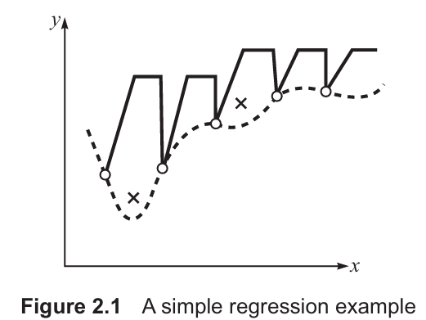

- Example (Classification - Figure 2.2): A complex decision boundary that separates every training point correctly might misclassify simple test points that were not in the training set.
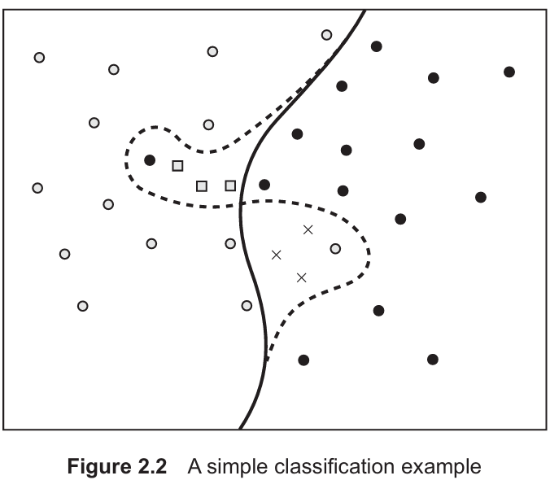
6. The Ultimate Goal: Generalization
- Generalization: The ability of the trained machine to accurately predict outputs for novel patterns (data it has never seen before).
- Test Dataset: We measure generalization performance by checking the error on a separate test dataset (data not used for training). This error is called the off-training set error.
- Inductive Learning: The process of using specific training examples to create a general hypothesis (h(x)) that hopefully approximates the true unknown function f(x) well, allowing it to generalize.
7. Limitations of Theory
- No Free Lunch Theorem: There is no single "best" machine learning algorithm that works best for all possible problems. An algorithm's success depends entirely on how well it fits the specific problem context.
- Practical Approach: Because perfect theoretical solutions are elusive, practitioners often rely on:
  - Heuristics (Trial-and-Error): Trying different algorithms and configurations.
  - Occam’s Razor Principle: Favouring the simplest hypothesis (the simplest function f(x)) that adequately explains the data, as this is often less prone to overfitting.

Bias and Variance
Imagine you are trying to hit a target (the true function, f(x)) using a dartboard. Every time you train your machine learning model, it's like throwing a dart. Since you get slightly different training data samples each time, your dart hits a slightly different spot.
The overall error in your model's prediction comes from two main sources: Bias and Variance.
1. Bias (The "Wrong Spot" Error)
- Simple Term: Underfitting.
- Analogy: You are aiming for the bullseye, but all your darts land consistently in the upper-left quadrant. You are consistently missing the true target because of a fundamental flaw in your aim.
- In ML: Bias is the error that arises from the chosen model being too simple or too inflexible to capture the true underlying relationship in the data. The model is so simple (e.g., a straight line on a curve) that even if you train it on infinite data, the average prediction will still be wrong.
2. Variance (The "Scattered" Error)
- Simple Term: Overfitting.
- Analogy: Your darts are scattered all over the board. Sometimes you hit the bullseye perfectly, sometimes you miss widely, but your average aim (the center of the scatter) is correct. Your individual throws are wildly sensitive to tiny differences in how you throw.
- In ML: Variance is the error that arises from the model being too complex or too sensitive to the specific training data. If you change the training set slightly, the model's predictions change wildly. The model is learning the noise in the data, not the signal.

The Bias-Variance Trade-Off (The Dilemma)
There is a fundamental dilemma:
- Make the Model Simple (Low Complexity): → High Bias (Can't fit the curve) and Low Variance (Gives consistent, but wrong, answers).
- Make the Model Complex (High Flexibility): →Low Bias (Can fit the curve perfectly) and High Variance (Gives scattered, unreliable answers).
To get the Minimum Total Error, you must find the sweet spot where the combination of Bias and Variance is lowest.

I. The Core Concepts
Term | Definition | Simple Result
Bias | The difference between the average prediction of the model (over many different datasets) and the true function f(x). | High Bias means the model is too simple (Underfitting).
Variance | The amount by which the model's prediction fluctuates when trained on different datasets. | High Variance means the model is too complex (Overfitting).
Total Error | The expected squared error between the model's prediction and the true function. It is decomposed as: | Total Error $≈{Bias}^{2}$+ Variance

II. The Bias-Variance Dilemma
- Low Complexity Model: Results in High Bias and Low Variance. The model consistently misses the target because it's too rigid.
- High Complexity Model: Results in Low Bias and High Variance. The model's predictions are accurate on average but wildly inconsistent depending on the training data.
- Goal: Find the model complexity that minimizes the Total Error $≈{Bias}^{2}$+ Variance
III. Overfitting and Generalization
- Overfitting: Occurs when a model fits the training data (including its noise and coincidental patterns) so well that it performs worse on new, unseen data.
- Training Accuracy: Always increases as model complexity increases (the solid line in Fig. 2.7).
- Testing/Generalization Accuracy: Increases, but then decreases sharply as complexity increases past the optimal point (the broken line in Fig. 2.7). The goal is to maximize this.

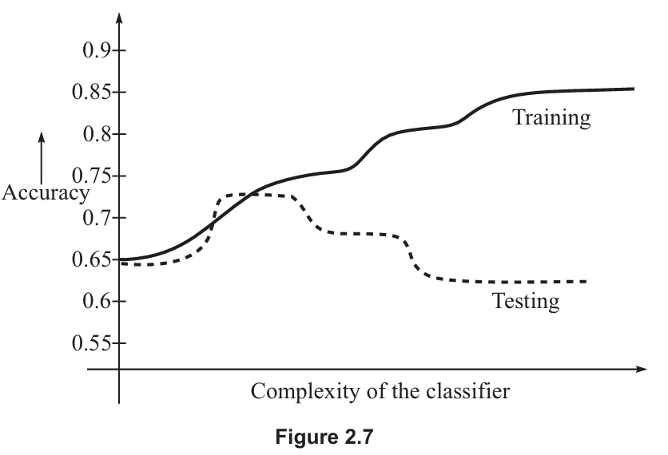
IV. Principles for Overfitting Avoidance
A. Occam’s Razor Principle
- Idea: When faced with two hypotheses (models) that perform equally well on the training data, choose the simpler one.
- Reasoning: The simpler model is less likely to have accidentally captured noise or coincidental regularities in the training data, thus offering better generalization on unseen data.
If there are two algorithms and both of them perform equally well on the training set, then according to Occam’s razor principle, the simpler algorithm can be expected to do better on a test set; ‘simpler’ may imply needing lesser parameters, lesser training time, fewer attributes for data representation, and lesser computational complexity. Our design methodology itself imposes a bias toward ‘simple’ solutions in applied machine learning. We usually stop looking for a design when the solution is ‘good enough’, not necessarily the optimal one. Occam’s razor principle suggests hypothesis functions that avoid overfitting of the training data.

B. Computational Learning Theory (CLT)
The CLT tries to give mathematical answers to: How can we guarantee a learned hypothesis h(x) is close to the true function f(x)?
The Problem: The Law of Large Numbers (which suggests that the Empirical Risk ${ R}_{emp}$
approaches the True Risk R as the number of samples N →∞ doesn't guarantee that the function that minimizes ${ R}_{emp}$ will be the same as the function that minimizes R. This is where the Bias-Variance dilemma surfaces.
The Solution (VC Theory): Uniform Convergence is needed, meaning the difference between R and ${ R}_{emp}$ must approach zero uniformly across the entire set of possible functions (F).
- VC Dimension ($h_{c}$): A measure of the capacity or complexity of the set of functions F.
- Structural Risk Minimization (SRM): Instead of just minimizing the empirical risk ${ R}_{emp}$ SRM minimizes a bound on the true risk R. This bound depends on two things:
- The training Error ${ R}_{emp}$
- The Capacity Term ($h_{c}$): The principle is to select a model that has small training error and comes from a function class with small capacity (simpler). .

C. PAC Learning (Probably-Approximately-Correct)
- Focus: Determining Sample Complexity—the minimum number of training examples ($N_{PAC}$) needed to ensure the hypothesis is approximately correct with a high probability.
- Key Insight: The required sample size N depends on the desired accuracy 𝟄, the confidence 𝟃, and the complexity (VC Dimension, $h_{c})$ of the hypothesis space.

HEURISTIC SEARCH IN INDUCTIVE LEARNING
1. The Core Goal: Generalization
Machine learning is not about memorizing the training data; it is about building a statistical model that understands the underlying process. The goal is generalization—the ability to make accurate predictions on new, unseen data.
- Example: If you are training a model to recognize cats, you don't want it to just recognize the specific 100 cats in your photos. You want it to recognize any cat it sees in the future.
2. The Bias-Variance Trade-off
This is the fundamental "balancing act" in machine learning.
- Bias (Underfitting): The model is too simple (e.g., a straight line for a curved relationship). it misses the complexity of the data.
- Variance (Overfitting): The model is too complex (e.g., a jagged line that touches every single data point). It mistakes random noise for a real pattern.
- Example: * High Bias: Studying only one page of a textbook for a final exam. You’ll be too prepared for that page but fail the rest.
  - High Variance: Memorizing every word of the textbook without understanding the concepts. If the exam questions are phrased slightly differently, you’ll fail.

Search through Heuristics space
The word ‘heuristic’ indicates that strategies for the search problem cannot be precisely pre-defined. Trial-and-error is the approach of searching for a ‘good enough’ solution. This approach, however, gets more organized if we exploit the prior knowledge about the learning domains and experience with a broad range of algorithms.
Machine learning entails looking through a space of probable hypotheses to decide on one that fits the data observed. and any previous knowledge held by the learner. Space of probable hypotheses is infinite in theoretical terms. The learning task, therefore, is to explore a widespread space to find the hypothesis that is most consistent with the existing training examples.
Applied machine learning organizes the search as per the following two-step procedure
- The search is first focused on a class of the possible hypotheses, chosen for the learning task in hand. Prior knowledge and experience are helpful in this selection. Different classes are appropriate for different kinds of learning tasks.
- For each of the classes, the corresponding learning algorithm organizes the search through all possible structures of the learning machine.
In simple terms, Inductive Learning is the process of learning general rules from specific examples. Because there are an infinite number of possible "rules" or "theories" (hypotheses) that could explain a set of data, machine learning uses a two-step search to narrow things down quickly.
Think of this process like trying to find the right tool to fix something in your house.
Step 1: Choosing the "Toolbox" (The Hypothesis Class)
Before you start fixing a leak, you don't look at every single object in your house (that would take forever). Based on your experience (prior knowledge), you decide you need a "Plumbing Toolbox" rather than a "Sewing Kit."
- In Machine Learning: We don't search through every possible mathematical formula. Instead, we use a heuristic (a smart shortcut) to pick a category of models, such as "Decision Trees" or "Neural Networks," because we know from experience they work well for this type of data.
- The Heuristic: "This problem looks like a classification task with tabular data, so I'll start with Decision Trees."

Step 2: Finding the "Right Tool" (The Specific Structure)
Now that you have your plumbing toolbox open, you have to find the exact wrench that fits the pipe. You don't just pick one at random; you try one, see if it’s too big (overfitting) or too small (underfitting), and then adjust.
- In Machine Learning: Once we've picked a "class" (like a Neural Network), the algorithm searches for the specific settings (weights and layers) that fit the data best.
- The Heuristic: Since we can’t test every possible version of the network, we use tools like Early Stopping (quitting while we're ahead) or Pruning (cutting off parts of the model that are too specific) to find a "good enough" solution without getting lost in the details.

The techniques used in heuristic search to optimize hypothesis complexity for a given training dataset.
- Regularization
Regularization adds a "penalty" to the model for being too complicated. If the model uses very large numbers (weights) to explain the data, the regularization formula "punishes" it. It forces the model to stay "smooth" and simple.
Augmented Error function is given by
$\overline{E}$=E+ λΩ

Where E (Error on Data) = is the standard error or "loss" that the model calculates based on the training set. It measures how poorly the model is performing on the data it is currently seeing. A high E means model is making many mistakes on training examples

Ω (hypothesis complexity) = is the regularization term, which represents the "intricacy" or complexity of the hypothesis (the model). It measures how "wiggly" or complicated the mathematical function is. For example, in neural networks, this is often calculated as the sum of the squares of the weights
Ω=$\frac{1}{2}\sum_{i,j}{W_{i,j}^{2}}$
λ(Weight of Penalty) = This is a "tuning knob" that determines how much importance we give to the complexity penalty versus the actual error.
If λ is very small, the model ignores complexity and tries to get zero errors on the data (risking high variance/overfitting).
If λ is large, the model ignores the data and focuses only on being simple (risking high bias/underfitting).

$\overline{E}$ (Augmented Error) = This is the "Total Cost." The machine learning algorithm does not just try to minimize the mistakes (E); it tries to minimize the combination of mistakes and complexity.

- Early stopping
The Concept: When a machine is learning, its error on the training data usually keeps going down the longer it practices. However, after a certain point, it starts memorizing the "noise" (random errors) instead of the actual patterns. Early Stopping tells the machine to stop training the moment its performance on new data starts to get worse.

Real-Life Example: Think of Baking a Cake.
- If you take it out too early, it’s undercooked (Underfitting).
- If you leave it in too long to make sure every single molecule is dry, it burns (Overfitting).
- Early Stopping is like checking the cake with a toothpick and taking it out the exact second it’s done, rather than waiting for the timer to hit zero.

- Pruning (The "Gardening" Approach)
The Concept: In models like "Decision Trees," the machine often grows a massive, complicated tree to explain every single data point. Pruning is the process of letting the tree grow fully and then cutting off the "weak" or "useless" branches that don't really help in making general predictions.
Real-Life Example: Imagine a Company Strategy.
- A startup might try to sell 50 different products to see what happens. This is the "Full-Grown Tree."
- After a year, they realize that 45 of those products only sold once to a specific person.
- Pruning is when the CEO shuts down those 45 tiny departments to focus only on the 5 core products that everyone actually buys. By "cutting the branches," the company becomes more efficient and better at serving the general public.

Ensemble Learning
Instead of relying on one "expert" hypothesis, ensemble learning combines the predictions of many models to get a more reliable result.
- Bagging: Training multiple models independently and averaging them (e.g., Random Forests).
- Boosting: Training models sequentially, where each new model tries to fix the mistakes of the previous one (e.g., AdaBoost).
- Example: Asking 20 different doctors for a diagnosis and taking the majority opinion (Voting) is much safer than just asking one.

5. Class-Imbalance Problems
This occurs when one category of data is much more frequent than the other, making it hard for the machine to "see" the rare cases.
- Example: In Credit Card Fraud detection, 99.9% of transactions are legitimate, and 0.1% are fraudulent. A model could get 99.9% accuracy by simply guessing "Legitimate" every time, but it would fail its actual job (finding fraud).
- Solutions: Oversampling (duplicating rare cases) or Undersampling (removing common cases).

Evaluation Metrics
To know if a system is "good," we look at more than just accuracy:
- Robustness: Can it handle messy or "noisy" data? ‘Robustness’ means that the machine can perform adequately under all circumstances, including the cases when information is corrupted by noise, is incomplete, and is interfered with irrelevant data.
- Computational Complexity: How much memory and time does it take? (Crucial for apps on phones). Computational complexity of a learning algorithm and learning speed determine the efficiency of a learning system: how fast the systems can arrive at a correct answer, and how much computer memory is required. We know how important speed is in real-time situations.
- Interpretability: Can a human understand why the machine made that decision? (Crucial for medical or legal AI).
- Scalability: Can it handle millions of rows of data, or does it crash?

Estimating generalization Errors
To understand how we measure a machine’s performance, we have to look at how it handles future data, not just the data it already studied. A model might perform perfectly on its training notes but fail miserably on a real exam.

1. The Three Datasets
Think of these as the three stages of a student's education:
- Training Data: This is the "Textbook." The model uses this to build its basic structure and learn patterns.
- Validation Data: This is a "Practice Quiz." It is used to fine-tune the model's settings (parameters) or choose between different models.
- Test Data: This is the "Final Exam." It consists of completely unseen data used only once at the very end to calculate the true error rate.

2. Simple Splitting Methods
If you have a limited amount of data, you need clever ways to split it.
In the holdout technique, some amount of data is earmarked for the purpose of testing, while the remainder is employed for training (and a portion of it is kept aside for validation, if needed). Practically speaking, it is common to hold out one-third of the data for testing and use the remainder for training.
  - The Holdout Method
This is the simplest way to test a model. You take your original dataset and divide it into two main parts:
- Training Set: This is what the machine uses to learn.
- Test Set: This is "earmarked" or set aside and used only to check the final accuracy.
Key takeaways from the text:
- The 1/3 Rule: It is common practice to use two-thirds of the data for training and hold out one-third for testing.
- Time-Series Data: If your data is collected over time, you should use the earlier part for training and the later part for testing. This mimics the real world, where the model is built on the past to predict the future.

  - Stratification: Keeping it Fair
A simple random split can sometimes be "unfair." For example, if you are classifying diseases but the test set accidentally ends up with zero cases of the disease, the test is useless.
- Definition: Stratification ensures that each class (category) is represented in the same proportion in the training and test sets as it is in the full dataset.
- The Check: You check if the percentage of each class in the training and test sets is more or less the same as the full dataset.

3. Random Subsampling
Even with stratification, one single split might result in a biased or "lucky" outcome. To fix this, we use Random Subsampling.
- The Process: You repeat the holdout method K times, each time using different random samples for the training and test sets.
- The Result: You calculate the accuracy for each of the K repetitions and then average them to get a more reliable overall estimate.

4. Swapping Roles
Another variation involves a 50:50 split where you train on the first half and test on the second, then swap (train on the second and test on the first).
- Pros: This helps decrease the effect of an uneven data distribution.
- Cons: It is usually not ideal because it is better to have more than 50% of your data dedicated to training the machine

3. Cross-Validation (The Standard Approach)
This is a more thorough way to test a model when you don't have unlimited data.
K-Fold Cross-Validation
- Divide your data into K equal parts (usually K = 10).
- In the first round, use parts 2–10 for training and part 1 for testing.
- Repeat this until every part has been the "test set" once.
- Average all the errors to get a final score.

Leave-One-Out Cross-Validation (LOOCV)
This is an extreme version where K equals the number of total samples. You train on every single piece of data except for one lone sample, which you use for testing. You repeat this for every single sample in the set.
- Pro: Great for getting the most out of tiny datasets.
- Con: Very slow and expensive for large datasets.

Bootstrapping
The bootstrap technique is based on the process of sampling with replacement. In the earlier techniques, whenever a sample was used from the dataset to form a training or test set, it was never replaced. In other words, the same instance, which was once chosen could not be chosen again. However, most learning techniques can employ an instance several times, and it affects the learning outcome if it is available in the training set more than once. The concept of bootstrapping aims to sample the dataset by replacement, so as to form a training set and a test set.

There are many bootstrap techniques. The most popular one is the 0.632 bootstrap, which works as follows:

1. The "Names in a Hat" Analogy
Imagine you have a hat with 10 different names in it. You want to create a "Training Team" of 10 people.
The Process: You reach in, pull out a name, write it down, and put the name back in the hat.
The Result: You repeat this 10 times. Because you put the names back, you might pick "John" three times and never pick "Sarah" at all.
The Split: The names you picked go on the Training Team. The names that were left in the hat (the ones you never picked) become your Test Set.

2. Where does "63.2%" come from?
The probability that a particular instance will be picked is 1/N; so the probability of not being picked is (1-1/N)
This method is called 0.632 Bootstrap because after drawing samples n times roughly 63.2% of data is drawn at least once and 36.8% of the data is never drawn.
on average, your training set will contain 63.2% of your original unique data points, while the remaining 36.8% are your "unseen" test instances.

The 0.632 Error Formula
If we only measured the error on the test set, it would be too "pessimistic" (it would look worse than it is) because the model only learned from 63.2% of the unique data. To get a more realistic score, we combine the performance from both sets using a weighted average:

Final Error= (0.632× Error on test data) +(0.368 × Error on training data)

4. Why use this?
- Best for Small Data: When you don't have enough data to comfortably set aside a large "Test Set," bootstrapping allows you to use every single piece of data for both training and testing in different iterations.
- The Catch: It can be "overly optimistic," meaning it might make the model look slightly better than it actually is.

