CREATIVE THINKING AND INNOVATION

UNIT 1 INTRODUCTION
Creative thinking, blocks to creativity, factors that influence creative design, engineering design and creative design, influence of society, technology and business on creativity, force field analysis, market pull & technology push, attribute of a creative person, thinking in groups.
EMOTIONAL DESIGN
Emotional Design – Three levels of Design – Visceral, Behavioral and Reflective design; designs with personality – machines that senses emotions and induce emotions- Robots, personality products, products for games, fun, people and places; Simulation – dimensional or mathematical, virtual simulation, physical simulation, scale down models;

1.1CREATIVE THINKING

Creative thinking is a skill that involves generating new ideas and solutions. It is not merely an innate talent but also a set of skills that can be learned, developed, and utilized in daily problem-solving
Creative thinking is all about developing innovative solutions to problems. Creative thinkers brainstorm not only a large number of ideas but also a variety and range of them.
Creativity is a thought process that, in the best case, leads to an extraordinary and unique idea. The light bulb moment of realization.
Creative thinking can involve:
- A new approach to a problem
- A resolution to a conflict between employees
- A new result from a data set
- A previously untried approach to earn revenue
- A new product—or product feature

Benefits of Creative Thinking
- Employers want creative thinkers because it benefits their bottom line. Companies that foster creativity may see more revenue growth.³ Positioning yourself as a creative thinker can make you a more appealing job candidate or leader within your current organization.
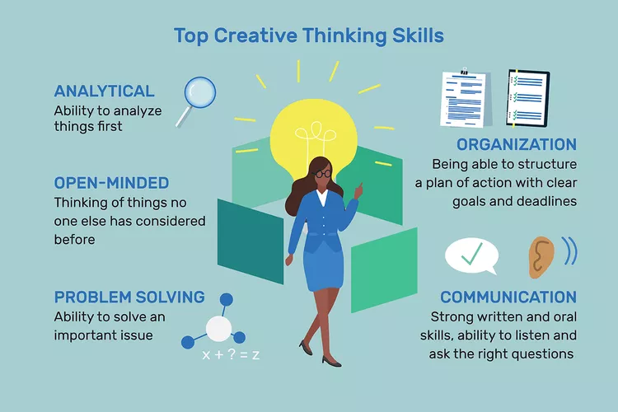

Divergent and convergent thinking are key components of problem-solving and decision-making, often used across different fields. They represent two different ways of approaching challenges: one focuses on generating many ideas, while the other narrows them down to find the best solution.
Convergent Thinking

Convergent thinking focuses on narrowing down a problem to find the most probable solution. It involves analyzing information, identifying patterns, and arriving at a single, logical conclusion.
Divergent Thinking

Divergent thinking encourages open-mindedness and exploration. Individuals think of various answers to a single question, drawing upon their experiences and perspectives. This approach fosters creativity and generates a wider range of potential solutions.

ASPECT | DIVERGENT THINKING | CONVERGENT THINKING
Goal | Generate many ideas or possibilities. | Select the best idea or solution.
Approach | Free-flowing and creative brainstorming. | Analytical and decision-making.
Emphasis | Exploration of new and different possibilities. | Evaluation and logical selection.
Process | Quantity-focused, exploring various perspectives. | Quality-focused, seeking the optimal choice.
Function | Idea generation and creativity. | Decision-making and solution selection.
Flexibility | Open-ended and exploratory. | Structured and analytical.
Outcome | Numerous ideas without immediate judgment. | A specific, chosen solution.

Strategies for Creative Thinking
Cultivate Curiosity
Develop a habit of wider reading and asking questions. This expands your knowledge base and encourages exploration.
Generate Multiple Ideas
For a particular problem, generate as many ideas as possible. Think of alternatives and never accept the first idea. Let more ideas come and then select the best.
Embrace Brainstorming
Let your mind think freely and let the ideas come. Do not start evaluating their worth immediately. This allows for uninhibited creativity.
Practice Associations
Practice making unusual associations and analogies. Let conflicting thoughts coexist. This can lead to unexpected insights.
Seek Feedback
Indulge in activities that bring forward your originality and get feedback from outsiders, those not involved. This provides fresh perspectives and constructive criticism.

1.2 Blocks to Creative Thinking

Artificial Constraints
Defining boundaries of problems too narrowly. People assume that some problem definitions or alternative solutions are off limits, so they ignore them.
Self-Doubt or Fear of Failure
One of the most common reasons people don't want to engage in creative thinking is that they are afraid to fail.
No Curiosity or Non-Inquisitiveness
Not asking questions. Sometimes the inability to solve problems results from reticence to ask questions, to obtain information, or to search for data.
Over Reliance on Logic
Our thought processes, social interactions, and final decisions are all governed by logic. However, keep in mind that not everything has a logical explanation and that you may occasionally need to abandon logic in favour of a more imaginative approach to problem-solving.

1.3 Factors that Influence Creative Design

Freedom
The level of independence affects creativity. If a person in business gets the freedom to do something new without permission or fear of failure, such a person becomes creative
Resources
Available resources also affect creativity. Sufficient resources (human resources, capital, machines, raw materials, and methods) are encouraged by creative activities
Pressure
The level of pressure at work also affects creativity. A certain level of pressure to work expands creativity. When there is a lot of work to be done in a short period of time, people have to think of new and creative ways to do it within the allotted time.
Organizational Culture
Organizational culture encourages creativity through fear, creative conclusions of ideas, identification, encouragement of creative work, and mechanisms for developing new ideas.

EXAMPLES
- Zappos is an online shoe and clothing retailer whose number one priority is company culture. It places a strong emphasis on cultural fit when hiring people, One of Zappos’ core values is to be adventurous, creative, and open-minded. Even its customer service representatives don’t have to follow scripts or abide by time limits on their calls. The only aim is to wow the customers with creativity and presence of mind
- Tesla is one of the leading electric car and clean energy companies in the world. Tesla CEO Elon Musk tweeted last year that, to be hired at the firm, “educational background is irrelevant, but all must pass a hardcore coding test.” Musk encourages his employees to think outside the box and is always eager to anticipate future trends. Elon also allows his employees to share their ideas freely to improve innovation in the company.
- Autodesk is an innovative tech company that makes 3D design, engineering, and entertainment software. It also helps businesses prepare their workforces for the future by upskilling and training them in the latest technologies, including automation and artificial intelligence. Autodesk’s vision is to help people imagine, design, and make a better world by leveraging innovative tools and having the best people in their industry creating new technologies. And this vision to help people imagine begins with its own people—the firm wants creative people to help it build the future of design.

Project resources can be simply defined as anything needed to execute project tasks, including the people executing the work. Here are some examples of project resources.
- Time
- Raw materials
- Human resources
- Machinery and equipment
- Financial resources
- Information and data
Allow Flexible Work Schedule
Generally, human resource managers expect employees to work from 9am to 5pm. In practice, however, and to maximize creativity in the workplace, you must allow a creative mind more time Opens a new window . Much as they want to co-create with their workmates, they also require time alone to re-think about their ideas. And having a fixed work schedule can result in an employee feeling stifled instead of getting motivated.
Provide Incentives for Your Workers
Workers have so far proven to be a valued source of inventive ideas; which is why many companies are incorporating crowdsourcing initiatives to encourage innovativeness. Giving financial incentives have been one of the methods to do this.
To achieve the intended creativity, you must strategize ways aimed at rewarding the generation of brand-new concepts among employees. Create a culture that prizes the invention of knowledge.

1.4 Engineering Design
Focuses on creating solutions that meet specific technical requirements and functional criteria. The primary goal is to develop products, systems, or structures that are safe, efficient, and cost-effective.
Creative Design
Is more focused on aesthetics, innovation, and user experience. It often involves creating visually appealing or emotionally engaging products, such as graphic design, fashion design, or industrial design.

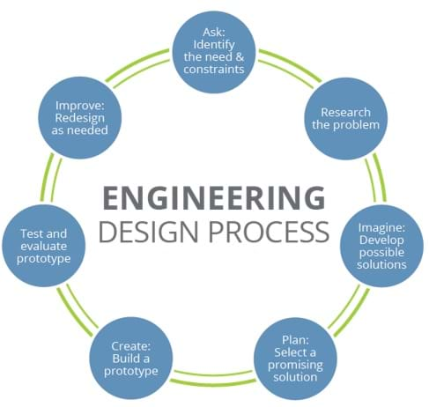

IDENTIFY THE NEED AND CONSTRAINTS
Engineers ask critical questions about what they want to create, whether it be a skyscraper, amusement park ride, bicycle or smartphone. These questions include: What is the problem to solve? What do we want to design? Who is it for? What do we want to accomplish? What are the project requirements? What are the limitations? What is our goal?
RESEARCH THE PROBLEM
This includes talking to people from many different backgrounds and specialties to assist with researching what products or solutions already exist, or what technologies might be adaptable to your needs.
DEVELOP POSSIBLE SOLUTION
You work with a team to brainstorm ideas and develop as many solutions as possible. This is the time to encourage wild ideas and defer judgment! Build on the ideas of others! Stay focused on topic, and have one conversation at a time! Remember: good design is all about teamwork! Help students understand the brainstorming guidelines by using the TE handout and two sizes of classroom posters.
SELECT AND PROMISING SOLUTION
For many teams this is the hardest step! Revisit the needs, constraints and research from the earlier steps, compare your best ideas, select one solution and make a plan to move forward with it.
BUILD A PROTOTYPE
Building a prototype makes your ideas real! These early versions of the design solution help your team verify whether the design meets the original challenge objectives. Push yourself for creativity, imagination and excellence in design.
EVALUATE THE PROTOTYPE
Does it work? Does it solve the need? Communicate the results and get feedback. Analyze and talk about what works, what doesn't and what could be improved.

REDESIGN AS NEEDED
Discuss how you could improve your solution. Make revisions. Draw new designs. Iterate your design to make your product the best it can be.
And now, REPEAT!

1.5 Influence of Society, Technology, and Business on Creativity
The influence of society, technology, and business on creativity is multifaceted and interdependent. Society provides the cultural and social context, technology offers tools and platforms for creation, and business supplies the economic framework and incentives. Together, they create a dynamic environment that shapes the possibilities and directions of human creativity.
SOCIETY
Provides the cultural and social context, shaping values, norms, and expectations that influence creative expression.
TECHNOLOGY
Offers tools and platforms for creation, enabling new forms of expression and expanding the possibilities of creative endeavors.
BUSINESS
Supplies the economic framework and incentives, driving innovation and the commercialization of creative ideas.

Society’s Influence on Creativity:
1. Environmental Sustainability:
Example: The increasing societal demand for sustainable solutions has driven engineers to develop renewable energy technologies, such as solar panels and wind turbines. This societal pressure has led to innovations like the development of more efficient photovoltaic cells and energy storage systems.

2. Healthcare Needs:
Example: The aging population and rising healthcare costs have pushed engineers to create advanced medical devices, such as wearable health monitors and portable diagnostic tools. The societal need for better healthcare access led to the creation of devices like the portable ultrasound machine, making medical imaging more accessible in remote areas.

3. Urbanization:
Example: Rapid urbanization has prompted engineers to design smart city solutions, integrating IoT (Internet of Things) technologies to manage resources efficiently. For instance, the development of smart traffic management systems in cities like Singapore helps reduce congestion and pollution.
Technology has had a profound impact on creativity, reshaping how we generate, share, and experience creative work. Here are some key ways technology influences creativity:
- Access to Tools and Resources: Technology provides access to a vast array of creative tools and resources. Software for design, music production, writing, and video editing allows creators to experiment and refine their work with unprecedented ease. Platforms like Adobe Creative Cloud, Final Cut Pro, and various digital art tools enable creative professionals and amateurs alike to bring their ideas to life.
- Inspiration and Learning: The internet offers a wealth of inspiration and learning resources. Websites like Behance, YouTube, and educational platforms provide access to tutorials, showcases of innovative work, and discussions about creative techniques, helping individuals stay updated with trends and learn new skills.
- Expanding Creative Possibilities: Technology introduces new mediums and techniques for creativity. Virtual reality (VR), augmented reality (AR), and artificial intelligence (AI) are creating new avenues for artistic expression. For instance, AI algorithms can generate music, art, and writing, offering novel ways to explore creativity.

1.6 FORCE FIELD ANALYSIS

The force field analysis, developed by Kurt Lewin in 1947, is a very powerful creative problem-solving tool. The strength of the force field technique stems from its focus on forces already at work in a problem or situation.
The process begins with a detailed analysis of the problem or situation. This analysis leads to discovery of forces already “driving” the problem toward solution and forces “restraining” progress.
Once these driving and restraining forces have been discovered, they are maximized or minimised to generate progress toward solution.
The beauty of force field analysis is that it capitalizes on forces already present within the problem and it breaks the solution into bite-sized.

1.6.1 How Force Field Analysis Works
- Analyze the situation and fine tune the problem statement / session Objective
- List all the forces that are currently driving this problem toward situation
- List all the forces at work to keep the problem a problem
- Review all the forces and have the group determine the most significant driving and restraining forces.
- Restate the chosen forces into problem statement
- Start the creative idea generating portion of your session
- Once you have ideas the group thinks will solve the problem, test each one or all of them together with a BenBalance
- List all the actions needed to achieve the goal on the specific

1.6.2 Force field analysis diagram
Problem: Upgrade factory with new manufacturing equipment
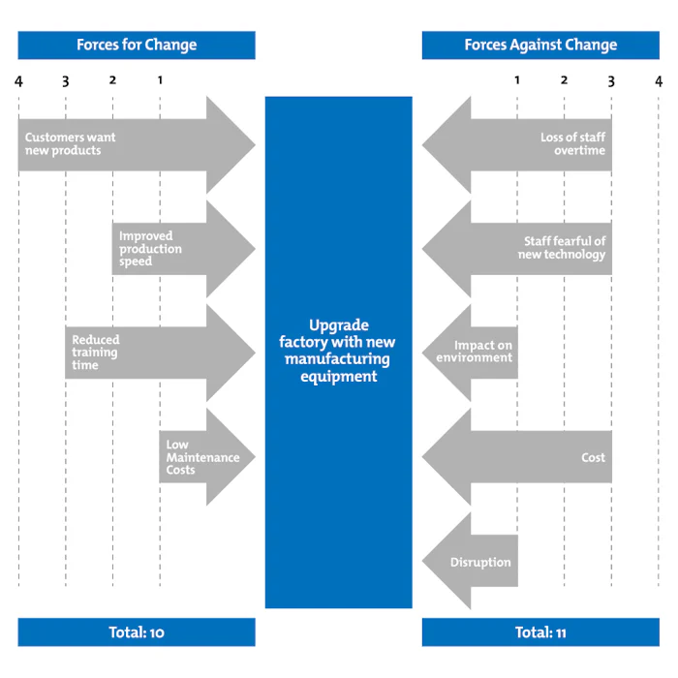

Driving Forces  (Supporting the Change) | Restraining Forces  (Resisting the Change)
Increased Production Efficiency (5) | High Initial Investment Costs (5)
Reduced Maintenance Costs (4) | Training Costs and Time (4)
Higher Product Quality (4) | Downtime During Transition (4)
Competitiveness in the Market (5) | Resistance to Change from Employees (3)
Employee Morale and Training Opportunities (3) | Uncertainty about ROI (3)
Total: 21 | Total: 19

Driving Forces have a total strength of 21, while Restraining Forces have a total strength of 19.
The driving forces are slightly stronger than the restraining forces, indicating that upgrading to new manufacturing equipment is feasible but requires careful management of the challenges.

1.7.1 Market Pull
The term 'Market Pull', refers to the need/requirement for a new product or a solution to a problem, which comes from the market place. The need is identified by potential customers or market research. A product or a range of products are developed, to solve the original need.
- Customer-Centric Approach
- Identifying Needs: Market pull starts with understanding what customers need or want. This involves market research, customer feedback, and analyzing trends to identify gaps or areas where existing solutions fall short.
- Design and Development: Based on these insights, businesses develop products or services that address specific needs or solve particular problems. This approach ensures that new innovations are directly relevant to the target audience.

2. Innovation Driven by Demand
- Responsive Innovation: Instead of creating a product and trying to find a market for it, market pull focuses on creating solutions that align with actual market demand. This can lead to more successful product launches and higher customer satisfaction.
- Adaptation and Improvement: Companies often use market pull to adapt and improve existing products based on customer feedback and changing market conditions.
3. Risk Mitigation
- Reducing Market Risk: By focusing on existing market demands, companies can reduce the risk of investing in innovations that might not find a receptive audience. This approach helps ensure that resources are spent on developing solutions that have a higher likelihood of success.

4. Examples of Market Pull
- Consumer Electronics: The development of smartphones and smart home devices often involves listening to consumer demands for greater connectivity, convenience, and integrated functionalities.
- Healthcare: Medical device innovations are frequently driven by patient needs, regulatory requirements, and healthcare provider feedback to improve treatment outcomes and efficiency.
5. Market Research and Feedback
- Methods: Techniques like surveys, focus groups, and customer interviews are commonly used to gather information about market needs and preferences. Social media and online reviews can also provide valuable insights.
- Continuous Improvement: Market pull involves ongoing engagement with customers to refine and improve products based on their evolving needs and feedback.
6. Challenges
- Predicting Future Needs: While market pull focuses on current demands, it can sometimes be challenging to anticipate future needs or shifts in consumer behavior.
- Short-Term Focus: Emphasizing immediate market demands might lead to solutions that address current issues but might not be innovative or forward-thinking in the long run.
In summary, market pull emphasizes creating solutions that address real market demands and customer needs. This approach can lead to more relevant and successful innovations but requires a thorough understanding of the market and continuous engagement with customers.

1.7.2 Technology Push
Technology Push is when research and development in new technology, drives the development of new products. Technology Push usually does not involve market research. It tends to start with a company developing an innovative technology and applying it to a product. The company then markets the product.
1. Innovation Focus
- Emerging Technologies: Technology push often involves the exploration and application of cutting-edge technologies, such as advancements in artificial intelligence, biotechnology, or materials science. Innovators develop new technologies based on their potential applications and capabilities.
- Technical Feasibility: The emphasis is on what is technically possible rather than on immediate market needs. Innovations are driven by scientific discovery and technological breakthroughs.
2. Product Development
- Prototyping and Experimentation: Companies or researchers may develop prototypes and experiment with new technologies to explore their potential uses. This can lead to the creation of novel products or services that were not previously envisioned.
- Market Introduction: Once a technology is developed, efforts are made to introduce it to the market, sometimes requiring educational campaigns to help consumers understand and appreciate its value.
3. Examples of Technology Push
- Consumer Electronics: The development of early smartphones, which introduced new features like touchscreens and internet connectivity, was driven by advances in technology rather than existing consumer demand for such features.
- Medical Devices: Innovations in medical technology, such as advanced imaging techniques or robotic surgery systems, often emerge from technological advances rather than immediate healthcare needs.

4. Potential Benefits
- Disruptive Innovation: Technology push can lead to groundbreaking innovations that create new markets or significantly alter existing ones. For example, the introduction of the internet transformed many aspects of daily life and business.
- Early Market Leadership: Companies that successfully push new technologies can establish themselves as leaders in emerging fields, gaining a competitive advantage and shaping market trends.
5. Challenges
- Market Acceptance: Technologies developed through a technology push approach may face challenges in gaining market acceptance. Consumers or businesses may not immediately see the value or application of the new technology.
- Resource Intensive: Developing new technologies can be costly and resource-intensive, with uncertain returns on investment. This approach may involve significant R&D investments with no guarantee of commercial success.
- Misalignment with Market Needs: There is a risk that the technology developed may not align with current market needs or preferences, requiring additional effort to adapt or find suitable applications.
6. Balancing Push and Pull
- Integration with Market Pull: Successful innovation often involves a combination of technology push and market pull. For instance, developing new technologies (push) while simultaneously researching market needs and preferences (pull) can help ensure that innovations are both technically advanced and market-relevant.
In summary, technology push focuses on the development and commercialization of new technologies driven by their inherent capabilities and potential, rather than existing market demands. While it can lead to innovative and disruptive products, it requires careful consideration of how these technologies will be introduced and accepted in the market.

1.8 ATTRIBUTE OF A CREATIVE PERSON:
Imagination
Creative individuals often have vivid imaginations and can envision possibilities beyond the ordinary.
Curiosity
They are naturally curious and eager to explore new ideas, concepts, and experiences.
Open mindedness
Creativity thrives on being open to different perspectives, allowing for novel connections and ideas.
Persistence
Creativity often involves facing challenges and setbacks, so perseverance is crucial in pursuing new ideas to fruition.
Flexibility
Being adaptable and willing to consider alternative solutions or approaches is important in creative endeavors.
Risk taking
Creativity often involves taking risks by exploring unconventional ideas or methods.
Passion
Creative individuals are often deeply passionate about their work, which drives them to overcome obstacles and keep exploring.
Playfulness
A sense of playfulness and the ability to experiment without fear of failure can lead to innovative ideas.

  - THINKING IN GROUPS

Brain storming
A collaborative technique where a group generates a large number of ideas, building on each other's contributions, to find creative solutions.
- Formulated a problem statement
- Generate ideas
Brain storming can be such a high energy, often used, idea producing tool
- Avoid criticism.
- Every idea is welcome
- Free wheel – it is always easier to tame down a wild idea than to bring a new one up
- Shoot for quantity – the more ideas you have , the more you have to choose from and the more likely you are to spark even more ideas. Always go for one or two more ideas.
- Combine and improve – ideas spark ideas

Nominal group technique
A structured method that encourages individual ideation, followed by group discussion and prioritization, to reach consensus on the best ideas.
It is designed to generate ideas in much the same way as classic brainstorming. The main difference is that initial ideas are generated silently, written down then reported to the group with no discussion until each participant has reported to the group with no discussion until each participant has reported all his ideas.
The advantage of nominal group technique is that it allows each participant to assemble her thoughts and ideas before the discussion begins.
- Silent idea generation
- Reporting of ideas
- Clarifying and understanding
- Ranking
Mind mapping

A visual technique that helps organize thoughts and ideas by diagramming connections and relationships, stimulating creative problem-solving.
Mind mapping may seem to take you in many different directions before leading you to a solution. It is unique in that it provides a creative maze thoughts and ideas that can offer new ways to view and explore problems.
Mind mapping steps
1. Identify the Central Idea
- Choose the Main Topic: Start by defining the central idea or theme of your mind map. This could be a project, a problem, a concept, or a goal.
- Place in Centre: Write or draw the central idea in the middle of your page or digital canvas. This is the core from which all branches will radiate.
2. Generate Main Branches
- Identify Key Categories: Think of the main categories or major aspects related to your central idea. These categories should represent the primary subdivisions or components of your topic.
- Draw Branches: Draw lines or branches extending from the central idea, each representing one of these key categories.
3. Add Sub-Branches
- Detail Subcategories: For each main branch, identify and add subcategories or related ideas. These are the details that support or elaborate on each main category.
- Expand Further: Continue to add sub-branches as needed, breaking down each subcategory into more detailed points or ideas.
4. Use Keywords and Images
- Keywords: Write concise keywords or short phrases on each branch and sub-branch. This helps keep the mind map clear and focused.
- Images and Icons: Incorporate images, symbols, or icons to represent ideas visually. This can make the mind map more engaging and easier to understand.
5. Organize and Connect
- Group Related Ideas: Arrange and group related ideas together to highlight connections and relationships.
- Use Lines or Arrows: Draw lines or arrows between branches and sub-branches to show connections or dependencies between different ideas.
6. Review and Refine
- Check for Completeness: Review your mind map to ensure that all relevant aspects of the central idea have been covered.
- Refine and Adjust: Make adjustments to improve clarity and organization. Remove or modify branches if they don’t fit well or if additional information needs to be added.
7. Update and Expand
- Iterate: Mind maps are dynamic tools. Update and expand your mind map as new information or ideas emerge. This makes it a living document that evolves with your thinking.

