

**Anekant Education Society’s**

**Tuljaram Chaturchand College of Arts, Science and Commerce, Baramati (Autonomous)**

**413102**

A Project Report on

**“Synthesis and Characterization of CdS Thin Films by chemical bath deposition”**

**Submitted to**

**Department Of Physics**

**Tuljaram Chaturchand College**

**of Arts, Science and Commerce , Baramati**

Under the guidance of

Prof. S. E. Bhosale

2022-2023

By

Miss Dhame Ashwini Rohidas (15680)



**ACKNOWLEDGEMENT**

We have satisfaction upon completion of the project entitled “Synthesis and characterization CdS thin film by chemical bath deposition method” at the Department Of Physics in Tuljaram Chaturchand College of Arts , Science and Commerce , Baramati during the academic year 2022-2023.

First of all, We wish to express my sincere gratitude and due respect our principal **Dr. C. V. Murumkar sir** for their continuous encouragement , positive support and inspiration.

Also, thanks to **Dr. P. C. Pingale** Head of the Department Of Physics for providing us an opportunity to do this project and giving us all the support and their valuable guidance for successful completion of this project work. The Timely and successful completion of this project could hardly be possible without the guidance and assistance of our guide **Prof. S. E. Bhosale.**

We are thankful to all the teaching staff of the Department Of Physics for giving their priceless guidance and encouragement to embark thus project work . Also, we would like to express whole hearted thanks to my friends for their help and support for completion of project work.

**INDEX**

|  |  |  |  |  |  |  |  |  |  |  |  |  |  |  |  |  |  |  |  |  |
| --- | --- | --- | --- | --- | --- | --- | --- | --- | --- | --- | --- | --- | --- | --- | --- | --- | --- | --- | --- | --- |
| |  |  |  | | --- | --- | --- | |  |  |  | |  |  |  | |  |  |  | |  |  |  | |  |  |  | |  |  |  | |  |  |
|  |  |  |
|  |  |  |
|  |  |  |
|  |  |  |
|  |  |  |
|  |  |  |

**ABSTRACT**

CdS thin films were prepared by chemical bath deposition (CBD) from a bath containing thiourea, cadmium sulfate, and ammonia(drop wise) in an aqueous solution onto glass substrates at a bath temperature of 70 °C. Ammonia used as a complexing agent for cadmium ions. A spectrophotometer, X-ray diffraction (XRD), digital two-point probe resistance measurement and scanning electron microscopy (SEM) were used to characterize their properties. The thicknesses of the CdS films obtained at 70 °C are in the range of 400-600 nm. The XRD patterns show that the CdS thin films were polycrystalline in nature after deposition.The Band gap of obtained thin films is about 1.65ev .The obtained thin film is used for to prepared efficient solar cell.

**INTRODUCTION**

Cds , a group 2-4 compound semiconductor ,is an ideal material for use as a non-layer in Cu (ln,Ga) Se2 (CIGS) solar cells is known to deposite CdS films with two of two different phases, metastable cubic phase and stable hexagonal phase. CdS, an n-type semiconductor with a 1.56eV wide direct bandgap ,has been extensively studied in this film form various application such as solar cells, light-emitting diodes, and thin film transistors(TFTs).

Various techniques such as vacuum evaporation , sputtering, molecular beam epitaxy (MBE) , metal organic chemical vapor deposition (MOCVD) , indoor sublimation (CSS) , spray for pyrolytic deposition (SPD), electro deposition, continuous ion layer adsorption and reaction (SILAR)[12] and chemical bath deposition (CBD),preparation CdS films. Among these, chemical bath deposition takes place from aqueous solutions at low temperature by a chemical reaction between dissolved precursors composed with cadmium salt as source of S with the help of a complexing agent.

The role of complexing agent is to ensure the slow release of Cd2+ and S2- in the aqueous solution and the subsequent condensation on a substrate dropped in the bath and to reduce the powder formation and precipitation. Ammonia NH3 is the most used complexing agen.

**EXPERIMENTAL DETAILS**

1. Took two beakers , thermometer, magnetic Bar , Glass substrate, Heater
2. Then cadmium chloride (1.2078) gm taken in one beaker and thiorea (0.6850)gm second beaker.
3. One beaker took CdCl2 (0.91344)gm and 30ml distilled water mixed.
4. Second beaker took CH4N2S(0.6850) and 30 ml distilled water mixed.
5. 1st beaker CdCl2 mixture kept in hot plate and keep thermometer solution heat and sturing 700 C temperature then and thiorea solution.
6. Then heat 700 C and put glass substrate on solution and mix 2, 3 drop ammonia.
7. After that when the sample is turned into yellow colour then heating stop and keep 10 min.
8. Then, On glass substrate cadmium sulphide remains. That is cadmium sulphide thin film.

**WORK IN THIN FILM LABORATORY**

 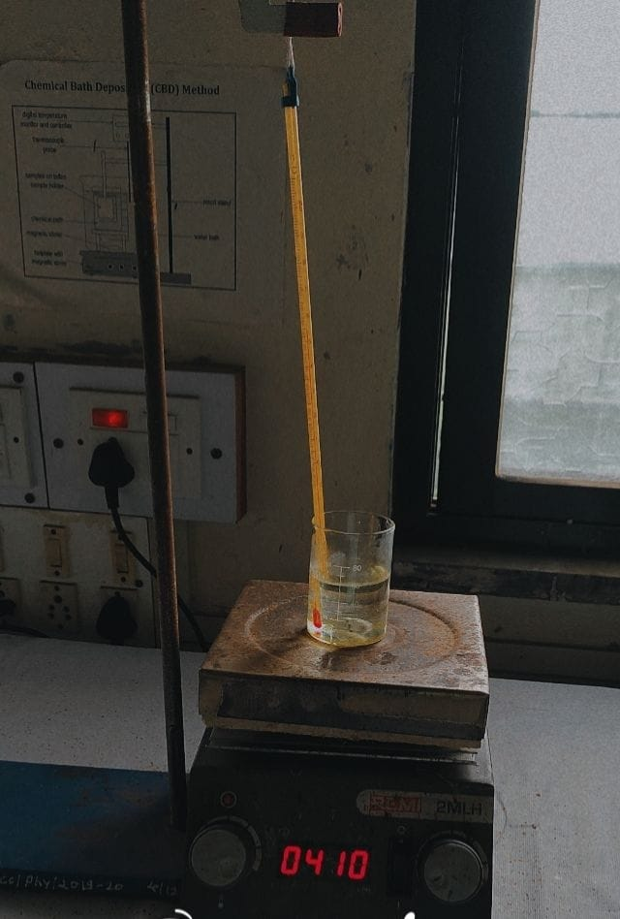

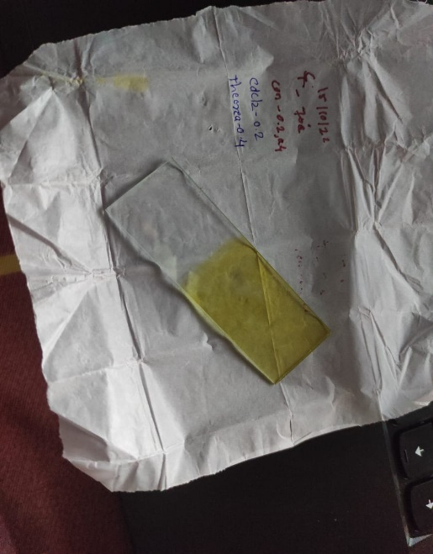

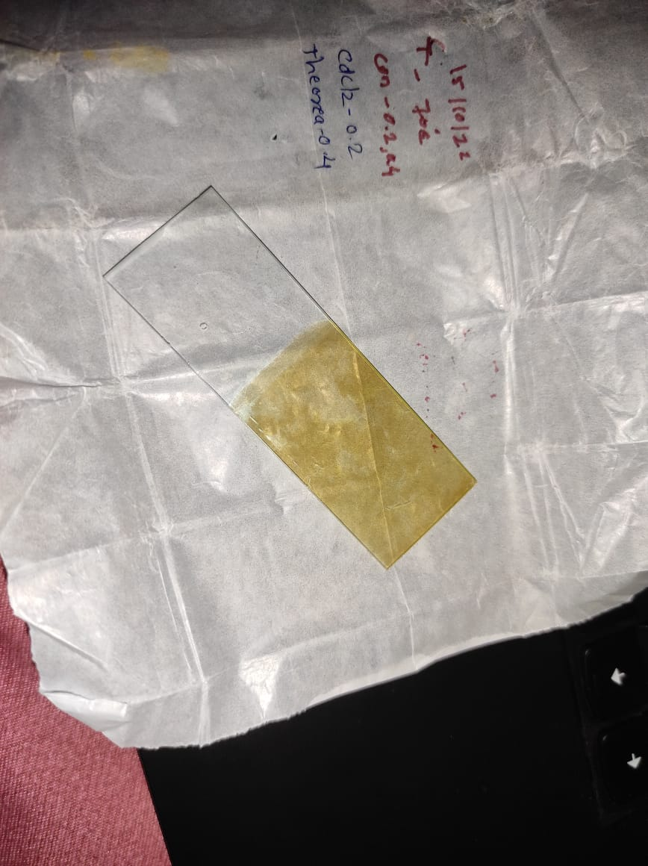

**1.2 Why cadmium Sulphide?**

**cadmium sulfate** is an [inorganic compound w](http://en.wikipedia.org/wiki/Inorganic_compound)ith the [formula c](http://en.wikipedia.org/wiki/Chemical_formula)ds. It finds limited use in electronic devices. CdS, also known as [galena,](http://en.wikipedia.org/wiki/Galena) is the principal ore and most important compound of [lead.](http://en.wikipedia.org/wiki/Lead)

[Molecular formula:](http://en.wikipedia.org/wiki/Chemical_formula)  cds

.Appearance Yellow-orange to brown solid

Density 4.826 g/cm3,solidS

[Molar mass:](http://en.wikipedia.org/wiki/Molar_mass)  144.48 g.mol-1

[Melting point:](http://en.wikipedia.org/wiki/Melting_point)  1,750°C (3,180 0F;2,020 K)10 Mpa

[Boiling point :](http://en.wikipedia.org/wiki/Boiling_point) 980 °C (1,800 0F;250 K) (sublimation)

Solubility in water insoluble[1]

Solubility soluble in acid

Refractive index 2.529

[Crystal structure:](http://en.wikipedia.org/wiki/Crystal_structure)  hexagonal.

## 

## 1.3 Applications of cadmium Sulphide

CdS is one of the oldest and most common detection element materials in various [infrared detectors.](http://en.wikipedia.org/wiki/Infrared_detector)

As an infrared detector, cds functions as a photon detector, responding directly to the photons of radiation, as opposed to thermal detectors, which respond to a change in detector element temperature caused by the radiation.

applications

1.For solar cells applications.

2.used in the deposition of CdS semiconductor thin films since the 1960s.

CdS.used as a window material in high efficiency thin film solar cells based on CdTe and Cu(In,Ga)Se2 (CIGS) .

3. It has also been used in other applications including electronic and optoelectronic devices.

4.Although other techniques have been used in the deposition of CdS, chemical bath deposition is known to enhance the performance of cadmium sulfide window used in solar cell.

5. CdS films also need to have a suitable conductivity, and adequate thickness to allow high transmission (50–100 nm) and good uniformity to avoid short circuit effects.

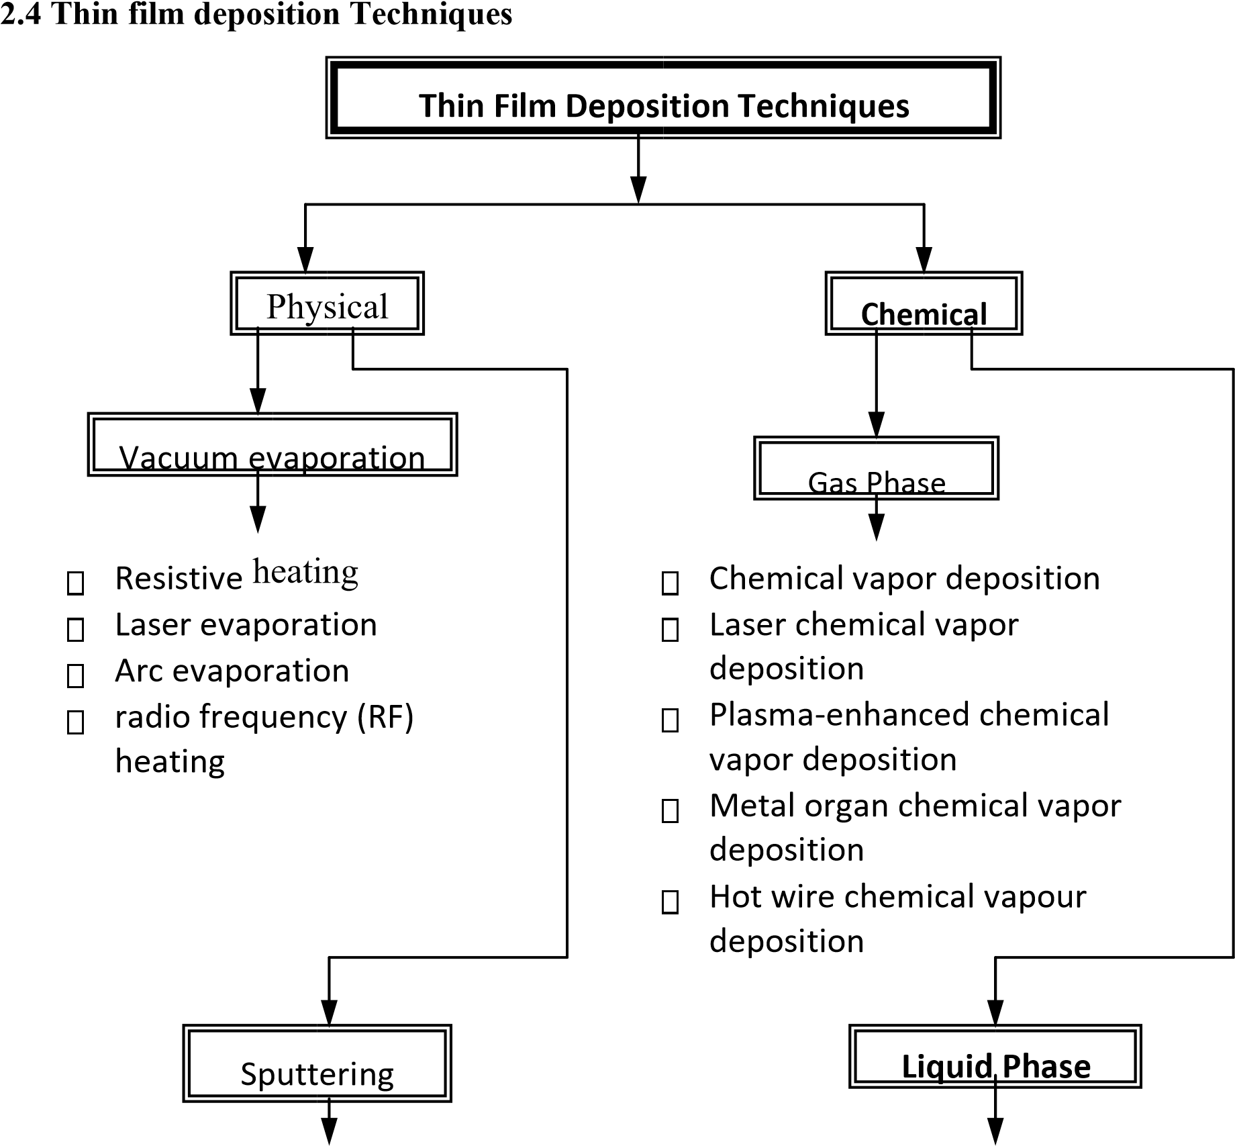

* Glow discharge DC sputtering Chemical Bath deposition
* Triode sputtering Electroless deposition
* Radio frequency (RF) sputtering spray pyrolysis
* Magnetron sputtering sol gel process
* Ion beam sputtering successive ionic layer
* AC sputtering absorption and reduction
* Electrodeposition

Since the physical methods are costly and required sophisticated instruments. For chemical methods in gas phase vacuum is always necessary, so we give our attention to chemical methods in liquid phase.

**2.4.1 Electro deposition**

Electro deposition is widely used in making metallic coatings. Electrodeposition can be understood as a special electrolysis resulting in the deposition of solid material on an electrode. This process involves i) oriented diffusion of charged growth species (typically positively charged ions) through a solution when an external electric field is applied and ii) reduction of the charged growth species at the growth or deposition surface which also serves as an electrode. Electrodeposition is only applicable to electrically conductive substrates. The process is also known as electroplating. When deposition is confined inside the pores of template membranes, if the template membrane is removed, nanorods or nanowires are prepared.

**2.4.2 Chemical bath deposition**

Chemical bath deposition (CBD) is a method for the deposition of metal chalcogenide thin films. In chemical bath deposition metal chalcogenide thin film occurs due to substrates maintained in contact with dilute chemical baths containing the metal and chalcogenides ions. The film formation takes place when ionic product exceeds solubility product. In chemical bath deposition (CBD) method, deposition of metal chalcogenide semiconducting thin films occurs due to substrate maintained in contact with dilute chemical bath containing metal and chalcogen ions. The film formation on substrate takes place when ionic product exceeds solubility product.

**2.4.3 Electroless deposition**

In the electroless deposition films of metals may be deposited directly without any electrode potentials being involved, by the use of suitable compound in solutions. Such deposition is known as electroless deposition or chemical reduction plating. In electroless deposition films can be grown on substrate by dipping them in appropriate solutions of metal salt and reducing agent without the application of any electric field. Deposition may occur by homogeneous chemical reactions usually reduction of metal ions in solution by a reducing agent. There are three type of reaction takes place, i) Noncatalytic reaction where any type of substrate used, ii) Catalytic reaction where the film formation takes place on metallic substrate and iii) Catalytic reaction using activators where deposition takes place with the help of activators to activate non catalytic surface.

**2.4.4 Spray pyrolysis**

This is thermally stimulated reaction between the clusters of liquid / vapour atoms of different spraying solutions of the desired compound onto the substrate maintained at elevated temperature. The sprayed droplets on reaching the hot substrate undergo pyrolytic decomposition and form a single crystal or cluster of a crystallite product. The other volatile byproducts and excess solvents escape in the crystallite of the product. The other volatile byproduct and excess solvents escape in the vapour phase. The thermal energy for decomposition, subsequent combination of the species, sintering and recrystalization of crystallites is provided by hot substrates.

**2.4.5 Sol-gel method-**

Sol-gel method is commonly useful in formation of metal oxide. Sol-gel process is low temperature process. Sols are solid particles in liquid. Gels are nothing but a continuous network of particles with pores filled with liquid. A sol-gel process involves formation of sols in liquid and then connecting the sol particles to form porous network. By drying the liquid, it is possible to obtain powders, thin films.

**2.4.6 Successive ionic layer adsorption and reaction (SILAR)**

In SILAR method thin films are obtained by immersing substrate into separately placed cationic and anionic precursors and rinsing between every immersion with ion-exchanged water. The rinsing time in ion exchange water is critical for ionic layer formation. Basic mechanism of SILAR involves three most important steps: (i) specific adsorption of the most strongly adsorbed ions of the compound to be grown, by the substrate immersion in a solution of one of its cationic precursor, (ii) water rinsing of the excess solution still adhering to the substrate, and (iii) chemical reaction between the most strongly specific adsorbed cations and the less strongly adsorbed anions by the subsequent substrate immersion in the solution.

**2.5 Why Chemical bath deposition?**

The chemical bath deposition is the chemical liquid phase which is one of the cheapest methods to deposit thin films and nonmaterial’s, as it does not depend on expensive equipment and is a scalable technique that can be employed for large area batch processing or continuous deposition. In 1933 Bruckman deposited Cd S thin film by chemical bath deposition (CBD) or solution grown method. The major advantage of CBD is that it requires o nly solution containers and substrate mounting devices.

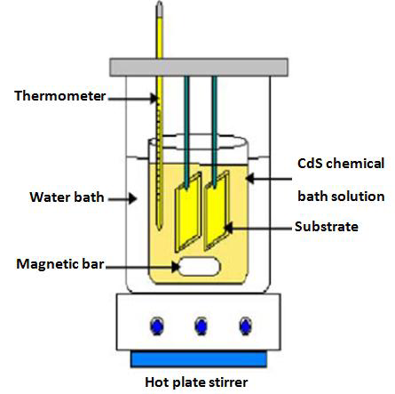

**Fig 2.2 Schematic diagram of chemical bath deposition technique**

The Chemical bath deposition (CBD) method is one of the cheapest methods to deposit thin films and nanomaterials, as it does not depend on expensive equipment and is a scalable technique that can be employed for large area batch processing or continuous deposition. In 1933 Bruckman deposited Lead (II) sulfide (CdS) thin film by chemical bath deposition (CBD) or solution grown method. The experimental set-up is shown in figure. The substrate is stirred with the help of magnetic stirrer .Water or paraffin baths with constant stirring are used to heat the chemical bath to the desired temperature. In some cases, stirring is continuous from room temperature. In some cases, it is started after attaining the desired temperature. The beaker Containing precursor solution and the deionised water are alternately placed as shown in fig 2.2.

**2.6 Advantages of Chemical Bath Deposition Method**

This method is presently attracting considerable attention as it does not require any sophisticated instrumentation like vacuum system and other expensive equipment’s. Simple equipment’s like water bath with temperature indicator, magnetic stirrer with solution beakers are used in this method. The starting chemicals are commonly available and cheap. With this method, a large number of depositions of thin films can be done with number of cycles. Any insoluble surface of any shape can be a suitable substrate for deposition. The low temperature deposition avoids oxidation and corrosion of metallic substrates. The preparative parameters are easily controllable and better orientations and improved grain structure can be obtained. It is low cost and efficient method and easy to scale up for industrial purpose.

Disadvantage

* Wastage of solution after every deposition.
* Proper substrate cleaning is a very important factor in obtaining good adherent films

**Chapter-III**

**Characterization Techniques**

**3.1 Introduction**

This chapter describes various experimental techniques used in the present investigations for the characterization thin films. Thin films are widely used in electronic, optical and magnetic devices; its structure, surface morphology and nature of crystallites/grains have a prime importance in deciding the suitability of the materials for above mentioned applications. In order to study the different properties of these semi conducting materials in the form of thin films, various characterization techniques are used. These techniques include thickness measurement, structural morphology by X-ray diffraction (XRD), Surface morphology by Scanning Electron Microscopy (SEM) and Atomic Force Microscopy (AFM), Optical absorption and transmission by UV-VIS spectrophotometer, Electrical resistivity measurement, I-V characteristics, TEP etc. Following sections describe these methods.

**3.2 Characterization techniques**

**3.2.2 UV-Vis spectroscopy**

It involves the spectroscopy of photons & spectrophotometer. It uses light in the visible & adjacent near ultraviolet & near infrared ranges. In this region of energy molecules of space 17 undergo electrons transitions. UV/Visible spectroscopy is routinely used in the quantitative determination of solution in the transition metal ions & highly conjugated organic compounds.

1) Solution of transition metal ions can be colored (i.e. absorb visible light) with ‘d’electrons within the metal atoms can be excited from one electronic state to another. The colors of metal ions solution in strongly affected by the other species such certain anions or legends.

2) Organic compounds also absorb light in the UV or visible regions of the electromagnetic spectrum solvents for these determinations are often water for water soluble compounds or ethanol for organic soluble compounds.

3) While charge transfer complexes also give rise to color so the color are often too intense to be used for quantitative measurement.

The **Beer-Lambert law** states that the absorbance of a solution is directly proportional to the concentration of the absorbing species in the solution and the path length. Thus, for a fixed path length, UV/VIS spectroscopy can be used to determine the concentration of the absorber in a solution. The method is most often used in a quantitative way to determine concentrations of an absorbing species in solution, using the Beer-Lambert law:

**A=_log10(I/I0)= €.c.L**

where A is the measured absorbance, I0 is the intensity of the incident light at a given wavelength, I is the transmitted intensity, L the path length through the sample, and c the concentration of the absorbing species. For each species and wavelength, ε is a constant known as the molar absorptivity or extinction coefficient. The instrument used in ultraviolet-visible spectroscopy is called a UV-Vis spectrophotometer. It measures the intensity of light passing through a sample (I), and compares it to the intensity of light before it passes through the sample (Io). The ratio I / Io is called the transmittance, and is usually expressed as a percentage (%T). The absorbance, A, is based on the transmittance:

**A = − log ( %T / 100% ) (3.3) – 18**

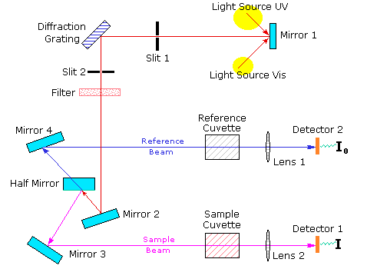

The spectrophotometer consists of a light source (an incandescent bulb for visible wavelength or a deuterium arc lamp in UV), a sample holder, diffraction grating or monochromatic to separate the different wavelength of light & a detector. The detector is typically photodiode or a CCD. Photodiodes are used with monochromatic which filter the light so that only light of single wavelength reaches the sample difference gratings are used with CCD’s which collect light of different wavelength on different pixels.

Study of the optical properties of the films is necessary for applications of the films in opto-electronic devices. The considerable theoretical and experimental investigations on the optical behaviour of thin films deal primarily with reflection, transmission and absorption properties and their relation to the optical constants of the film. The equilibrium situation semiconductor can be distributed by generation of carriers due to optical absorption. Optical photon incident on any material may be reflected, transmitted or adsorbed. The phenomenon of radiation absorption in a material is altogether considered to be due to (i) inner shell, (ii) valance band electron, (iii) free carriers including holes as well as electrons, and (iv) electron bound to localized impurity centre or defects of some type.

In study of fundamental property of the semiconductors, absorption by the second type of electron is of great importance. In an ideal semiconductor, at absolute zero temperature the valance band would be completely full of electros, so that electron could not be excited to higher energy state from the valance band. Absorption of quanta of sufficient energy tends to transfer of electrons from valence band to conduction band. For crystalline materials, the transition of electrons from valance band to conduction band can be grouped into direct and indirect process. in direct inter band optical transition the value of wave vector K for elements remains unchanged in E-K space and momentum also does not change, while in indirect inter band transition the wave vector K for electros changes in the E-K. It is possible to differentiate the nature of optical transition as direct allowed or direct forbidden by classical relation

**h A h E( g) ½**

**UV-Vis spectroscopy result:**

**CdS A1:**



**Band gap 1.65 eV**

**3.2.1 X-Ray Diffraction (XRD)**

X-ray diffraction (XRD) is well known technique to obtain the information of composition, phase and crystallite orientations of the material. Structure identification, determination of lattice parameters and grain size are based on the X-ray diffraction pattern. Improved detection methods for X-ray, the availability of commercial mono-chromators and intense micro focus X-ray sources have made X-ray diffraction method applicable to film as thin as 100Å. The several workers have described X-ray diffraction arrangement, suited to study of thin films. This technique employs a chromate to provide a diffracted beam, which is further diffracted from the film surface oscillating about the mean diffraction position. The X-ray diffraction technique based on monochromatic radiation is more important because the spacing of the planes can be deduced from the observed diffraction angles. The phenomenon of X-ray diffraction can be considered as reflection of X-rays from the crystallographic planes of the material and is governed by the Bragg’s equation; 2d sinθ = n λ

**APPLICATION**

1. For solar cells applications
2. used in the deposition of CdS semiconductor thin films since the 1960s.CdS used as a window material in high efficiency thin film solar cells based on CdTe and Cudin.Ga)Se2 (CIGS)
3. It has also been used in other applications including electronic and optoelectronic devices.
4. Although other techniques have been used in the deposition of CdS, chemical bath deposition is known to enhance the performance of cadmium sulfide window used in solar cell.

**FUTURE PLANS**

* Analysis of structural, optical and microstructural properties of (CdS ) Thin films by various characterization method.
* To study gas sensing properties (CdS ) of thin film.
* Synthesis and characterization of various metal oxide.

**Conclusion**

* CdS thin films can be successfully deposited by chemical bath deposition method .
* XRD confirms the formation of hexagonal wurzite structure of CdS.
* It is confirmed from the electrical measurement that the prepared CdS thin films from chemical bath deposition are suitable for application in Solae Cell as a window layer.