**Computer Network Lab By Ashwini L**

**Week 0**

**Ex1**

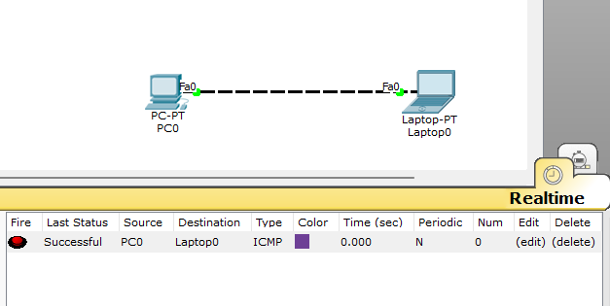

**Ex2**

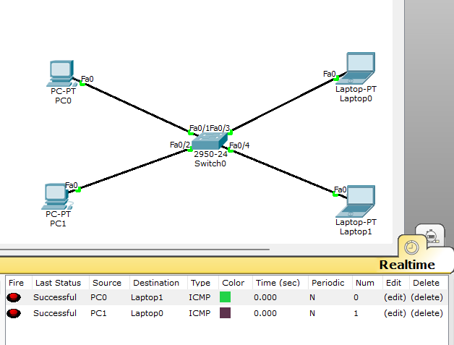

**Ex3**

