Computer Network Lab By Ashwini L

Week-02

Configure a DHCP within a LAN and Outside LAN

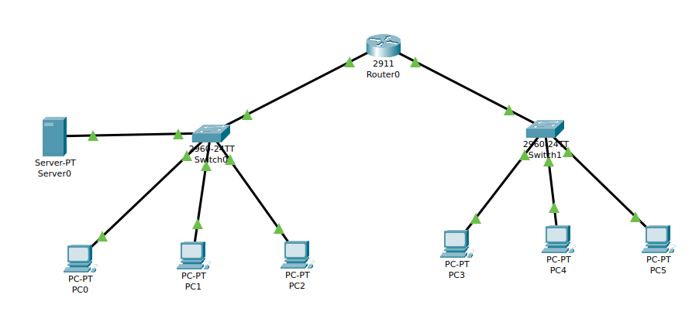

Output :

