Week-07

Conect the router to smart phone ,pc and laptop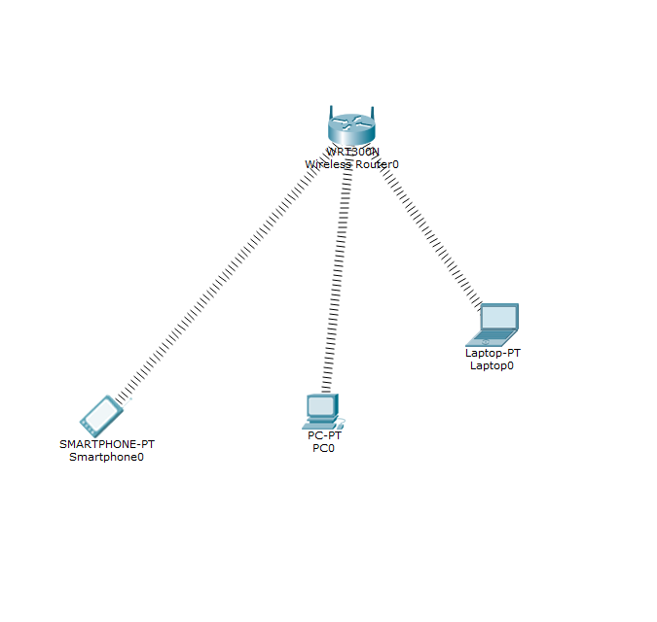

2. Turn off the Laptop and remove the Ethernet and add the Wi-Fi and turn on the laptop

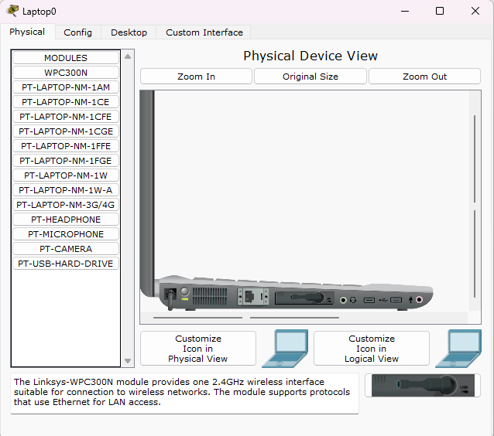

3. Turn off the CPU and remove the ethernet and add the Wi-Fi and turn on the CPU.

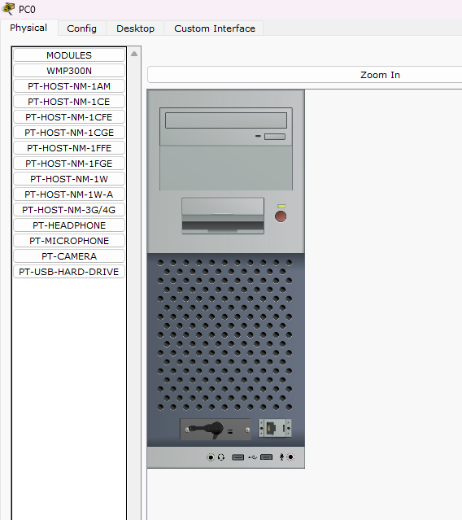

4. Now transfer the data packet from one end device another end device and the connection will be established and it will be successful

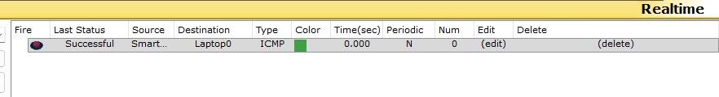

5. Now for the security purpose we can add the password and SSID to the router.

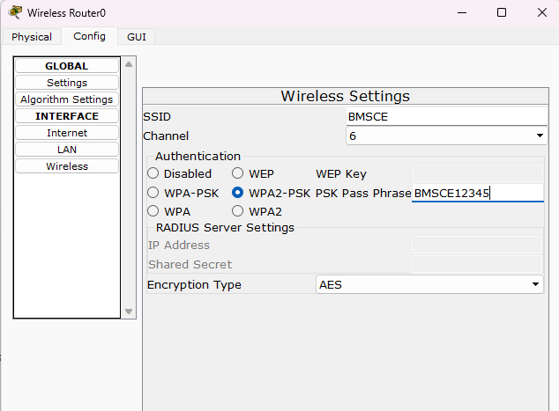

6. Now the connection which is established will be disconnected now configure the end devices.

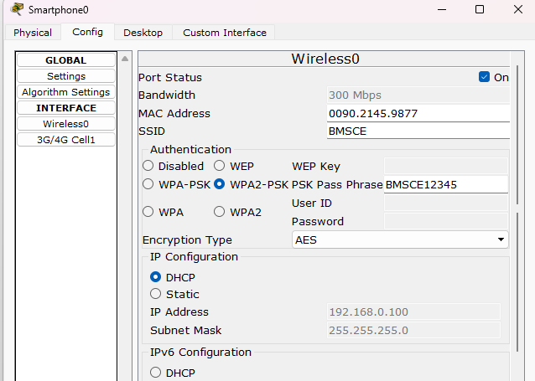

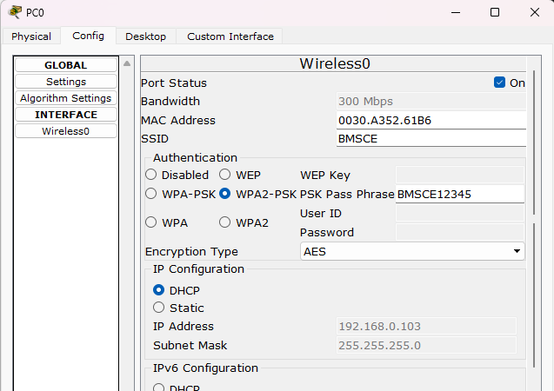

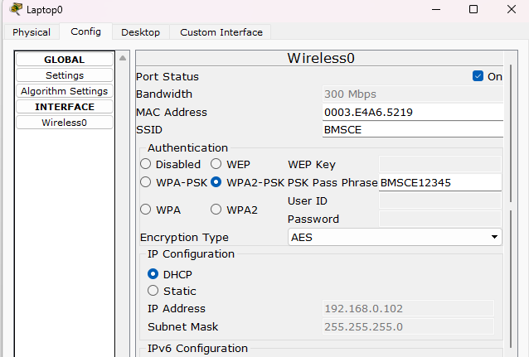

7. Now the connection will be established between the Router and the End-devices.



8. If the packet is transferred from one device to another device it is successful.

