Week-08

1. Connect the end-devices to the Switch and Switch to the Server .

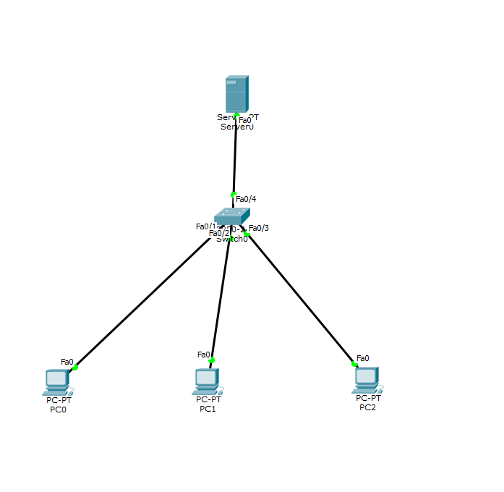

1. Assign the IP Address for the PC’s

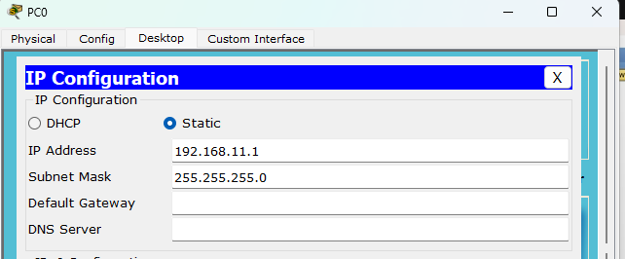

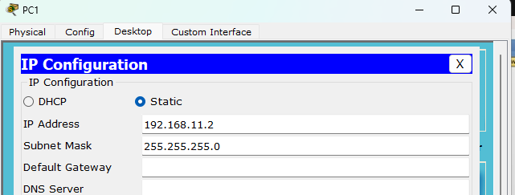

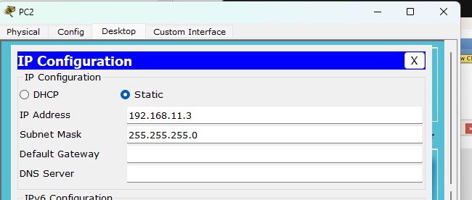

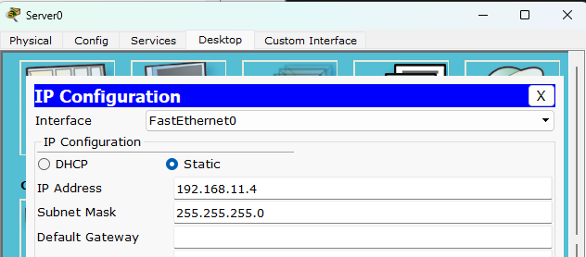

1. Ping the PC and the server and the data transfer will be successful.

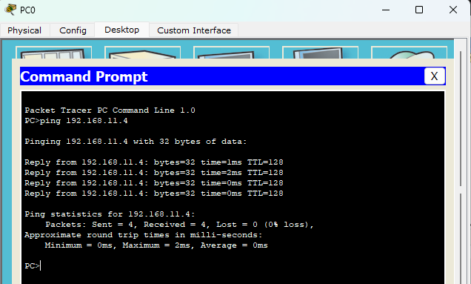

1. Now take the inspect and click on the device which the MAC address needs to identified and another inspect on Server and send the packet from PC-0 to server and the hardware address will be displayed.

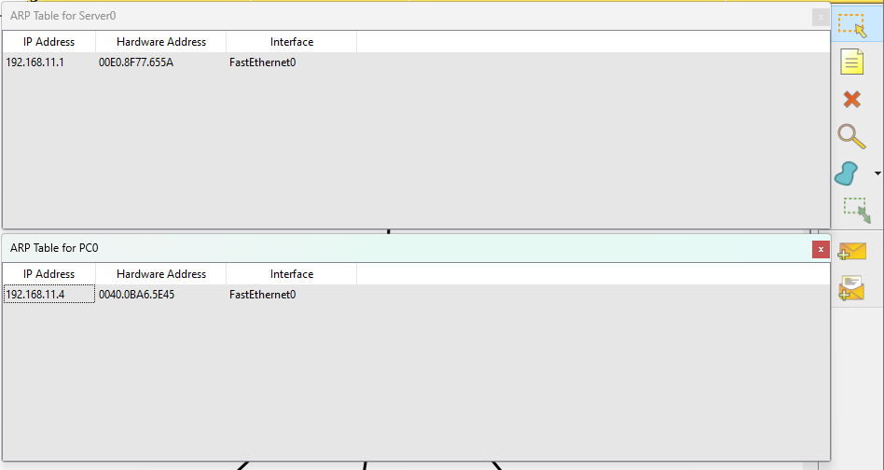

1. Output

