RETAIL SALES &
PROFITABILITY ANALYSIS
Final Tableau Integration, Evaluation & Reporting
Week 6 – Final Virtual Internship Deliverable
Prepared by: Ashwa Desai
Tool: Tableau Desktop | Dataset: Sample – Superstore

Document Guide
This report consolidates the work completed across Weeks 1–5 and evaluates the resulting Tableau analysis, dashboards and data story. The page references below reflect the current document layout.
Executive Summary ····················································· 2
1. Project Context and Objectives ····································· 3
2. Week 1 – Exploratory Data Analysis ································· 4
3. Week 2 – Dashboard Planning and Design ····························· 5
4. Week 3 – Interactive Dashboard and Data Storytelling ··············· 6
5. Week 4 – Advanced Visualization Techniques ························· 7
6. Week 5 – Performance Review and Optimization ······················· 8
7. Integrated Evaluation ·············································· 10
8. Challenges and Lessons Learned ····································· 10
9. Recommendations and Future Enhancements ···························· 11
10. Reflective Conclusion ············································· 12
Appendix A – Visual Evidence ·········································· 12
Appendix B – Key Metrics and Interpretation ··························· 15
References ···························································· 15

Executive Summary
This report presents the final integration and evaluation of a Tableau-based retail sales and profitability analysis using Tableau’s Sample – Superstore dataset. The work progressed from exploratory data analysis to dashboard planning, interactive storytelling, advanced visualization and final dashboard refinement. The objective was to transform transactional data into clear, navigable business information that helps a reader compare sales and profit, identify weaker product areas and investigate differences across time, geography and customer groups.
The exploratory workbook examined sales, profit, discount, quantity, order dates, product categories and sub-categories, customer segments, regions and states. The recorded overview showed approximately $2.33 million in sales and $292.30 thousand in profit. Technology contributed the highest displayed category profit (approximately $146.54 thousand), followed by Office Supplies (approximately $126.02 thousand) and Furniture (approximately $19.73 thousand). The West region recorded the highest displayed regional profit (approximately $110.80 thousand). Tables and Bookcases were identified as loss-making sub-categories in the exploratory views.
The final dashboard portfolio includes an interactive performance dashboard with KPI cards, category and regional comparisons, discount-versus-profit analysis, sub-category profitability and a state profitability map. A separate briefing page translates the analysis into findings, risks and recommended actions. Later advanced views add a dual-axis monthly Sales and Profit chart, a profitability heat map and a month-over-month sales-growth line. These views broaden the analysis, but their results should be interpreted with attention to date aggregation, missing prior-period values and the limitations of a fictitious sample dataset.
The project demonstrates a structured Tableau workflow and an increasing focus on business interpretation, usability and visual communication. The principal recommendation is to extend the work through stronger validation, explicit profit-margin and growth definitions, documented filter testing, and performance benchmarking before making claims about measurable speed improvements.

1. Project Context and Objectives

1.1 Project background
The project uses Tableau Sample – Superstore, a fictitious retail dataset containing order, customer, product, sales, discount, profit and geographic information. The connected Orders table was used as the main analytical source. The workbook metadata recorded a source range of A1:U10195, representing a header row and approximately 10,194 order-line records.

1.2 Business problem
A retail business needs to understand more than its total revenue. Sales can be high while profitability remains weak because of product mix, discounting, regional differences or other factors. The analysis therefore focuses on the relationship between sales and profit and on the dimensions that may explain variation in performance.

1.3 Objectives
- Establish the overall scale and structure of the dataset.
- Explore sales and profit trends across time, product groups, customer segments and geography.
- Identify unusually weak or strong product and regional results for further investigation.
- Design an accessible dashboard that connects summary KPIs to diagnostic detail.
- Use interactive filters and visual storytelling to support exploration.
- Apply advanced views and review the final presentation for clarity and usability.

1.4 Scope and limitations
This is a descriptive and exploratory analysis, not a causal study or a live operational performance assessment. Sample – Superstore is fictitious. Findings describe the dataset and should not be represented as the results of a real retailer. Trend lines and visual associations do not establish that one variable causes another.

2. Week 1 – Exploratory Data Analysis

2.1 Data understanding and setup
The Orders table was connected in Tableau and the fields were reviewed in the Data pane. Dimensions included Order Date, Ship Date, Segment, Region, State, Category and Sub-Category. Measures included Sales, Profit, Quantity and Discount. Tableau’s native aggregation, date hierarchy, geographic roles, filtering and visualization features were used to build the exploratory views.

2.2 Exploratory views
View | Analytical purpose
Data Overview | Establish total Sales and Profit as baseline measures.
Time Period / Monthly Sales Trend | Inspect the available date range and month-level sales movement.
Profit Trend | Review changes in profitability over time.
Category and Category Profit | Compare sales and profit across Furniture, Office Supplies and Technology.
Sub-category Analysis | Identify variation hidden by category totals, including negative-profit areas.
Discount vs Profit | Explore category-level associations between discount and profit.
Regional Analysis and State Profit Map | Compare regional totals and inspect geographic variation.
Segment Analysis | Compare Consumer, Corporate and Home Office contributions.
Order Outliers | Flag unusually high or low order-level sales and profit for investigation.

2.3 Main findings
Measure / group | Recorded result
Total Sales | Approximately 2,326,534
Total Profit | Approximately 292,297
Technology profit | Approximately 146,543
Office Supplies profit | Approximately 126,023
Furniture profit | Approximately 19,730
West regional profit | Approximately 110,799
East regional profit | Approximately 94,883
South regional profit | Approximately 46,749
Central regional profit | Approximately 39,865
Consumer segment profit | Approximately 136,371
Corporate segment profit | Approximately 94,250
Home Office segment profit | Approximately 61,676

The analysis showed that positive overall profit can coexist with loss-making sub-categories. Tables and Bookcases were visible as negative-profit areas, while Copiers, Phones and Chairs were among the stronger sub-categories in the displayed analysis. The order-level scatter plot also contained a dense cluster of ordinary observations and a smaller number of extreme observations. These outliers were treated as investigation candidates rather than automatically classified as errors.

2.4 Critical evaluation
The EDA was effective in mapping the dataset and identifying questions for deeper analysis. Its strength was breadth: it covered temporal, product, geographic and customer dimensions rather than relying on a single sales summary. A limitation is that several findings were based on aggregated views. Further work should inspect product- and order-level records, calculate profit margin consistently and test whether patterns remain after controlling for category, region and customer mix.

3. Week 2 – Dashboard Planning and Design

3.1 Audience and dashboard objective
The dashboard was planned for business managers, sales and operations stakeholders, analysts and project evaluators. Its central purpose was to provide a quick overview of performance and then allow users to investigate category, sub-category, discount and regional drivers without navigating through unrelated worksheets.

3.2 Visual hierarchy and design logic
Dashboard component | Purpose and rationale
KPI cards | Orient users with Sales, Profit, Orders and Average Discount.
Category comparison | Show whether sales scale is matched by profit contribution.
Sub-category profitability | Expose loss-making or high-performing product groups.
Discount vs Profit scatter | Show dispersion and potential category-specific relationships.
Regional comparison | Provide a precise ranking of regional performance.
State map | Add spatial context and enable geographic exploration.
Filters and tooltips | Let users narrow the context and inspect detail without clutter.

The intended reading sequence was: orient with KPIs; compare categories and regions; diagnose sub-category profitability; investigate discount-profit patterns; explore state-level results; and reset filters before the next question. The planning stage also considered clear titles, consistent number formatting, restrained colour use, predictable filter placement and avoiding unnecessary decoration.

3.3 Evaluation
The planning document created a traceable link between Week 1 findings and the dashboard design. It identified the business questions, target audience, visual choices, layout hierarchy and expected interactions before implementation. This reduced the risk of creating charts without a defined analytical purpose.

4. Week 3 – Interactive Dashboard and Data Storytelling

4.1 Interactive performance dashboard
The Week 3 dashboard brought several analytical views into a single performance overview. It displayed four headline KPIs: Total Sales of approximately $2.33M, Total Profit of approximately $292.30K, Total Orders of 5,111 and Average Discount of 15.5%. Category, Segment and Region filters supported focused exploration.
The dashboard combined Sales and Profit by Category, Sales and Profit by Region, Average Discount versus Profit, Profit by Sub-Category and a State Profitability map. This arrangement helped users move from overall performance to potential problem areas. The sub-category chart highlighted Tables at an approximate loss of $17,753 and Bookcases at an approximate loss of $3,632 in the displayed view.
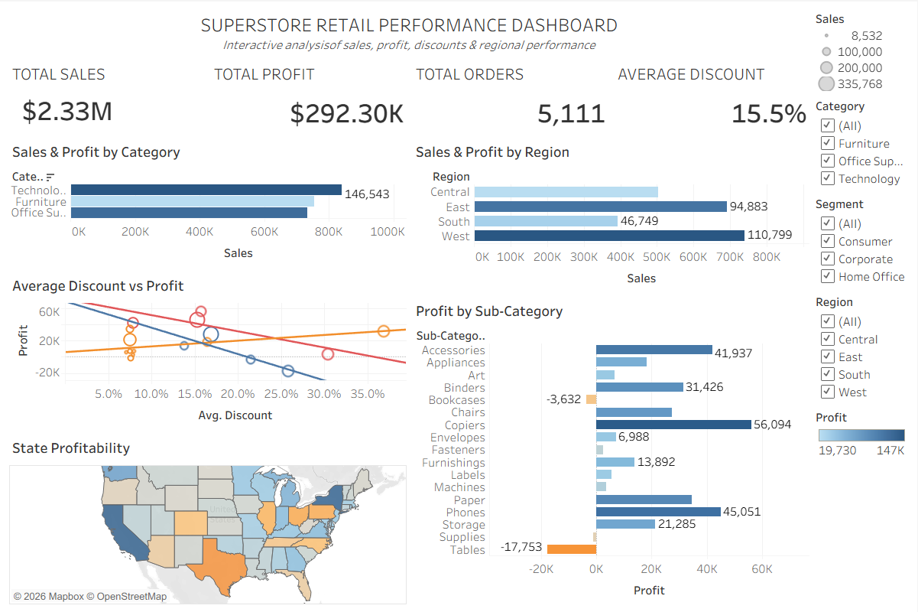
Figure 1. Week 3 – Superstore Retail Performance Dashboard.

4.2 The Retail Profitability Briefing
A companion story page distilled the dashboard into a concise management narrative. It presented key findings, business risks, recommendations and a final takeaway: focus on profitable growth rather than sales volume alone. Its recommendations included reviewing pricing, costs and discounts for loss-making products, comparing margins across regions and segments, and monitoring monthly sales and profit.
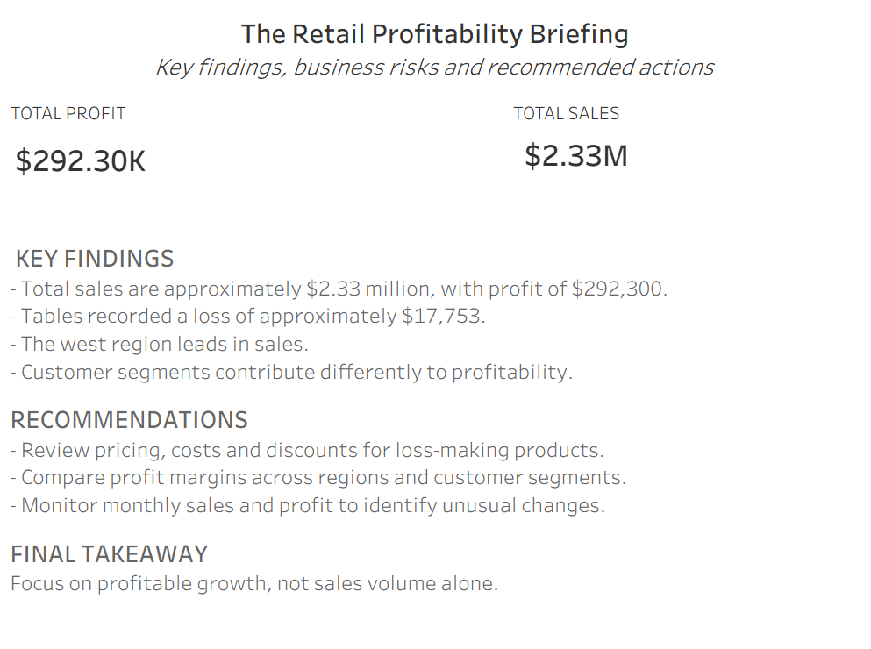
Figure 2. Week 3 – The Retail Profitability Briefing.

4.3 Storytelling effectiveness
The dashboard provided analytical depth, while the briefing page reduced the findings to a decision-oriented narrative. This two-part approach is effective because an interactive dashboard supports investigation and a story page communicates the implications. The narrative should nevertheless be read as a set of hypotheses and recommended investigations, not as proof of causes. For example, a discount-profit pattern does not by itself establish that discounting caused a loss.

5. Week 4 – Advanced Visualization Techniques

5.1 Dual-axis Sales and Profit trend
The advanced dashboard used a dual-axis line chart to display monthly Sales and Profit together. The separate axes make it possible to compare the direction and timing of changes while retaining each measure’s own scale. The chart indicates that both measures vary across the year and that their peaks and troughs do not always coincide.

5.2 Profitability heat map
The heat map arranged Category and Sub-Category as a matrix and used colour to encode Profit Margin. This supports rapid scanning for areas with relatively stronger or weaker margins. The legend shown in the screenshot ranges from approximately -0.0853 to 0.4390. Colour interpretation should be supported by the legend and, in a future version, accessible labels or tooltips.

5.3 Month-over-month sales growth
A line chart displayed monthly sales change as a percentage. The Week 4 screenshot labels several movements, including a March increase of 252.6%, a September increase of 90.9% and a November increase of 70.3%. These large percentage movements should be interpreted in relation to the prior period’s sales base and the exact date aggregation used in the calculation.
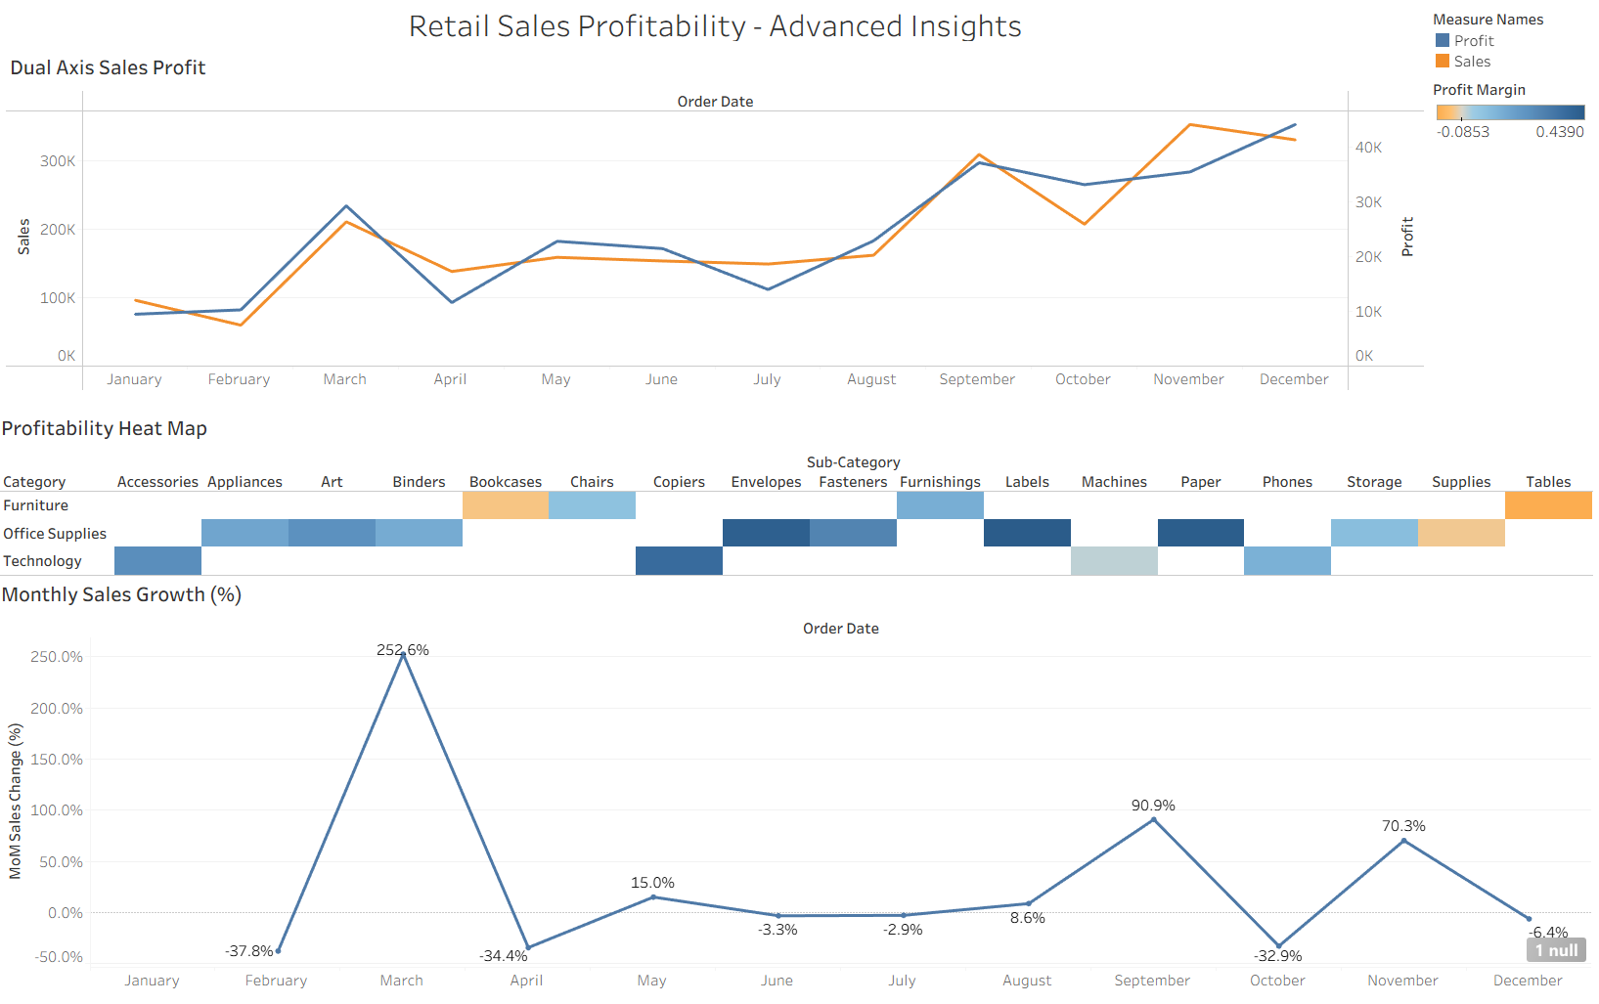
Figure 3. Week 4 – Advanced visualizations with labelled monthly sales growth.

5.4 Critical evaluation
The advanced views add analytical dimensions that were not as visible in the initial dashboard. The dual-axis chart is compact but can be misread if viewers compare line heights rather than values on the separate axes. The heat map is useful for pattern recognition but depends on a clear colour scale. The growth chart can exaggerate movement when the previous period is small and requires a defined month-over-month calculation and date grain.

6. Week 5 – Performance Review and Optimization

6.1 Final dashboard presentation
The Week 5 final screenshot retains the advanced analytical structure: Dual Axis Sales Profit, Profitability Heat Map and Monthly Sales Growth (%). It also presents the Category filter alongside the heat map. The final screenshot uses a cleaner presentation of the growth line without the point labels visible in the Week 4 version. This can reduce label clutter, although it also means exact point values are less immediately visible.
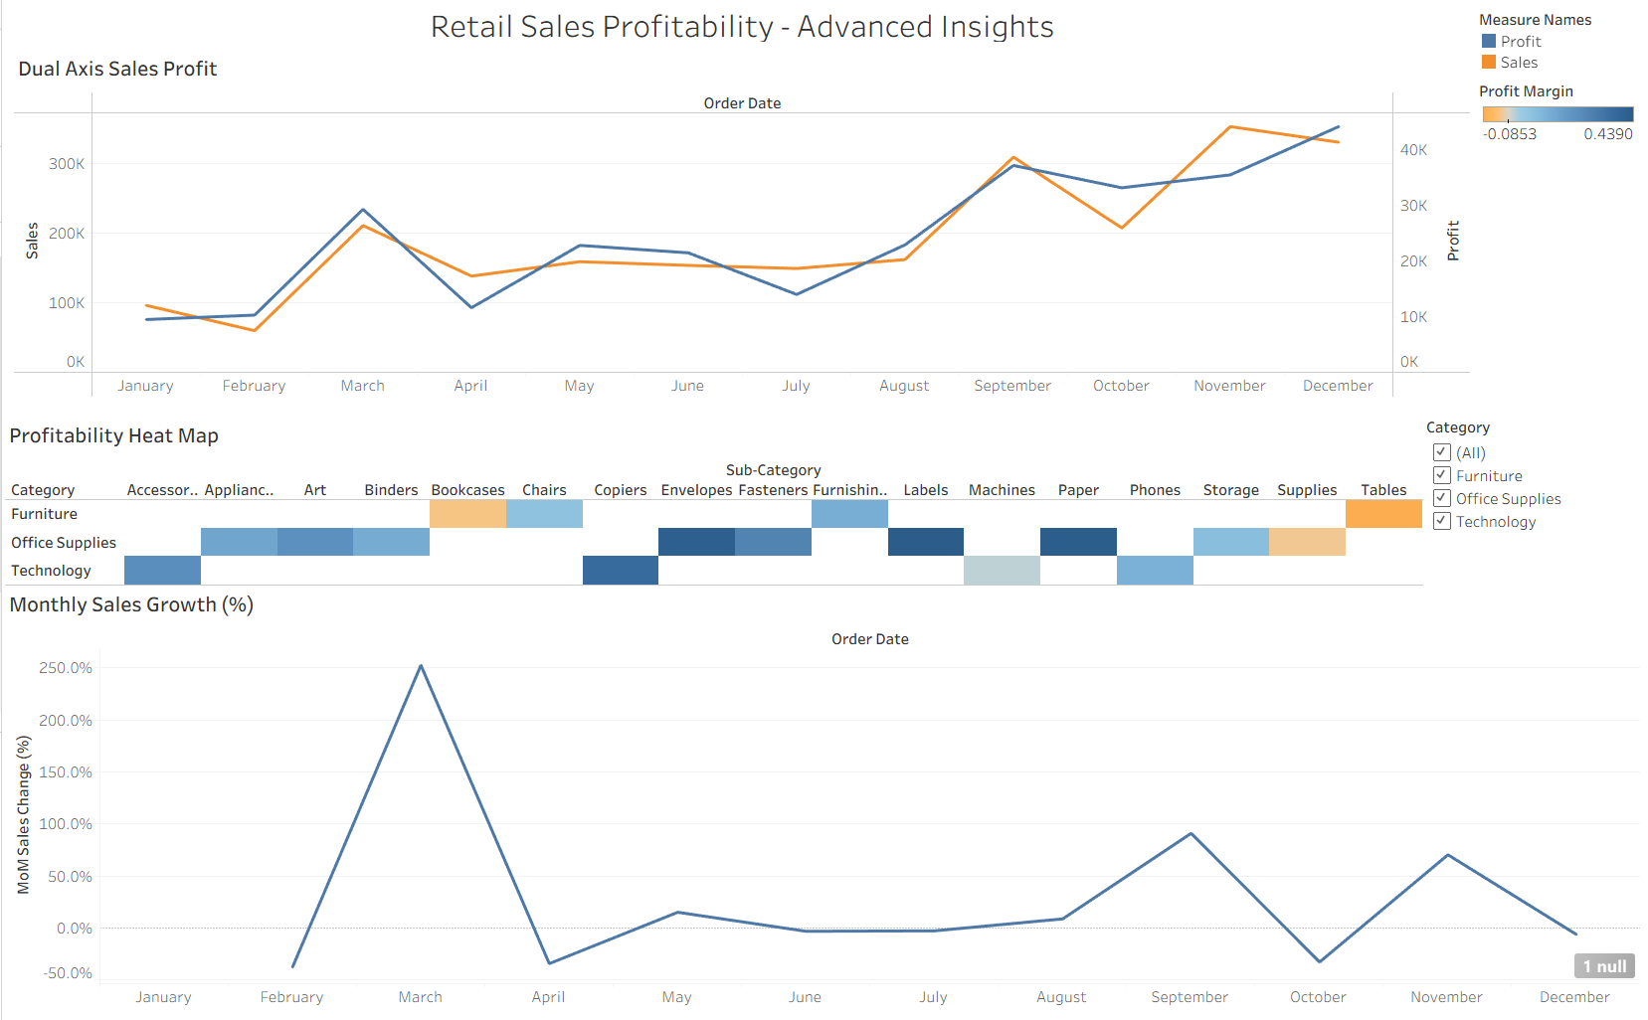
Figure 4. Week 5 – Final Retail Sales Profitability: Advanced Insights dashboard.

6.2 Optimization and quality considerations
The evidence supports a review of dashboard layout, visual density, filter placement, chart readability and the handling of missing values. The Week 5 screenshot displays a '1 null' indicator on the Monthly Sales Growth view. A likely explanation is that the first displayed period has no preceding period from which to calculate growth; this should be verified in the worksheet and documented as an expected calculation limitation if confirmed.
No measured before-and-after render-time or query-time benchmark is included in the supplied evidence. Therefore, this report does not claim a quantified speed improvement. Performance optimization should be validated using Tableau’s Performance Recording or another repeatable timing procedure, with identical filters and data conditions before and after changes.

6.3 Final quality review
- Confirm that each chart title describes the measure and dimension.
- Check that Sales, Profit and Profit Margin use consistent formats and aggregation logic.
- Test the Category filter and verify that the intended views respond correctly.
- Inspect the '1 null' indicator and confirm whether it is expected for the first period.
- Check tooltips, axis labels, colour legends and negative values.
- Save the final Tableau workbook and ensure the workbook and report are included in the repository.
- Record actual performance timings before making quantified optimization claims.

7. Integrated Evaluation

7.1 How the weekly deliverables connect
Stage | Contribution to the integrated project
Week 1 – Explore | Established data structure, baseline metrics, trends, outliers and business questions.
Week 2 – Plan | Translated EDA findings into an audience-focused dashboard blueprint.
Week 3 – Explain | Connected interactive views to a concise management briefing and recommendations.
Week 4 – Extend | Added dual-axis comparison, margin heat map and month-over-month growth analysis.
Week 5 – Refine | Reviewed the final dashboard layout, filter presentation, null handling and readability.
Week 6 – Integrate | Consolidates evidence, evaluates decisions and identifies future improvements.

7.2 Evaluation against the task objectives
Evaluation area | Assessment
Completeness | The report integrates the documented EDA, planning, storytelling and advanced dashboard evidence from Weeks 1–5.
Analytical relevance | Visuals address sales, profit, margin, discount, product, region, segment and time.
Storytelling | The dashboard and briefing page connect findings to business risks and actions.
Usability | KPI hierarchy, filters, chart titles and tooltips support navigation; filter behaviour should be retested before final publication.
Technical validation | Core metrics are documented; date grain, growth calculation and null handling need explicit validation.
Performance evidence | Presentation refinement is visible, but numerical performance gains have not been benchmarked.

7.3 Overall assessment
The strongest aspect of the project is the progression from broad exploration to a more focused analytical product. The dashboard does not rely only on total sales; it includes profit, margin, discount, geography and product-level differences. The main opportunities are stronger calculation documentation, reproducible testing and a clearer distinction between visual refinement and measured performance optimization.

8. Challenges and Lessons Learned

8.1 Challenges
- Choosing the right chart for each business question rather than using visual variety for its own sake.
- Balancing multiple views and filters within a single dashboard canvas.
- Interpreting negative profit and distinguishing unusual observations from data errors.
- Using a dual-axis chart without implying that the two measures share the same scale.
- Interpreting percentage growth when the previous month’s base is small.
- Recognising and investigating null values rather than hiding them without explanation.
- Maintaining a clear distinction between observed association and causal explanation.

8.2 Lessons learned
- Data exploration should precede dashboard construction because it provides the questions that visuals need to answer.
- Every chart should have a defined purpose and should contribute to the overall user journey.
- Sales and profitability are different dimensions; revenue growth alone is not sufficient evidence of business health.
- Interactive filters improve exploration only when their behaviour is predictable and tested.
- Visual clarity is part of analytical quality: titles, labels, legends and number formats affect interpretation.
- Claims about speed or performance require measurement, not visual impression.

9. Recommendations and Future Enhancements

9.1 Analytical enhancements
- Add a clearly defined Profit Margin calculation, such as SUM(Profit) / SUM(Sales), and validate it at the required aggregation level.
- Add year-over-year growth and a consistent month-over-month calculation with an explicit date grain.
- Investigate Tables and Bookcases by product, discount band, region and customer segment to understand the source of negative profit.
- Add top and bottom products, average order value and sales per order where they answer a defined business question.
- Compare category and regional profitability using a consistent margin measure rather than profit totals alone.

9.2 Dashboard and technical enhancements
- Add a clear reset-filters control and test all filter combinations.
- Improve heat-map accessibility with a colour-blind-conscious diverging palette and explanatory tooltips.
- Add annotations for important growth peaks and negative-profit areas where they improve the story.
- Document all calculated fields, aggregation choices, date settings and filter actions.
- Use Tableau Performance Recording to identify expensive queries or rendering steps, then compare timings before and after each change.
- Consider extracts, reduced mark counts, hiding unused fields and simplifying calculations only where measurement shows a benefit.

9.3 Portfolio and governance recommendations
For portfolio use, publish a clean workbook or Tableau Public link where permitted, include the data-source description, provide a short project overview and keep the repository organised by weekly deliverables. Remove private or unnecessary source files before public sharing. Clearly identify the dataset as a fictitious sample and state that recommendations are analytical suggestions rather than real company decisions.

10. Reflective Conclusion
The six-week sequence provided a practical opportunity to work through the stages of a Tableau analysis project. The work began with understanding a dataset and identifying patterns, then moved into planning a dashboard around business questions. The interactive dashboard and briefing page demonstrated how charts can support both exploration and communication. Advanced visualizations added further ways to compare performance over time and across product groups, while the final review highlighted the importance of readability, null handling and evidence-based optimization.
A key learning from the project is that an effective dashboard is not simply a collection of attractive charts. It is a structured analytical interface in which the data, visual choices, interactions and narrative reinforce one another. The work also reinforced the need to question results carefully: an association is not causation, an outlier is not automatically an error, and a visible design improvement is not proof of faster performance.
The final deliverable provides a foundation for a stronger portfolio case study. With further validation of calculated fields, filter behaviour and performance, the project can be extended into a more decision-ready retail analytics dashboard.

Appendix A – Visual Evidence
The following figures are included as evidence of the dashboard and storytelling stages. Week 1 and Week 2 supporting reports are referenced in the project history; the screenshots below focus on the visual deliverables supplied for Weeks 3–5.
Figure A1. Week 3 interactive performance dashboard.
Figure A2. Week 3 data-story briefing.
Figure A3. Week 4 advanced dashboard.
Figure A4. Week 5 final dashboard.

Appendix B – Key Metrics and Interpretation
Metric | Interpretation / caution
Sales | Revenue measure; does not independently indicate profitability.
Profit | Absolute profit contribution; can be affected by scale and extreme orders.
Profit Margin | Profit relative to sales; ensure the calculation is aggregated consistently.
Average Discount | Discount level; its relationship with profit may vary by category and product mix.
MoM Sales Growth | Percentage change from the previous month; undefined for the first period and sensitive to a small prior-period base.
Order Outliers | Observations requiring record-level investigation; not automatically data errors.

References
- Tableau Public. Sample Data – Superstore Sales. https://public.tableau.com/app/learn/sample-data
- Tableau Help. Build a Basic View to Explore Your Data. https://help.tableau.com/current/pro/desktop/en-us/getstarted_buildmanual_ex1basic.htm
- Tableau Help. Find Good Data Sets. https://help.tableau.com/current/pro/desktop/en-gb/find_good_datasets.htm
- Project documentation: Retail Sales and Profitability – Exploratory Data Analysis (Week 1).
- Project documentation: Tableau Dashboard Planning and Design Strategy (Week 2).

