WEEK 2 TASK
Dashboard Planning and Design Strategy
Tableau – Superstore Retail Sales & Profit Analysis

Prepared as a blueprint for the subsequent Tableau dashboard build

Dataset | Tableau Sample Superstore
Dashboard theme | Retail sales, profitability and regional performance
Primary audience | Business managers, sales/operations stakeholders and analysts
Dashboard type | Interactive analytical dashboard
Planned engagement | 32-hour structured design/build preparation

1. Executive Summary
The proposed dashboard is designed to transform the exploratory findings from Week 1 into a focused, interactive business intelligence view. The dashboard will help users move from a high-level performance question—“How are sales and profit performing?”—to diagnostic questions such as “Which categories, sub-categories, regions and discount levels are contributing to the result?”
The design intentionally combines KPI cards, comparison charts, a discount-versus-profit relationship view, regional analysis and a geographic view. These elements are connected through filters and cross-highlighting so that the dashboard behaves as one analytical system rather than a collection of unrelated charts.

2. Project Context and Week 1 Insights
The dashboard is based on Tableau's Sample Superstore retail dataset. Relevant fields include order and ship dates, customer and segment information, category/sub-category/product, sales, profit, quantity, discount, geography and shipping mode.
The Week 1 exploratory analysis identified several findings that directly inform the dashboard design:
- Technology recorded the strongest overall sales and profit performance among the major categories.
- Furniture generated substantial sales but much lower profit, making the gap between revenue and profitability important to highlight.
- Tables and Bookcases were identified as notable loss-making sub-categories, making profitability diagnostics essential.
- The West region recorded the highest sales and profit, while the South region was comparatively lower in both measures.
- The relationship between discount and profit varied by category, supporting the use of an interactive scatter plot rather than a single aggregate discount KPI.
These findings are not treated as final conclusions for every possible filter combination. Instead, they are used as design signals for questions the interactive dashboard should allow users to investigate.

3. Dashboard Objective
Primary objective: provide a single interactive view that enables a user to understand overall retail performance, identify profitability drivers and investigate regional/category differences with minimal navigation.

3.1 Business questions
- What are the overall sales, profit, order and discount levels?
- Which categories contribute most to sales and profit?
- Which sub-categories create unusually high or low profit?
- How does discount relate to profitability?
- Which regions and states are driving performance?
- How do results change when the user filters by date, region, segment or category?
- Where should the user investigate further?

3.2 Target audience
- Business managers who need a quick performance overview.
- Sales and operations stakeholders interested in regional and product performance.
- Analysts who need to move from summary metrics into diagnostic detail.
- Academic/project evaluators assessing the logic, usability and visual communication of the dashboard.

4. Key Metrics and Data Hierarchy
Metric / Dimension | Role | Recommended Visual | Reason
Total Sales | Primary KPI | KPI card | Immediate view of revenue scale
Total Profit | Primary KPI | KPI card | Measures financial outcome rather than volume alone
Orders / Order Count | Context KPI | KPI card | Adds activity/volume context
Average Discount | Diagnostic KPI | KPI card | Supports discount-profit investigation
Category | Comparison dimension | Bar chart | Clear comparison of major product groups
Sub-Category Profit | Diagnostic dimension | Horizontal bar chart | Makes gains/losses easy to compare
Discount vs Profit | Relationship | Scatter plot + trend | Shows distribution and potential association
Region | Geographic dimension | Bar chart | Provides ranked regional comparison
State | Geographic detail | Map | Allows spatial exploration and selection

5. Dashboard Storytelling Strategy
The visual hierarchy follows a top-to-bottom analytical story:
1. Orient: KPI cards establish the current overall performance context.
2. Compare: Category and regional charts show where performance is concentrated.
3. Diagnose: Sub-category profitability highlights specific product groups that deserve attention.
4. Investigate relationships: The discount-versus-profit scatter plot helps users examine whether discounting is associated with weaker profitability.
5. Explore geographically: The state map lets users identify geographic patterns and select a location for cross-filtering.
6. Interact and iterate: Filters, tooltips and cross-filter actions allow users to test different segments of the data without leaving the dashboard.

6. Layout Strategy and Wireframe
The proposed layout uses a 16:9-style canvas with a clear hierarchy: title → KPIs → global filters → primary comparisons → diagnostics → geographic detail. The objective is to keep the most important information visible without excessive scrolling.
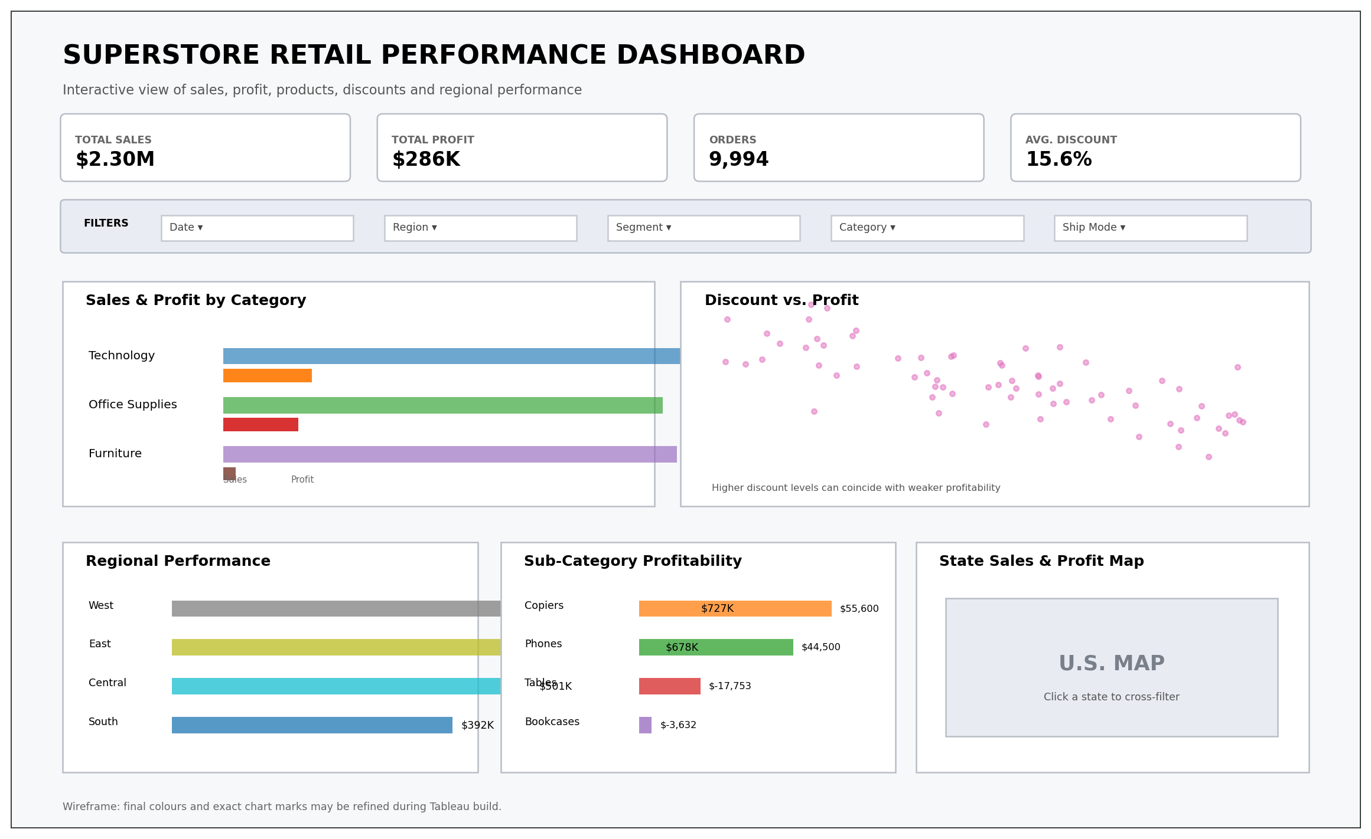
Figure 1. Proposed dashboard wireframe/mock-up. This is a planning sketch; exact Tableau marks and spacing can be refined during implementation.

6.1 Component placement
Component | Position | Content | Design rationale
Header | Top | Dashboard title, short subtitle and purpose. | Creates orientation before analysis begins.
KPI cards | Upper section | Sales, profit, orders and average discount. | Makes core metrics visible immediately.
Global filters | Below KPIs | Date, region, segment, category and shipping mode. | Lets users define the analytical context.
Category comparison | Middle-left | Sales and profit by category. | Answers the first comparison question.
Discount-profit scatter | Middle-right | Discount against profit with trend/reference cues. | Supports diagnostic analysis.
Regional performance | Bottom-left | Ranked regional comparison. | Shows geographic concentration without requiring map interpretation.
Sub-category profitability | Bottom-middle | Positive/negative profit comparison. | Surfaces specific product-level concerns.
State map | Bottom-right | Sales/profit geographic exploration. | Provides spatial detail and an interactive selection point.

7. Colour and Visual Design Strategy
The dashboard should use a restrained professional palette so that colour communicates meaning rather than decoration.
- Neutral background: light grey/white to preserve visual clarity.
- Primary analytical colour: a consistent blue/teal family for ordinary sales or performance marks.
- Profitability emphasis: use a contrasting warning colour only for negative-profit values or exceptions.
- Avoid using many categorical colours simultaneously; category colours should remain stable across views if used.
- Use colour saturation to establish hierarchy: the most important finding receives the strongest visual emphasis.
- Maintain sufficient contrast between marks, labels and the background.

7.1 Typography and formatting
- Dashboard title: large and bold.
- Section/chart titles: concise and consistent.
- KPI values: largest numerical text on the page.
- Axis and tooltip text: readable but secondary.
- Currency values: consistently formatted in $K/$M where appropriate.
- Negative profit: displayed clearly with a minus sign and visually distinct treatment.

8. Interaction Design
The dashboard should be interactive but predictable. Every interaction must produce a visible analytical benefit.
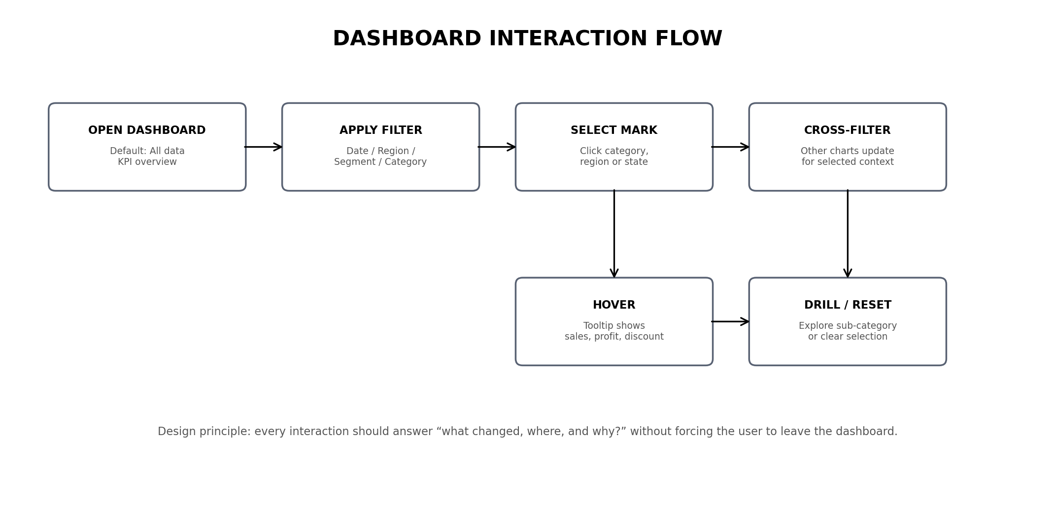
Figure 2. Proposed interaction flow.
Interaction | Trigger | Expected behaviour | User benefit
Global filters | Date, Region, Segment, Category, Ship Mode | All relevant visuals update together. | Lets the user narrow the analysis.
Chart selection | Click a category, region or state | Cross-filter/highlight related views. | Connects summary and detail.
Hover tooltips | Hover over bars, points or map marks | Show sales, profit, discount and relevant dimensions. | Adds detail without cluttering the canvas.
Drill-down | Category → sub-category/product where appropriate | Moves from broad performance to detailed diagnosis. | Supports root-cause exploration.
Reset | Clear filters / reset view | Returns to the default overview. | Prevents users from becoming trapped in a filtered state.

9. Visualization Rationale and Integration
KPI cards
KPI cards provide rapid orientation and establish the baseline against which every other visual can be interpreted. They answer the initial 'how are we doing?' question before the user investigates why.
Category bar chart
Bars provide a straightforward comparison of sales and profit across a small number of categories. Users can immediately see situations where high sales do not translate into high profit.
Sub-category profitability
A ranked horizontal bar chart is effective for positive/negative comparisons and long sub-category names. It exposes specific areas such as Tables and Bookcases that may be hidden inside category totals.
Discount-profit scatter
A scatter plot preserves individual observations and makes patterns, outliers and potential relationships visible. It prevents the dashboard from implying that one average discount value explains all profitability outcomes.
Regional bar chart
A ranked bar chart is easier to compare precisely than a map for regional totals. It gives a clear performance ordering while the map is reserved for spatial exploration.
State map
Maps are useful for geographic pattern recognition and location-based filtering. The map adds spatial context without replacing the more precise regional comparison chart.

10. User Journey
- User opens the dashboard and sees the four KPI cards.
- User checks category and regional charts to identify where sales/profit are concentrated.
- User notices a potential mismatch between sales and profit and selects the relevant category.
- All linked views update to show the selected category's regional and sub-category performance.
- User examines the discount-versus-profit scatter plot to investigate whether discount levels coincide with weaker outcomes.
- User selects a state or region on the geographic view to isolate the location.
- User reads tooltips for detailed values and, where needed, drills into sub-category/product detail.
- User clears filters and returns to the overall view for the next question.

11. Usability and Accessibility Considerations
- Keep the number of simultaneous visuals manageable; each chart must have a distinct purpose.
- Use clear chart titles that state the measure and dimension rather than generic labels such as 'Chart 1'.
- Do not rely on colour alone to communicate positive/negative status; use signs, labels or position as additional cues.
- Keep filters together in one predictable area.
- Use tooltips to provide detail without filling the canvas with labels.
- Maintain consistent number formatting across all views.
- Design the dashboard so that the default state tells a coherent story even before the user interacts with it.
- Avoid unnecessary 3D charts, decorative icons and excessive borders.

12. Strategic Insights the Design Must Preserve
The dashboard should preserve the following analytical tensions discovered during Week 1 rather than flattening them into a single performance score:
- Sales volume versus profit: high sales should not automatically be interpreted as strong profitability.
- Category versus sub-category: category totals can conceal loss-making sub-categories.
- Regional totals versus state detail: a region-level result can contain meaningful state-level variation.
- Discount versus profit: the relationship is not assumed to be identical across all categories, so the scatter plot should support filtering.
- Overview versus diagnosis: the dashboard should make it easy to move from a summary observation to a specific area for investigation.

13. Proposed Dashboard Build Sequence
Phase 1 – Data preparation: Confirm field types, date hierarchy, calculated fields and aggregation logic.
Phase 2 – KPI layer: Build and validate Sales, Profit, Orders and Average Discount cards.
Phase 3 – Core comparisons: Create category, regional and sub-category views.
Phase 4 – Diagnostic analysis: Build discount-versus-profit scatter and appropriate trend/reference elements.
Phase 5 – Geographic analysis: Build state map and connect it to dashboard filtering.
Phase 6 – Interactions: Add filter actions, highlight/cross-filter actions, tooltips and reset behaviour.
Phase 7 – Layout and formatting: Implement the wireframe, spacing, typography and colour rules.
Phase 8 – Testing: Test default view, every filter, combinations of filters, tooltips, negative values and reset functionality.
Phase 9 – Refinement: Remove clutter, improve labels and verify that every element supports a business question.

14. Suggested 32-Hour Engagement Plan
The assignment specifies 30–35 hours of engagement. The following 32-hour plan provides a realistic structure. These are planned work allocations, not a claim that the hours have already been completed.
Activity | Hours | Deliverable
Data and Week 1 review | 4 | Revisit fields, findings and analytical questions.
Dashboard objective and audience | 2 | Define user needs and success criteria.
Metric and visualization selection | 4 | Map questions to measures and chart types.
Wireframe and layout design | 5 | Draft, critique and refine dashboard structure.
Interaction strategy | 4 | Plan filters, selections, tooltips and drill paths.
Colour, typography and accessibility | 3 | Define visual standards and usability rules.
Integration rationale | 3 | Document how visuals work together as one story.
Mock-up and flow diagram | 3 | Create and refine visual planning artifacts.
Documentation and quality review | 4 | Assemble, proofread and validate the blueprint.
Total planned engagement: 32 hours.

15. Evaluation Checklist
- ☐ Dashboard objective and target audience are clearly defined.
- ☐ Key metrics and analytical questions are documented.
- ☐ Every visualization has a specific rationale.
- ☐ Layout position and hierarchy are explicitly planned.
- ☐ Colour and typography decisions are documented.
- ☐ Mock-up/wireframe is included.
- ☐ Interaction flow is documented.
- ☐ Cross-filtering and tooltip behaviour are specified.
- ☐ Week 1 insights directly influence the design.
- ☐ Usability and accessibility considerations are addressed.
- ☐ The document can be used as a blueprint for the Tableau build.

16. Conclusion
This dashboard plan converts the Week 1 exploratory analysis into a structured design blueprint. The proposed dashboard begins with high-level KPIs, moves into category and regional comparisons, then provides diagnostic views for sub-category profitability, discount versus profit and state-level performance. Interactive filters and cross-filtering connect these views so that users can investigate the reasons behind observed performance rather than simply reading isolated charts.
The design is intentionally modular: each component has a defined analytical purpose, each interaction has a defined user benefit, and the wireframe provides a clear implementation sequence for the subsequent Tableau build. This creates a traceable link between the data findings, the visual choices and the final dashboard experience.

