LOGIN PAGE:
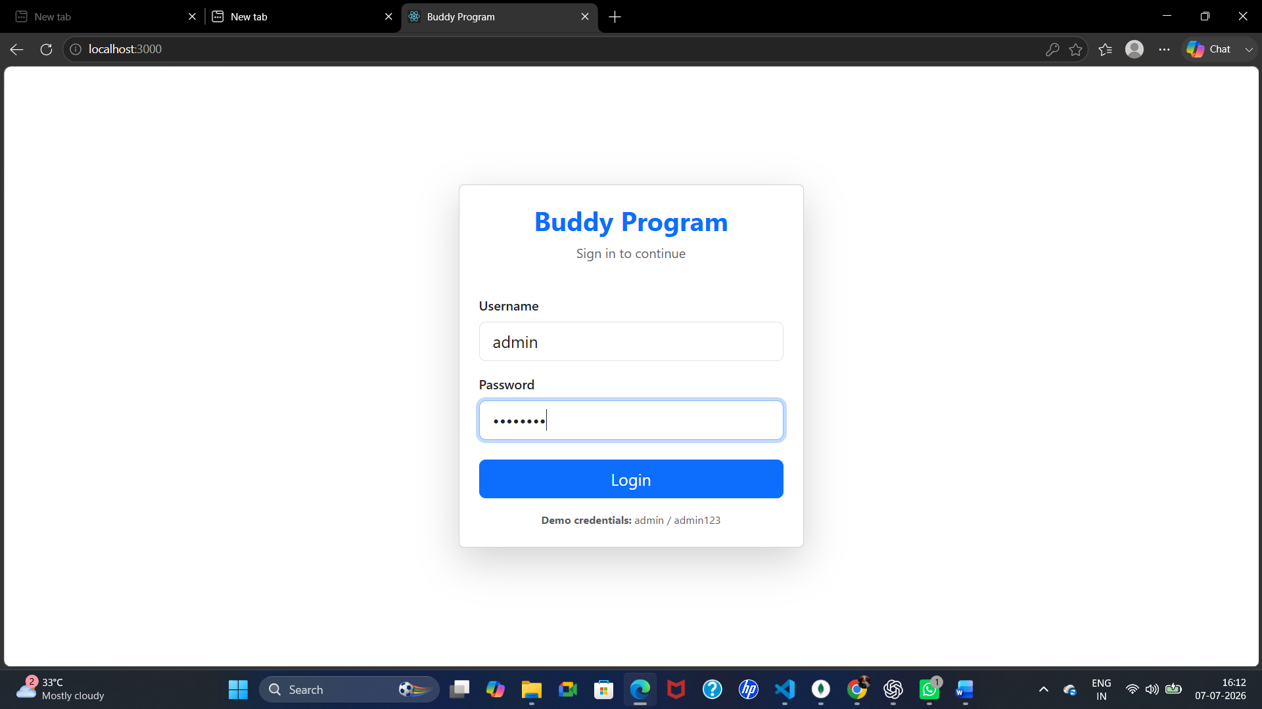

HOME PAGE:
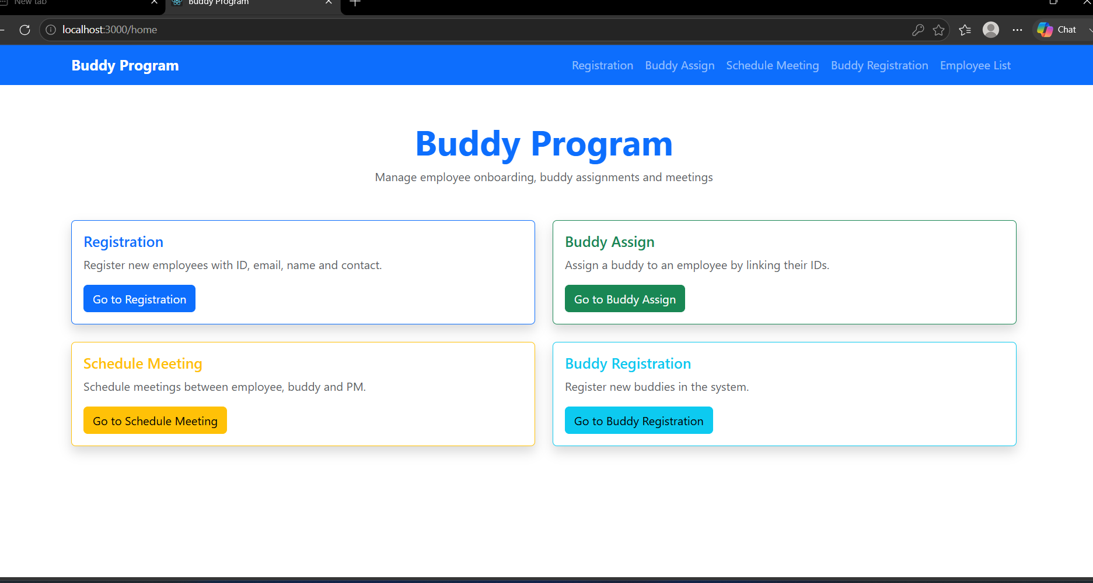

EMPLOYEE REISTRATION PAGE:
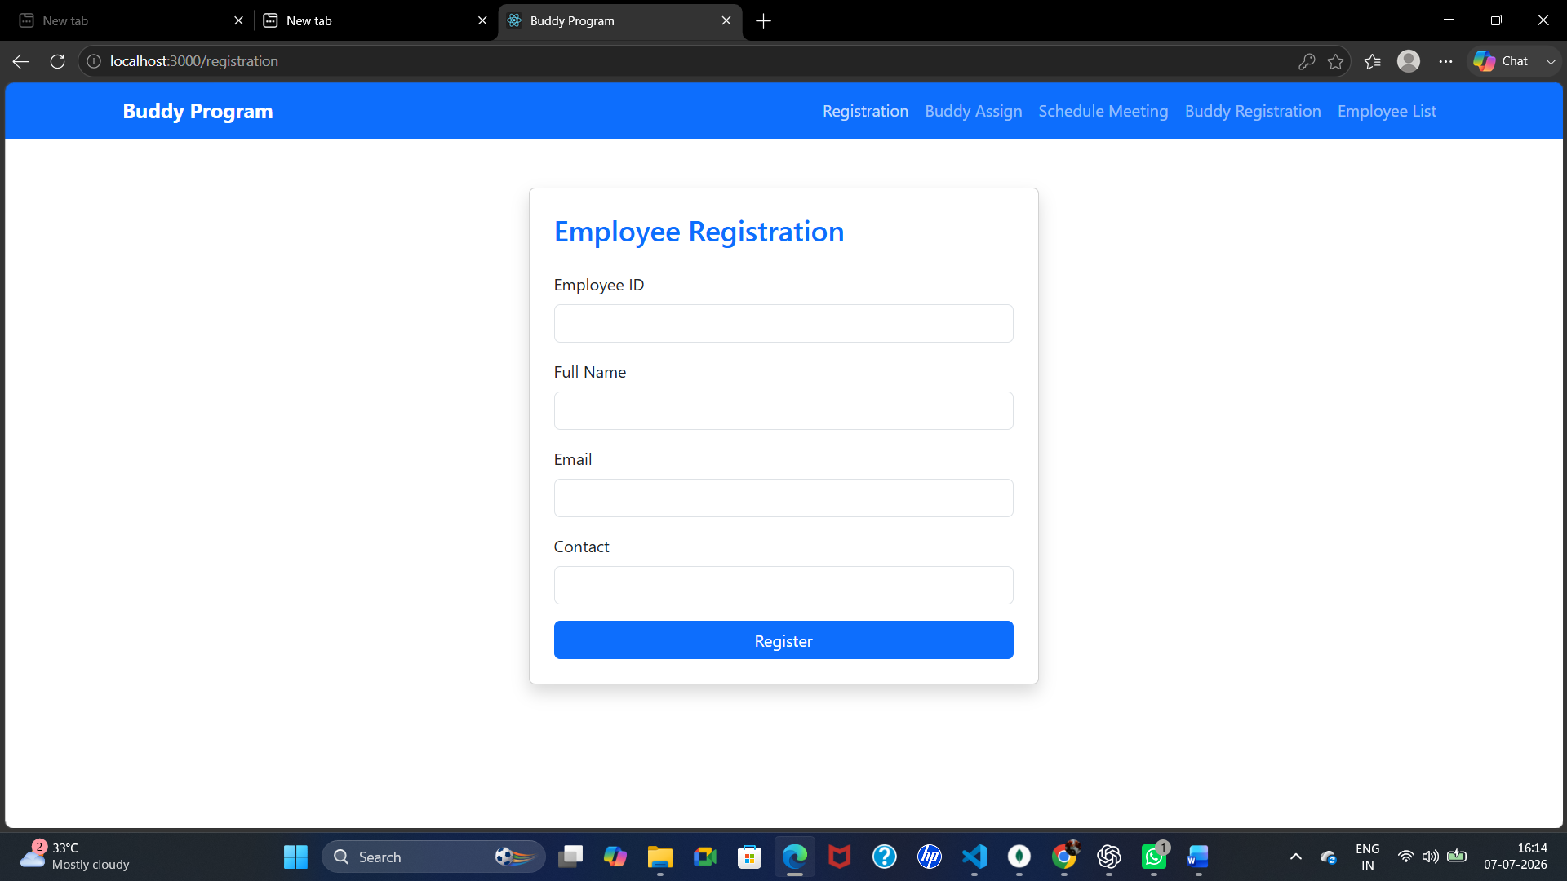

BUDDY ASSIGNMENT PAGE:
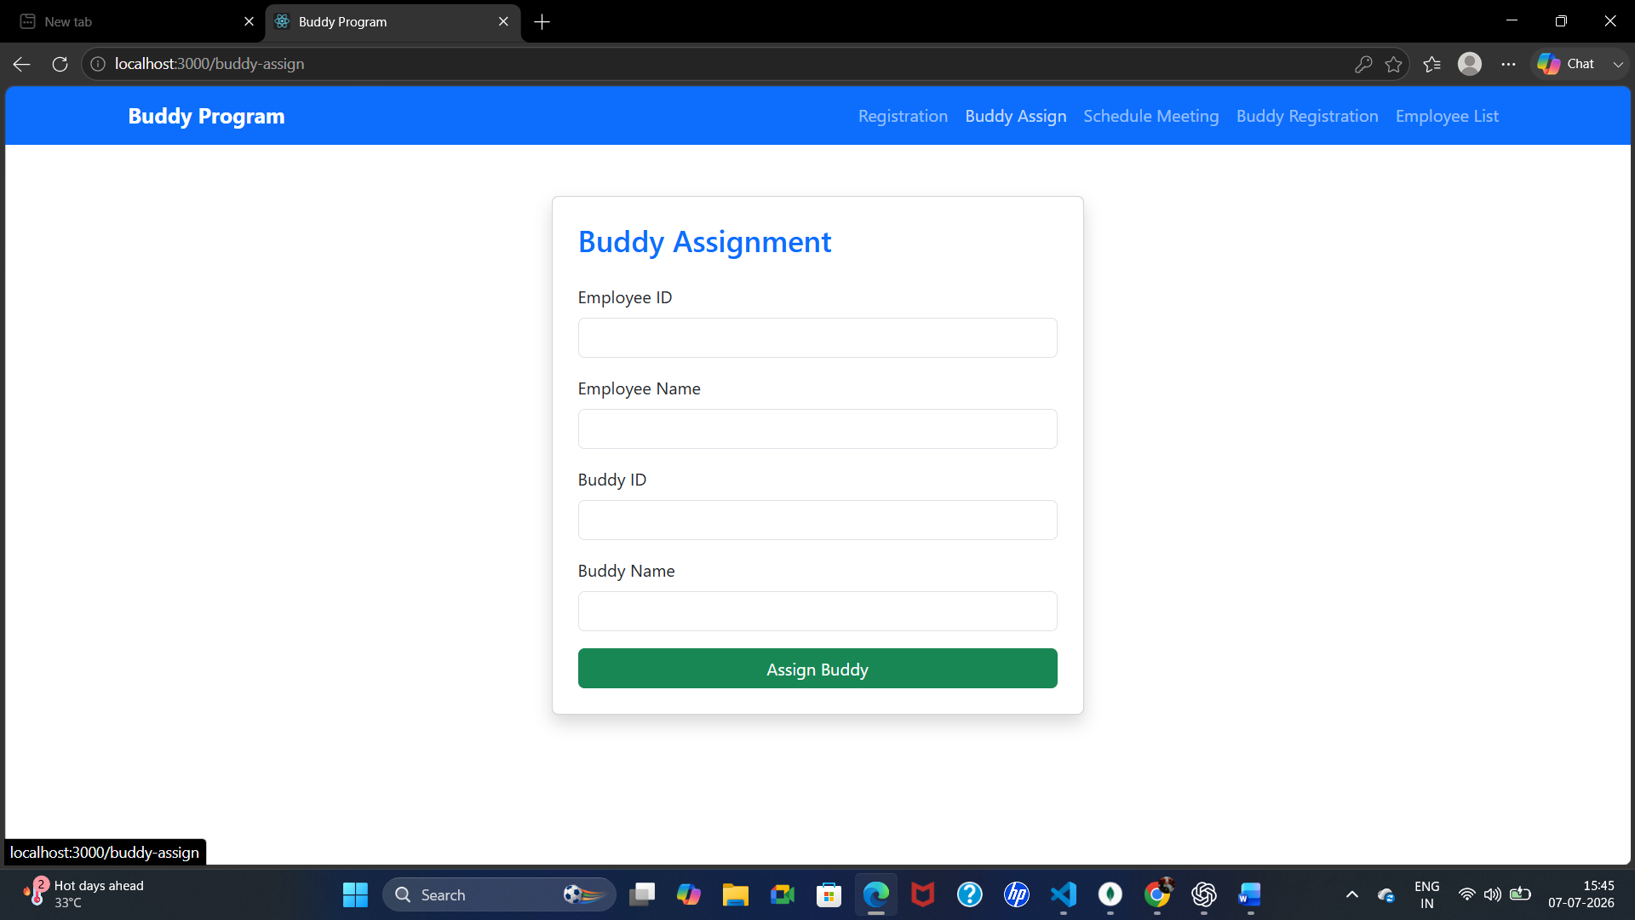
SCHEDULE MEETING PAGE: 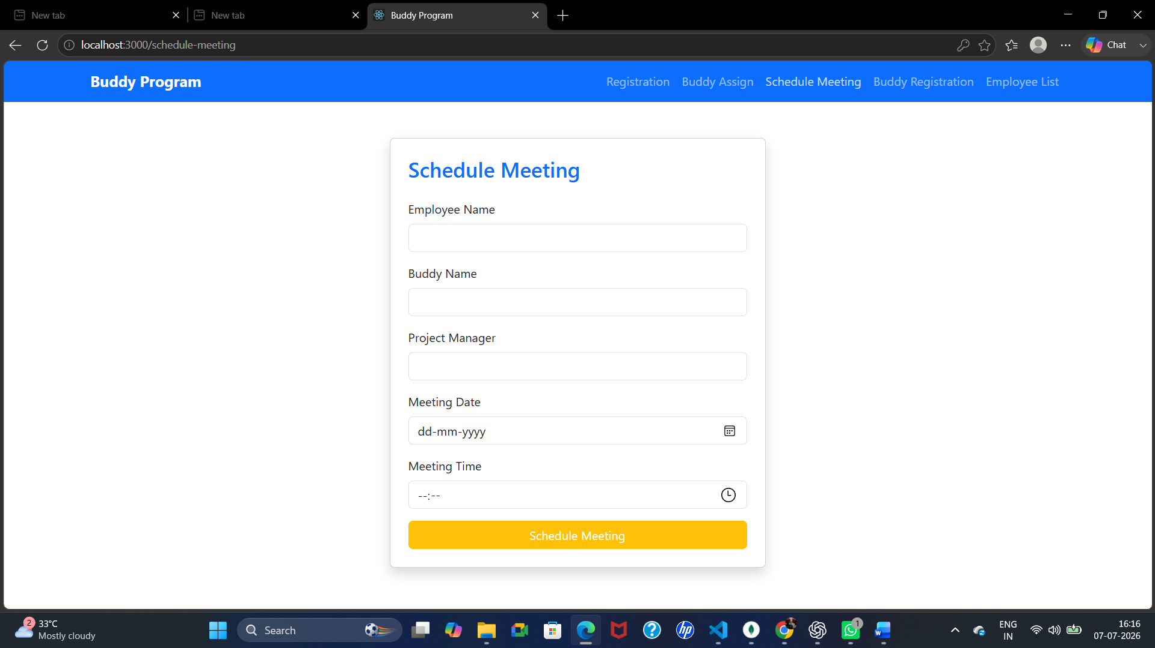

BUDDY REGISTRATION PAGE:
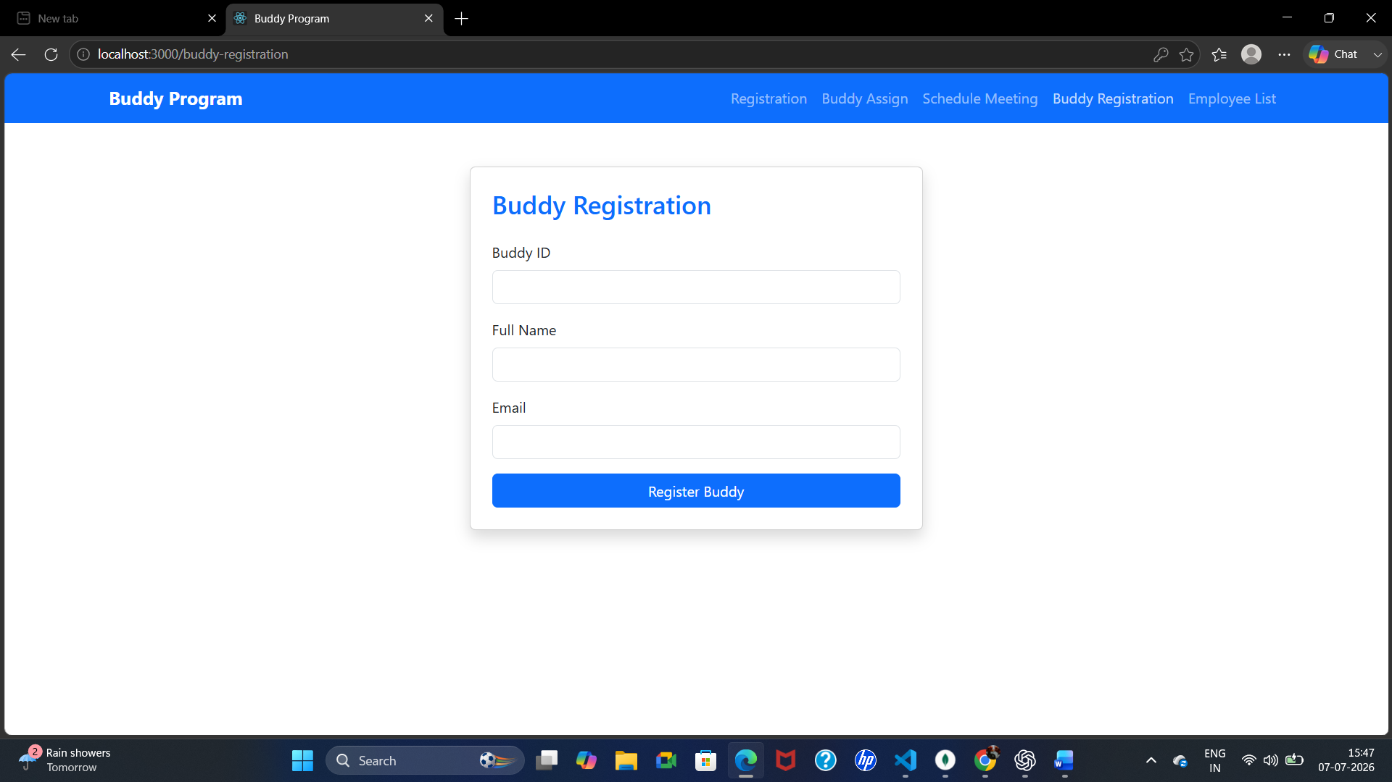
REGISTER EMPLOYEE LIST :