**Admin login**

**List Students**

**Add Student**

**Update Student**

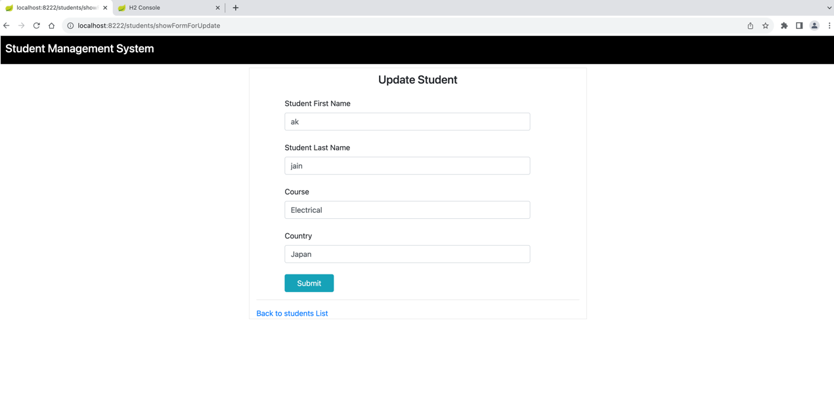

**User Login**

**User trying to delete**

**User Access Denied**

