1. HealthCheck

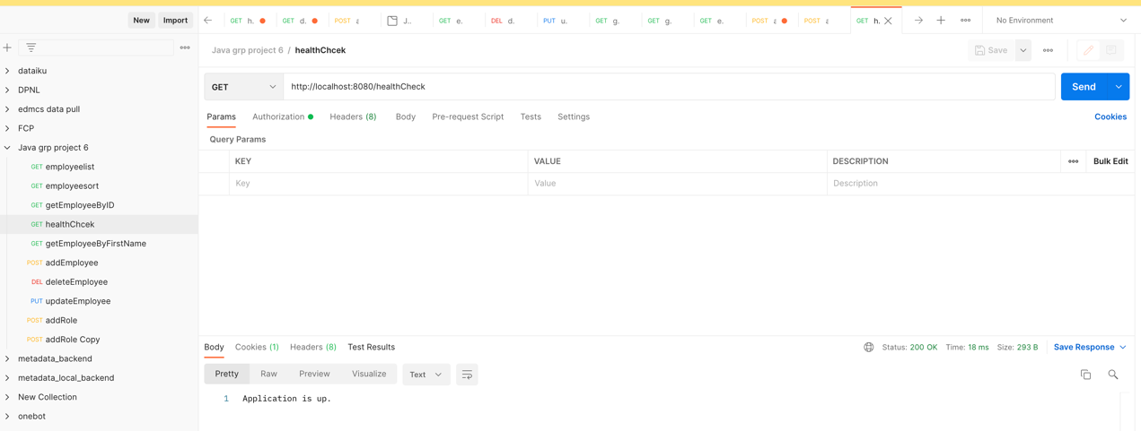

1. Add Role

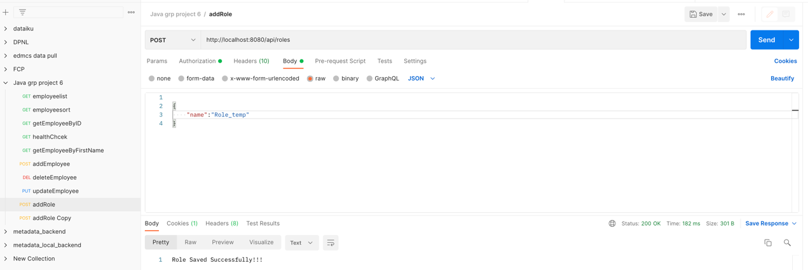

1. Add User

1. Add Employee by User & Admin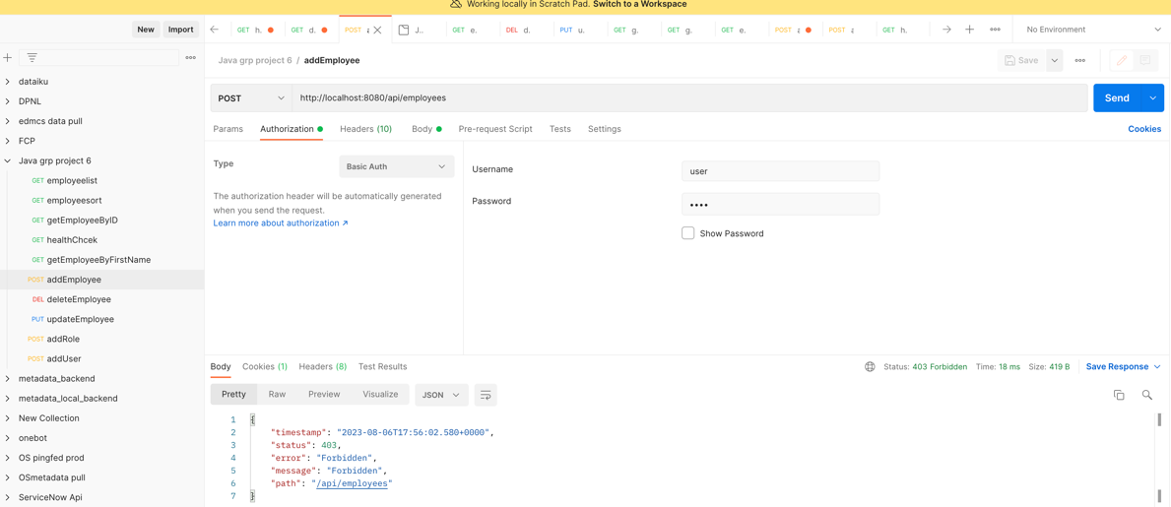

By - User

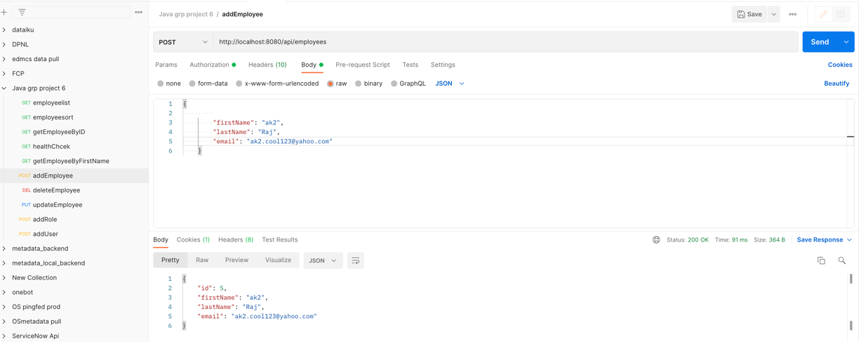

**By- Admin**

1. **List Employees**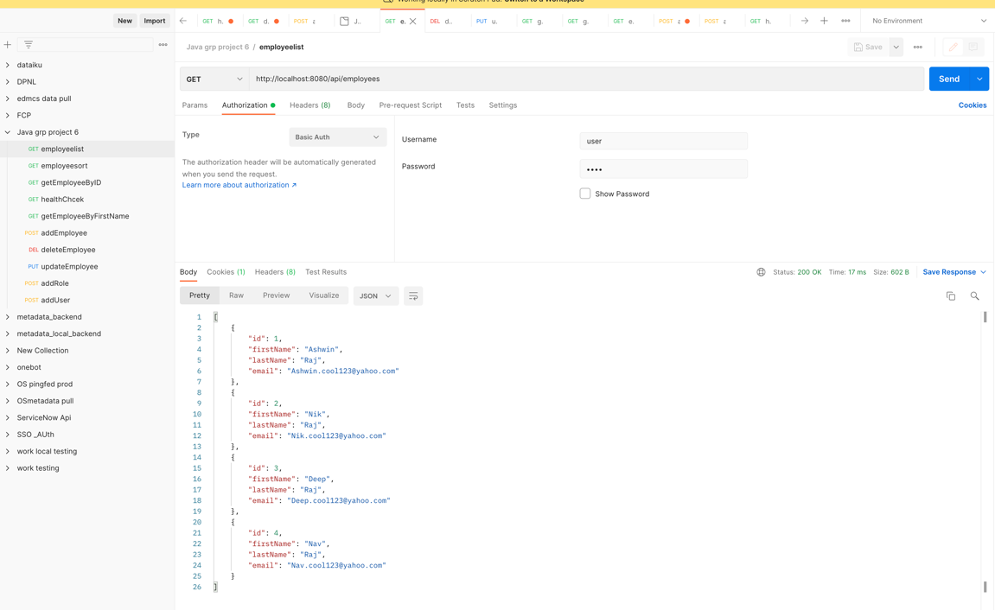
2. **Search by ID**

1. **Update Employee record**

1. **Delete Employee by ID**

1. **Search Employee by First name**

1. **Sort Employee List**

