
LAB RECORD
BACHELOR OF TECHNOLOGY

B.Tech. CS&E _Sec.C_ Semester ( 1st )

(Academic Session ~ 2021-2025 )

Course Title : B.Tech CSE

Course Code : 11052
Enrollment No. : A7605221101
Name of Student : Ashwani Kumar Singh
Date of Submission : __ __ / __ __ /2021
Signature of Student : 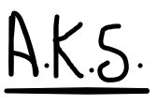

Grade/Marks Obtained:

Faculty Name & Signature: Dr. Sheenu Rizvi

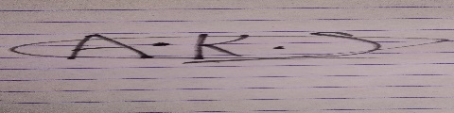



Department of Computer Science & Engineering
Amity School of Engineering & Technology
Amity University, Lucknow Campus

Index
S.No | PROGRAMS | Date | Sign | Remark
1. | Input two numbers and print their sum.
2. | Input principle amount, rate and time and calculate S.I.
3. | Input length and breadth and calculate area of rectangle
4. | Input the side and calculate area of square.
5. | Input radius and calculate area and circumference of circle.
6. | Input base and height and calculate area of triangle
7. | If Basic salary is input through keyboard write a program to calculate gross salary. Where,  da is 10% of bs.  ta is 12% of bs.  hra is 10% of bs.
8. | Input temperature in Fahrenheit and convert into Celsius.
9. | Input two numbers and swap them.
10. | Input 5 digit numbers and calculate sum of its digits.
11. | Input two numbers and print the greater number.
12. | Input a number and check if it is even or odd.
13. | Input a number and check if it is Armstrong.
14. | Display reverse of a number.
15. | Input a number and check if it is palindrome or not.
16. | Generate Fibonacci series.
17. | Display pattern below  *  **  ***  ****
18. | 1  12  123  1234
19. | ****  ***  **  *
20. | Input an alphabet and check it is vowel or not.
21. | Design a calculator.
22. | Write a program Input the marks and print the remarks.
23. | Write a program enter three number and find Largest among 3 numbers.
24. | Write a program to find Average of the elements of an array.
25. | Write a program to find Largest element of an array.
26. | Write a program for Linear search.
27. | Write a program input two array and Merge.
28. | Write a program Selection sort.
29. | Write a program Bubble sort.
30. | Write a program Insertion sort.
31. | Write a program for Binary search.
32. | Write a program for Sum of two matrices.
33. | Write a program for Product of two matrices.
34. | Write a program for Transpose of a matrix.
35. | Write a program for Sum of two numbers using functions.
36. | Write a program for Swap two numbers using functions.
37. | Write a program for Armstrong number using function.
38. | Write a program for Add two number using call by reference.
39. | Write a program for Swap two numbers using call by reference.
40. | Write a program for Sum of digits of a number using function.
41 | Write a C program to copy contents of one file to another file

Open-Ended Questions

Q1 A library charges a fine for every book returned late. For first 5 days fine is 50 paise, for 6-10 days fine is one rupees and above 10 days fine is 5 rupees. If you return the books after 30 days your membership will be cancelled. Write a program to accept the number of days the member is late to return the book and display the fine or appropriate message.
Q2 With the help of an example explain how an array can be passed to a function? Is it possible to send just a single element of the array to a function?
Q3 Define a structure data type called TStruct containing 3 members called hour, minute and second. Develop a program that would assign values to the individual members and display the time in the form 16:40:30

1. To Input two numbers and print their sum

/* Calculating Sum of two numbers*/
#include<stdio.h>

int main()
{

int a, b, sum;

printf("Enter two integers: ");
scanf("%d %d", &a, &b);

// calculating sum
sum = a + b;

printf("%d + %d = %d", a, b, sum);
return 0;
}
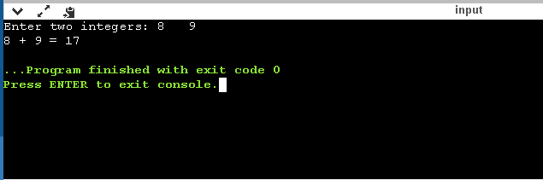

2. To Input principle amount, rate and time and calculate S.I.

#include<stdio.h>

float main()
{
float principle, time, rate, SI;

/* Input principle, rate and time */
printf("Enter the principal amount : ");
scanf("%f", &principle);

printf("Enter the number of years : ");
scanf("%f", &time);

printf("Enter the rate of interest : ");
scanf("%f", &rate);

/* Calculate simple interest */
SI = (principle * time * rate) / 100;

printf("Simple Interest = %f", SI);

return 0;
}

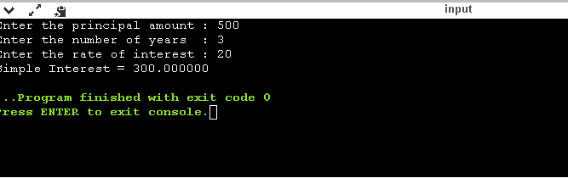

3.To Input length and breadth and calculate area of rectangle

/**
* C program to find area of rectangle
*/

#include<stdio.h>

float main()
{
float length, width, area;

/*
* Input length and width of rectangle
*/
printf("Enter length of rectangle: ");
scanf("%f", &length);
printf("Enter width of rectangle: ");
scanf("%f", &width);

/* Calculate area of rectangle */
area = length * width;

/* Print area of rectangle */
printf("Area of rectangle = %2f sq. units ", area);

return 0;
}
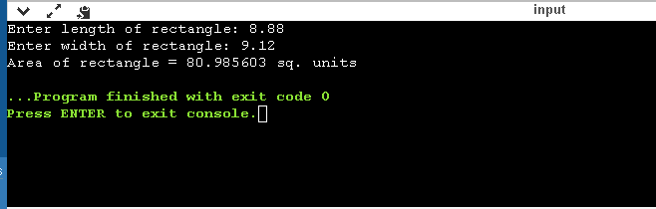

4.To Input the side and calculate area of square.

#include<stdio.h>

int main() {
int side, area;

printf("\nEnter the Length of Side : ");
scanf("%d", &side);

area = side * side;
printf("\nArea of Square : %d", area);

return (0);
}

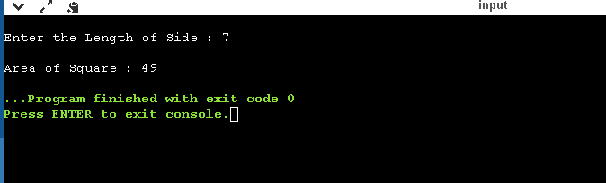

5.To Input radius and calculate area and circumference of circle

#include<stdio.h>
void main()
{
float radius, area, cf;
printf("Enter Radius of Circle\n");
scanf("%f",&radius);

//value of pi is 3.14
area=3.14*radius*radius;
printf("The area of Circle is %f",area);

cf=2*3.14*radius;
printf("\nThe Circumference of Circle is %f",cf);
}

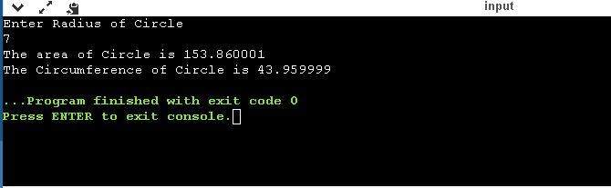

6. To Input base and height and calculate area of triangle

#include <stdio.h>

float main()
{
float base, height, area;

/* Input base and height of triangle */
printf("Enter base of the triangle: ");
scanf("%f", &base);
printf("Enter height of the triangle: ");
scanf("%f", &height);

/* Calculate area of triangle */
area = (base * height) / 2;

/* Print the resultant area */
printf("Area of the triangle = %2f sq. units", area);

return 0;
}

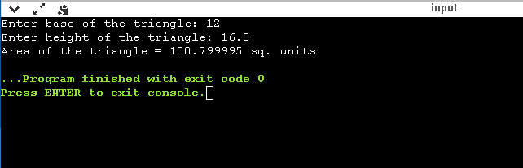

7. If Basic salary is input through keyboard write a program to calculate gross salary. Where,
da is 10% of bs. ta is 12% of bs hra is 10% of bs.

#include<stdio.h>
float main()
{
float bs,da,ta,hra,gs;
printf("Enter basic salary:\n");
scanf("%f",&bs);
da=((10*bs)/100);
printf("DA: %f",da);
ta=((12*bs)/100);
printf("TA: %f",ta);
hra=((10*bs)/100);
printf("HRA: %f",hra);
gs=bs+da+hra+ta;
printf("Gross Salary=: %f" , gs) ;
return 0;
}
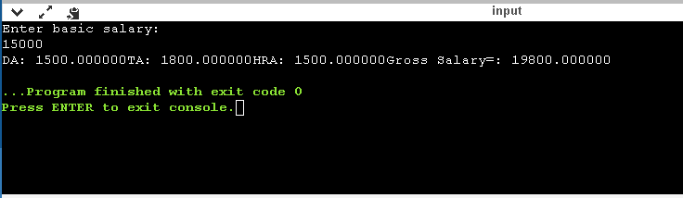

8. To Input temperature in Fahrenheit and convert into Celsius

#include<stdio.h> // include stdio.h

int main()
{
float fah, cel;

printf("Enter a temp in fah: ");
scanf("%f", &fah);

cel = (5.0/9) * (fah - 32);

printf("%.2f°F is same as %.2f°C", fah, cel);

return 0;
}

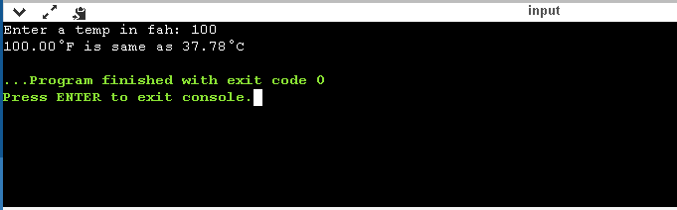

9. To Input two numbers and swap them.

#include<stdio.h>
int main() {
double first, second, temp;
printf("Enter first number: ");
scanf("%lf", &first);
printf("Enter second number: ");
scanf("%lf", &second);

// value of first is assigned to temp
temp = first;

// value of second is assigned to first
first = second;

// value of temp (initial value of first) is assigned to second
second = temp;

// %.2lf displays number up to 2 decimal points
printf("\nAfter swapping, first number = %.2lf\n", first);
printf("After swapping, second number = %.2lf", second);
return 0;
}

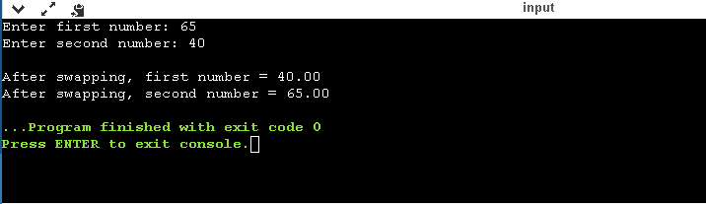

10. To Input 5 digit numbers and calculate sum of its digits.

#include<stdio.h>
int main ()
{
int number, last_digit, next_digit, total;
printf ("Enter the number whose sum of digits is to be calculated: ");
scanf ("%d", &number);
last_digit = number%10;
total = last_digit;
next_digit = (number/10) % 10;
total = total + next_digit;
next_digit = (number/100) % 10;
total = total + next_digit;
next_digit = (number/1000) %10;
total = total + next_digit;
next_digit = (number/10000) %10;
total = total + next_digit;

printf ("The sum of the digits of the entered number is: %d", total);

}

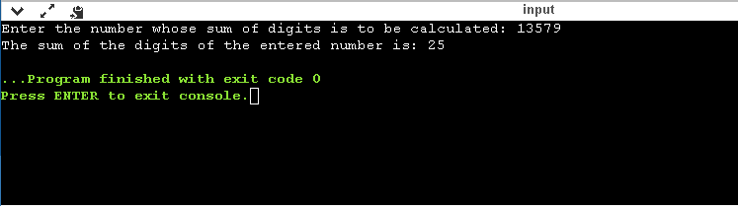

11. To Input two numbers and print the greater number.

#include <stdio.h>
int main()
{
int num1, num2;
// Ask user to enter the two numbers
printf("Please Enter any Two different numbers\n");
// Read two numbers from the user
scanf("%d %d", &num1, &num2);
if(num1 > num2)
{
printf("%d is the Largest one\n", num1);
}
else if (num2 > num1)
{
printf("%d is the Largest one\n", num2);
}
else
{
printf("Both numbers are Equal\n");
}
return 0;
}

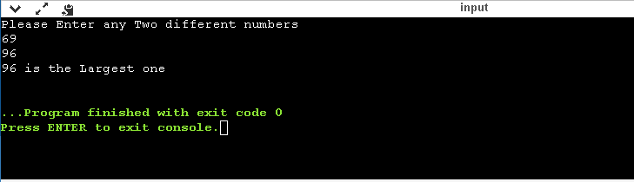

12. To Input a number and check if it is even or odd.

#include <stdio.h>
void main()
{
int num1, rem1;

printf("Input an integer : ");
scanf("%d", &num1);
rem1 = num1 % 2;
if (rem1 == 0)
printf("%d is an Even integer\n", num1);
else
printf("%d is an Odd integer\n", num1);
}

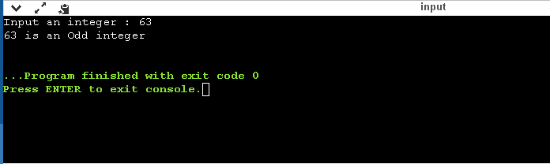

13. To Input a number and check if it is Armstrong.

#include<stdio.h>
int main()
{
int n,r,sum=0,temp;
printf("Enter the number=");
scanf("%d",&n);
temp=n;
while(n>0)
{
r=n%10;
sum=sum+(r*r*r);
n=n/10;
}
if(temp==sum)
printf("Yes it is a Armstrong number ");
else
printf("It is NOT a Armstrong number");
return 0;
}

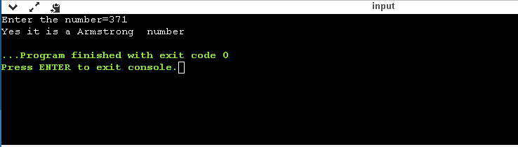

14. To Display reverse of a number

#include <stdio.h>
int main() {
int n, rev = 0, remainder;
printf("Enter an Integer: ");
scanf("%d", &n);
while (n != 0) {
remainder = n % 10;
rev = rev * 10 + remainder;
n /= 10;
}
printf("Reversed number is = %d", rev);
return 0;
}

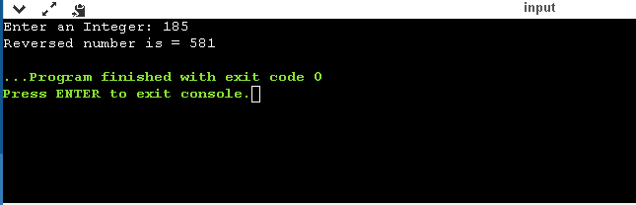

- To Input a number and check if it is palindrome or not.

#include<stdio.h>
int main()
{
int n,r,sum=0,temp;
printf("Enter the number=");
scanf("%d",&n);
temp=n;
while(n>0)
{
r=n%10;
sum=(sum*10)+r;
n=n/10;
}
if(temp==sum)
printf("YES, It is a palindrome number ");
else
printf("NO, It’s not a palindrome number ");
return 0;
}

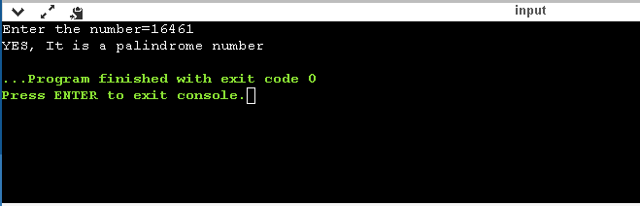

16. To Generate Fibonacci series.

#include<stdio.h>
int main()
{
int n1=0,n2=1,n3,i,number;
printf("Enter number of elements you want to get appeared:");
scanf("%d",&number);
printf("\n%d %d",n1,n2);//printing 0 and 1
for(i=2;i<number;++i)//loop starts from 2 because 0 and 1 are already printed
{
n3=n1+n2;
printf(" %d",n3);
n1=n2;
n2=n3;
}
return 0;
}

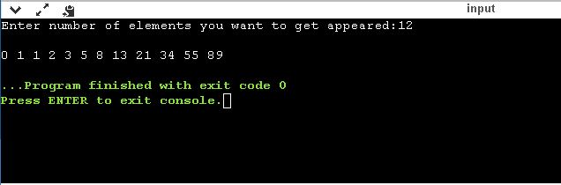

17. To Display pattern below
*
**
***
****
#include<stdio.h>
int main()
{
int i,j;

// outer for loop to represent rows
for(i=1;i<=4;i++)
{
// inner for loop to represent columns
for(j=1;j<=i;j++)
{
printf("* ");
}

// new line
printf("\n");
}

return 0;
}

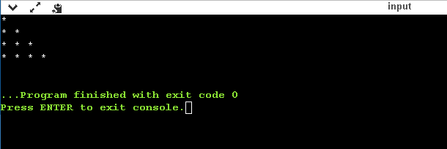

18. To Display pattern below
1
1 2
1 2 3
1 2 3 4

#include<stdio.h>
int main()
{
int a, i;
for(a = 1;a < 5;a++)
{
for(i = 1;i <= a;i++)
{
printf("%d", i);
}
printf("\n");
}
return 0;
}

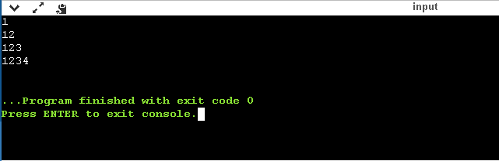

19. To Display Following Pattern
****
***
**
*
#include<stdio.h>
int main()
{
int i, j, k;
for(i=4;i>=1;i--)
{
for(j=4;j>i;j--)
{
printf(" ");
}
for(k=1;k<=i;k++)
{
printf("*");
}
printf("\n");
}
return 0;
}

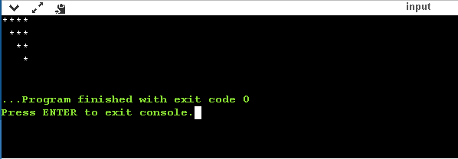

20. To Input an alphabet and check it is vowel or not.

#include <stdio.h>
int main()
{
char ch;
int lowercase_Vowel, uppercase_Vowel;

printf("Enter an alphabet: \n");
scanf(" %c", &ch);

lowercase_Vowel = (ch == 'a' || ch == 'e' || ch == 'i' || ch == 'o' || ch == 'u');
uppercase_Vowel = (ch == 'A' || ch == 'E' || ch == 'I' || ch == 'O' || ch == 'U');

if (lowercase_Vowel || uppercase_Vowel) {
printf("\n %c is a VOWEL.", ch);
}
else {
printf("\n %c is NOT a VOWEL.", ch);
}
return 0;
}

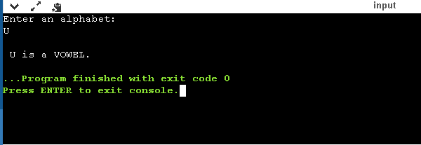

21. To Design a Calculator.

#include<stdio.h>
int main() {
char op;
double first, second;
printf("Enter any operator (+, -, *, /): ");
scanf("%c", &op);
printf("Enter two Numbers: ");
scanf("%lf %lf", &first, &second);

switch (op) {
case '+':
printf("%.1lf + %.1lf = %.1lf", first, second, first + second);
break;
case '-':
printf("%.1lf - %.1lf = %.1lf", first, second, first - second);
break;
case '*':
printf("%.1lf * %.1lf = %.1lf", first, second, first * second);
break;
case '/':
printf("%.1lf / %.1lf = %.1lf", first, second, first / second);
break;
// operator doesn't match any case constant
default:
printf("Error! operator is not correct, TRY AGAIN");
}

return 0;
}

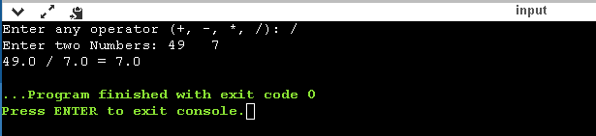

22. To Write a program Input the marks and print the remarks.

#include<stdio.h>
int main()
{
int physics, chemistry, english, mathematics, computer;
float per;
/* Input marks of five subjects from user */
printf("Enter marks of each subject : ");
scanf("%d%d%d%d%d", &physics, &chemistry, &english, &mathematics, &computer);
/* Calculate percentage */
per = (physics + chemistry + english + mathematics + computer) / 5.0;
printf("Percentage = %.2f\n", per);
/* Find grade according to the percentage */
if(per >= 90)
printf("Grade A");
else if(per >= 80)
printf("Grade B");
else if(per >= 70)
printf("Grade C");
else if(per >= 60)
printf("Grade D");
else if(per >= 40)
printf("Grade E");
else
printf("Grade F");
return 0;
}

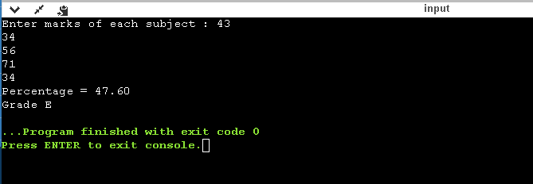

23. Write a program enter three number and find Largest among 3 numbers

#include<stdio.h>
int main() {
double n1, n2, n3;
printf("Enter any three different numbers: ");
scanf("%lf %lf %lf", &n1, &n2, &n3);

// if n1 is greater than both n2 and n3, n1 is the largest
if (n1 >= n2 && n1 >= n3)
printf("%.2f is the largest number.", n1);

// if n2 is greater than both n1 and n3, n2 is the largest
if (n2 >= n1 && n2 >= n3)
printf("%.2f is the largest number.", n2);

// if n3 is greater than both n1 and n2, n3 is the largest
if (n3 >= n1 && n3 >= n2)
printf("%.2f is the largest number.", n3);

return 0;
}

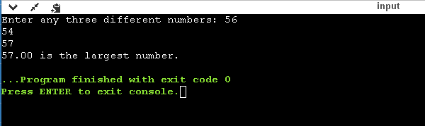

24. To Write a program to find Average of the elements of an array.

#include<stdio.h>
int main() {
int n, i;
float num[100], sum = 0.0, avg;

printf("Enter the numbers of elements: ");
scanf("%d", &n);

while (n > 100 || n < 1) {
printf("Error! number should in range of (1 to 100).\n");
printf("Enter the number again-: ");
scanf("%d", &n);
}

for (i = 0; i < n; ++i) {
printf("%d. Enter any number-: ", i + 1);
scanf("%f", &num[i]);
sum += num[i];
}

avg = sum / n;
printf("The Average of given numbers is = %.2f", avg);
return 0;
}

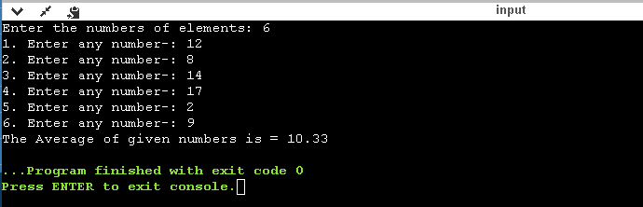

25. To Write a program to find Largest element of an array.

#include<stdio.h>
int main() {
int n;
double arr[100];
printf("Enter the number of elements (1 to 100):- ");
scanf("%d", &n);

for (int i = 0; i < n; ++i) {
printf("Enter number%d: ", i + 1);
scanf("%lf", &arr[i]);
}

// storing the largest number to arr[0]
for (int i = 1; i < n; ++i) {
if (arr[0] < arr[i]) {
arr[0] = arr[i];
}
}

printf("Largest element = %.2lf", arr[0]);

return 0;
}

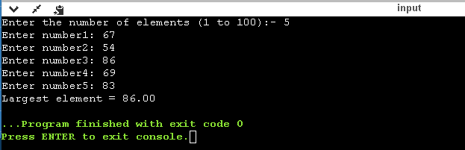

26. To Write a program for Linear search

#include<stdio.h>
int main()
{
int array[100], search, c, n;

printf("Enter number of elements in array\n");
scanf("%d", &n);

printf("Enter %d integer(s)\n", n);

for (c = 0; c < n; c++)
scanf("%d", &array[c]);

printf("Enter a number you want to search\n");
scanf("%d", &search);

for (c = 0; c < n; c++)
{
if (array[c] == search) /* If required element is found */
{
printf("%d is present at location %d.\n", search, c+1);
break;
}
}
if (c == n)
printf("%d isn't present in the array provided.\n", search);

return 0;
}

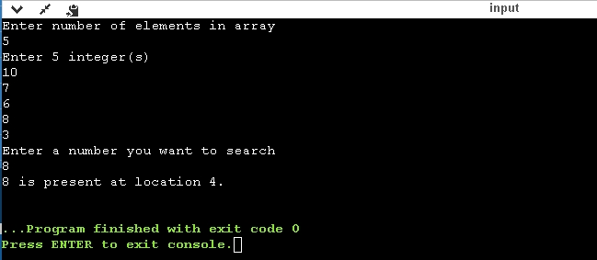

27. To Write a program input two array and Merge

#include<stdio.h>
int main()
{
int n1, n2, n3, i, j;
printf("\n Enter the number of elements for First Array : ");
scanf("%d", &n1); //Array Size Declaration
int a[n1]; //Array Declaration
printf("\nEnter the elements for First Array : ");
for(i = 0; i < n1; i++)
scanf("%d", &a[i]);
printf("\n Enter the number of elements for Second Array : ");
scanf("%d", &n2); //Array Size Declaration
int b[n2]; //Array Declaration
printf("\nEnter the elements for Second Array : ");
for(i = 0; i < n2; i++)
scanf("%d", &b[i]);
n3 = n1 + n2; //Array Size Declaration
int c[n3]; //Array Declaration
for(i = 0; i < n1; i++)
c[i] = a[i];
for(i = 0, j = n1; j < n3 && i < n2; i++, j++)
c[j] = b[i];
printf("\n a[%d] Array Elements After Merging \n", n3);
for(i = 0; i < n3; i++)
printf(" %d \t ",c[i]);
return 0;
}

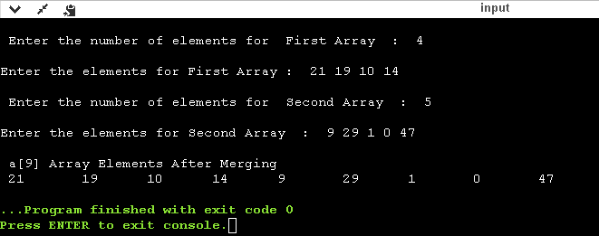

28. Write a program of Selection sort

#include<stdio.h>
int main()
{
int t,n,ele;
int a[100];
printf("Number of elements you want to enter: ");
scanf("%d",&n);
printf("enter elements: ");
for(int i=0;i<n;i++)
{scanf("%d",&ele);
a[i]=ele;
}
for (int i = 0; i < n; i++)
{
for (int j = i + 1; j < n; j++)
{
if (a[j] < a[i])
{
t = a[i];
a[i] = a[j];
a[j] = t;
}
}
}
printf("\nSorted elements{Ascending Order}: ");
for (int i = 0; i < n; i++)
{
printf(" %d", a[i]);}
}
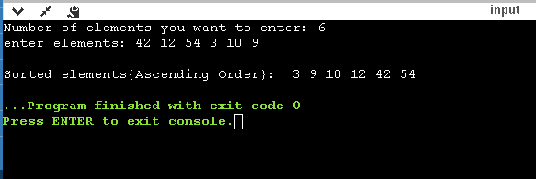

29. To Write a program Bubble sort

#include<stdio.h>
int main()
{
int t,n,ele,x=0,y=1,chk=0,cnt=0;;
int a[100];
printf("Numbers of Elements you want to Enter: ");
scanf("%d",&n);
printf("Enter Elements: ");
for(int i=0;i<n;i++)
{scanf("%d",&ele);
a[i]=ele;
}
while(chk==0)
{
for(int i=0;i<n-1;i++)
{
if(a[i+1]<a[i])
{
t=a[i];
a[i]=a[i+1];
a[i+1]=t;
}else{cnt++;}
}
if(cnt==n-1)
{chk=1;}
else{cnt=0;}
}
for(int i=0;i<n;i++)
{printf("%d ",a[i]);}
}

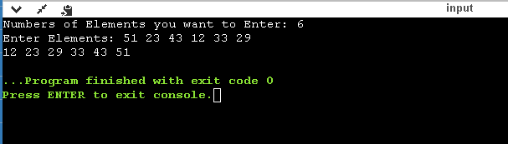

30. Write a program Insertion sort

#include<stdio.h>
void InsertionSort(int a[], int n)
{
int j, p;
int tmp;
for(p = 1; p < n; p++)
{
tmp = a[p];
for(j = p; j > 0 && a[j-1] > tmp; j--)
a[j] = a[j-1];
a[j] = tmp;
}
}

int main()
{
int i, n, a[10];
printf("Enter the number of elements :: ");
scanf("%d",&n);
printf("Enter the elements :: ");
for(i = 0; i < n; i++)
{
scanf("%d",&a[i]);
}
InsertionSort(a,n);
printf("The sorted elements are :: ");
for(i = 0; i < n; i++)
printf("%d ",a[i]);
printf("\n");
return 0;
}

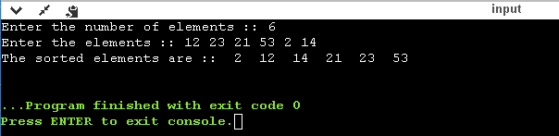
31. To Write a program for Binary search
#include<stdio.h>
#include<conio.h>
int main()
{
int t,n,ele;
int a[100];
printf("Numbers of elements You want to Enter: ");
scanf("%d",&n);
printf("Enter Elements: ");
for(int i=0;i<n;i++)
{scanf("%d",&ele);
a[i]=ele;}
for(int i=0;i<n;i++)
{
for(int j=i;j>=-1;j--)
{
if(j==-1)
{
t=a[i];
for(int k=i;k>j+1;k--)
{
a[k]=a[k-1];
}
a[j+1]=t;
break;
}
else{if(a[i]>a[j])
{
t=a[i];
for(int k=i;k>j;k--)
{
a[k]=a[k-1];
}
a[j+1]=t;
break;
}}
}
}
printf("\nSorted Array: ");
for(int i=0;i<n;i++){printf("%d ",a[i]);}
}
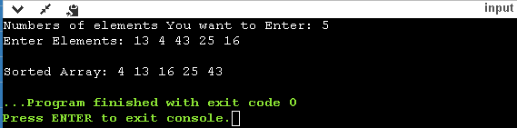

32 . To Write a program for Sum of two matrices

#include<stdio.h>
int main()
{
int m, n, c, d, first[10][10], second[10][10], sum[10][10];

printf("Enter the number of rows and columns of matrix\n");
scanf("%d%d", &m, &n);
printf("Enter the elements of first matrix in order a11,a12,a13,a21,a22,a23,a31,a32,a33\n");

for (c = 0; c < m; c++)
for (d = 0; d < n; d++)
scanf("%d", &first[c][d]);

printf("Enter the elements of second matrix in same order\n");

for (c = 0; c < m; c++)
for (d = 0 ; d < n; d++)
scanf("%d", &second[c][d]);

printf("Result {Added Matrix}:-\n");

for (c = 0; c < m; c++) {
for (d = 0 ; d < n; d++) {
sum[c][d] = first[c][d] + second[c][d];
printf("%d\t", sum[c][d]);
}
printf("\n");
}
return 0;
}
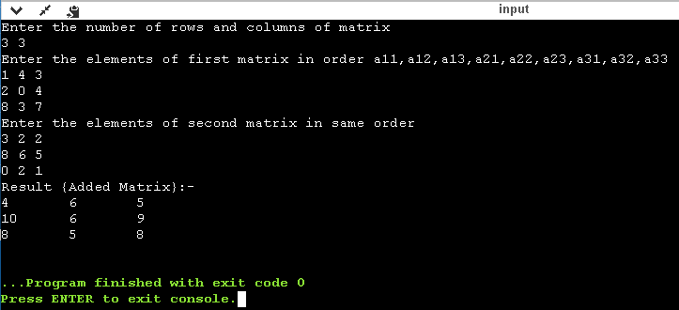

33. To Write a program for Product of two matrices

#include<stdio.h>
#include<stdlib.h>
int main(){
int a[10][10],b[10][10],mul[10][10],r,c,i,j,k;
printf("Enter the number of rows=");
scanf("%d",&r);
printf("Enter the number of columns=");
scanf("%d",&c);
printf("Enter the first matrix elements in order a11,a12,a13,a21,a22,a23,a31,a32,a33=\n");
for(i=0;i<r;i++)
{
for(j=0;j<c;j++)
{
scanf("%d",&a[i][j]);
}
}
printf("Enter the second matrix element in same order=\n");
for(i=0;i<r;i++)
{
for(j=0;j<c;j++)
{
scanf("%d",&b[i][j]);
}
}

printf("Multiplication of the matrix{Result}=\n");
for(i=0;i<r;i++)
{
for(j=0;j<c;j++)
{
mul[i][j]=0;
for(k=0;k<c;k++)
{
mul[i][j]+=a[i][k]*b[k][j];
}
}
}
//for printing result
for(i=0;i<r;i++)
{
for(j=0;j<c;j++)
{
printf("%d\t",mul[i][j]);
}
printf("\n");
}
return 0;
}

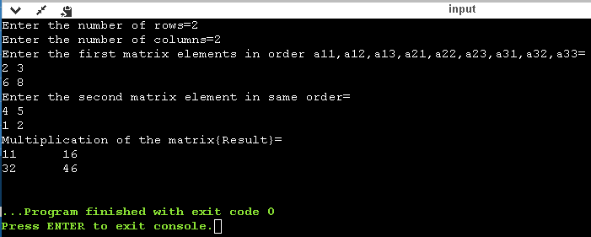

34. To Write a program for Transpose of a matrix

#include<stdio.h>

int main()
{
int m, n, c, d, matrix[10][10], transpose[10][10];

printf("Enter the number of rows and columns of matrix\n");
scanf("%d%d", &m, &n);
printf("Enter elements of the matrix in order a11,a12,a13,a21,a22,a23,a31,a32,a33\n");

for (c = 0; c < m; c++)
for (d = 0; d < n; d++)
scanf("%d", &matrix[c][d]);

for (c = 0; c < m; c++)
for (d = 0; d < n; d++)
transpose[d][c] = matrix[c][d];

printf("Transpose of the matrix:\n");

for (c = 0; c < n; c++) {
for (d = 0; d < m; d++)
printf("%d\t", transpose[c][d]);
printf("\n");
}

return 0;
}

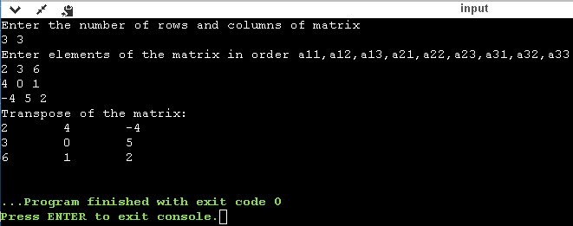

35. To Write a program for Sum of two numbers using functions

#include<stdio.h>
int add(int, int);
int main()
{
int a, b;

printf("Enter 2 integer numbers\n");
scanf("%d%d", &a, &b);

//function call add(a, b);
printf("%d + %d = %d\n", a, b, add(a, b));

return 0;
}

//function definition
int add(int x, int y)
{
return(x+y);
}

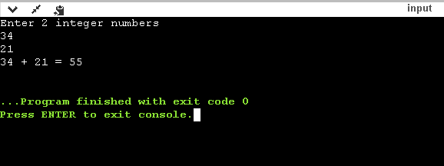

36. Write a program to Swap two numbers using functions

#include<stdio.h>

void swap(int *,int *);
int main()
{

int n1,n2;
printf("\n\n Function : Swapping two numbers using function :\n");
printf("------------------------------------------------\n");
printf("Input 1st number : ");
scanf("%d",&n1);
printf("Input 2nd number : ");
scanf("%d",&n2);

printf("Before Swapping: n1 = %d, n2 = %d ",n1,n2);
//pass the address of both variables to the function.
swap(&n1,&n2);

printf("\nAfter Swapping: n1 = %d, n2 = %d \n\n",n1,n2);
return 0;
}

void swap(int *p,int *q)
{
//so *p store the value of n1
//so *q store the value of n2

int tmp;
tmp = *p; // tmp store the value of n1
*p=*q; // *p store the value of *q that is value of n2
*q=tmp; // *q store the value of tmp that is the value of n1
}

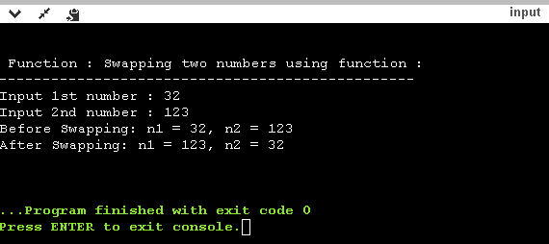

37. Write a program for Armstrong number using function

#include<stdio.h>
int isArmstrong(int number)
{
// declare variables
int lastDigit = 0;
int power = 0;
int sum = 0;

// temporary variable to store number
int n = number;

while(n!=0) {
// find last digit
lastDigit = n % 10;
// find power of digit (order = 3)
power = lastDigit*lastDigit*lastDigit;
// add power value into sum
sum += power;
// remove last digit
n /= 10;
}
if(sum == number) return 0;
else return 1;
}
int main()
{
int number;
printf("Enter number: ");
scanf("%d",&number);

if(isArmstrong(number) == 0)
printf("%d is an Armstrong number.\n", number);
else
printf("%d is not an Armstrong number.", number);
return 0;
}

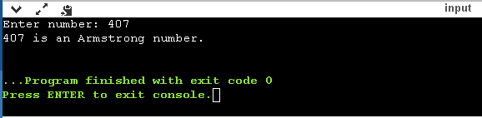

38. Write a program for Adding two number using call by reference

#include<stdio.h>
long addTwoNumbers(long *, long *);

int main()
{
long fno, sno, sum;

printf("\n\n Pointer : Adding two numbers using call by reference:\n");
printf("-------------------------------------------------------\n");

printf(" Input the first number : ");
scanf("%ld", &fno);
printf(" Input the second number : ");
scanf("%ld", &sno);
sum = addTwoNumbers(&fno, &sno);
printf(" The sum of %ld and %ld is %ld\n\n", fno, sno, sum);
return 0;
}
long addTwoNumbers(long *n1, long *n2)
{
long sum;
sum = *n1 + *n2;
return sum;
}

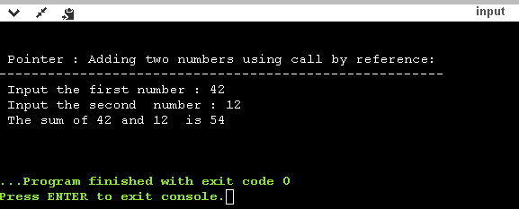

39. Write a program to Swap two numbers using call by reference

#include<stdio.h>

void swap(int*, int*);

int main()
{
int A, B;

printf("Enter Two Numbers A and B:\n");
scanf("%d%d",&A,&B);

printf("Before Swapping:\nA = %d\nB = %d\n", A, B);

swap(&A, &B);

printf("After Swapping:\nA = %d\nB = %d\n", A, B);

return 0;
}

void swap(int *a, int *b)
{
int temp;

temp = *b;
*b = *a;
*a = temp;
}

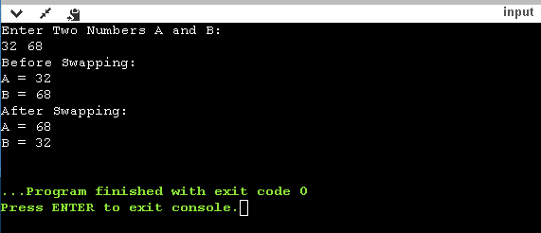

40. Write a program for Sum of digits of a number using function

/* sun of digits of a number using recursion*/
#include<stdio.h>
int sum(int,int );
int main()
{
int n,s=0;
printf("\n Enter the number: ");
scanf("%d",&n);
printf("\n Sum of digits of given number = %d",sum(n,s));
return 0;

}
int sum(int n,int s)
{
int i,k;
k=n%10;
i=n/10;
s=s+k;
if(i!=0)
sum(i,s);
else
return s;
}

