Proof of Appearance: The British Art Prize exhibition
Exhibition: The British Art Prize 2025 Exhibition
Location: gallery@oxo, Oxo Tower Wharf, London, SE1 9PH
Dates: 26th November to 30th November
Nature of Selection: Curated selection by Jury Adebanji Alade, Alvaro Castagnet, Dr Amy Orrock, Tiffany Panter, Niki Browes

Proof of Exhibition
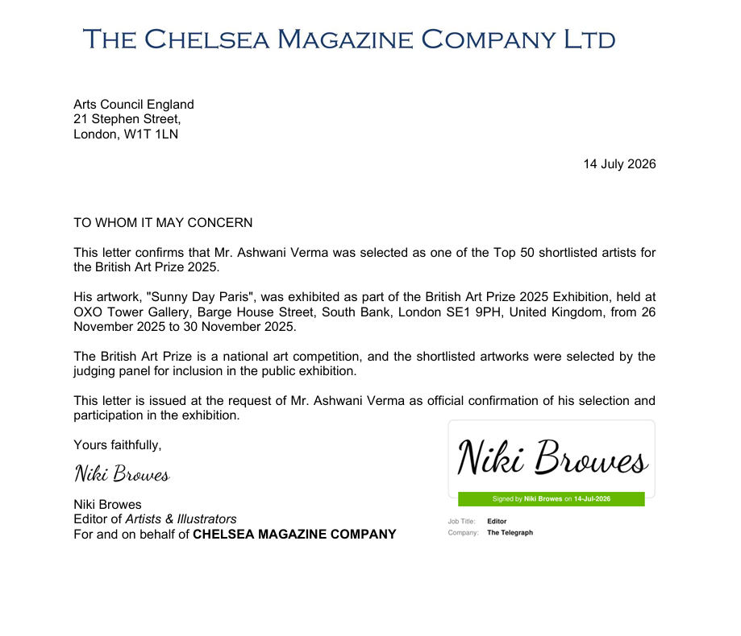

Event Poster and Photo taken at Oxo Gallery

