Proof of Appearance : The Base Greenham Exhibition
​​Exhibition Details:
- ​Artwork: Sunny Day in Manhattan (Painting)
- ​Venue: The Base, Greenham Business Park, RG19 6HN
- ​Dates: 13 September 2025 – 27 September 2025
- ​Status: Shortlisted Artist (Curated Selection)

Supporting Document
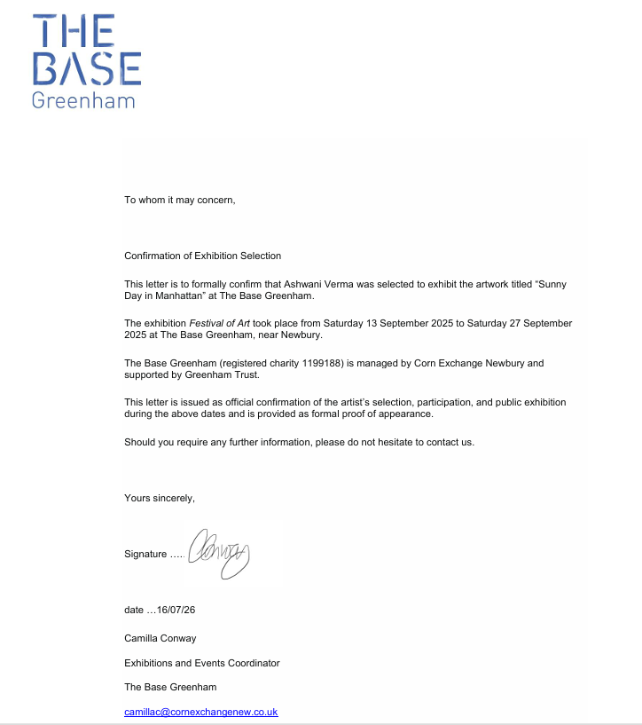
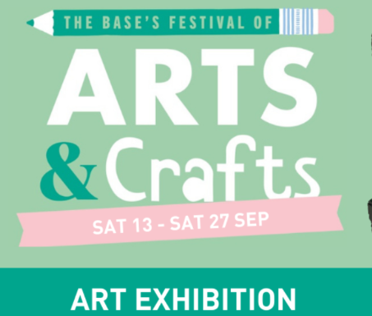
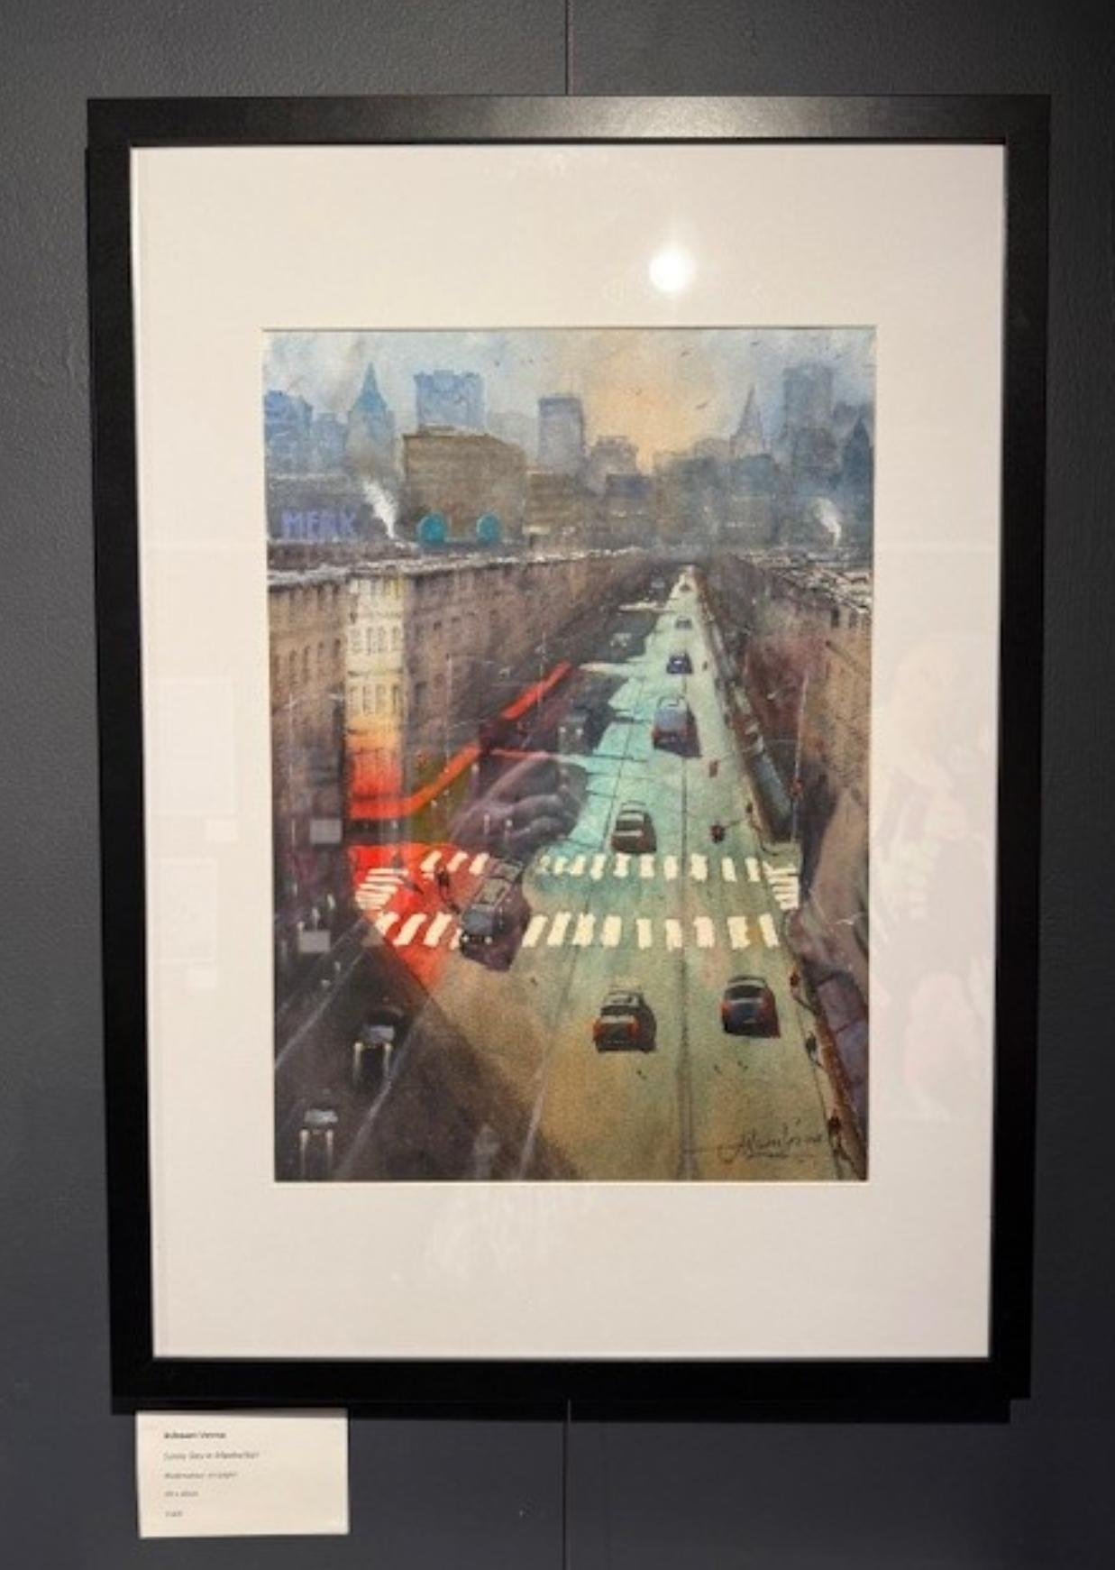
​Attached Evidence and Poster Listing Event.

