Proof of Appearance: Confirmation of my participation in the Woodley & Earley Art Group exhibition

Exhibition: Woodley and Early Art Group Autumn Exhibition
Location: Oakwood Centre, Headley Road, Woodley
Dates: 18th-19th October 2024
Stewarding: 18th October, 2024

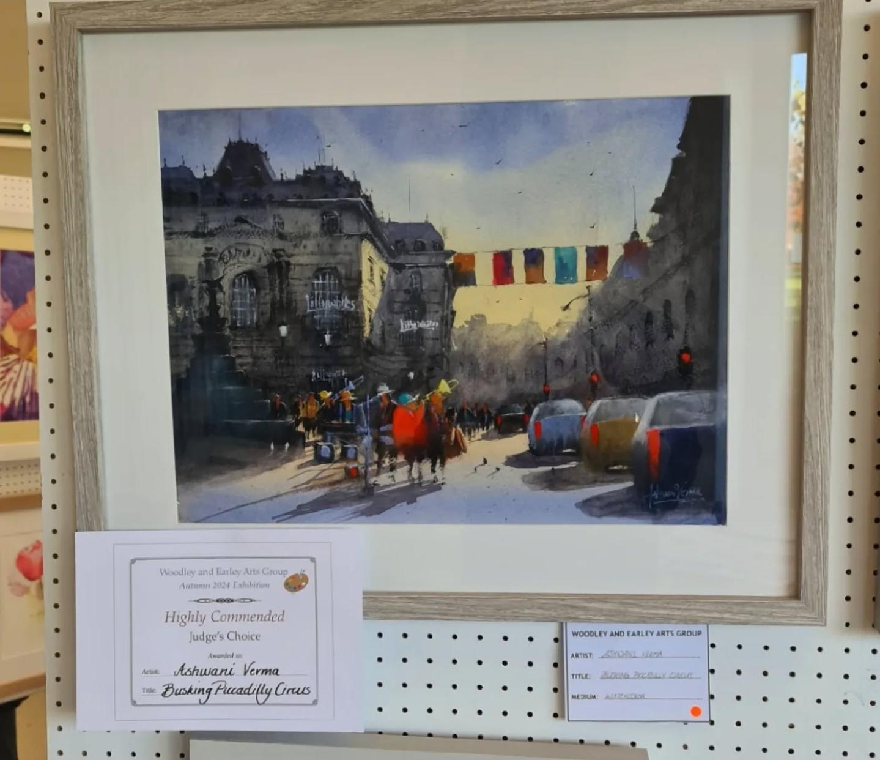
Poster Listing Detail of Exhibition and my painting awarded by Judges with the label of Woodley & Earley Art Group saying Highly Recommended.

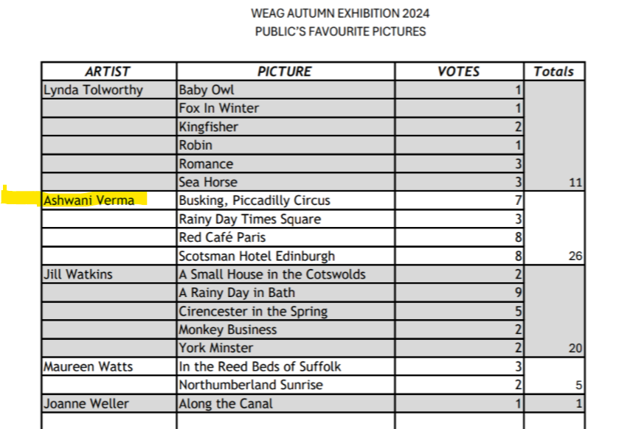
List of Artists with paintings and their counts of public vote for best painting in shows by PUBLIC VOTEs one of the categories of award apart from awards by Judges.
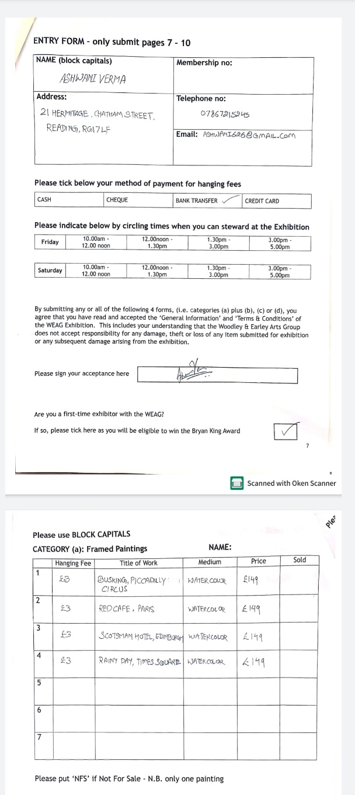
Supporting Document Entry form for WEAG

