Evidence of International Award Nomination for British Art Prize 2025
Date: 25th November 2025
Awarding Body: Artists & Illustrators Magazine
Nature of Selection: Curated selection by internation jury of 5 members
Judging Panel: Adebanji Alade: President of the Royal Institute of Oil Painters, Alvaro
Castagnet: Award-winning master artist, Dr. Amy Orrock: Curator and Art Historian, Tiffany Hall: Co-founder of Panter & Hall gallery, Niki Browes: Editor of Artists & Illustrators
The British Art Prize is an international competition conducted by Artists & Illustrators, the UK’s longest-running publication for the visual arts. It provides significant national exposure, a £10,000 prize fund, and London gallery exhibitions for shortlisted artists.
My painting Sunny Day Paris was shortlisted/Nominated against 2900 entries for British Art Prize 2025
Official Confirmation from Parker Harris, renowned agency which organize these events in UK.
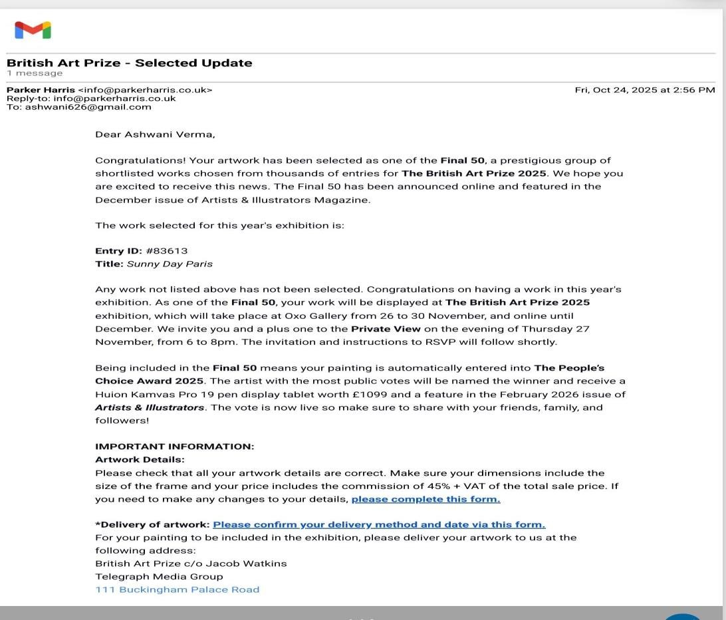
Official Confirmation on ArtOpps platform shows my painting was selected for British Art Prize Top 50.

