RICHARD YOUNG
Professional Artist | Founder & Director, RYoung Gallery
PROFESSIONAL PROFILE
Richard Young is a British professional artist and Founder & Director of RYoung Gallery, an independent contemporary gallery in Wokingham, Berkshire. With over 20 years of professional artistic practice, he works exclusively with palette knives to create contemporary realist oil paintings recognised for dramatic light, atmosphere and expressive compositions. Through RYoung Gallery he exhibits his own work, represents established and emerging artists, curates exhibitions, and provides publishing and framing services. His work has been exhibited internationally across the United Kingdom, Europe, Asia and North America and recognised through exhibitions, awards and publications.

PROFESSIONAL EXPERIENCE
- Founder & Director – RYoung Gallery, Wokingham, Berkshire
- Professional Artist (20+ years)
- Former Engineering & Design Consultant with international management experience
EDUCATION
- Engineering HNC (Distinction)
- Art A Level
SELECTED EXHIBITIONS
- May 2024 – Landmark Art Fair, UK
- October 2023 – Surrey Contemporary Art Fair, UK
- November 2022 – Windsor Contemporary Art Fair, UK
- May 2022 – ART, World Trade Centre, Taipei, Taiwan
- July 2021 – Newbury Contemporary Art Fair, UK
- March 2020 – Affordable Art Fair, London, UK
- July 2019 – La Galleria Pall Mall, London, UK
- August 2018 – X-Power Gallery, Taichung, Taiwan
- May 2018 – ART, World Trade Centre, Taipei, Taiwan
- May 2017 – Burton Art Gallery, Devon, UK
- June 2016 – Patchings Art Centre, Nottingham, UK
- May 2015 – ART, World Trade Centre, Taipei, Taiwan
- May 2013 – ART, World Trade Centre, Taipei, Taiwan
- March 2012 – ART, World Trade Centre, Taipei, Taiwan
SELECTED AWARDS
- Visual Art Open Competition – Finalist
- Art in the City Open Competition – Finalist
- Artavita Excellence Awards
- Fine Art Trade Guild Awards – Finalist
- RedBubble – Best in Show & 1st Place
- Aesthetica Creative Works Competition – Finalist
SELECTED PUBLICATIONS
- Art Reveal Magazine
- Superior Magazine
- Berkshire Life Magazine
- Art & Museums
- Aesthetica Creative Works Annual
- International Art Treasures
- JADE Magazine
PROFESSIONAL MEMBERSHIP
- Design and Artists Copyright Society (DACS)

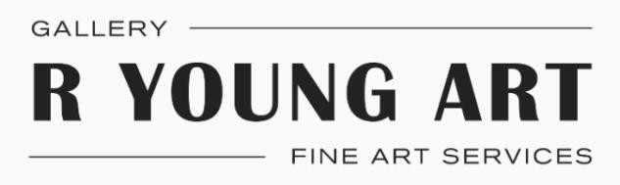
RYoung Art
1 Southgate House
Alexandra Court
Denmark Street
Wokingham RG40 2SL
10 July 2026

Letter of Recommendation
To Whom It May Concern,

It is my pleasure to provide my strongest recommendation in support of Mr. Ashwani Verma's application for endorsement under the Global Talent Visa (Exceptional Promise) – Visual Arts route.

I first became acquainted with Ashwani's work in 2023 when I was introduced to his watercolour cityscape paintings. As Founder and Director of RYoung Gallery, I review many artists for exhibition and representation. I was so impressed by his knowledge of watercolor medium, work and capturing the atmosphere of British Architecture, so I decided to represent Ashwani in my gallery in Wokingham. I personally selected Ashwani's paintings because of their originality, technical excellence and commercial potential. Three of those paintings were sold through RYoung Gallery. I also witnessed visitors and collectors engaging deeply with the stories behind his paintings, particularly his interpretation of British architecture and urban landscapes. His work creates a genuine emotional connection with audiences.

I have seen his professional profile continue to grow in UK through curated selection and independent recognition. His selection for the many art societies and exhibition, his international level recognition in British Art Prize competition, I was equally impressed when he was awarded highly commended for his work Piccadilly Circus in Woodley and Early Autumn exhibitions and 2nd prize for his work Aerial View Paris in Rotary Club Reading by panel of 3 judges, his featured work for many magazines like Artist and Illustrator and Artist Talk Magazine, and recognition in the Henley Standard newspaper, demonstrate an artist whose reputation continues to grow within the UK.

Since discovering Ashwani, we identified him as valuable asset and we personally invited him to the Wokingham Plein Air competition and exhibition organized by my gallery this year, so he can participate and interact with art lovers and guide them.
I am also planning and discussing in person meeting with Ashwani to produce more paintings of British architecture for my gallery. I also would like to work with Ashwani to run plein air sessions, run watercolor workshops to attract more people to our gallery and to learn art. We definitely need Ashwani to reside here in UK as his understanding of watercolor medium, creative approach would make him invaluable addition to UK.

He will make a valuable contribution to UK cultural life by sharing his knowledge through exhibitions, demonstrations, workshops, plein air painting sessions while encouraging greater appreciation of British architecture through his watercolour paintings. I have seen personally how audience connects with his paintings of cityscapes scenes and wants to learn his style of painting.

I strongly support Ashwani Verma’s application for a Global Talent Visa will full recognition of his exceptional talent and knowledge.

Sincerely,

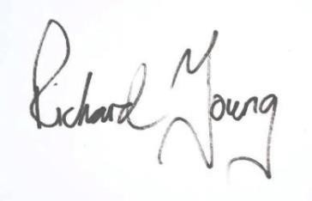
Richard Young
07813 138680 richard@ryoungart.com www.ryoung-art.com

