For sentiment analysis the sentence subjective and polarity is shown in the below graphs:

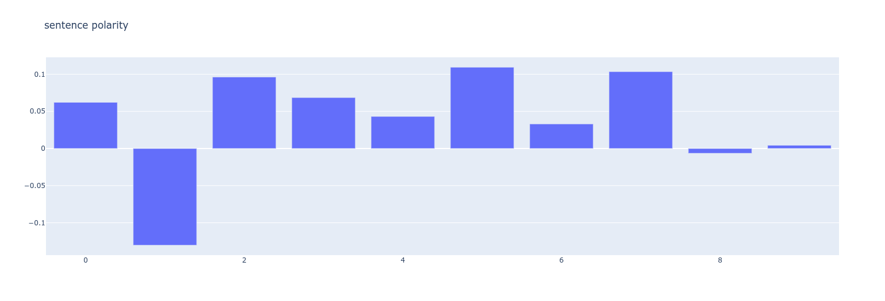

As we can see above some articles are positive and some are nehgative but none of them looks to be neutral as we have not got 0 score of polarity.

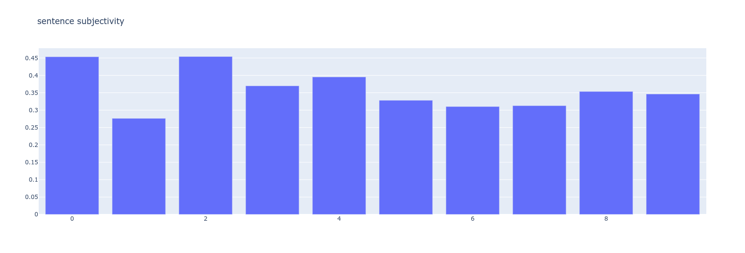

The value of subjectivity is nearly same for all the articles, only the first and third one looks to be more sujective than others.