**Unity ML-Agents** **– Reinforcement Learning**

## **1. Summary**

In the project, I started off by doing a **Hummingbird** tutorial from Unity-Learn to get an idea about ML-Agents, reinforcement learning, and training a model. Simultaneously, I explored the Unity Editor and tried out building the entire scene. While training the bird’s model, I understood a lot about hyperparameters which I then tweaked and tuned to try out new models, the trial and testing sometimes gave me horrible results making me realize how much a change in a parameter could affect the performance of a model.

Once I was through the tutorial and had a basic understanding of how ML-Agents work, I decided to build another game and empower it with ML-Agents. I chose **Air Hockey** where I wrote my own observations and change the config file to train the model in such a way that it performs best. It didn't work out great at the beginning, then I added more observations, rewards, made some code changes, and provided a scoring UI to finally create an amazing ML-Agent that was smart enough to never let me win!!

## **2. Getting Started**

You can create a new project, or you can use the existing project to empower your game components with ML-Agents.

**2.1 Installation**

1. Go to the package manager and install the ‘Ml Agents’ to your Unity Project.
2. Install python or conda (to manage different python versions) -[python](https://www.python.org/downloads/), [conda](https://docs.conda.io/projects/conda/en/latest/user-guide/install/)
3. If using conda, create the conda environment with the following command in the terminal  
    conda create -n <environment name> python=<python version>
4. If using conda, to list the existing environment  
    conda env list
5. If using conda, activate the created environment  
   conda activate <environment name>
6. Install python’s ML Agent module  
    pip install mlagents

**2.2 Training**

To get started with the training, refer to this detailed official Unity documentation which can be found at [Unity ml-agents](https://github.com/Unity-Technologies/ml-agents/tree/master/docs).

**2.3 Workflow**

The workflow of ML-Agents has 3 main components:

* Agent - The agents will be our main players, characters, or something that will be performing a task by taking various actions. The agent actions will be driven by the machine learning algorithm and not any input from the user.
* Brain - Brains are the actual core component that perceives the environment and decides the actions that should be performed by the agents. One brain can control one or more agents. There can be multiple brains controlling multiple agents in an environment. Usually, similar agents would have a single brain controlling them whereas vastly different agents would be controlled by different brains.
* Academy - An academy object has all the brains in the environment as its child objects. There will only be a single academy per environment. An academy is used for configuration and settings like rendering quality or the timescale, resolution of the game.

And finally, the system uses a Python API to externally communicate with Tensorflow.

**2.4 Reinforcement Learning**

We are using ‘Reinforcement Learning’ to train the ML Agent where for every action the agent performs, there will be a certain reward associated with it which could be either positive or negative so that the ML-Agent trains in the right direction.

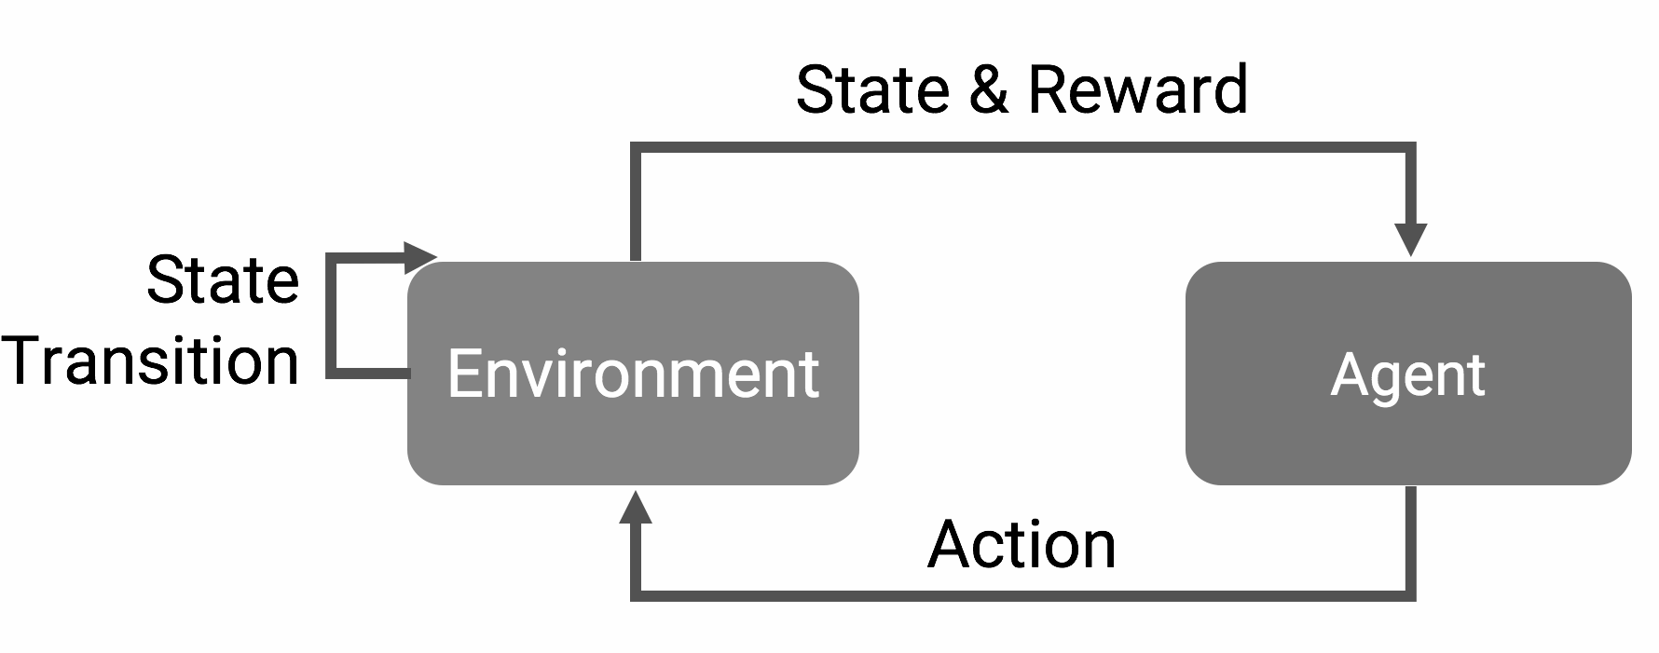

**Fig 1 - Reinforcement learning**

Typically if the action taken allows the agent to move closer to the goal or closer to completing a task, the agent will be positively rewarded and likewise, if the action taken is far off from task completion, then the agent is penalized. This reward system is called a reward function.

## **3. Projects**

## 

### **3.1 Hummingbird**

The idea behind the hummingbird project was to create intelligent flying hummingbirds that can navigate to flowers, dip their beaks in and drink nectar from the flower. While drinking nectar from the flower, initially the color of the flower is red and later turns to purple after the nectar has been consumed by the bird. We learned to craft a training environment, train the neural model in such a way that the birds learn to fly only towards the flowers, and drink the nectar from them. Towards the end, we created a mini game where we challenged the trained humming bird to play with us!

#### 3.1-1 Training

The training of our agent, i.e the hummingbird involved creating an environment and creating duplicates of it for it to train faster and give better results sooner.

The picture below shows the reward awarded to the bird while training:

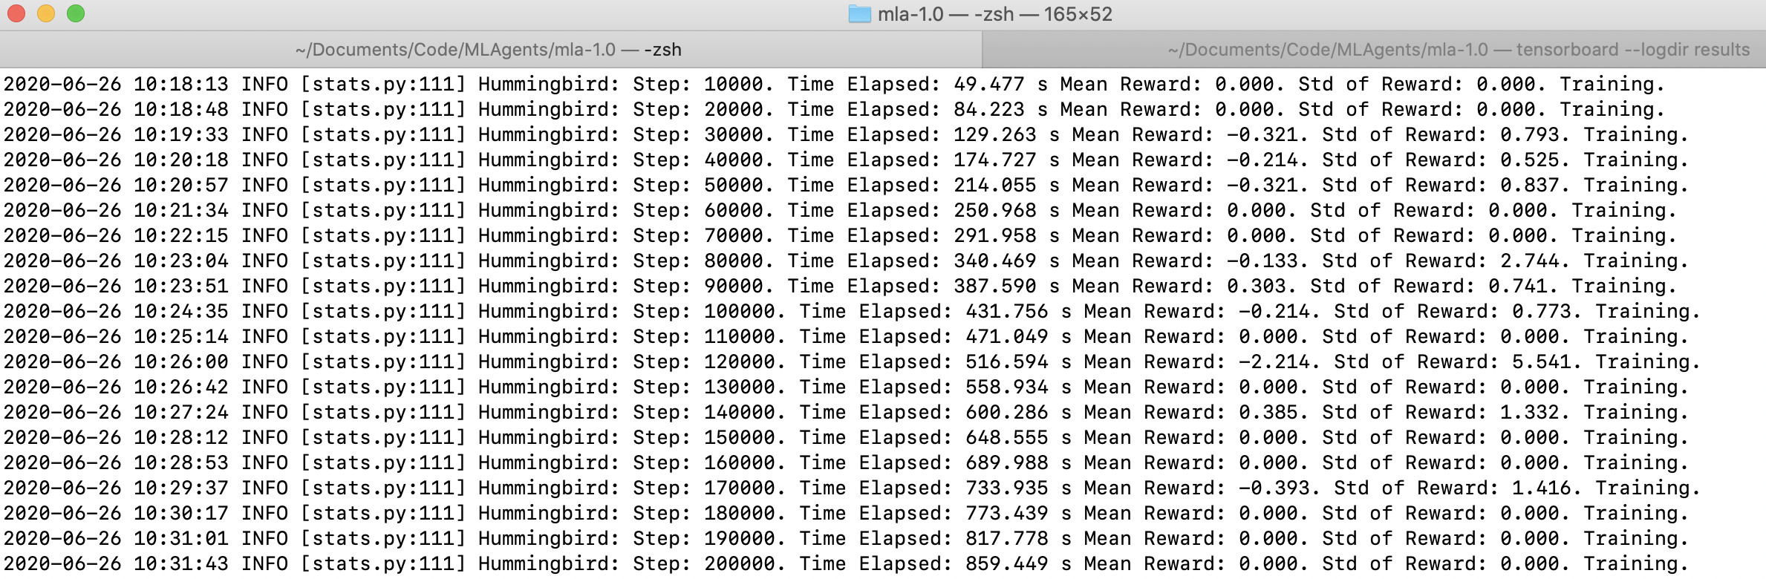

**Fig 2 - Humming Bird’s training results**

Initially, as you can see the hummingbird seems to be wandering around in the scene and therefore has received 0 reward. However, as the bird moves out of the boundary set in the environment or is around the tree (which is far from the flowers) it gets a negative reward. Slowly, as the bird comes closer to the flower, it begins to get positive reward and soon after multiple iterations, the bird learns to stay closer to the flowers and then gets the nectar from them.

Initial phase of the humming bird training - [Initial_Training.mp4](https://drive.google.com/file/d/12Be1V9St6C598hNSSZakjHw6pKN4VCAN/view?usp=sharing)

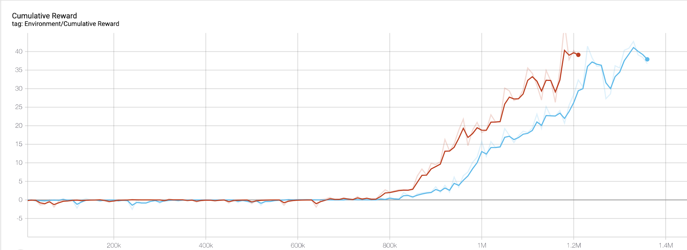

**Fig 3 - Humming Bird’s training results, Graphs showing the performance of 2 best-trained models, X-Axis represents the number of iterations, Y-Axis represents mean reward the humming bird earns**

#### 3.1-2 Implementation

Finally, after training a couple of models we noticed that the humming bird has learnt to drink nectar from the flower.

Refer to this video of the humming bird training well : [Training_well.mp4](https://drive.google.com/file/d/1rXNqsxIkozDhY-tv7VaAAbkMbPl2lBZ4/view?usp=sharing)

#### Initially, to test out the trained model, we played a match against the ML trained bird and the result was as follows:

First trained model: The bird wasn’t able to compete at all.

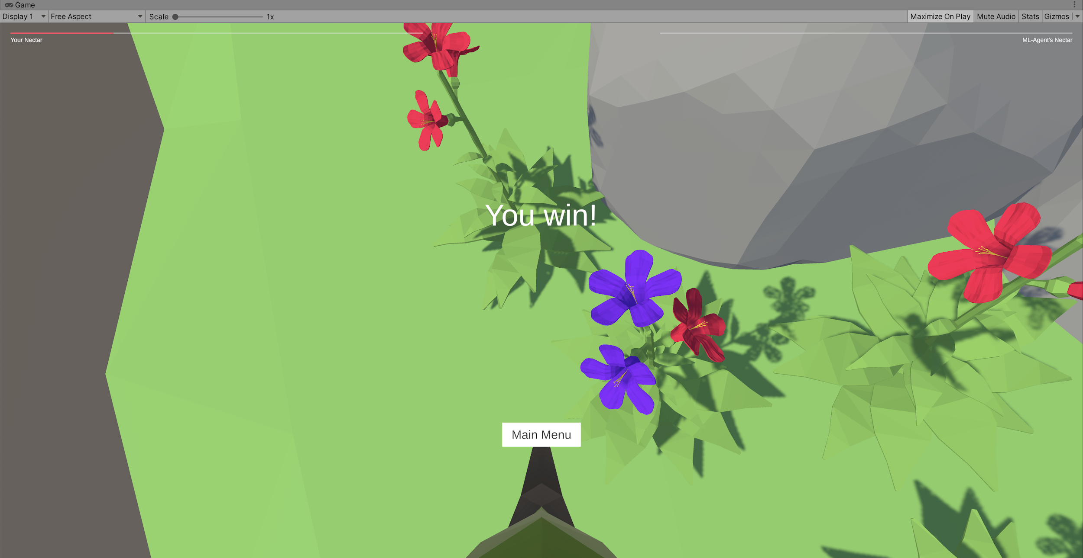

**Fig 4 - First trained model results**

Second trained model: The bird has learned and was able to drink nectar from the flower but we definitely were better.

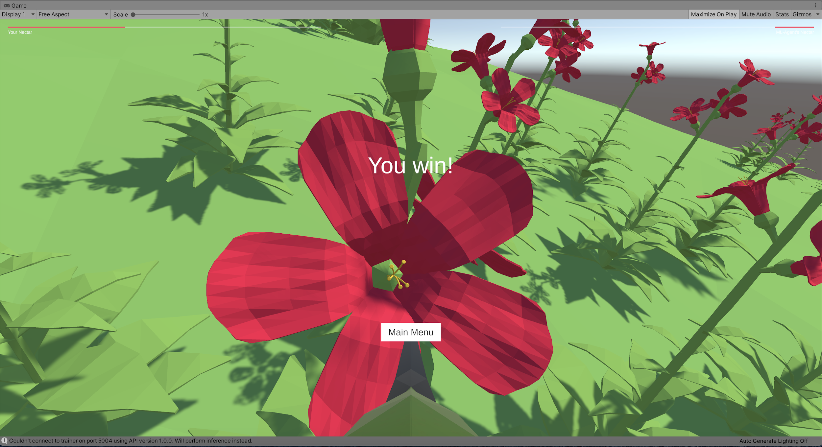

**Fig 5 - Second trained model results**

### **3.2 Air Hockey**

The goal was to apply the knowledge gained from the hummingbird tutorial to our own Air Hockey project. In this, we developed a game of Air Hockey which follows the old traditional rules as anyone would expect. We trained the air-hockey paddles by providing a set configuration so that it learns to score as well defend based on the opponent’s moves. In the end, we created a mini game where we challenged the trained ML Agent to play with us!

#### 3.2-1 Training

We started out by first training our player with just 5 observations for the air-hockey paddle, and then we later improved our observations making the observation count to 17 which got us the best possible results.

The Player observes these observations frame by frame as the game progresses. The 17 observations include:

1. Three 2d-vectors
   1. From Player’s air-hockey paddle to the puck
   2. From First Player’s air-hockey paddle to goal
   3. From second Player’s air-hockey paddle to goal
2. Five positions in a 2D plane
   1. Player’s air-hockey paddle
   2. Opponents air-hockey paddle
   3. Opponents goal
   4. Player’s own goal
   5. Puck’s position
3. One distance magnitude
   1. Player’s air-hockey paddle to the puck

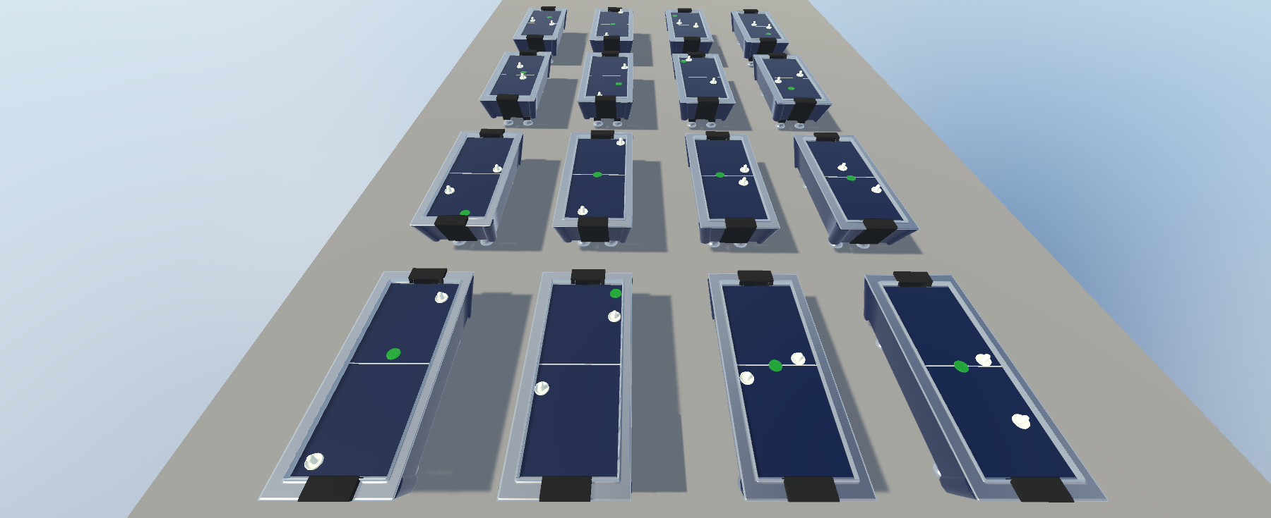

**Fig 6 - Training the Air Hockey model**

Based on these observations and the set configuration for the hyperparameters we trained our model and the following trend is observed.

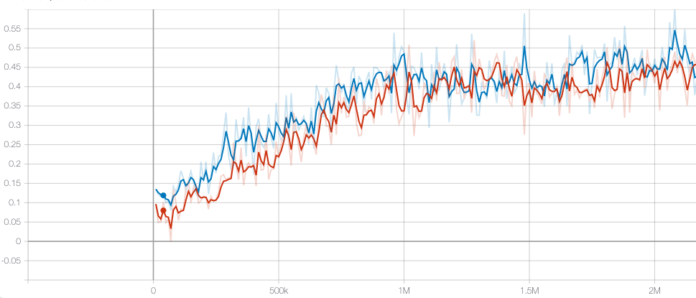

**Fig 7 - Air Hockey training results, the graph represents the mean reward of the Player’s air-hockey paddle in the y-axis and the number of iterations on the x-axis. The blue curve is for the first player and orange is for the second.**

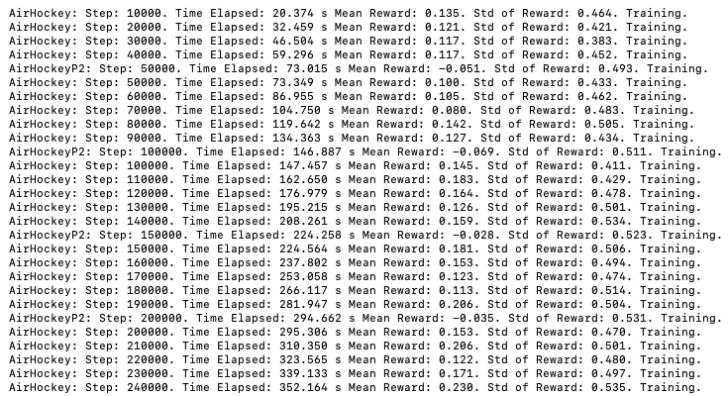

**Fig 8 - Air Hockey training results**

It is clearly visible from the trend that initially our model’s mean reward wasn’t very good and the player’s paddle was just moving randomly and were not able to score.

[Intitial_training_video](https://drive.google.com/file/d/1cuRIYUXA83Zm-nn3USId169jGtO02Y4s/view?usp=sharing)

But over the course of training and with the increase in the number of iterations our model learned to perform well. Players became more aggressive and started scoring more with each iteration. They started observing pucks position and based on the opponent’s paddle position they learned to defend their side too. A similar trend can also be seen in the training video.

[Training_over_time](https://drive.google.com/file/d/17SvftKe_EI__r0UauD3uLtlrOa38bzu2/view?usp=sharing)

#### 3.2-2 Implementation

After 2 days of training and lots of hyperparameter tweening, when our trained player started performing reasonably well, we decided to compete against it. We created a separate UI for the game and added a timer and a scoring mechanism to keep track of who’s winning.

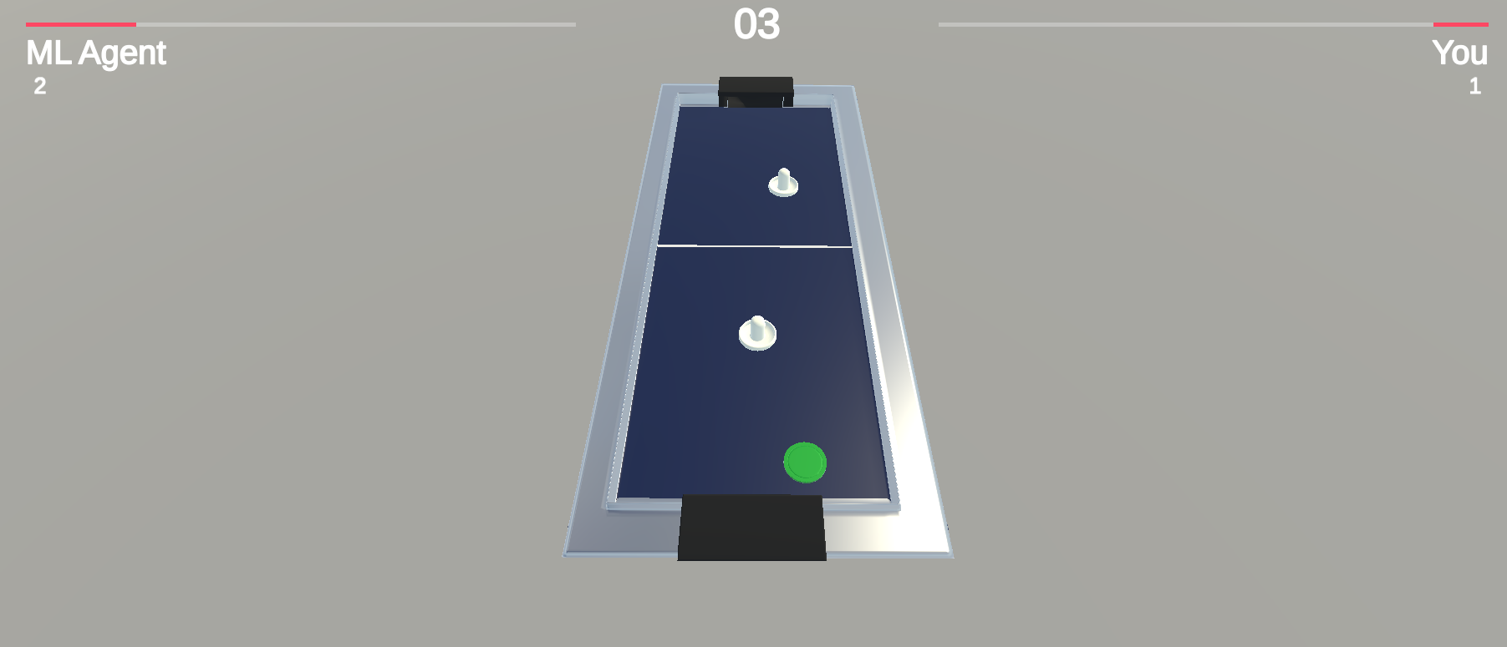

**Fig 9 - Ash vs ML-Agent**

Watch the nail-biting match against the superbly trained ML-Agent vs us here and to see who finally won! - [AirHockeyDemo.mp4](https://drive.google.com/file/d/1EDdhU2njD7nij0u1dVJguIU4xiKBgzuc/view?usp=sharing)

## **4. All Videos**

If you want to skip all the written stuff to the fun videos real quick, here you go:

Official Team video : [hw20-599-explore-ml-agents.MP4](https://drive.google.com/file/d/1PS18TBdYq-x-VODd_R1p8FeWTFzb_jXc/view)

### **4.1 Hummingbird**

* [Initial_Training.mp4](https://drive.google.com/file/d/12Be1V9St6C598hNSSZakjHw6pKN4VCAN/view?usp=sharing)
* [Training_well.mp4](https://drive.google.com/file/d/1rXNqsxIkozDhY-tv7VaAAbkMbPl2lBZ4/view?usp=sharing)

### **4.2 Air Hockey**

* [Intitial_training_video](https://drive.google.com/file/d/1cuRIYUXA83Zm-nn3USId169jGtO02Y4s/view?usp=sharing)
* [Training_over_time](https://drive.google.com/file/d/17SvftKe_EI__r0UauD3uLtlrOa38bzu2/view?usp=sharing)
* [AirHockeyDemo.mp4](https://drive.google.com/file/d/1EDdhU2njD7nij0u1dVJguIU4xiKBgzuc/view?usp=sharing)