ABES ENGINEERING COLLEGE, GHAZIABAD



Department of Electronics & Communication Engineering

Mini -Project report

on

DriveX

Submitted by

Ashwani Patel (2400320310049)

Bhumika Chaudhary (2400320310058)

Anuj Bansal (240320310038)

Anil Soni (2400320310027)

ACKNOWLEDGEMENT

We, express our sincere thanks to our supervisor, Mr. ......................... of ECE Department, ABES Engineering College, AKTU University for guiding us right from the inception till successful completion of the project. We would also like to thank our HOD Prof. (Dr.) Kimmi Verma for her valuable guidance and cooperation to decide the topic and its content. Signature: Name: Roll No: Date:

Abstract

The project “DriveX – Smart Dual Mode Car” is a compact robotic vehicle capable of operating in two distinct modes — Bluetooth Mode and Obstacle Avoidance Mode.
In Bluetooth Mode, the car can be manually controlled via a smartphone using the HC-05 Bluetooth module, while in Obstacle Mode, it navigates autonomously by detecting and avoiding obstacles using an ultrasonic sensor mounted on a servo motor.

The entire system is built around the Arduino Nano microcontroller, which processes sensor data and drives the motors through an L298N motor driver. A 16×2 LCD display provides real-time feedback about the current mode, direction, and measured distances.

This project demonstrates the integration of embedded systems, IoT communication, and robotic automation, making it an ideal prototype for learning about smart vehicle design and sensor-based navigation.

Table of Content

- Introduction

- Related Literature / Review

- Description of Components

- Work Done

- Results

- Conclusion

- References

Chapter 1 – Introduction

1.1 Overview
The concept of automation and intelligent vehicles is rapidly growing in today’s technological world. Robotic cars capable of both manual and autonomous control are key examples of embedded system applications.
This project, DriveX, is designed to demonstrate a dual-mode smart robotic car that can operate manually via Bluetooth and automatically through obstacle detection.

1.2 Motivation
The motivation behind DriveX was to develop a cost-effective, efficient, and educational robotic platform that helps students understand real-world applications of embedded systems and sensor integration. With the rise of self-driving cars and IoT devices, this project serves as a practical demonstration of such technologies.

1.3 Problem Statement
Manually operated robotic cars are common, but they lack autonomous intelligence. On the other hand, obstacle-avoiding bots cannot be controlled remotely.
DriveX aims to combine both features in one compact system — offering manual (Bluetooth) and automatic (obstacle avoidance) operation modes.

1.4 Objectives

- To design and develop a car that works in two modes: manual and autonomous.
- To use Bluetooth communication for wireless control.
- To implement ultrasonic sensors for real-time obstacle detection.
- To display operational information on an LCD display.
- To create a cost-effective and educational prototype for embedded systems learning.

Chapter 2 – Related Literature / Review

Several projects and research studies have explored individual aspects of robotic automation. For example:

- Robots based on ultrasonic sensors have been used for collision avoidance in mobile robotics.

- Bluetooth-controlled cars are widely used in IoT learning platforms to demonstrate wireless control.

- Arduino-based obstacle-avoiding robots have become standard educational prototypes in electronics and robotics.

However, most of these projects are single-mode systems. DriveX integrates both Bluetooth-based manual control and autonomous operation within a single system, along with a display interface for better interaction. This combination provides an enhanced learning experience and practical exposure to sensor fusion and embedded programming.

Chapter 3 – Description

3.1 Block Diagram

- Main Components:
- Input Devices: Bluetooth Module, Ultrasonic Sensor
- Controller: Arduino Nano
- Output Devices: Motors (via L298N), LCD Display, Servo Motor
- Data Flow:
DC Motor
Motor Driver
Arduino Nano
Bluetooth Module
Mobile App
Ultrasonic Sensor
Servo Motor
LCD

3.2 Components Used

Component | Description
Arduino Nano | Microcontroller that controls all inputs and outputs, programmed using Arduino IDE.
HC-05 Bluetooth Module | Enables wireless communication between mobile phone and Arduino.
Ultrasonic Sensor (HC-SR04) | Measures distance by sending and receiving ultrasonic waves.
L298N Motor Driver | Drives the DC motors according to Arduino’s control signals.
N20 DC Gear Motors | Provide torque and movement to the car.
Servo Motor (SG90) | Rotates the ultrasonic sensor for a wider detection range.
16×2 LCD Display | Displays mode, distance, and motion information.
Battery Pack (7.4V Li-ion) | Powers the complete system
Chassis and Wheels | Provides structure and movement to the car.

3.3 Working Principle

Mode 1: Bluetooth Mode

- The HC-05 module connects the Arduino Nano to a smartphone app.
- Directional commands (forward, backward, left, right) are transmitted via Bluetooth.
- Arduino interprets these signals and drives the motors accordingly.
- LCD shows “Bluetooth Mode” and the direction of motion.

Mode 2: Obstacle Avoidance Mode

- The ultrasonic sensor detects objects in front of the vehicle.
- If an obstacle is detected within a preset range (e.g., < 25 cm), Arduino commands the car to stop or turn.
- The servo motor scans the surroundings to choose a clear path.
- LCD shows “Obstacle Mode” and real-time distance readings.

Chapter 4 – Work Done

Circuit Design:
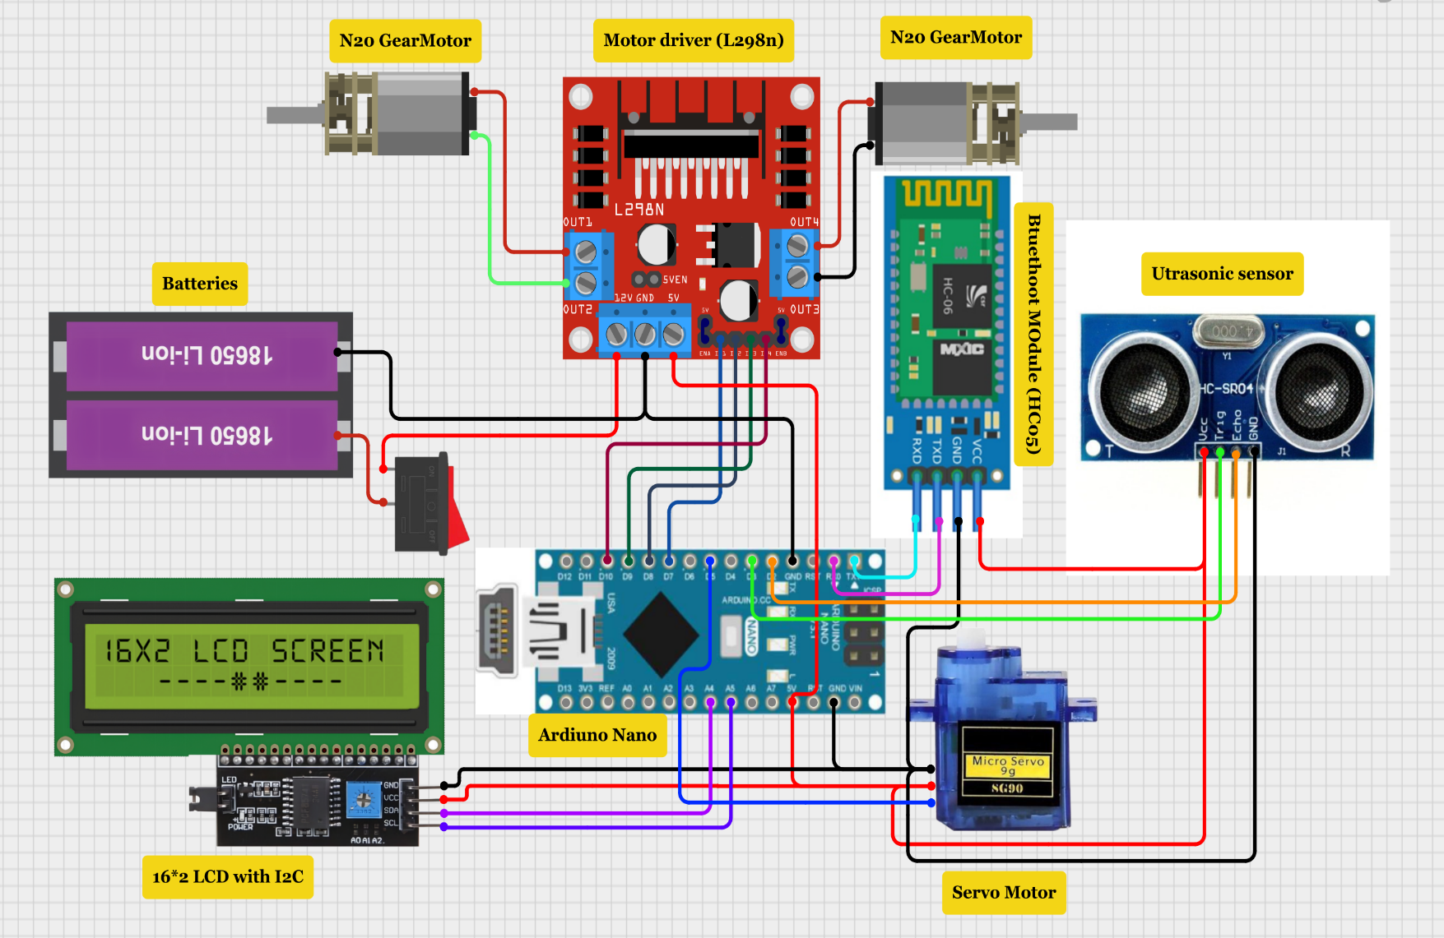

The circuit was designed on a breadboard and then transferred onto the chassis.
Proper connections were made between Arduino, sensors, motor driver, and Bluetooth module.

2. Coding and Testing:
The Arduino was programmed using Arduino IDE.
Separate code sections were written for each mode, then integrated for dual functionality.

3. Integration of LCD:
LCD was configured to display active mode and sensor readings using I2C interface.

4. Hardware Assembly:
Motors and driver were mounted on the chassis.
Ultrasonic sensor was attached on a servo motor for flexible scanning.
Battery and wiring were organized neatly for stability.

5. Testing and Debugging:
- Each mode was tested independently and then combined.
- Bluetooth mode worked seamlessly with a mobile app.
- Obstacle mode avoided collisions up to 30 cm detection range.
- Chapter 2 – Related Literature / Review Article
- Research on obstacle-avoiding robots using ultrasonic sensors.
- Studies on Bluetooth-based wireless robotic control.
- Previous Arduino-based autonomous vehicle prototypes.

Chapter 5 – Results

Bluetooth Mode: The car responded promptly to mobile commands.
Obstacle Mode: The car successfully avoided obstacles in real time.
Display: LCD accurately displayed the current mode and distance.
Switching: Transition between modes was smooth without reboot.
Performance: The system operated efficiently on battery power with minimal lag.

Key Performance Metrics:

Parameter | Observation
Bluetooth Range | 10–12 meters
Ultrasonic Detection Range | 2–160 cm
Battery Life | ~45 minutes continuous operation
Mode Switching Delay | <1 second

Chapter 6 – Conclusion

The project DriveX achieved its objective of developing a dual-mode smart car that can operate manually and autonomously. It combines hardware and software components to simulate real-world robotic systems.
Through this project, valuable practical experience was gained in Arduino programming, motor control, sensor integration, and wireless communication.

Future Scope

- Add camera and AI vision for intelligent object recognition.
- Integrate GPS and Wi-Fi for remote monitoring.
- Implement voice control and cloud data logging.
- Use solar energy for power efficiency and sustainability.

References

1. Arduino Official Documentation – https://docs.arduino.cc/

2. HC-05 Bluetooth Module Datasheet

3. Ultrasonic Sensor (HC-SR04) Datasheet

4. L298N Motor Driver Technical Manual

5. IoT & Robotics Tutorials

