**Image Description and Emotion Analysis Script**

**Overview:**

This script processes an image URL to generate a textual description using an image captioning model and then analyzes the emotional tone of the generated description using a sentiment analysis model. It utilizes models from the Hugging Face Transformers library and processes images fetched from a given URL.

**Requirements**

* Python 3.7 or higher
* transformers library
* PIL library (Pillow)
* requests library

**1. Importing Libraries:**

* **Blip Processor and BlipForConditionalGeneration**: For image captioning.
* **Image, requests, Bytes IO**: For image handling and fetching.
* **Pipeline**: For sentiment analysis.

**2. Fetching the Image:**

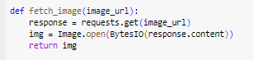

* **Purpose**: Fetches an image from the provided URL and returns it as a PIL Image object.
* **Parameters**: (image-URL) - URL of the image to be fetched.

**3. Generating the Image Description:**

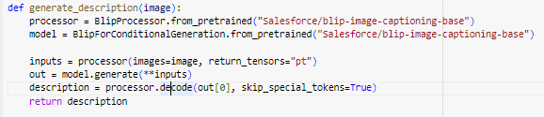

* **Purpose**: Generates a textual description of the provided image using the BLIP (Bootstrapped Language Image Pre-training) model.
* **Parameters**: image - The PIL Image object.
* **Returns**: A string containing the image description.

**4. Analyzing the Emotion of the Description**

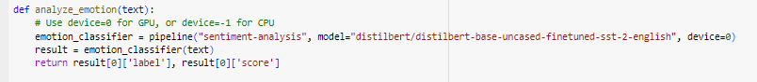

* **Purpose**: Analyzes the emotional tone of the generated description using a sentiment analysis model.
* **Parameters**: text - The textual description of the image.
* **Returns**: A tuple containing the emotion label (e.g., "POSITIVE" or "NEGATIVE") and the confidence score.

**5. Processing the Image**

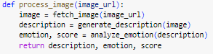

* **Purpose**: Orchestrates the entire process of fetching an image, generating a description, and analyzing the emotion of the description.
* **Returns**: A tuple containing the description, emotion, and confidence score.

**6. Main Execution Block**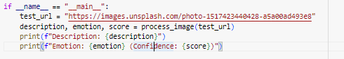

* **Purpose**: Runs the script with a test image URL, processes the image, and prints the description and emotion analysis results.

**Usage**

1. **Replace the** (image-URL) **variable** with the URL of the image you want to process.
2. **Run the script** using a Python interpreter:
3. **View the output** which will display the description of the image and the sentiment analysis result.

**Notes**

* The script uses a default sentiment analysis model. If you want to use a different model, you can replace "distilbert/distilbert-base-uncased-finetuned-sst-2-english" with the model of your choice.
* If a GPU is available and you want to use it, ensure that you have the appropriate setup for GPU usage in the pipeline function.