SIMATS ENGINEERING
ASSESSMENT TOOL 1
COURSE NAME: ARTIFICIAL INTELLIGENCE
COURSE CODE: CSA-1709
DONE BY: ASHWANT S.P
ANALYTICAL PROBLEM SOLVING
QUESTION 1: WATER JUG PROBLEM
The objective is to obtain exactly 2 gallons in the 4-gallon jug using a 4-gallon jug and a 3-gallon jug. The jugs have no measuring marks, and the permitted operations are filling a jug from the pump, emptying water onto the ground, and pouring water from one jug into the other. Represent each state as (x, y), where x is the amount in the 4-gallon jug and y is the amount in the 3-gallon jug.
Initially, both jugs are empty, so the state is (0, 0). Step 1: Fill the 3-gallon jug, producing (0, 3). Step 2: Pour the 3-gallon jug into the 4-gallon jug, producing (3, 0). Step 3: Fill the 3-gallon jug again, producing (3, 3). Step 4: Pour from the 3-gallon jug into the 4-gallon jug until the 4-gallon jug is full. Only 1 gallon fits, so the resulting state is (4, 2). Step 5: Empty the 4-gallon jug, producing (0, 2). Step 6: Pour the remaining 2 gallons from the 3-gallon jug into the 4-gallon jug, producing (2, 0). The 4-gallon jug now contains exactly 2 gallons.
Step | Operation | State (4-gal, 3-gal) | Result
0 | Start | (0, 0) | Both empty
1 | Fill 3-gallon jug | (0, 3) | 3-gallon jug full
2 | Pour 3-gallon into 4-gallon | (3, 0) | 4-gallon jug has 3
3 | Fill 3-gallon jug | (3, 3) | Both contain 3
4 | Pour into 4-gallon until full | (4, 2) | 2 gallons remain in 3-gallon jug
5 | Empty 4-gallon jug | (0, 2) | 2 gallons remain in 3-gallon jug
6 | Pour 3-gallon into 4-gallon | (2, 0) | Goal achieved
Final answer: The state (2, 0) means the 4-gallon jug contains exactly 2 gallons and the 3-gallon jug is empty.
QUESTION 2: MARS ROVER AS AN INTELLIGENT AGENT
A Mars Rover is an autonomous robotic agent that senses its surroundings, moves across the Martian surface, examines rocks and soil, and collects or analyzes samples. Its decisions must account for limited communication with Earth, uncertain terrain, energy limits, scientific priorities and equipment safety.
(i) Percepts of the agent
The rover’s percepts include camera images, terrain and obstacle measurements, wheel slip, tilt and orientation, distance measurements, temperature, battery and power status, instrument readings, and the chemical or mineral composition detected in rocks and soil. These percepts allow the rover to estimate its location, recognize hazards, identify scientifically interesting targets, and monitor its own condition.
(ii) Operating environment
The environment is partially observable because sensors cannot reveal every detail of the terrain or the interior composition of a sample. It is sequential because each movement affects future positions, energy use and available scientific opportunities. It is dynamic because environmental and rover conditions can change. It is continuous in physical space and time, and it is uncertain because terrain interactions and scientific measurements may not be perfectly predictable. The rover is also a multi-stage autonomous system with communication delays, so it cannot rely on immediate human instructions for every action.
(iii) Actions the agent can take
The rover can move forward or backward, turn, stop, choose a route, capture images, focus or reposition cameras, use a robotic arm, drill or abrade a rock when equipped, collect or place a sample, run onboard scientific instruments, transmit data to Earth, conserve power, and enter a safe mode when a fault or hazard is detected. The exact actions depend on the rover’s hardware and mission commands.
(iv) Performance evaluation
Performance can be evaluated by the quality and quantity of useful scientific data, the number and relevance of samples analyzed, successful completion of mission objectives, accuracy of navigation, distance traveled without damage, energy efficiency, communication and data-transfer success, equipment reliability, and the ability to avoid hazards. A good performance measure rewards meaningful scientific discoveries and safe mission completion rather than movement alone.
(v) Most suitable agent architecture
A hybrid architecture combining a model-based, goal-based and utility-based agent is most suitable. A model-based component maintains an internal map and a record of rover state because the environment is only partially observable. A goal-based component plans actions toward mission objectives, such as reaching a target or analyzing a sample. A utility-based component compares alternatives using scientific value, travel risk, energy consumption, time and hardware safety. A learning component can further improve terrain classification and target selection from experience.
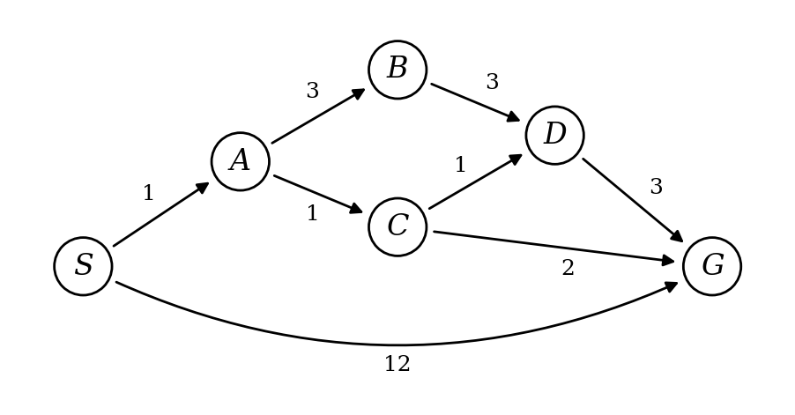
RUBRICS FOR CALCULATION:
Criteria | Weightage | Level 4 (Exemplary) | Level 3 (Proficient) | Level 2 (Developing) | Level 1 (Beginning)
Problem Understanding | 20% | Clearly interprets problem, identifies all parameters and requirements accurately | Understands problem with minor gaps | Partial understanding; misses key elements | Misinterprets or unable to understand problem
Method Selection | 20% | Selects most appropriate method/formula with strong justification | Selects correct method with minor errors | Inappropriate or partially correct method | Unable to select method
Solution Process | 25% | Logical, systematic steps with correct approach throughout | Mostly correct steps with minor mistakes | Disorganized steps; multiple errors | No clear process
Accuracy of Calculation | 20% | All calculations accurate; correct final answer | Minor calculation errors | Frequent errors; incorrect final answer | No valid calculation
Interpretation of Results | 15% | Clearly interprets results with units and engineering relevance | Basic interpretation with minor omissions | Limited or unclear interpretation | No interpretation
Problem Understanding | 20% | Clearly interprets problem, identifies all parameters and requirements accurately | Understands problem with minor gaps | Partial understanding; misses key elements | Misinterprets or unable to understand problem

