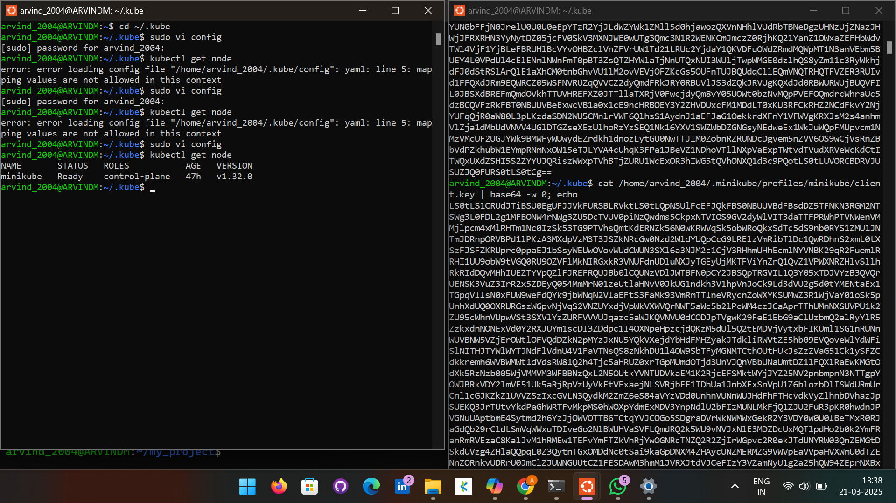
pipeline {
agent any

stages {
stage('scm') {
steps {
git branch: ''
}
}
stage('builb-clean') {
steps {
sh "mvn clean"
}
}
stage('build-validate') {
steps {
sh "mvn validate"
}
}
stage('build-com') {
steps {
sh "mvn compile"
}
}

stage('build-test') {
steps {
sh "mvn test"
}
}
stage('build-install') {
steps {
sh "mvn package"
}
}
stage('build to images') {
steps {
script{
sh 'docker build -t .'
}
}
}
stage('push to hub') {
steps {
script{
withDockerRegistry(credentialsId: 'Docker_cred', url: 'https://index.docker.io/v1/') {
sh 'docker push '
}
}
}
}
stage('Deploy App') {
steps {
withKubeConfig(caCertificate: '', clusterName: 'minikube', contextName: 'minikube', credentialsId: 'mukubeconfig_011', namespace: '', restrictKubeConfigAccess: false, serverUrl: 'https://192.168.49.2:8443') {
sh 'kubectl apply -f deployment.yml --validate=false'
}
}
}
stage('Test') {
steps {
withKubeConfig(caCertificate: '', clusterName: 'minikube', contextName: 'minikube', credentialsId: 'mukubeconfig_011', namespace: '', restrictKubeConfigAccess: false, serverUrl: 'https://192.168.49.2:8443') {

sh 'minikube service my-service --url | xargs curl'
}
}
}
}
}
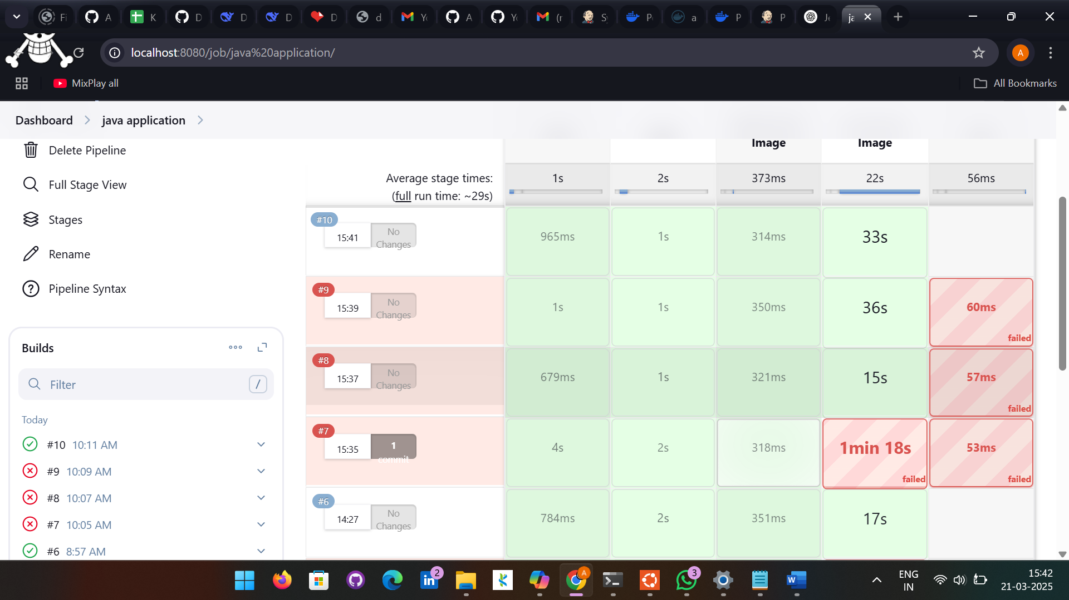

Terraform

terraform {
required_providers {
aws = {
source = "hashicorp/aws"
version = "5.92.0"
}
}
}

provider "aws" {
# Configuration options
region = "us-east-1"
}
resource "aws_vpc" "myvpc" {
cidr_block = "10.0.0.0/16"

tags = {
Name = "demovpc"
}
}
resource "aws_subnet" "pubsub" {
vpc_id = aws_vpc.myvpc.id
cidr_block = "10.0.1.0/24"
availability_zone = "us-east-1a"

tags = {
Name = "sn1"
}
}

resource "aws_subnet" "pri_sub" {
vpc_id = aws_vpc.myvpc.id
cidr_block = "10.0.1.0/24"
availability_zone = "us-east-1a"

tags = {
Name = "sn2"
}
}
resource "aws_subnet" "pri_sub" {
vpc_id = aws_vpc.myvpc.id
cidr_block = "10.0.1.0/24"
availability_zone = "us-east-1a"

tags = {
Name = "sn3"
}
}
resource "aws_subnet" "pri_sub" {
vpc_id = aws_vpc.myvpc.id
cidr_block = "10.0.1.0/24"
availability_zone = "us-east-1a"

tags = {
Name = "sn4"
}
}
resource "aws_internet_gateway" "tfigw" {
vpc_id = aws_vpc.myvpc.id

tags = {
Name = "tfigw"
}
}
resource "aws_route_table" "tfpubrt" {
vpc_id = aws_vpc.myvpc.id

route {
cidr_block = "0.0.0.0/0"
gateway_id = aws_internet_gateway.tfigw.id
}

tags = {
Name = "tfpublicroute"
}
}
resource "aws_route_table_association" "pubsn1" {
subnet_id = aws_subnet.pubsub.id
route_table_id = aws_route_table.tfpubrt.id
}
resource "aws_route_table_association" "pubsn2" {
subnet_id = aws_subnet.pub_sub.id
route_table_id = aws_route_table.tfpubrt.id
}
resource "aws_eip" "tfeip" {
domain = "vpc"
}
resource "aws_nat_gateway" "tfnat" {
allocation_id = aws_eip.tfeip.id
subnet_id = aws_subnet.pub_sub.id

tags = {
Name = "gw NAT"
}
}
resource "aws_route_table" "tfprirt" {
vpc_id = aws_vpc.myvpc.id

route {
cidr_block = "0.0.0.0/0"
gateway_id = aws_nat_gateway.tfnat.id
}

tags = {
Name = "tfprivateroute"
}
}

resource "aws_route_table_association" "prisn3" {
subnet_id = aws_subnet.prisub.id
route_table_id = aws_route_table.tfprirt.id
}
resource "aws_route_table_association" "prisn4" {
subnet_id = aws_subnet.pri_sub.id
route_table_id = aws_route_table.tfprirt.id
}
resource "aws_security_group" "allow_tfsg" {
name = "allow_tfsg"
description = "Allow TLS inbound traffic"
vpc_id = aws_vpc.myvpc.id

ingress {
description = "HTTPS "
from_port = 443
to_port = 443
protocol = "tcp"
cidr_blocks = ["0.0.0.0/0"]
}
ingress {
description = "HTTP "
from_port = 80
to_port = 80
protocol = "tcp"
cidr_blocks = ["0.0.0.0/0"]
}
ingress {
description = "SSH"
from_port = 22
to_port = 22
protocol = "tcp"
cidr_blocks = ["0.0.0.0/0"]
}

egress {
from_port = 0
to_port = 0
protocol = "-1"
cidr_blocks = ["0.0.0.0/0"]
}

tags = {
Name = "TfsecurityGroup"
}
}
resource "aws_instance" "pub_ins" {
ami = "ami-0fc5d935ebf8bc3bc"
instance_type = "t2.micro"
subnet_id = aws_subnet.pub_sub.id
vpc_security_group_ids = [aws_security_group.allow_tfsg.id]
key_name = "David"
associate_public_ip_address = "true"
}
resource "aws_instance" "pri_ins" {
ami = "ami-0fc5d935ebf8bc3bc"
instance_type = "t2.micro"
subnet_id = aws_subnet.prisub.id
vpc_security_group_ids = [aws_security_group.allow_tfsg.id]
key_name = "David"
}
#terraform init
#terraform validate
#terraform plan
#terraform apply
#terraform destroy

